"Sam's First Superpower"

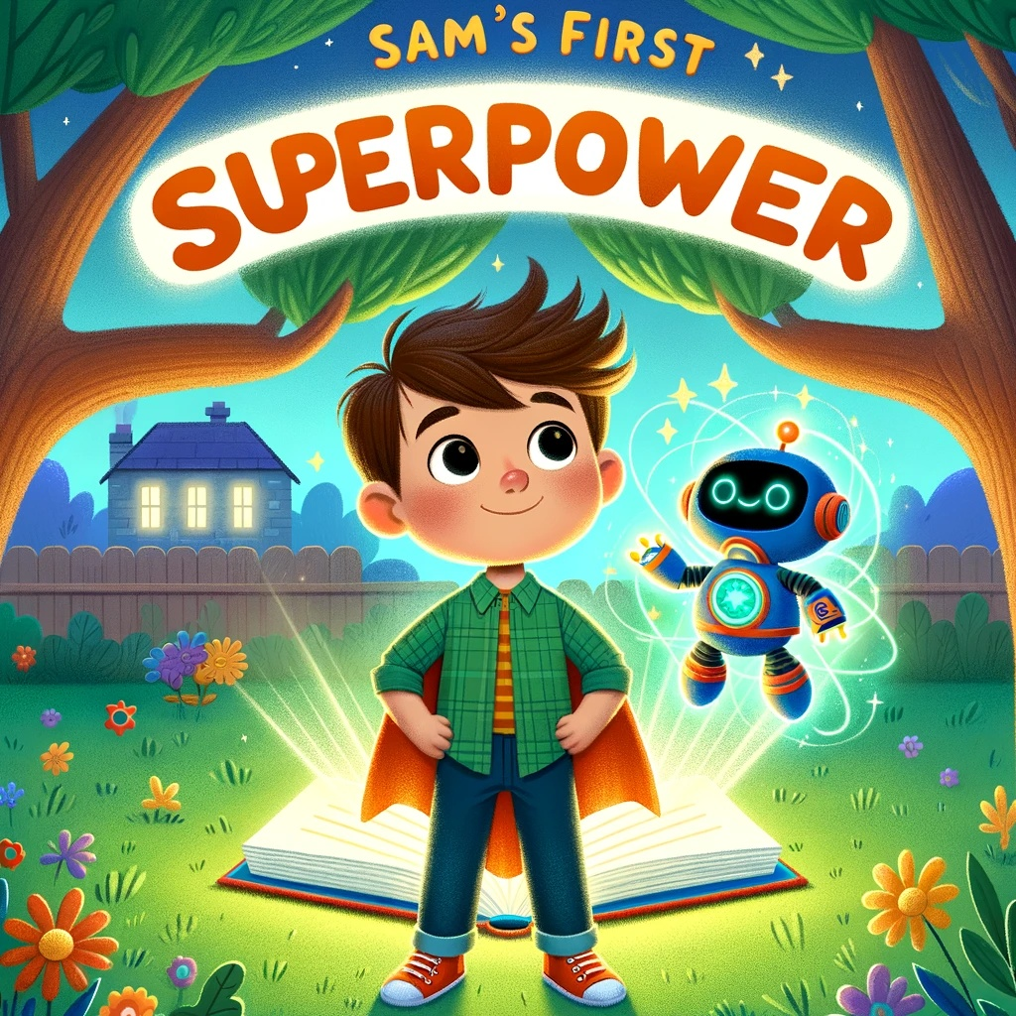

Chapter 1: The Magical Book

Sam was a curious boy who loved adventures. One sunny day, while playing in his backyard, he stumbled upon a shiny, magical book hidden under a tree. Excitedly, he opened it, and out popped Robo, a friendly robot with a big smile.

"Hello, Sam! I'm Robo. I'm here to help you learn and go on amazing adventures!" Robo said cheerfully.

"Wow! This is going to be fun!" Sam exclaimed.

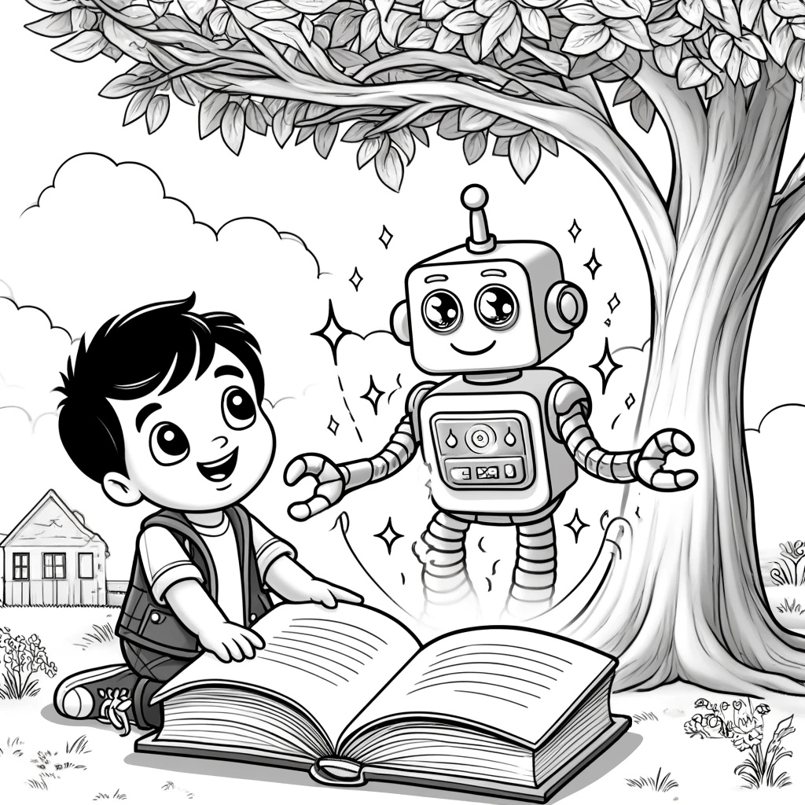

Question: What is the Name of Sam's new Friend?
Answer: Robo

Chapter 2: The Adventure Begins

Robo explained the importance of phonics and sight words. "Today, we'll learn the sounds 'at', 'an', and 'it', and some sight words like 'the', 'and', and 'can'."

Sam eagerly repeated the sounds and words after Robo. As they practiced, they heard a loud "meow." They ran towards the sound and saw a cat stuck in a tree.

"I can help the cat!" Sam said. He used his new word, "cat," to call the cat down. "Come here, cat!" The cat leaped into Sam's arms, purring happily.

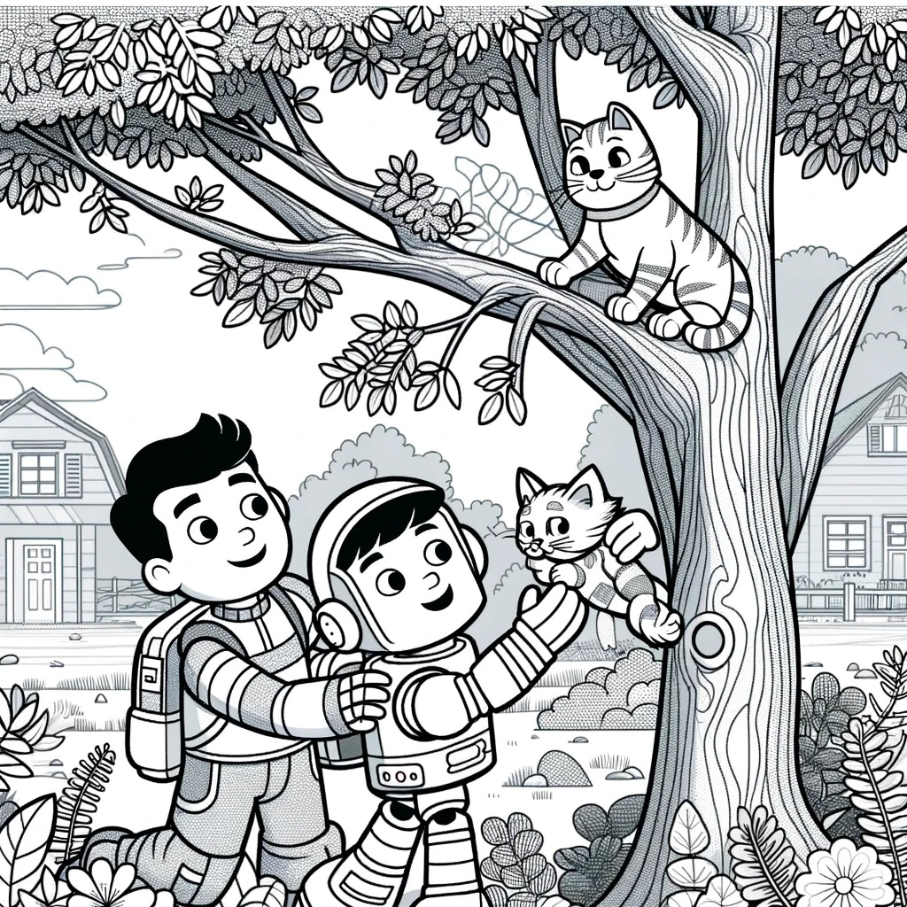

Question: What was stuck in the tree?
Answer: The Cat.

Chapter 3: Healthy Habits

Robo then taught Sam about healthy habits. "Brushing your teeth and eating vegetables are very important for staying healthy."

Sam nodded. "I brush my teeth every morning and night!"

As they walked through the garden, they found a rabbit looking for food. "Let's help the rabbit find some healthy vegetables," Robo suggested. They gathered some carrots and lettuce, and the rabbit nibbled happily.

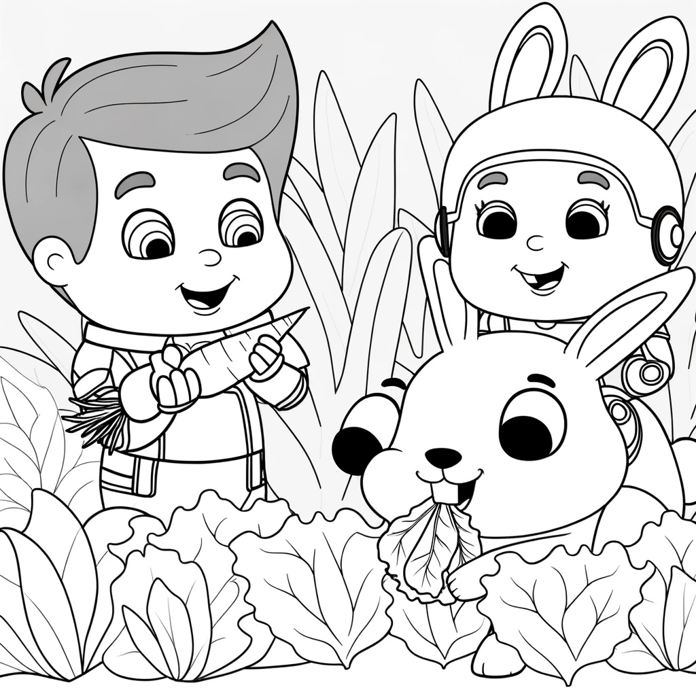Question: What did Robo gather for the rabbit?
Answer: The carrots.

Chapter 4: Sams Smart Heart

Later, Sam and Robo met a sad puppy and an angry bird. Robo explained, "It's important to recognize and manage emotions. Can you comfort the puppy and calm the bird?"

Sam gently petted the puppy and said, "It's okay, puppy. Everything will be alright." The puppy wagged its tail and felt better. Then, Sam spoke softly to the bird, "Calm down, bird. We're here to help." The bird relaxed and chirped happily.

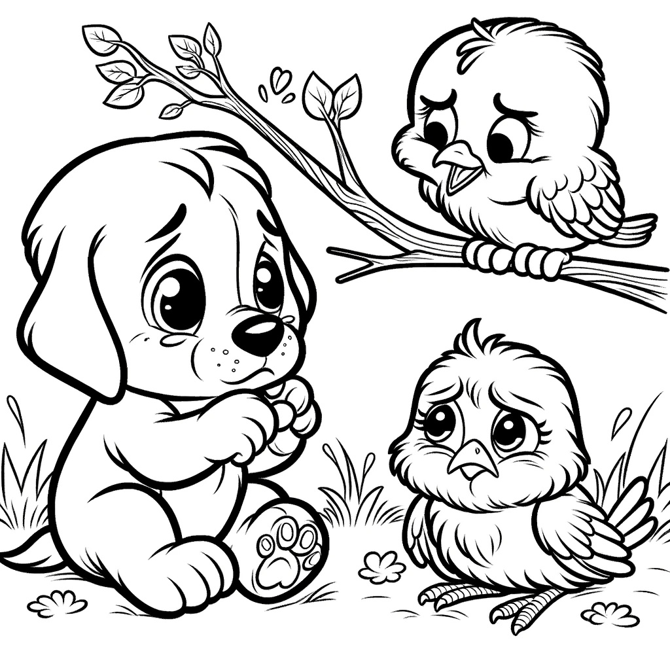

Question: How was Sam a good friend?
Answer: He made the puppy and bird feel better.

Chapter 5: Apples and Coins

As they continued their adventure, they met a farmer who needed help picking apples. Sam eagerly helped, and the farmer gave him a special coin as a reward.

"Remember, Sam," Robo said, "it's important to work hard to earn rewards. And sometimes, it's wise to save what you earn."

Sam looked at the coin and decided, "I'll save this for something important."

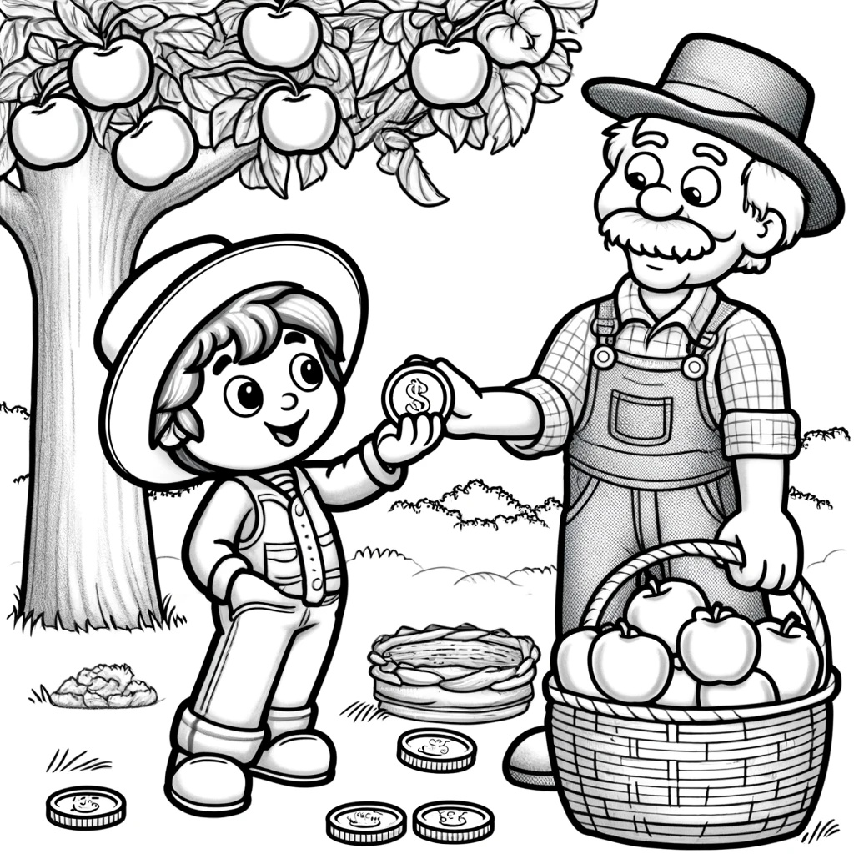

Question: How did Sam get his Special Coin?
Answer: Sam helped the farmer pick apples.

Chapter 6: Superpower Unlocked

By the end of the day, Sam had successfully completed all his tasks. Robo smiled and said, "Sam, you've earned your first superpower: the ability to understand and communicate with animals!"

Sam was thrilled. "Wow! This is amazing!" He used his new ability to talk to the animals, helping them with their needs.

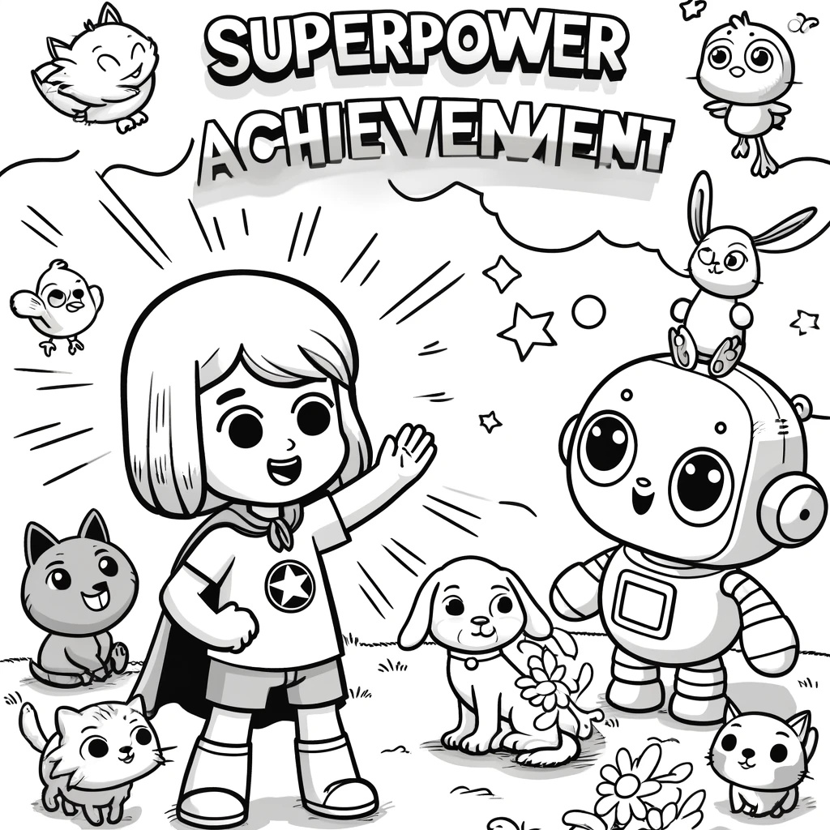

Sam thanked Robo for the adventures and the lessons learned. He felt proud of his new skills and looked forward to more adventures. "I can't wait for our next adventure, Robo!"

Robo replied, "There are many more adventures ahead, Sam.

Keep learning and helping others."

Great job reading with Sam and Robo. You did an amazing job and what an adventure. Keep reading to go on more adventures and unlock superpowers with Sam and Robo!

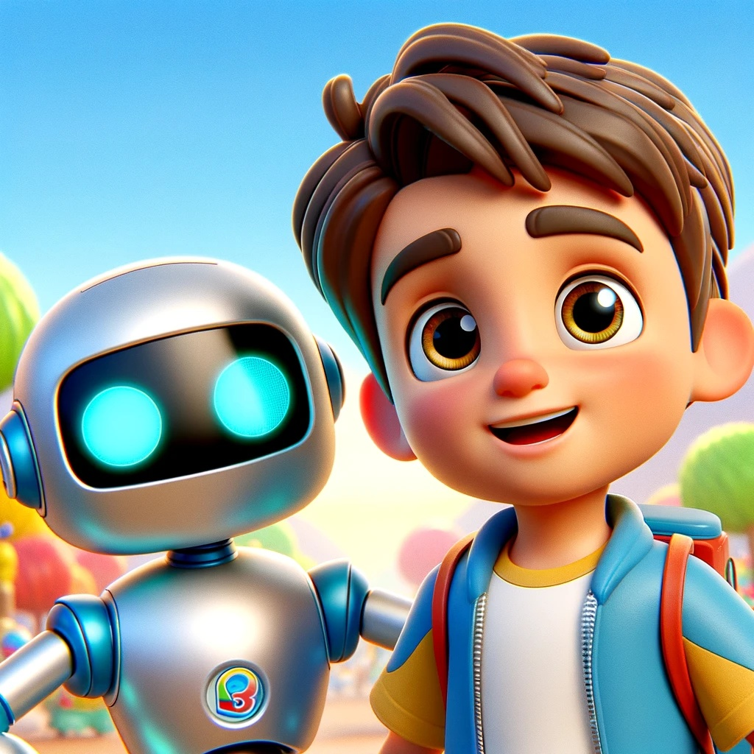

#########################################

### Summary for Parents

**"Sam's First Superpower"** is an engaging children's book designed for young readers aged 5-7. This book follows the adventures of Sam, a curious and adventurous boy, and his friendly robot companion, Robo. Together, they embark on fun-filled missions that introduce essential phonetic skills and valuable life lessons.

#### Book Overview

- **Phonics Progression**: Each chapter introduces new phonetic sounds and sight words, gradually building the child's reading abilities.
- **Chapter 1**: Basic phonics sounds ("at", "an", "it") and simple sight words ("the", "and", "can").
- **Chapter 2**: Compound words and practical application.
- **Chapter 3**: Blends and digraphs.
- **Chapter 4**: Long vowels and complex patterns.
- **Chapter 5**: Silent letters and diphthongs.
- **Chapter 6**: Review and application of all learned phonics.

#### Themes and Messages

- **Curiosity and Learning**: Encouraging children to be curious and eager to learn new things through Sam's adventurous spirit.
- **Hard Work and Rewards**: Teaching the importance of working hard to earn rewards and the value of saving, exemplified through Sam's tasks and the rewards he earns.
- **Healthy Habits**: Promoting basic healthy habits such as

brushing teeth and eating vegetables, as Robo teaches Sam these practices.
- **Emotional Awareness**: Helping children understand and manage their emotions through interactions with various animals displaying different emotions.
- **Teamwork and Helping Others**: Highlighting the importance of helping friends and working together, shown in Sam's missions to help animals and community members.

#### Additional Features

- **Interactive Questions**: At the end of each chapter, there are questions to engage readers and reinforce learning
- **Activity Pages**: Fun activities related to the story, such as coloring pages, simple puzzles, and drawing challenges, to make reading more interactive and enjoyable.

### Why Your Child Will Love This Book

"Sam's First Superpower" is not just a storybook; it is an educational tool that nurtures your child's reading skills, curiosity, and emotional intelligence. The book's interactive elements and colorful illustrations make learning fun and engaging. Each chapter builds on the previous one, ensuring a smooth and progressive learning experience.

By reading "Sam's First Superpower," your child will gain valuable skills and knowledge that will support their development and prepare them for future academic success.

