
Sam's Third Superpower

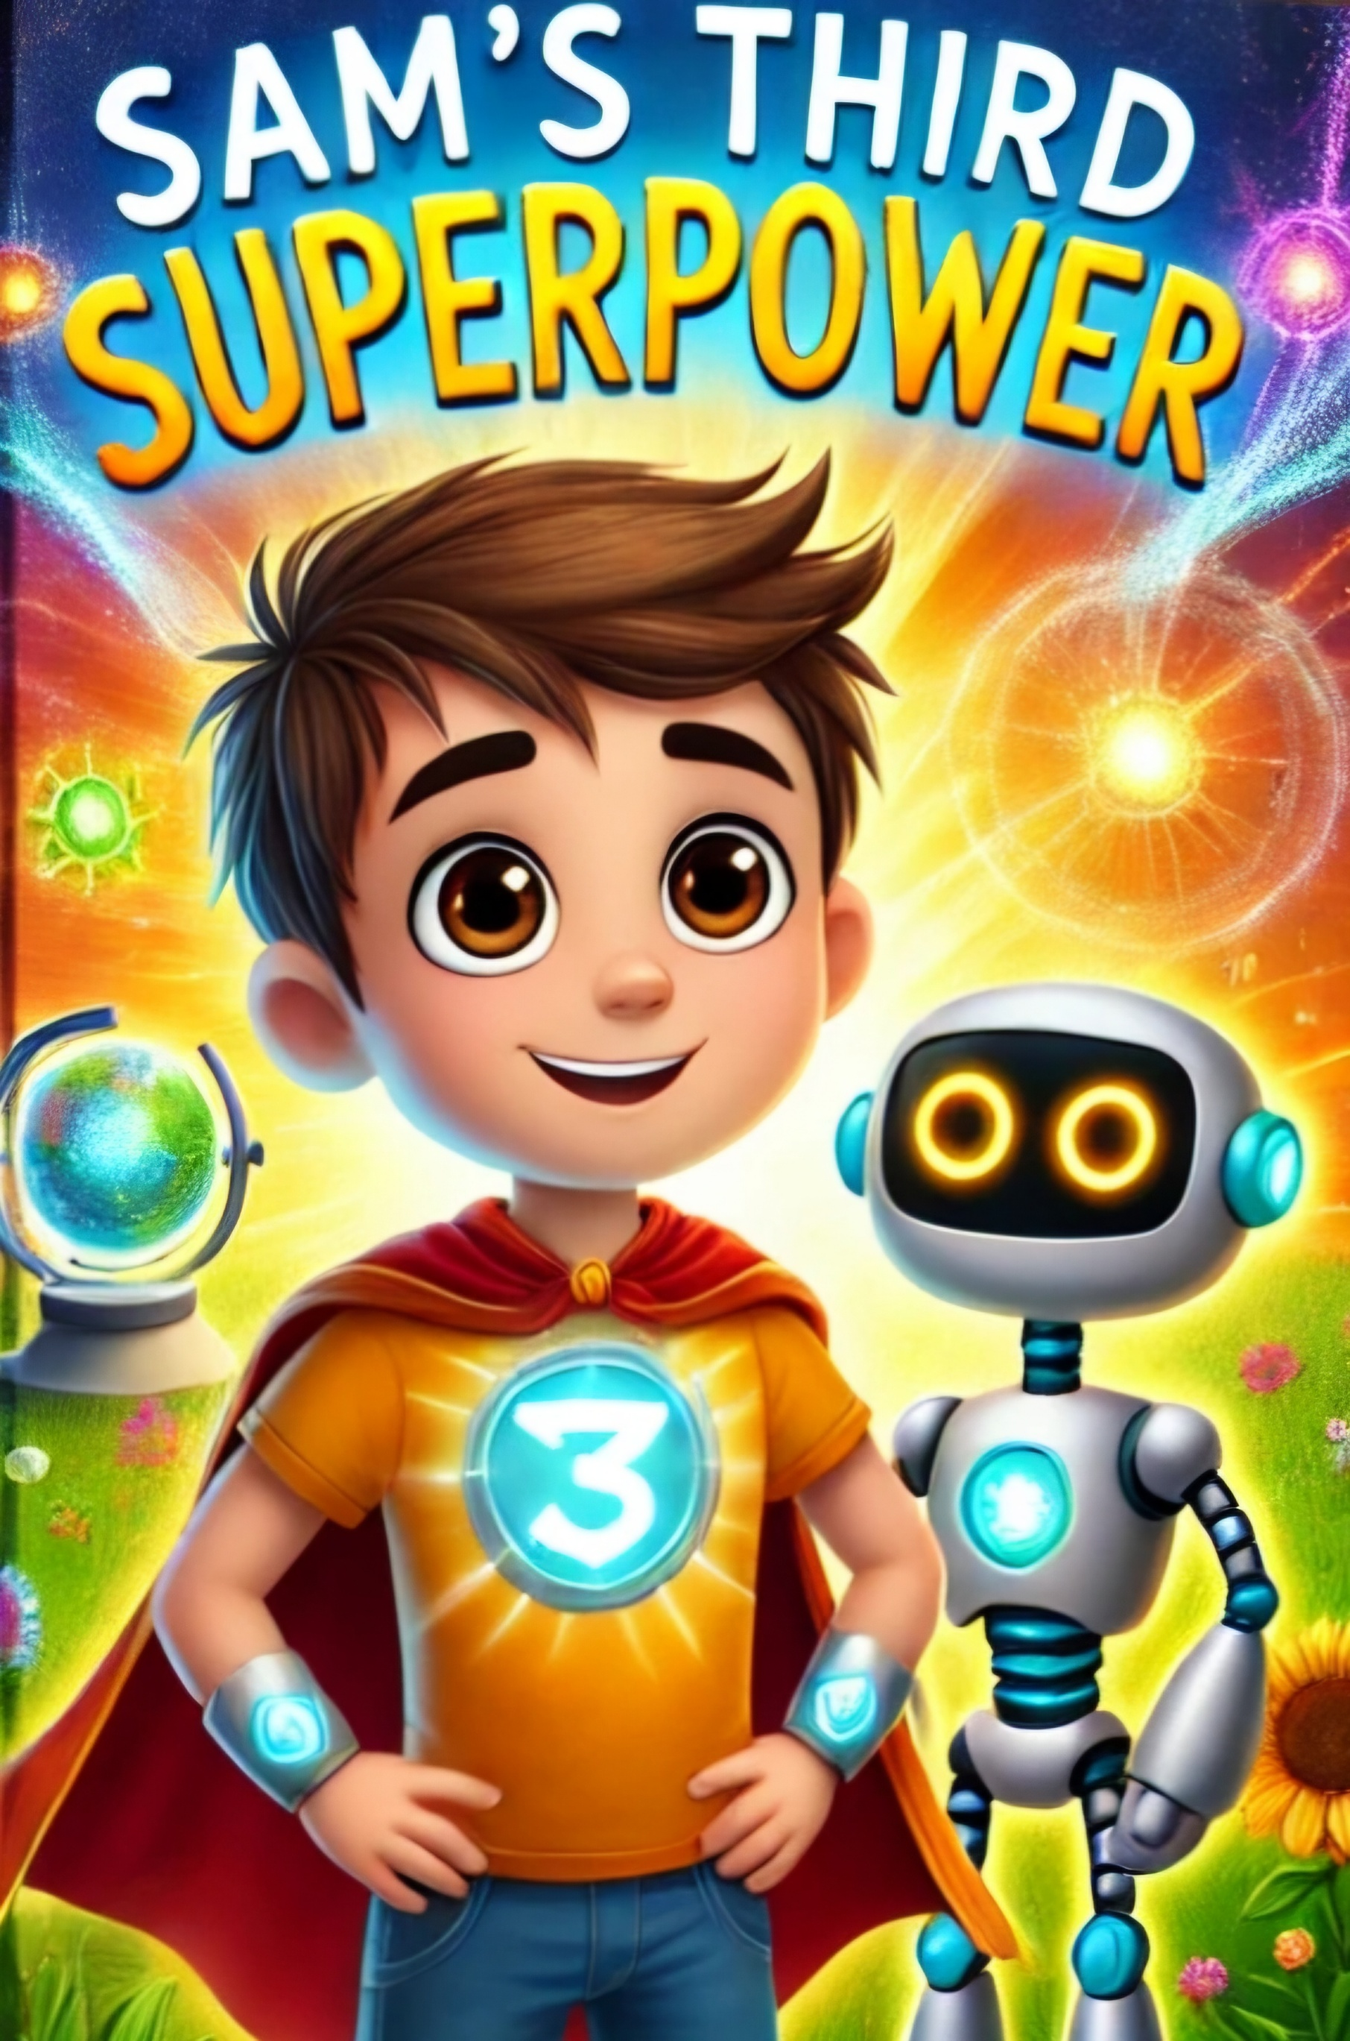

Chapter 1: The Mysterious Note

Sam and Robo woke up to a bright and sunny day, ready for a new adventure. They remembered their past adventures and the valuable lessons they had learned about phonics, healthy habits, and helping others. Today felt like another day to put those lessons to good use.


As they stepped outside, they noticed a strange note on their front porch. Sam picked it up and saw that it was filled with words using blends and digraphs, along with some familiar sight words they had learned before.

"Look, Robo! A mystery note!" Sam exclaimed.

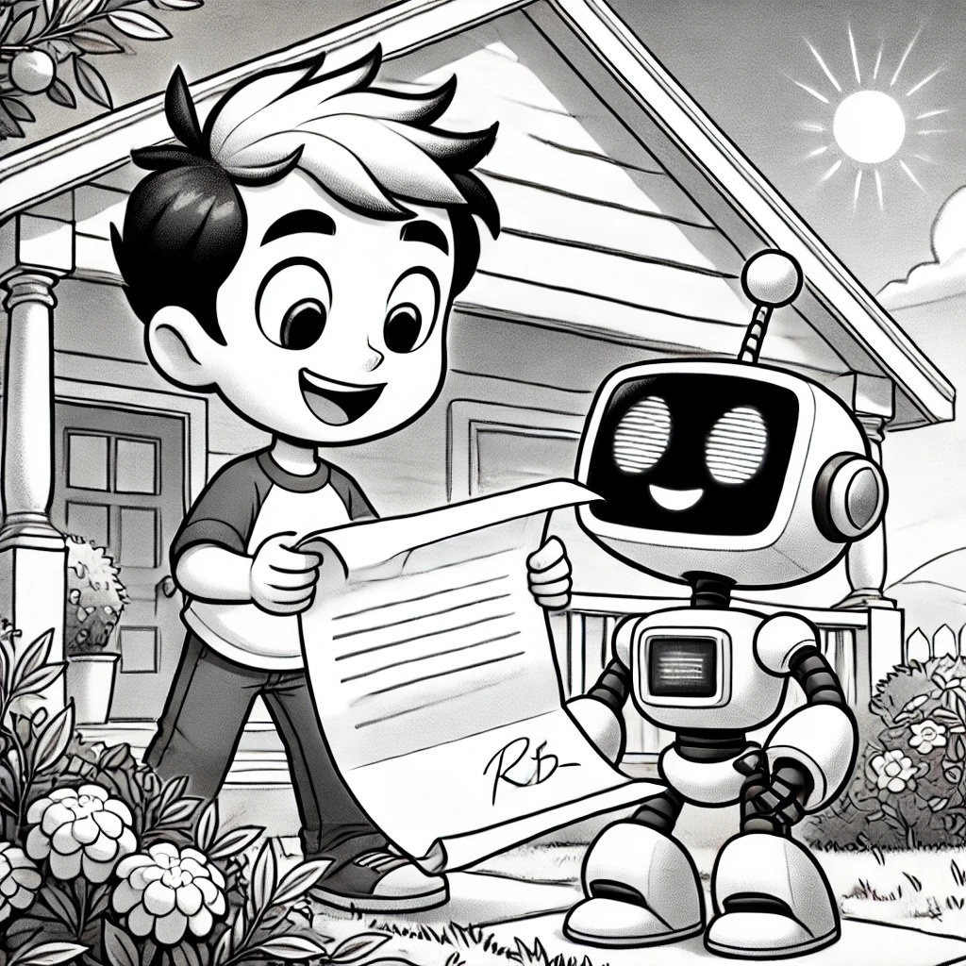

Robo beeped with excitement. "Let's decode it, Sam! We'll use our new blends and digraphs skills and review what we learned before."


The note read: "Find the blue plant by the stream and check the chest for the next clue."

"Blends like 'bl' in blue and 'st' in stream, and digraphs like 'ch' in check and 'sh' in chest," Robo pointed out.

"Wow! This is going to be fun!" Sam said. They repeated the blends and digraphs together: "bl, st, ch, sh."

Using their new phonics skills, they decoded the note and set off to find the blue plant by the stream. As they walked, they practiced sight words like "what," "where," and "which," and reviewed the ones they had learned before like "the," "and," "can."

"What will we find by the stream?" Sam wondered aloud.

"Where could the chest be hidden?" Robo asked.

On their way, they bumped into their old

friends, Lily and the farmer. Sam shared the mystery with them, and they all decided to help.

Lily said, "I remember when we grew that sunflower plant together. We can use our gardening skills to help find the plant."

The farmer added, "And remember, hard work pays off. Let's find that blue plant and solve this mystery together!"

Interactive Moment: Can you help Sam find the blue plant? Point to where you think it might be!
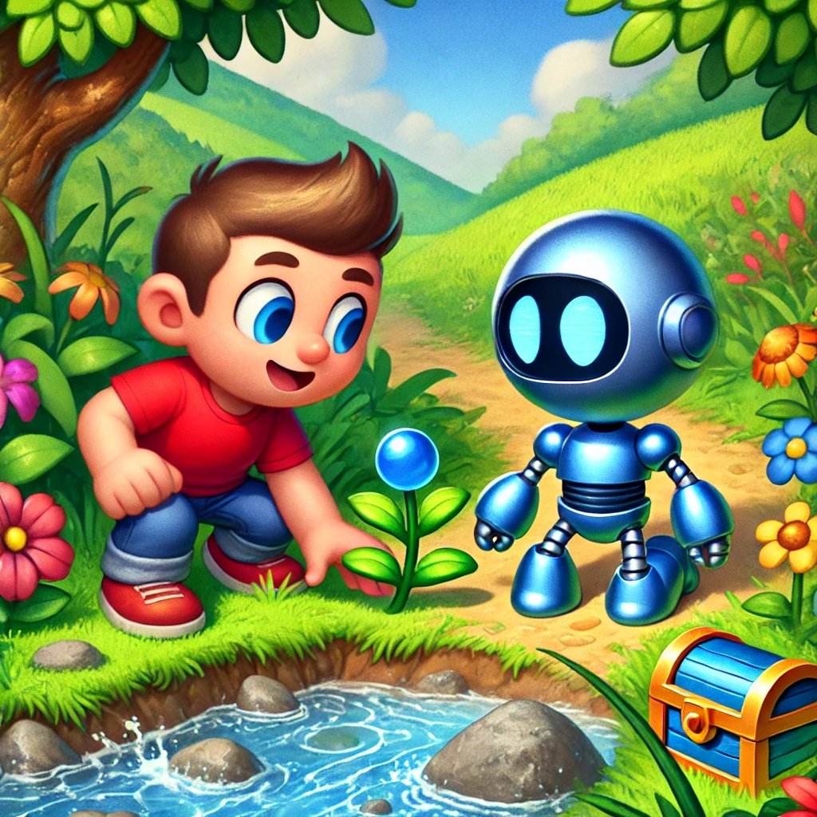


As they reached the stream, they saw the blue plant and a small chest beside it. Sam opened the chest and found another note inside.

"This is just the beginning, Robo. Let's keep going and solve the mystery!" Sam said with determination.

They felt proud of their new skills and the lessons they had learned. They knew that with teamwork, hard work, and their phonics skills, they could solve any mystery.

Question: What are the two blends that Sam and Robo first learn about?
Answer: "bl" and "st".

---

Chapter 2: The Missing Ring

With the new clue in hand, Sam and Robo set off to solve the first mystery. The note from the chest read: "Look behind the small tree to find the missing ring."


"Look, there's another blend—'sm' in small," Robo pointed out.

Sam nodded. "And we already know 'the' and 'find' from our sight words. Let's go!"

They walked towards the small tree, repeating the blends and digraphs as they went: "sm, bl, st, ch, sh." Along the way, they encountered various objects and scenarios that required their reading and decoding skills.

They reached the tree and looked behind it, but there was nothing there. Sam scratched his head. "Hmm, maybe we need to read the clue again."

Robo beeped and read aloud, "Look behind the small tree to find the missing ring."

Sam and Robo looked around and noticed several small trees nearby. "We need to check each one," Sam suggested.

As they searched, they found other notes

hidden along the way, each with blends and digraphs. One note read: "The ring is near the stream by the big rock."

"Big has the blend 'b' and 'g'," Robo observed.

Sam used the sight words in a sentence. "Let's go to the stream by the big rock."

Interactive Moment: Can you help Sam and Robo find the missing ring? Where should they look next?

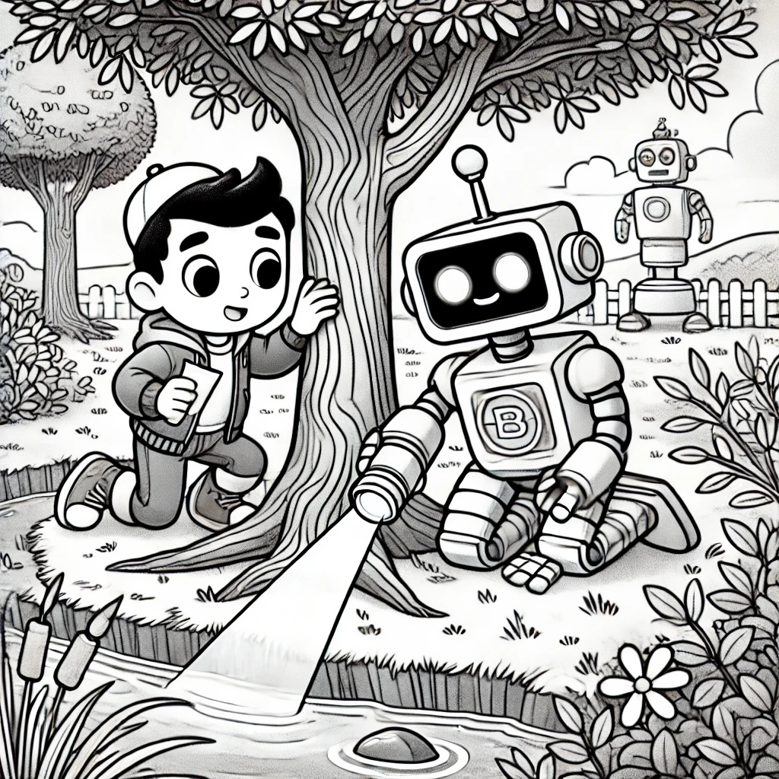

When they reached the big rock, they looked around and finally found a shiny ring hidden

in the grass. "We did it, Robo! We found the missing ring!"

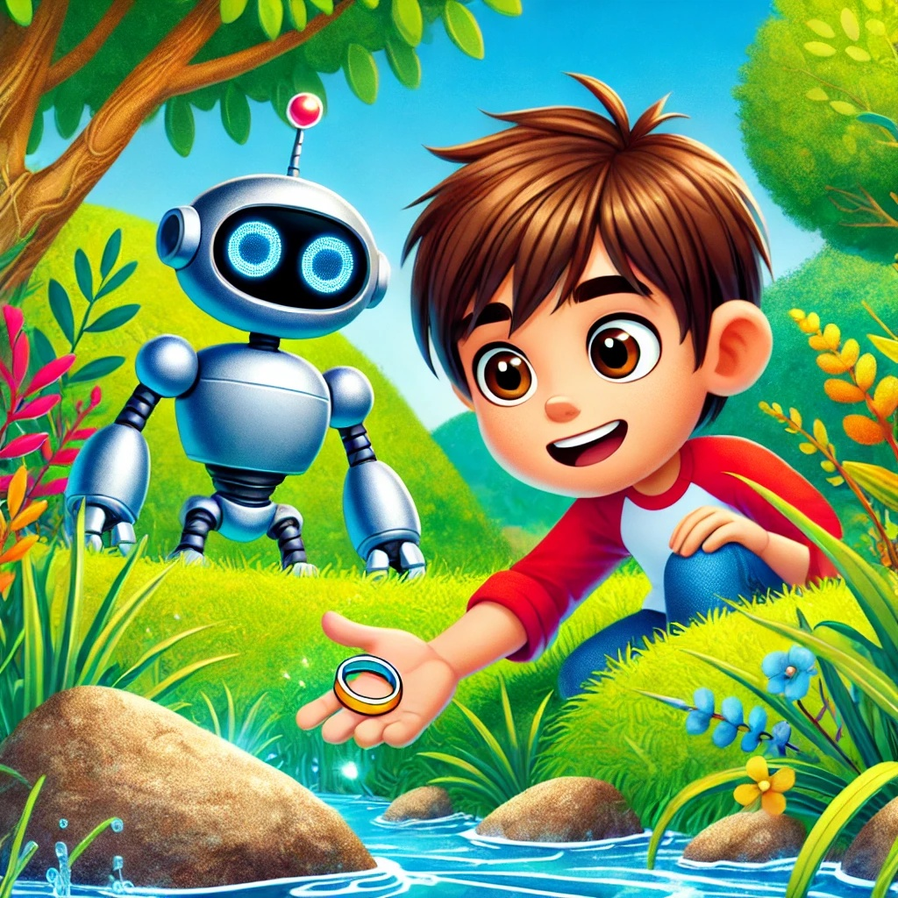

They both high-fived and read the next clue, which said: "Take the ring to Lily's house to find the next clue."

As they walked to Lily's house, they practiced more blends and sight words, feeling more confident with each step. When they arrived, Lily greeted them warmly.

"Great job finding the ring! Now let's see what the next clue says," Lily said, handing

them another note.

The note read: "Solve the next mystery by helping your friends with their garden."

Sam and Robo felt a sense of accomplishment and readiness for their next task. They knew they could use their phonics skills, teamwork, and the lessons they had learned to help their friends and solve any mystery that came their way.

Question: Where did Sam and Robo find the missing ring?
Answer: Near the stream by the big rock.

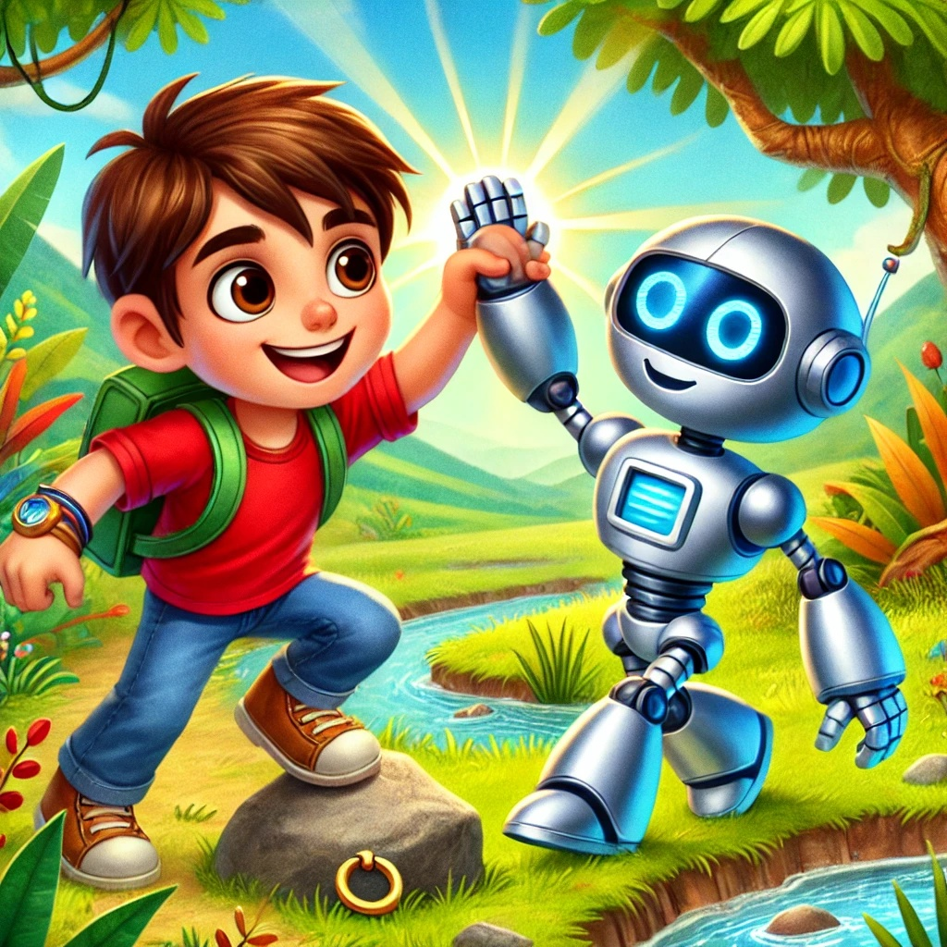


---

Chapter 3: Garden Adventure

The next clue led Sam and Robo to their friend Lily's garden. "We need to help Lily with her garden to solve the mystery," Sam said.

Lily greeted them with a smile. "Thank you for helping! We need to grow a sunflower plant to find the next clue."

Interactive Moment: Can you help Sam and Robo plant the sunflower seeds? Point to the spot where they should plant them!

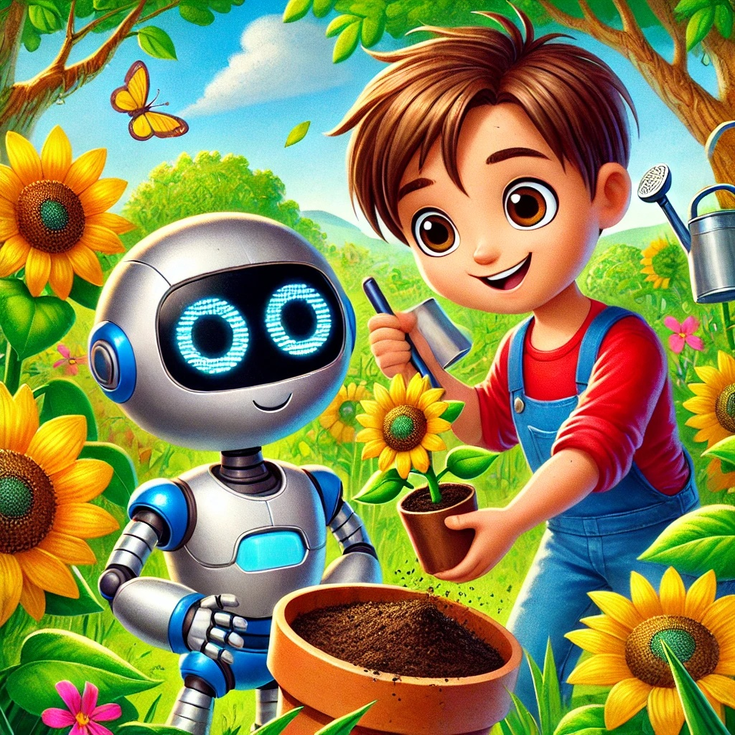


Robo beeped, "Let's use our knowledge of plants from our last adventure!"

They gathered seeds, soil, and water. "First, we plant the seeds in the soil," Sam explained. They patted the soil gently and made sure the seeds were well-covered.

"Next, we water the soil to help the seeds grow," Robo added. They took turns watering the soil and placed the pot in a sunny spot.

"Sunflower plants need plenty of sunlight and water to grow strong," Lily reminded them.

As they waited for the plant to grow, Robo suggested, "Let's learn some simple coding to unlock the digital clue while we wait."

Sam agreed. They used a tablet to follow simple coding instructions, which helped them unlock a digital clue: "The next clue is

hidden under the big oak tree."

They all cheered when they saw the sunflower sprout. "We did it!" Sam said.

"Great teamwork!" Lily praised.

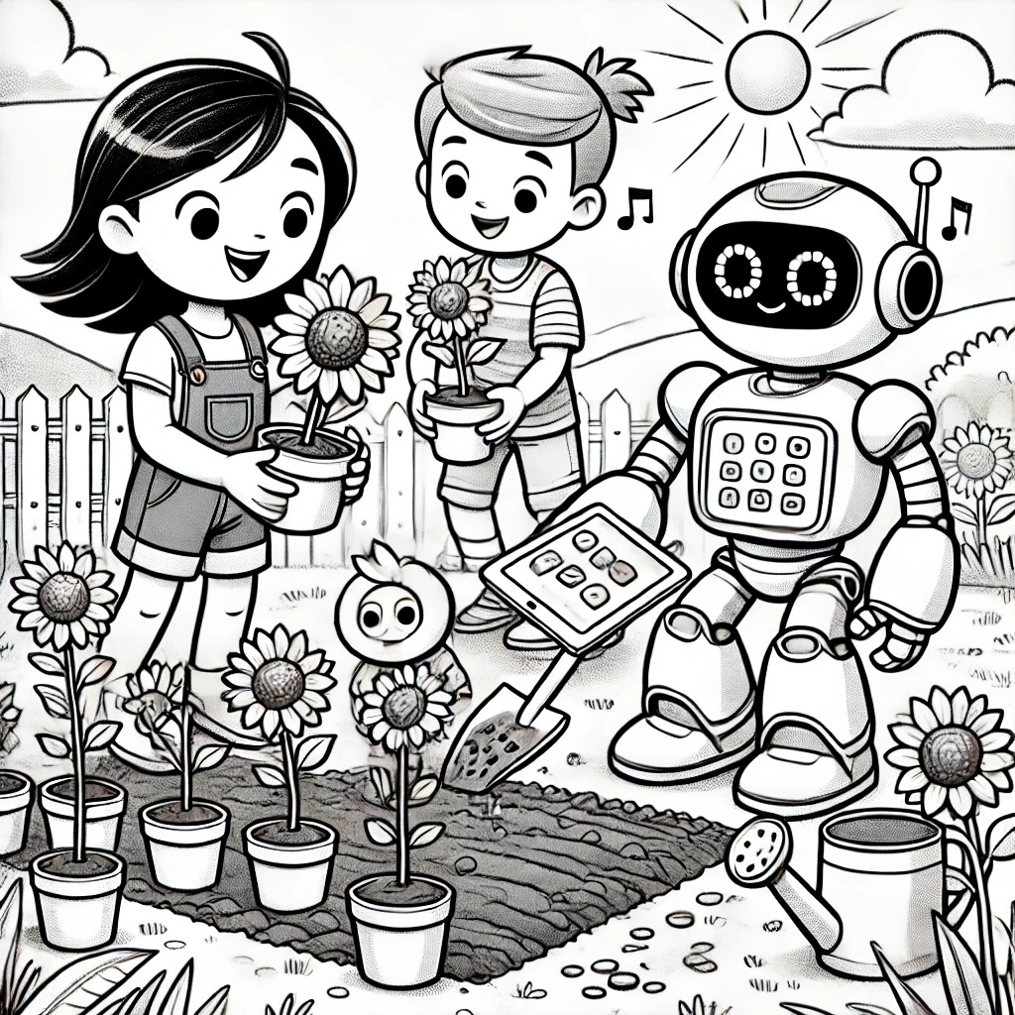

Question: What do sunflower plants need to grow strong?
Answer: Plenty of sunlight and water.

---

Chapter 4: The Missing Toy

With the next clue in hand, Sam and Robo headed to the big oak tree. On the way, they met their friend Max, who looked sad.

"What's wrong, Max?" Sam asked, concerned.

Max sighed, "I lost my favorite toy, and I can't find it anywhere."

Robo beeped, "Don't worry, Max. We'll help you find it!"

Sam remembered what Robo had taught him about empathy. "It's important to understand how others feel and help them," Sam said.

They searched around and found a note with blends and digraphs: "Look near the bench for the missing toy."

Max brightened up. "Let's go check the bench!"

Interactive Moment: Can you help Sam and Robo find Max's toy? Point to where you

think it might be!

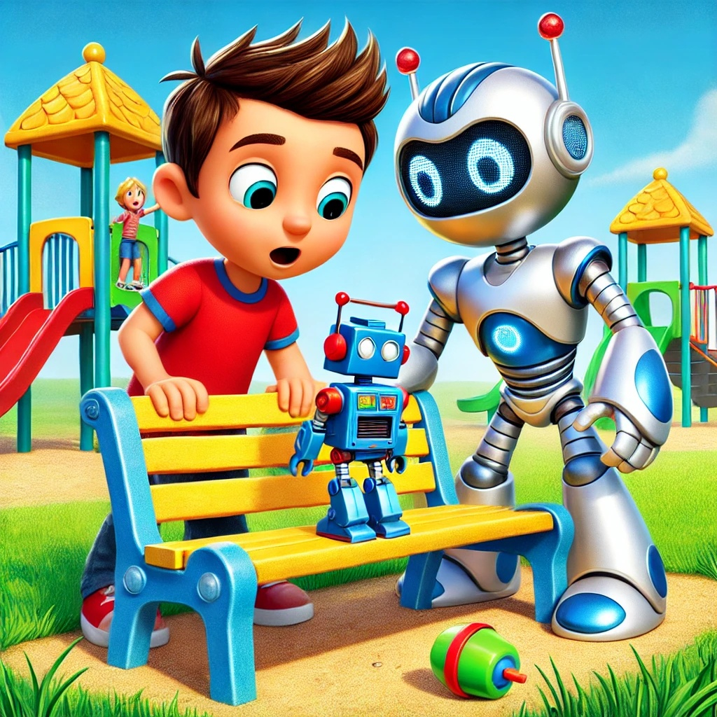

They reached the bench and found Max's toy hidden underneath. Max hugged his toy tightly. "Thank you, Sam and Robo! You really understand how I feel."

"Helping friends feels great," Sam said with a smile.

They continued to the big oak tree, feeling proud of their empathy and teamwork. Under the tree, they found another note: "The final clue is at the playground."

"Let's go to the playground and solve the final mystery!" Robo exclaimed.

Question: How did Sam and Robo help Max with his problem?
Answer: They found his missing toy and showed empathy.

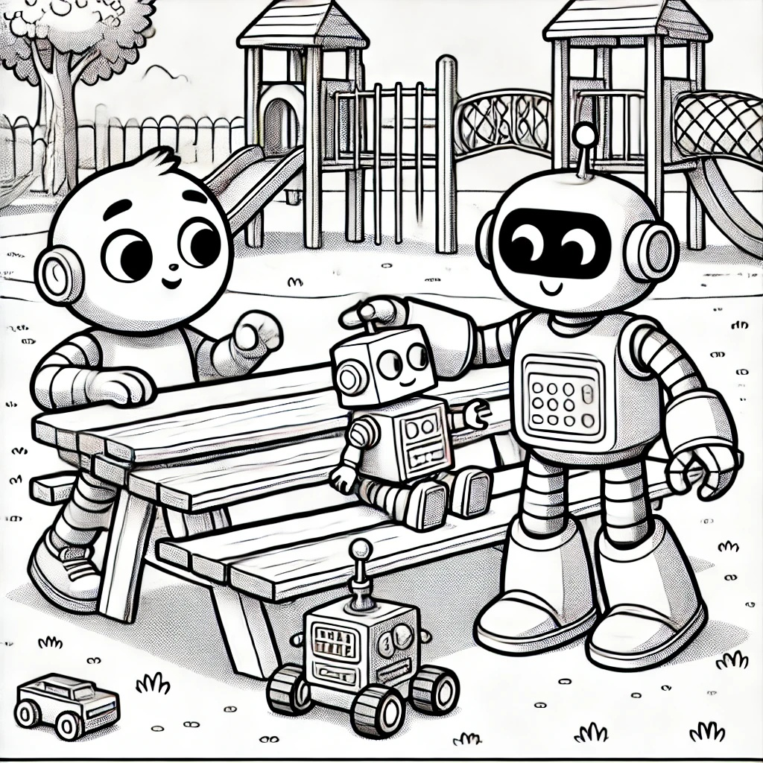

---

Chapter 5: Playground Treasure

Sam and Robo arrived at the playground, excited to solve the final mystery. The note they found under the oak tree said: "Find the

hidden box near the slide."

Using their heightened senses and new phonics skills, they searched around the slide. "Let's look carefully," Sam suggested.

Robo beeped, "I hear something under the slide!"

Interactive Moment: Can you help Sam and Robo find the hidden box near the slide? Point to where you think it might be!

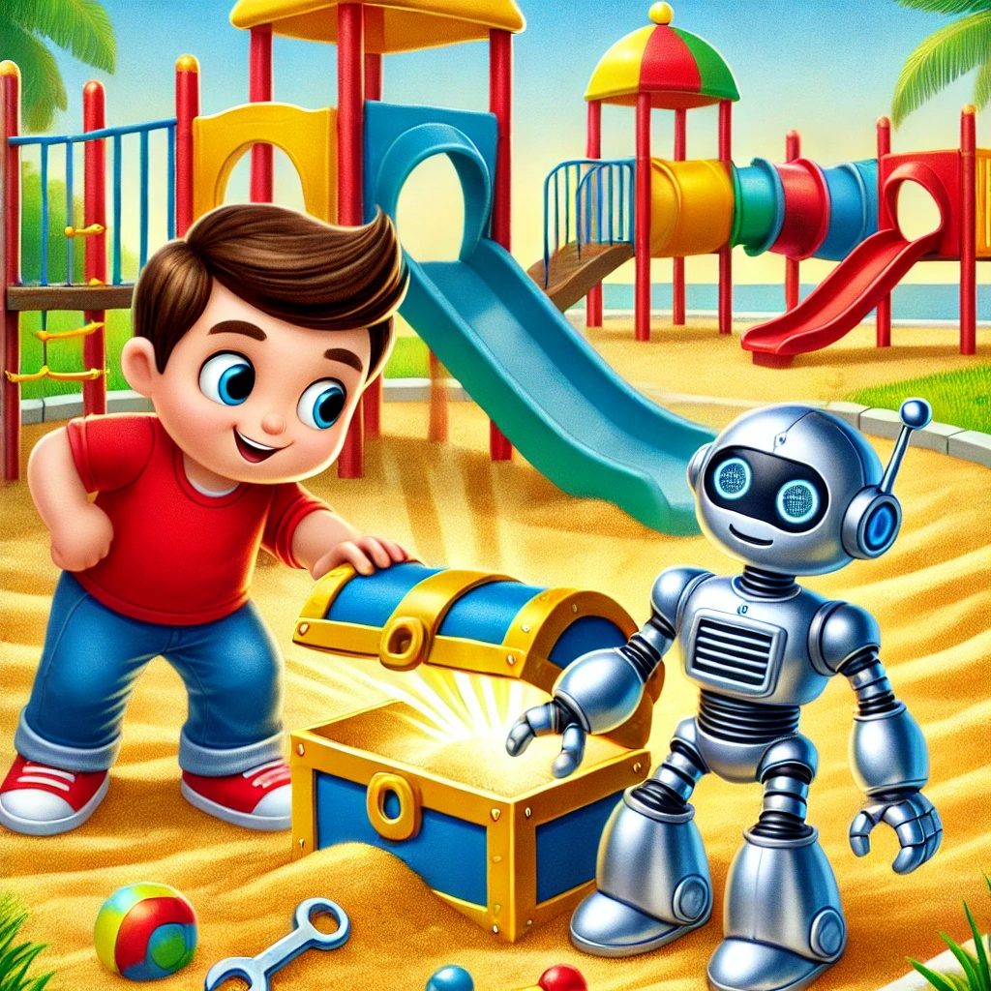

They found a small box hidden in the sand. Inside was a medal and a final note:

"Congratulations, Sam and Robo! You've unlocked the superpower of heightened senses. Use your skills to help your community."

Sam and Robo beamed with pride. "We did it! We solved all the mysteries and unlocked a new superpower!"

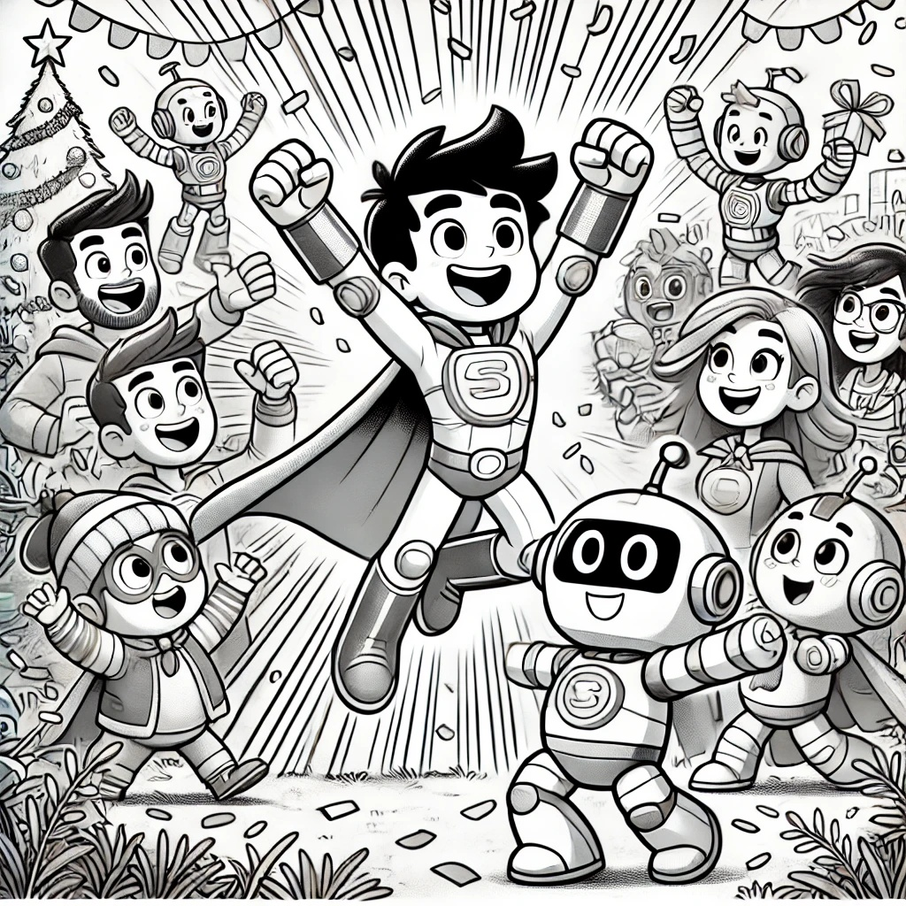

They celebrated with their friends, feeling accomplished and ready for more adventures.

"Remember to use your skills to help others," Sam said. "And always work

together as a team."

"Let's keep learning and growing!" Robo added.

With their new superpower, Sam and Robo felt prepared to tackle any challenge and make a positive impact on the world around them.

Question: What new superpower did Sam gain by the end of the book?
Answer: The ability to use heightened senses to detect clues.

---
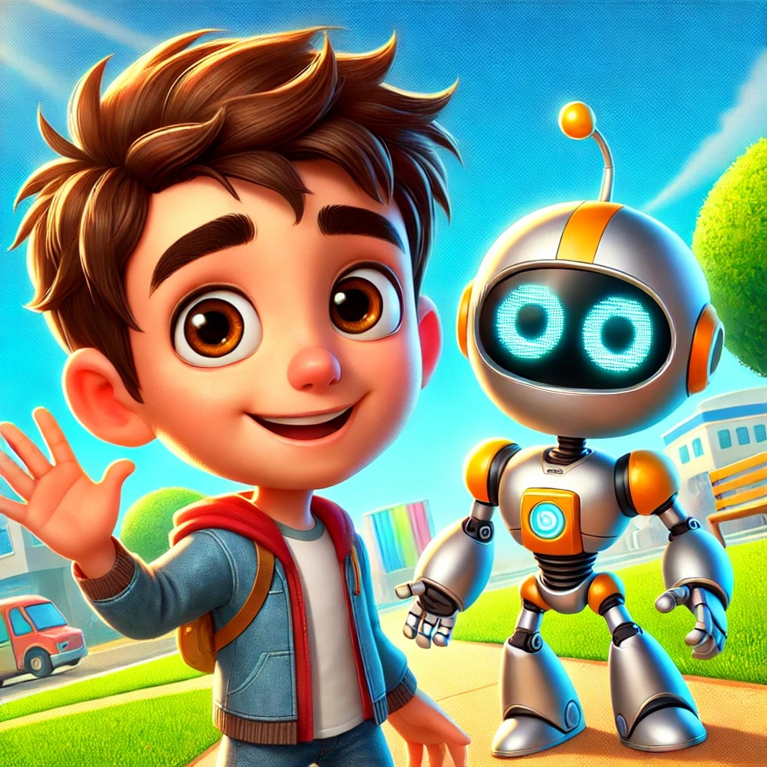


This concludes "Sam's Third Superpower" Keep up the great work, use your new superpowers. Sam and Robo will be waiting for the next adventure! Thanks for reading!

