Southern Methodist University

Bobby B. Lyle School of Engineering

Department of Computer Science   
CS 7343/5343 Operating Systems and System Software

* CS 5343 students must answer exactly 4 questions
* CS 7343 students must answer all questions

1. Consider the following set of processes with the following arrival tome and processing time (i.e. service time).

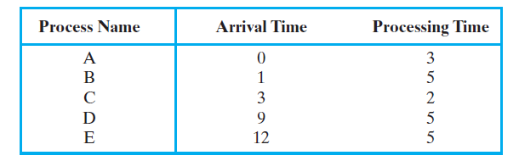

Perform the same analysis as depicted in the following table for this set.

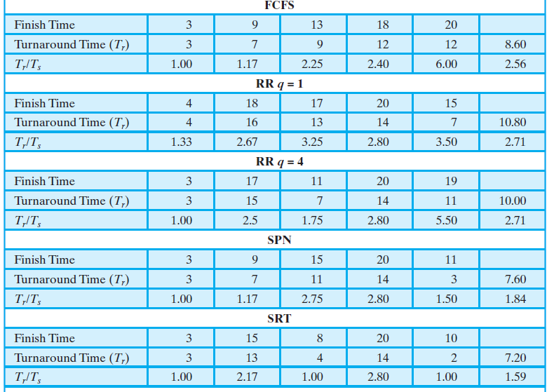

1. Repeat Problem 1 for the following set.

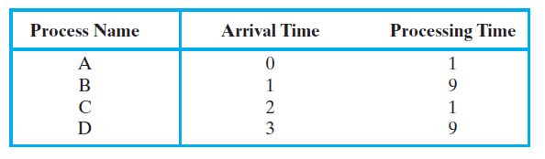

1. Prove (mathematically) or give a correct argument that, among nonpreemptive scheduling algorithms, SPN provides the minimum average waiting time for a batch of jobs that arrive at the same time. Assume that the scheduler must always execute a task if one is available.
2. Most round-robin schedulers use a fixed size quantum. Give an argument in favor of a small quantum. Now give an argument in favor of a large quantum. Compare and contrast the types of systems and jobs to which the arguments apply. Are there any for which both are reasonable?
3. An interactive system using round-robin scheduling and swapping tries to give guaranteed response to trivial requests as follows: After completing a round robin cycle among all ready processes, the system determines the time slice to allocate to each ready process for the next cycle by dividing a maximum response time by the number of processes requiring service. Is this a reasonable policy?
4. Five batch jobs, A through E, arrive at a computer center at essentially the same time. They have an estimated running time of 15, 9, 3, 6, and 12 minutes, respectively. For each of the following scheduling algorithms, determine the turnaround time for each process and the average turnaround for all jobs. Ignore process switching overhead. Explain how you arrived at your answers.
5. Round robin with a time quantum of 1 minute
6. FCFS (run in order 15, 9, 3, 6, and 12)
7. Shortest job first (i.e. Shortest process next (SPN)