Business Process analysis

Evers,Koen K.

2021-2022

Inhoudsopgave

**Research purpose** 2

**Research methods** 2

**Business process** 2

What is a business process? 2

How does a business process relate to a software application 2

**Business process & project** 2

Business process visualised 2

Roles of people involved in the process 2

Business process & software visualised 2

# **Research purpose**

To gain insight into what a process is, describe the process our software affects and visualise said process.

# **Research methods**

-Literature study

# **Business process**

## What is a business process?

A business process involves the steps required to produce a product or service. A process like this can often be seen visualised in a flowchart.

## How does a business process relate to a software application

A business process relates to a software application in the way that a software application always supports, facilitates or automates a business process.

# **Business process & project**

## Business process visualised

The business process in my group project is the ordering in a restaurant. This can be visualised as follows:

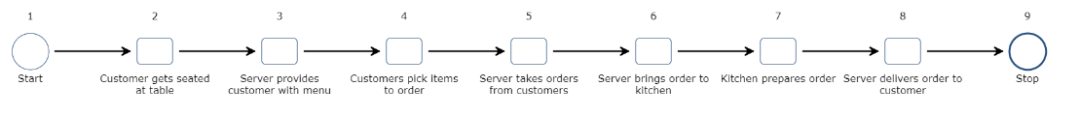

## Roles of people involved in the process

The people involved in this process are:

The customer: wants to eat food.  
The server: interacts with the customer facilitating the process of ordering and receiving food.  
The kitchen staff: receives order and produces food.

## Business process & software visualised

Our software makes it possible for customers to browse the menu themselves and place orders without the need of a server to start the process. The process with software looks like this:

