**Statistics of #kalypo Tweets**

#kalypo mentioned in tweets **753** times since (June 1, 2010 - November 28, 2016)

#kalypo mentioned in tweets before going viral was **126** times from (June 1,2010) to (September 30,2016)

#kalypo mentioned in tweets during the viral period from (October 1, 2016 - present) is **627** times.

#kalypo mentioned in tweets during the NPP Manifesto launch **103** times on (October 9, 2016)

#kalypo was not mentioned in any tweets during NDC Manifesto launch on (September 17, 2016)

|  |  |
| --- | --- |
| **Year** | **Total Number of #kalypo Tweets** |
| 2010 | 9 |
| 2011 | 51 |
| 2012 | 26 |
| 2013 | 20 |
| 2014 | 9 |
| 2015 | 5 |
| 2016 | 653 |

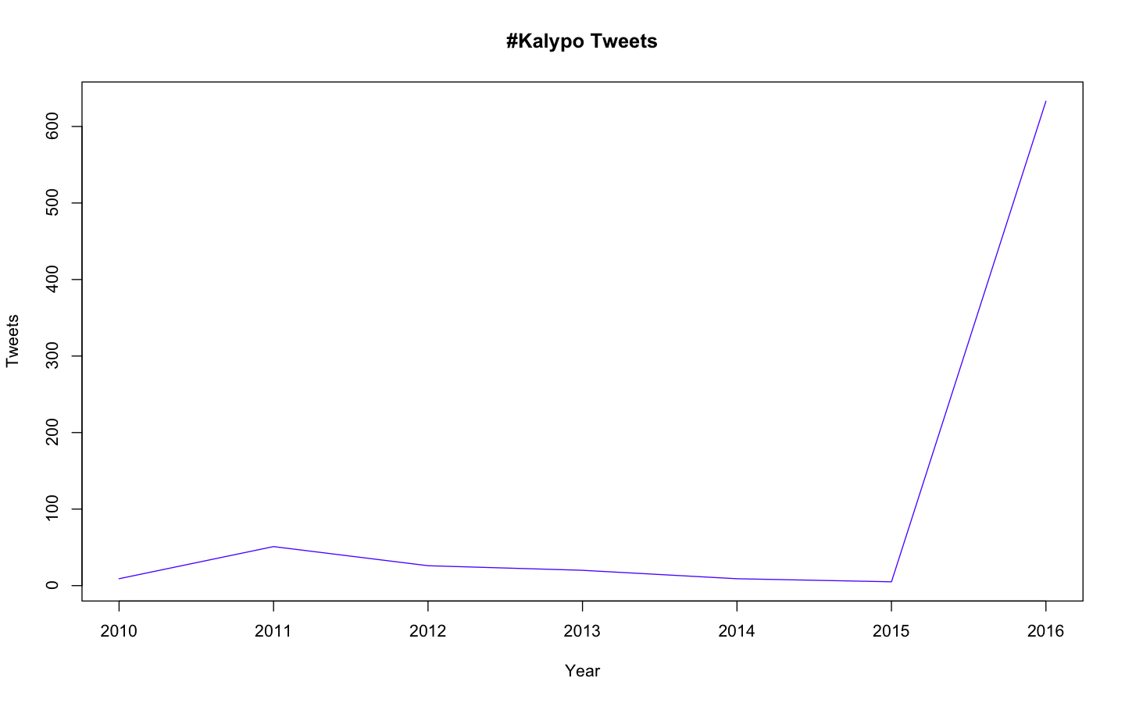

*Graph showing the dynamics of #kalypo tweets from 2010 - 2016*