### Duncan Baxter

Student Email Address : [s3737140@student.rmit.edu.au](mailto:s3737140@student.rmit.edu.au)

Your Locale : Melbourne, Australia

Background & Passion in IT :

[Your description goes here]

What are you good at / What you’re interested in ?

[Your personal answer goes here]

**What are your weak-points in the context of the project ?**

If I’m honest, I will struggle most, with not being “in charge”. When I look back over the years, I was made a partner at Deloitte in 1996. I then worked in senior leadership roles there, followed by Blakes (now Ashurst), for a decade and a half, until the collapse of my marriage/depression forced me into a long-term (sadly, ultimately permanent) leave of absence.

Here is one example of my work (I’m sure you could find others online):[1]

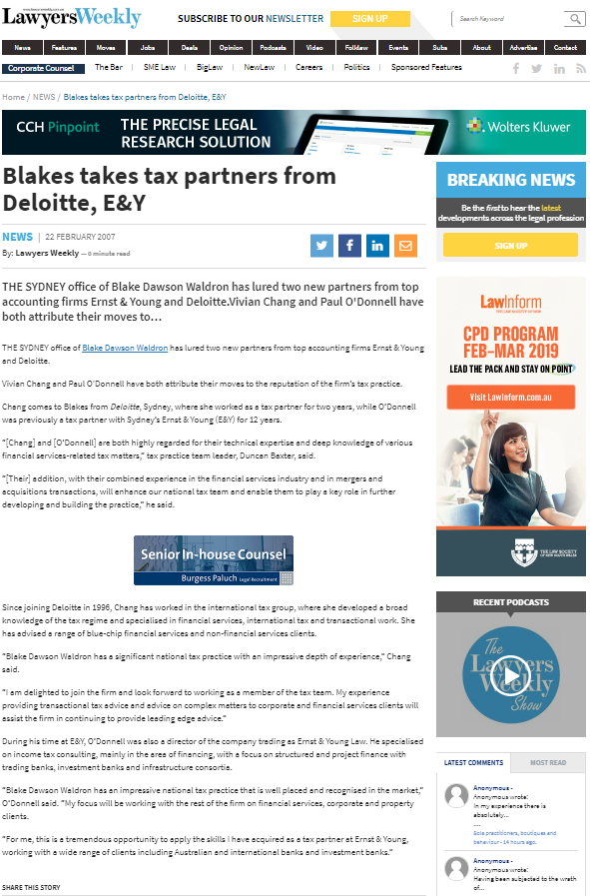

So, it’s easy enough for me to say, “Evert Visser is the leader of our team: and I support him” (which, of course, I do). But when things go astray, I must … really, must, resist the urge to step in and “fix them”.

I’ve already screwed this up, when a number of members of the team pulled out in advance of the Census date. Evert responded quickly to the issue, alerting ABM, and the rest of the team. What I should have done, is to quietly recommend that he also look at the “singletons” who were posting for teams. What I did instead, was to review the list and start the invitation process myself.

I apologise, Evert: that was wrong of me, and it converted a great opportunity for you to practice one of the key aspects of leadership (team member recruitment), into a very unworthy erosion of your authority. I promise it won’t happen again.

**What role do you see yourself mainly playing in the team ?**

I would like to believe that, despite my many faults as a mentor (refer above for details), I could supplement Clark’s advice to Evert, at least. But in reality, I think I’ll be best placed working with Michael and Kira to get the coding done.

1. <https://www.lawyersweekly.com.au/news/1224-blakes-takes-tax-partners-from-deloitte-e-amp-y> (last accessed at 12:45 am on 19 March 2019).