Cálculo Da Capacidade de Carga De Estaca

Dados de Entrada

Tipo da Estaca: HCM  
D = 30.0 cm (Diâmetro da estaca)  
Carga admissível esperada: 30.0 tf  
Lista NSPT: [4, 4, 8, 8, 8, 19, 19, 19, 26, 26, 26]  
Altura do bloco: 45.0 cm

Capacidade de carga por Aoki-Velloso

Capacidade De Carga Por Aoki-Velloso

|  |  |  |  |  |  |  |  |  |  |  |
| --- | --- | --- | --- | --- | --- | --- | --- | --- | --- | --- |
| Cotas de Apoio (m) | k (kPa) | rp (kPa) | Rp (kN) | rl (kPa) | Rl (kN) | Rl (kN) acum. | Rt (kN) | Pa (kN) NBR 6122 | Pa (kN) Escavadas | Pa (kN) Final |
| -1 | 700.0 | 1400.0 | 99.0 | 16.8 | 15.8 | 15.8 | 114.8 | 57.4 | 19.8 | 19.8 |
| -2 | 700.0 | 2800.0 | 197.9 | 16.8 | 15.8 | 31.7 | 229.6 | 114.8 | 39.6 | 39.6 |
| -3 | 700.0 | 2800.0 | 197.9 | 33.6 | 31.7 | 63.3 | 261.3 | 130.6 | 79.2 | 79.2 |
| -4 | 700.0 | 2800.0 | 197.9 | 33.6 | 31.7 | 95.0 | 292.9 | 146.5 | 118.8 | 118.8 |
| -5 | 700.0 | 6650.0 | 470.1 | 33.6 | 31.7 | 126.7 | 596.7 | 298.4 | 158.3 | 158.3 |
| -6 | 1000.0 | 9500.0 | 671.5 | 66.5 | 62.7 | 189.3 | 860.9 | 430.4 | 236.7 | 236.7 |
| -7 | 1000.0 | 9500.0 | 671.5 | 66.5 | 62.7 | 252.0 | 923.5 | 461.8 | 315.0 | 315.0 |
| -8 | 1000.0 | 13000.0 | 918.9 | 66.5 | 62.7 | 314.7 | 1233.6 | 616.8 | 393.4 | 393.4 |
| -9 | 1000.0 | 13000.0 | 918.9 | 91.0 | 85.8 | 400.5 | 1319.4 | 659.7 | 500.6 | 500.6 |
| -10 | 1000.0 | 13000.0 | 918.9 | 91.0 | 85.8 | 486.2 | 1405.1 | 702.6 | 607.8 | 607.8 |
| -11 | 1000.0 | 13000.0 | 918.9 | 91.0 | 85.8 | 572.0 | 1490.9 | 745.5 | 715.0 | 715.0 |

Capacidade de carga por Decout-Quaresma

Capacidade De Carga Por Decourt-Quaresma

|  |  |  |  |  |  |  |  |  |  |  |  |
| --- | --- | --- | --- | --- | --- | --- | --- | --- | --- | --- | --- |
| Cotas de Apoio (m) | C (kPa) | α | β | Rp (kN) | Rl (Kn) | Rl acum. (kN) | R total (kN) | Pa 6122 (kN) | Pa Escavadas (kN) | Pa Met. DecQua (kN) | Pa Final DecQuar (kN) |
| -1 | 400.0 | 0.3 | 1.0 | 45.2 | 22.0 | 22.0 | 67.2 | 33.6 | 27.5 | 28.2 | 27.5 |
| -2 | 400.0 | 0.3 | 1.0 | 56.5 | 22.0 | 44.0 | 100.5 | 50.3 | 55.0 | 48.0 | 50.3 |
| -3 | 400.0 | 0.3 | 1.0 | 67.9 | 34.6 | 78.5 | 146.4 | 73.2 | 98.2 | 77.4 | 73.2 |
| -4 | 400.0 | 0.3 | 1.0 | 99.0 | 34.6 | 113.1 | 212.1 | 106.0 | 141.4 | 111.7 | 106.0 |
| -5 | 400.0 | 0.3 | 1.0 | 130.1 | 34.6 | 147.7 | 277.7 | 138.9 | 184.6 | 146.1 | 138.9 |
| -6 | 400.0 | 0.3 | 1.0 | 161.2 | 69.1 | 216.8 | 377.9 | 189.0 | 271.0 | 207.0 | 189.0 |
| -7 | 400.0 | 0.3 | 1.0 | 181.0 | 69.1 | 285.9 | 466.8 | 233.4 | 357.4 | 265.2 | 233.4 |
| -8 | 400.0 | 0.3 | 1.0 | 200.7 | 69.1 | 355.0 | 555.7 | 277.9 | 443.7 | 323.3 | 277.9 |
| -9 | 400.0 | 0.3 | 1.0 | 220.5 | 91.1 | 446.1 | 666.6 | 333.3 | 557.6 | 398.3 | 333.3 |
| -10 | 400.0 | 0.3 | 1.0 | 220.5 | 91.1 | 537.2 | 757.8 | 378.9 | 671.5 | 468.4 | 378.9 |
| -11 | 400.0 | 0.3 | 1.0 | 220.5 | 91.1 | 628.3 | 848.9 | 424.4 | 785.4 | 538.5 | 424.4 |

Resultados Notáveis

Resultados Notáveis

|  |  |  |  |
| --- | --- | --- | --- |
| Cotas de Apoio (m) | Valor Pa Aoki (kN) | Valor Pa DecQua (kN) | Menor valor Aoki-DecQua (kN) |
| -1 | 19.8 | 27.5 | 19.8 |
| -2 | 39.6 | 50.3 | 39.6 |
| -3 | 79.2 | 73.2 | 73.2 |
| -4 | 118.8 | 106.0 | 106.0 |
| -5 | 158.3 | 138.9 | 138.9 |
| -6 | 236.7 | 189.0 | 189.0 |
| -7 | 315.0 | 233.4 | 233.4 |
| -8 | 393.4 | 277.9 | 277.9 |
| -9 | 500.6 | 333.3 | 333.3 |
| -10 | 607.8 | 378.9 | 378.9 |
| -11 | 715.0 | 424.4 | 424.4 |

Carga admissível final

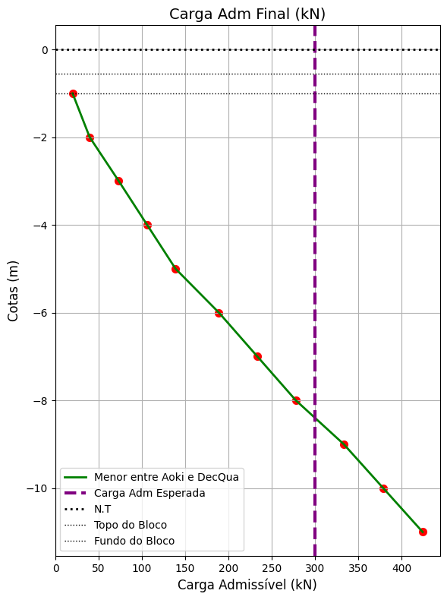

Comparação entre os dois métodos

