Week 2 Practice — Problem Statement –
Test Case Creator & Runner Simulator
What You Need to Build
Write a Python script using a def create_test_case(title, steps, expected) function that:
- Asks the user how many test cases to create
- Loops and collects for each test case:
  - Title
  - Steps (comma separated, e.g. "Open browser, Enter URL, Click login")
  - Expected result
  - Actual result
- Stores all test cases in a list of dicts (Week 1 concept)
- Compares expected vs actual inside the function and auto-decides status — no manual status input this time!
- Prints full summary after all inputs with test case numbers using enumerate() (Week 1 concept)
- Handles errors using try/except — e.g. if user enters 0 or a negative number for test case count
Acceptance Criteria
# | Criteria
1 | create_test_case() function must exist and return a dict
2 | Status is auto-decided by comparing expected vs actual — no manual input
3 | Steps stored as a list using .split(",")
4 | All test cases stored in a list of dicts
5 | Nothing printed until all inputs collected
6 | enumerate() used for test case numbering
7 | try/except handles invalid count input (0, negative, letters)
8 | Final line shows correct totals

Expected Output
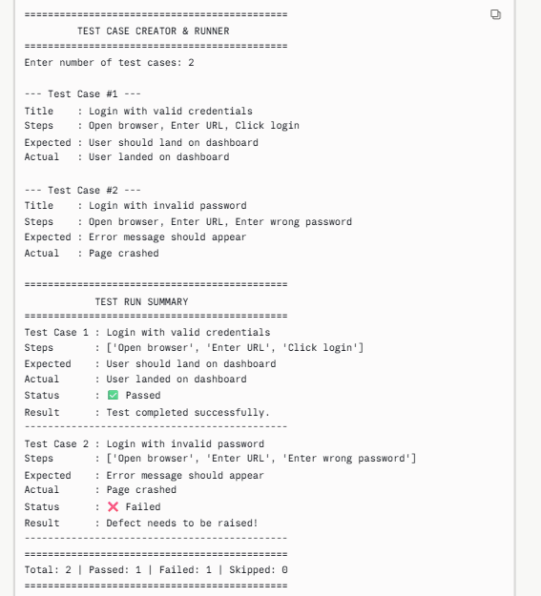

Points to be Noted
Step by Step — What Script Must Do
STEP 1 — Ask for count
- Ask the user how many test cases they want to create
- Wrap this in try/except — if they type letters or 0 or negative number, show an error and stop
STEP 2 — Collect inputs in a loop
- Loop that many times using for + range()
- For each test case collect:
  - Title
  - Steps → user types comma separated → you split into a list using .split(",")
  - Expected Result
  - Actual Result
STEP 3 — Call your function
- Inside the loop, call create_test_case(title, steps, expected, actual)
- This function must:
  - Compare expected vs actual → auto decide Passed or Failed
  - Return a dict with all fields + status
STEP 4 — Store in list
- append() the returned dict into test_case_list
- Do not print anything yet
STEP 5 — Print full summary
- After the loop ends, loop through test_case_list using enumerate()
- Print each test case with its number, steps, status, result message
STEP 6 — Print totals
- Count Passed / Failed using counters
- Print final line with totals

Code structure –
# 1. Define your function
def create_test_case(title, steps, expected, actual):
...
return { dict }
# 2. try/except for count input
try:
count = int(input(...))
except:
...
# 3. Loop → collect inputs → call function → append to list
test_case_list = []
for i in range(count):
...
test_case_list.append(create_test_case(...))
# 4. Print summary using enumerate
for index, tc in enumerate(test_case_list, start=1):
...
# 5. Print totals

