Network Research
Project: GhostLogin

1. Command executed

2. Starting the script

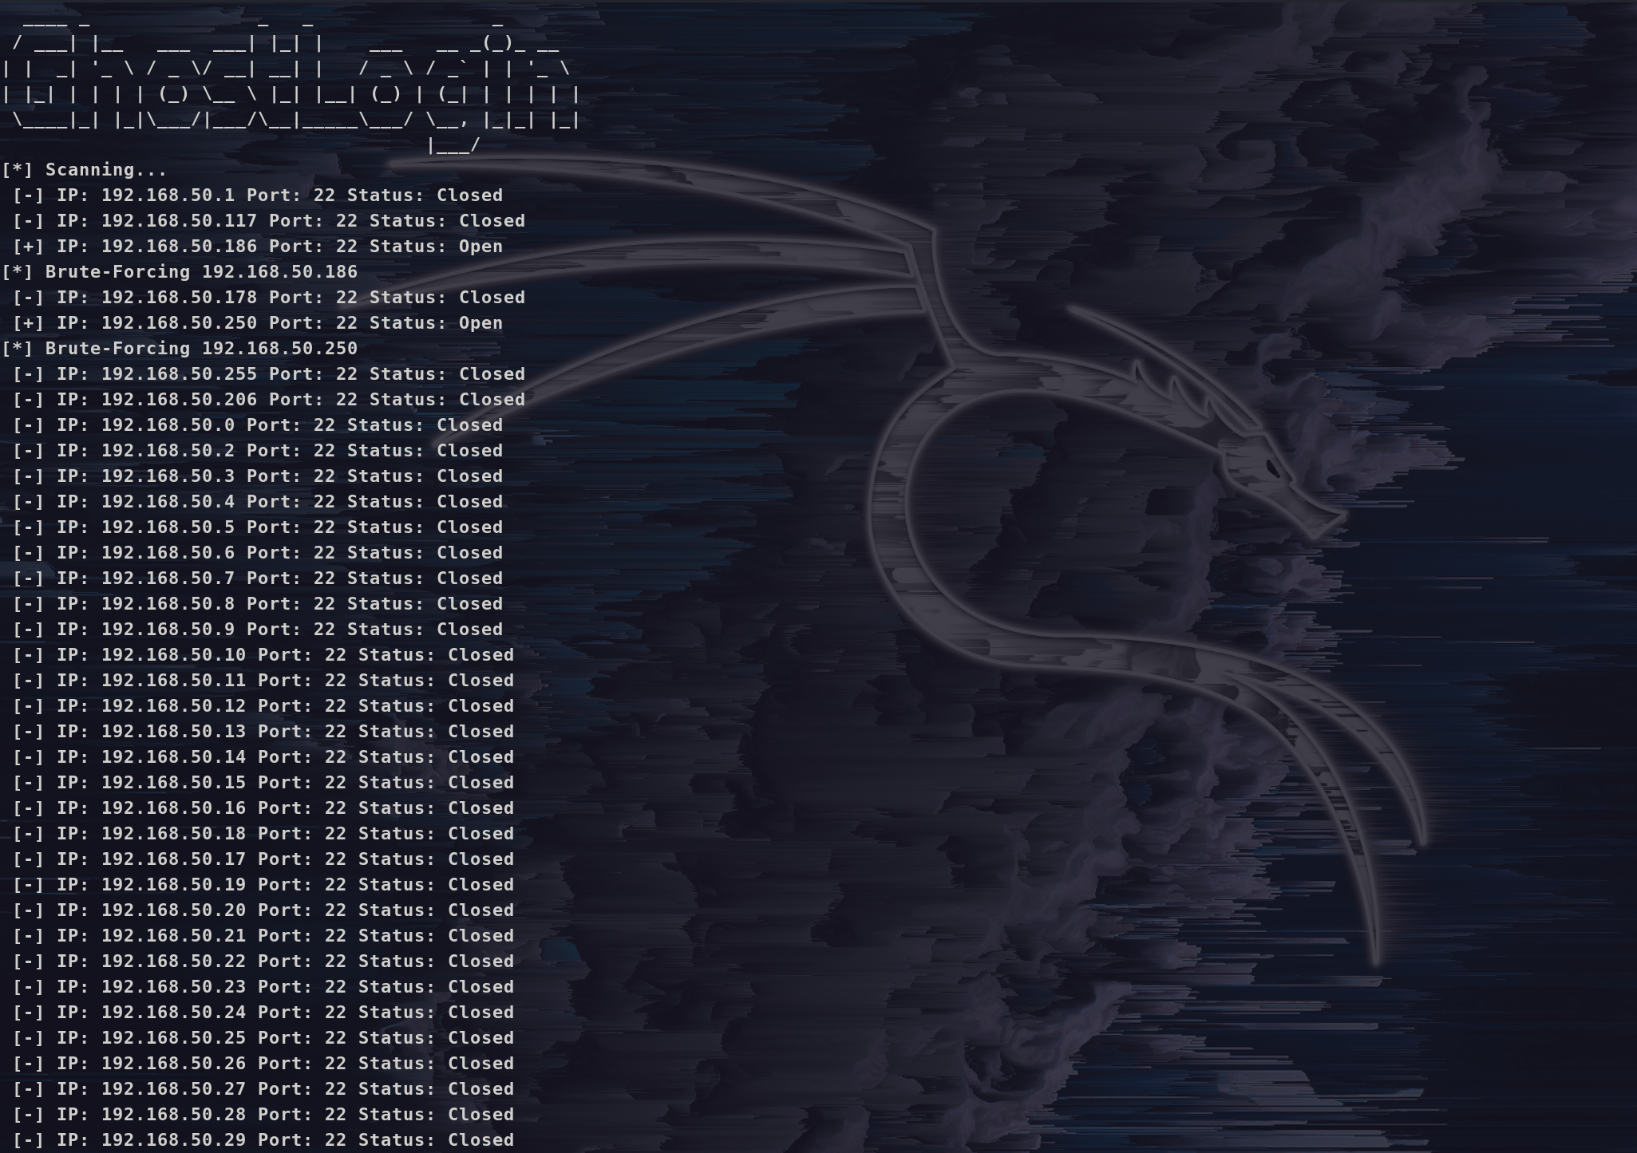
3. Found credential and SSH Login
