WINDOWS FORENSICS
PROJECT: ANALYZER
1. Command executed with the used parameters

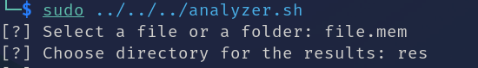
2. Analyzer output in the teminal

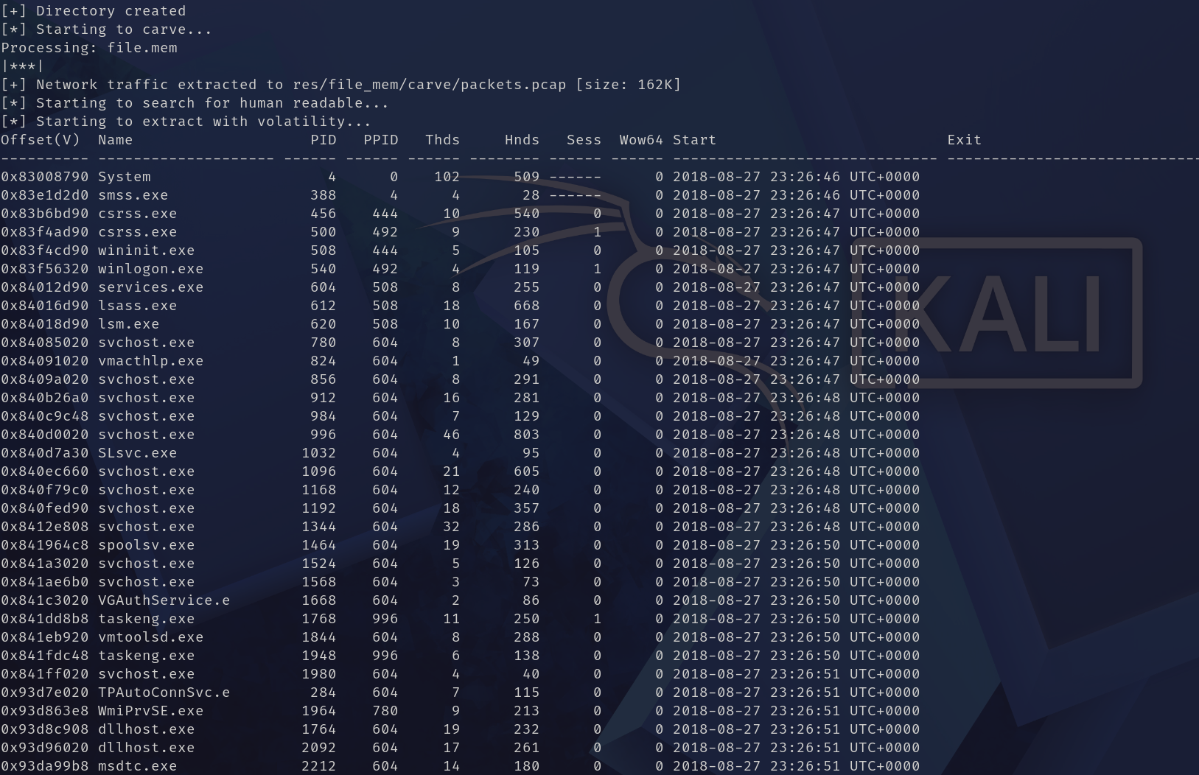

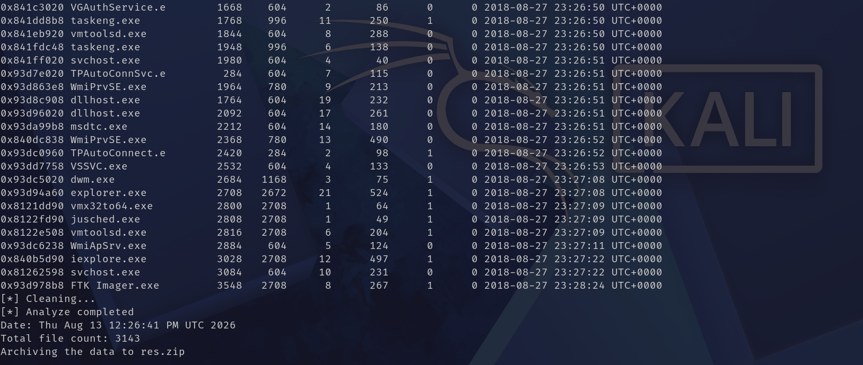

3. Analyzer saved files
