SOC ANALYST
PROJECT: CHECKER

1. Network scan and targets to choose of
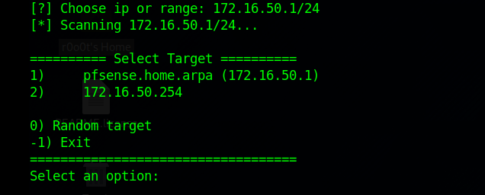

2. Attack menu
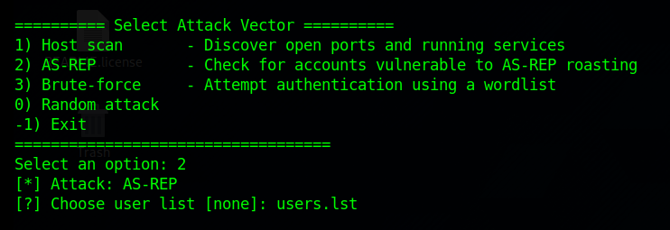

3. Attack results
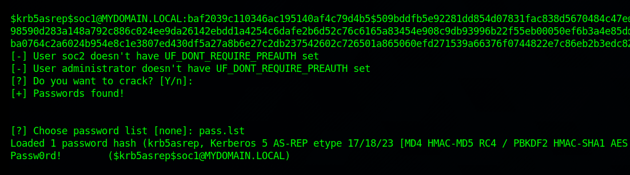

4. Saved logs in /var/log/checker/
