PROJECT: NET CRAFTS

1. Network Map:

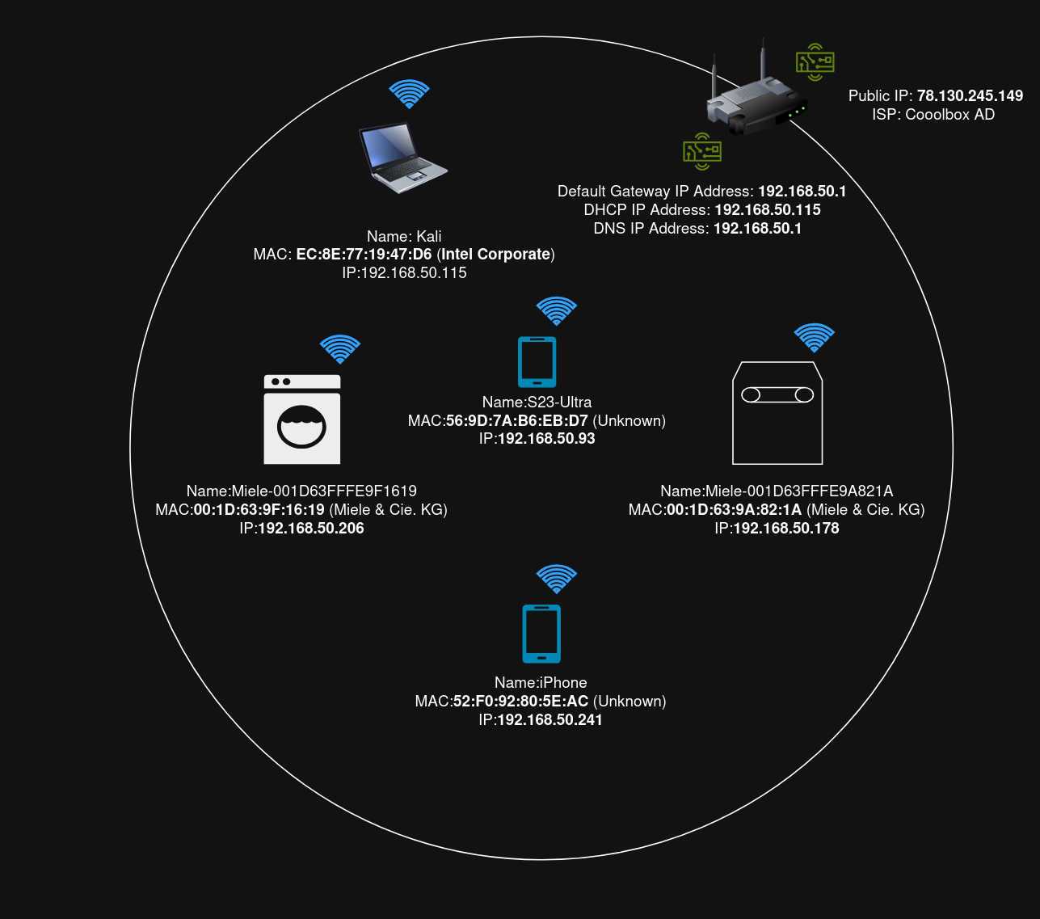

2. Collected Information:

2.1 Collected Data from Shodan:

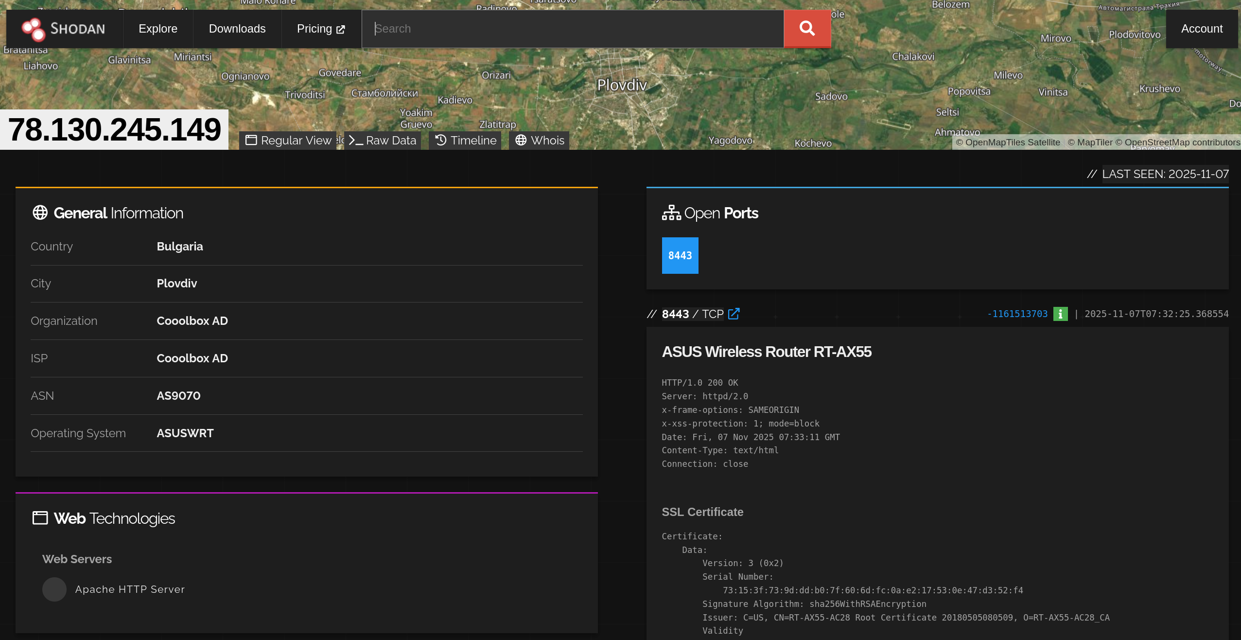

2.2 Collected Data form WHOIS Check:

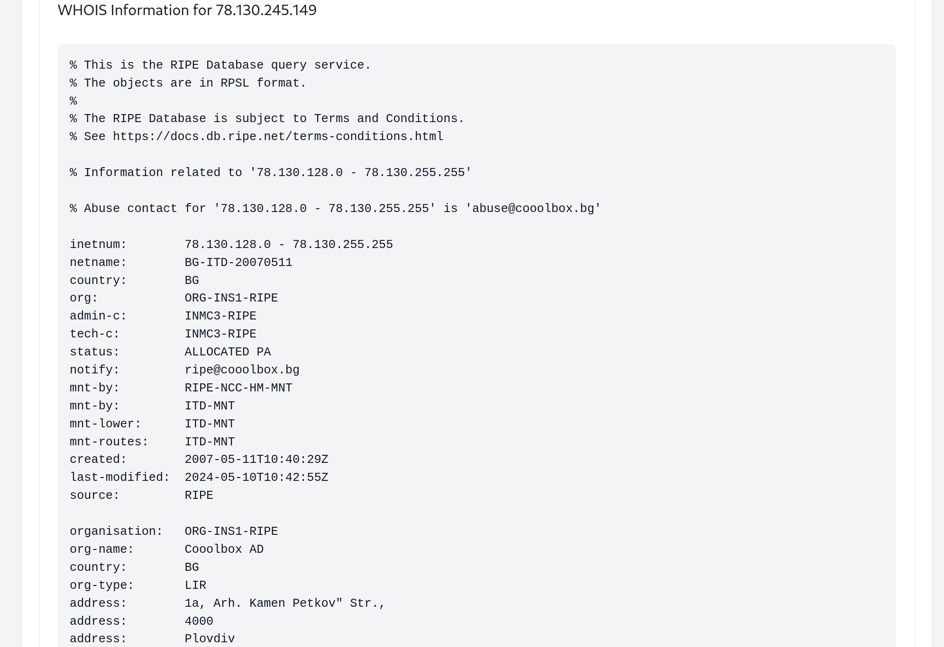

2.3 Analyze from Network Sniffing:
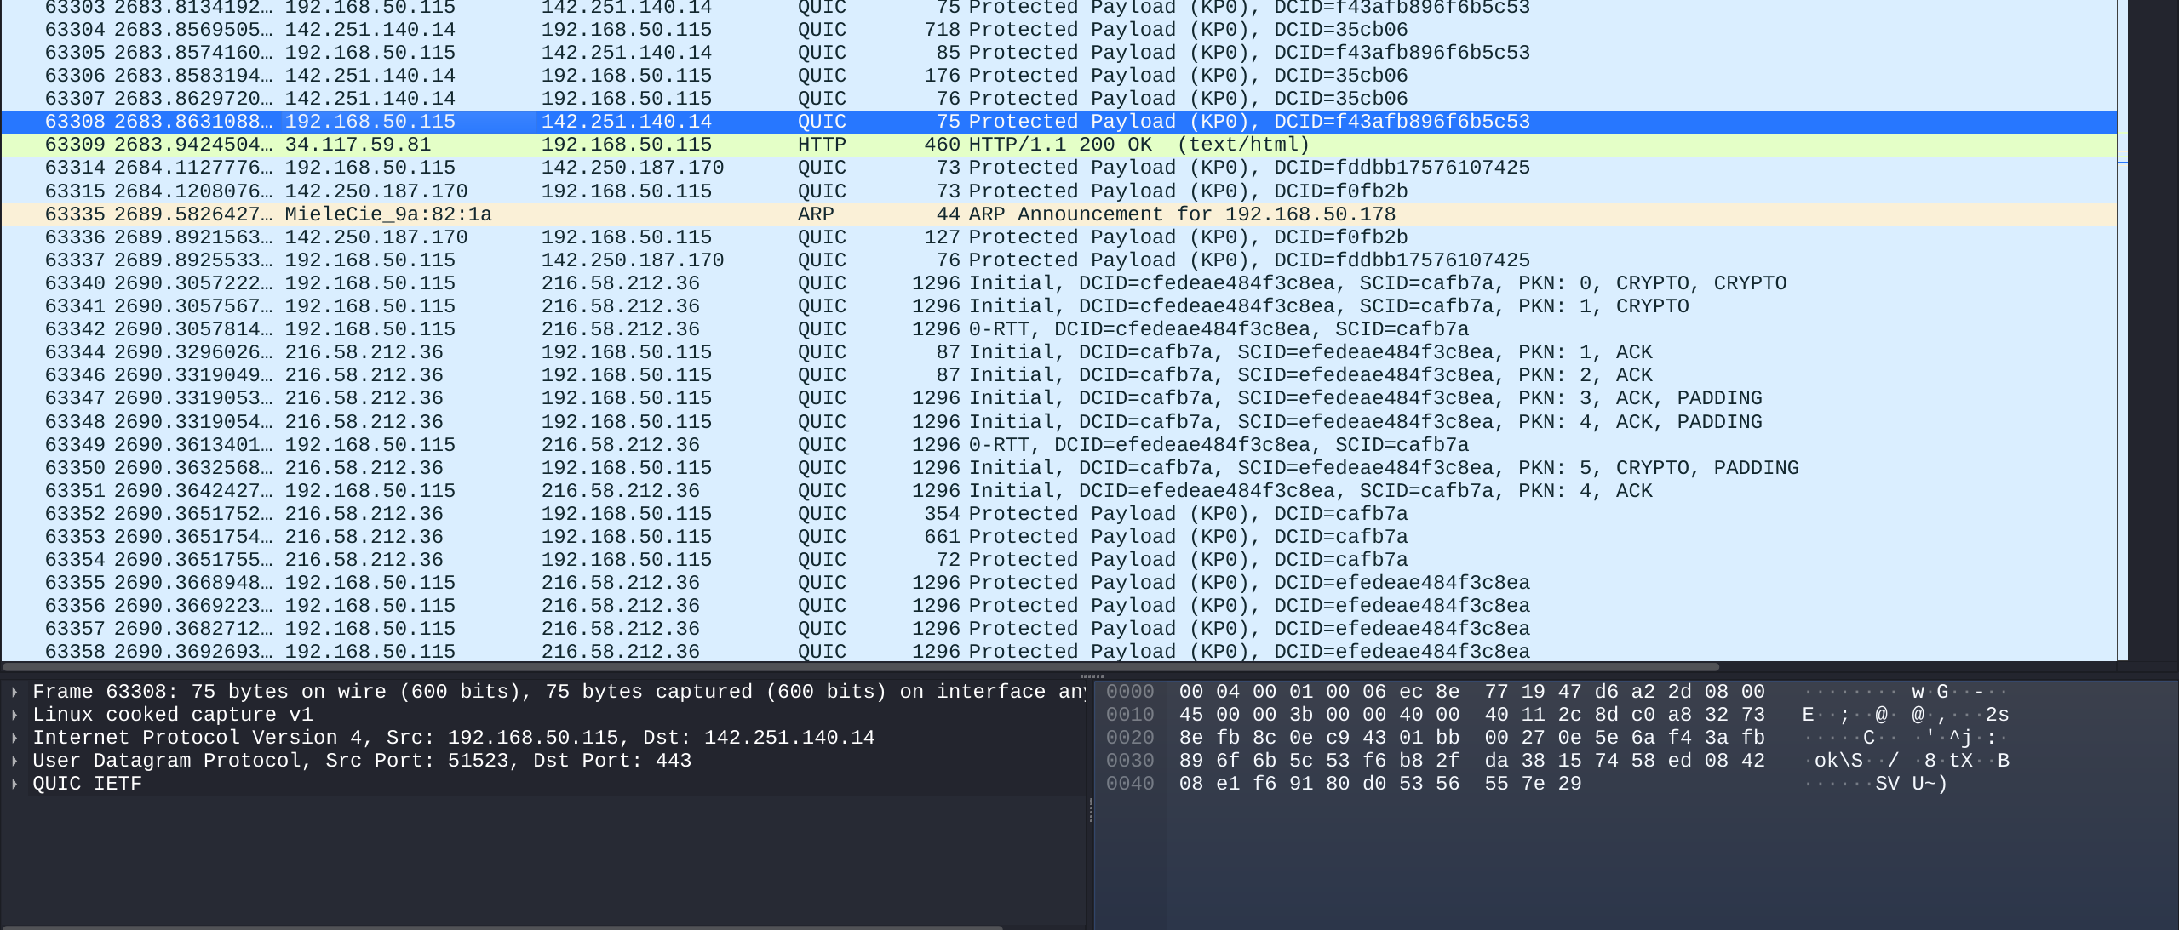
One of the protocols that I managed to identify is HTTP on port 80 is a protocol that is used to load web pages and web resources, its mainly used methods are GET, POST, PUT, DELETE. Other that I found is QUIC, a modern transport protocol, which works by running on top of UDP and integrating TLS for encryption directly into its handshake, resulting in quicker and more secure connections, thus it is as reliable as the TCP, but faster. In my case it was running on port 443, which means it was being used for an HTTPS request. The third one is ARP, a communication protocol that maps a device IP address to its corresponding MAC address on a local network, furthermore it does not use ports, as it operates on the Data Link Layer.

