Linux Fundamentals
PROJECT: INFO EXTRACTOR

1. Script overview:
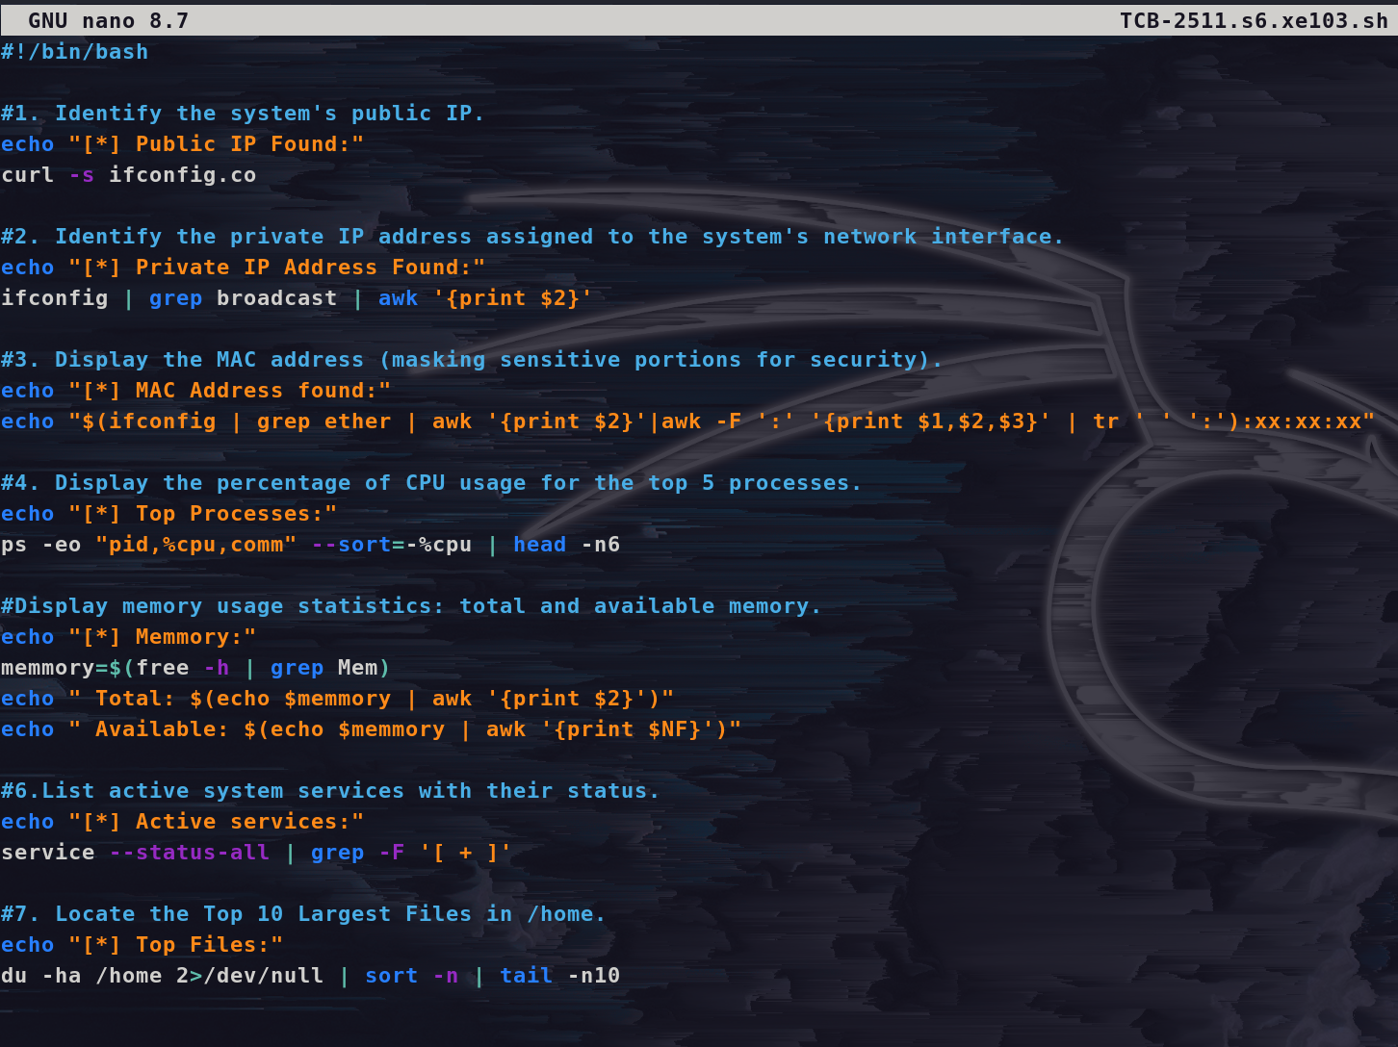

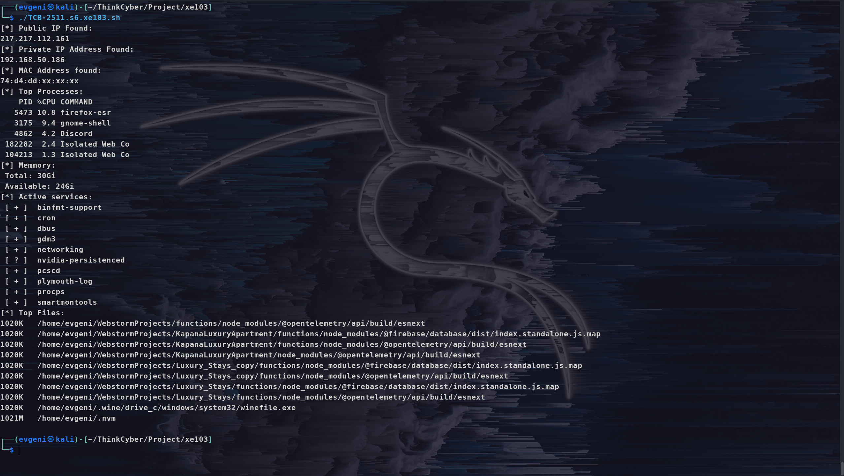
2. Output after executing the script:

