Web Fundamentals
Project: Phishing

1. Cloning website and using domain

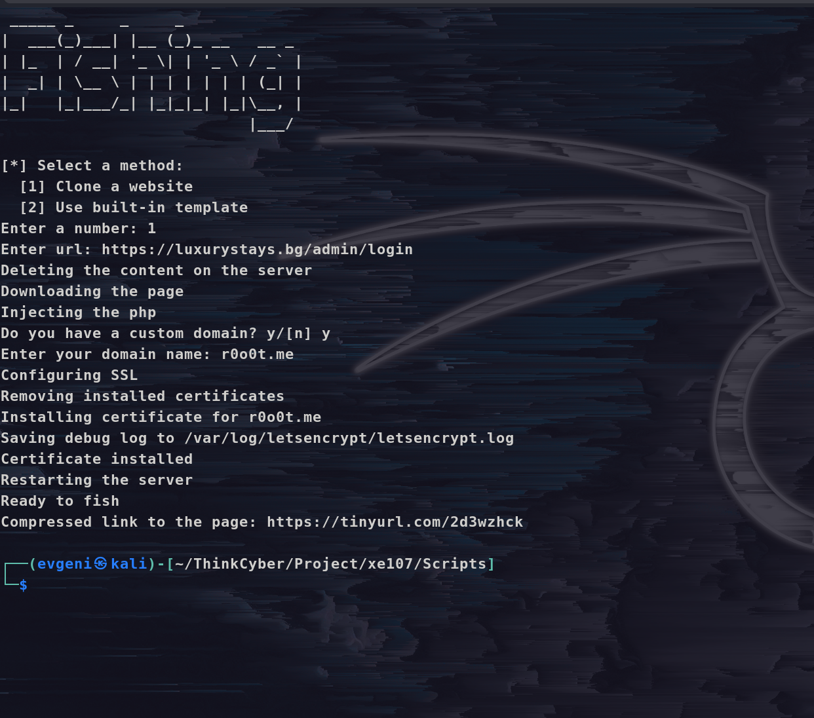
2. Cloned page (the cloned site login page is mine)
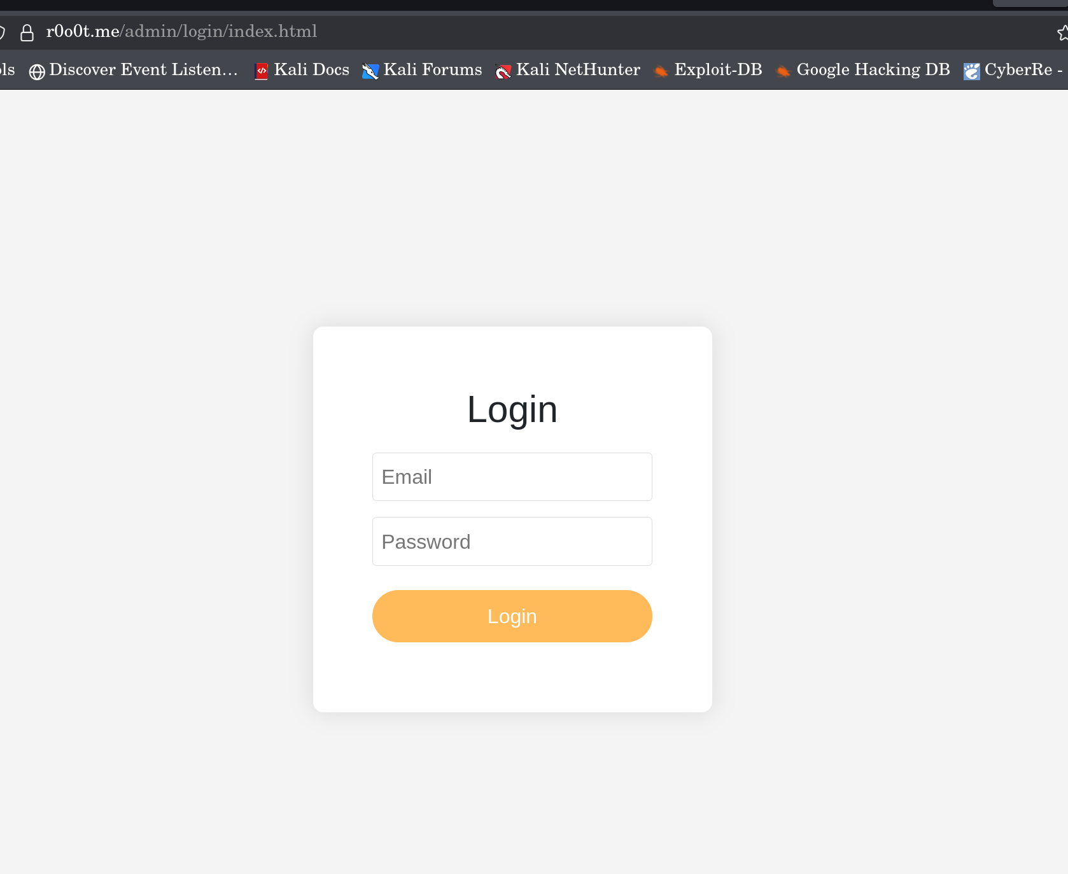
3. Using template without domain
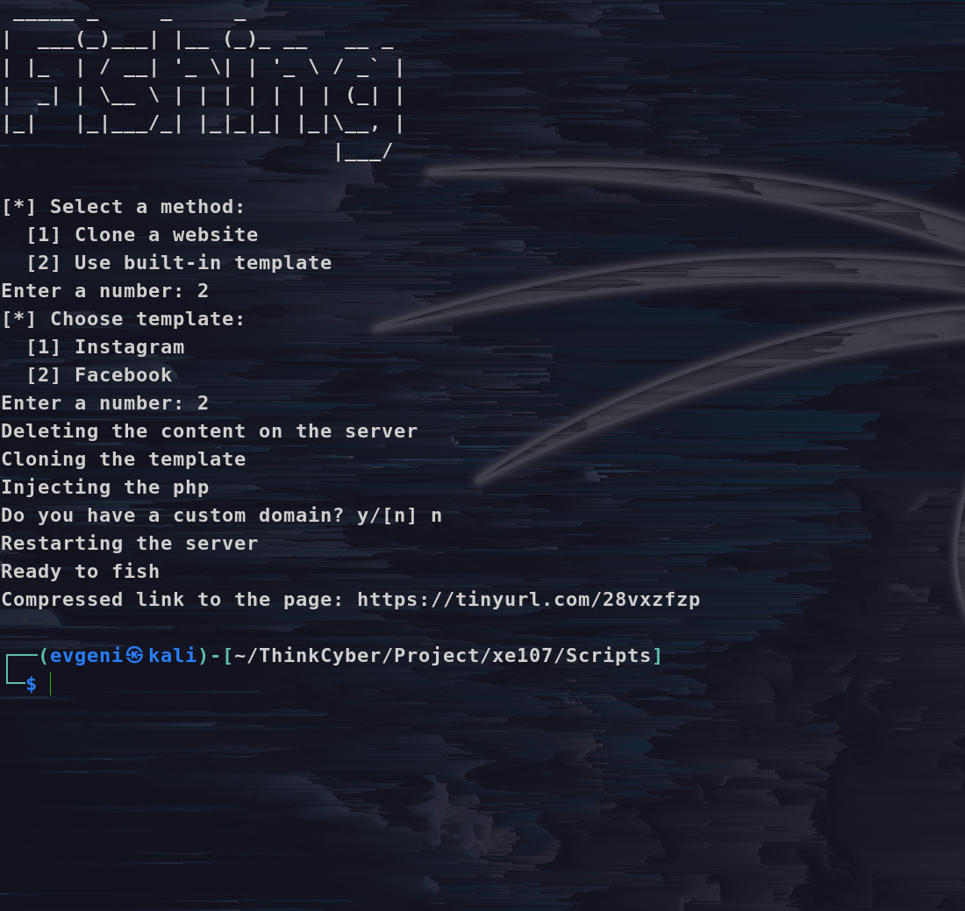
4. Cloned page
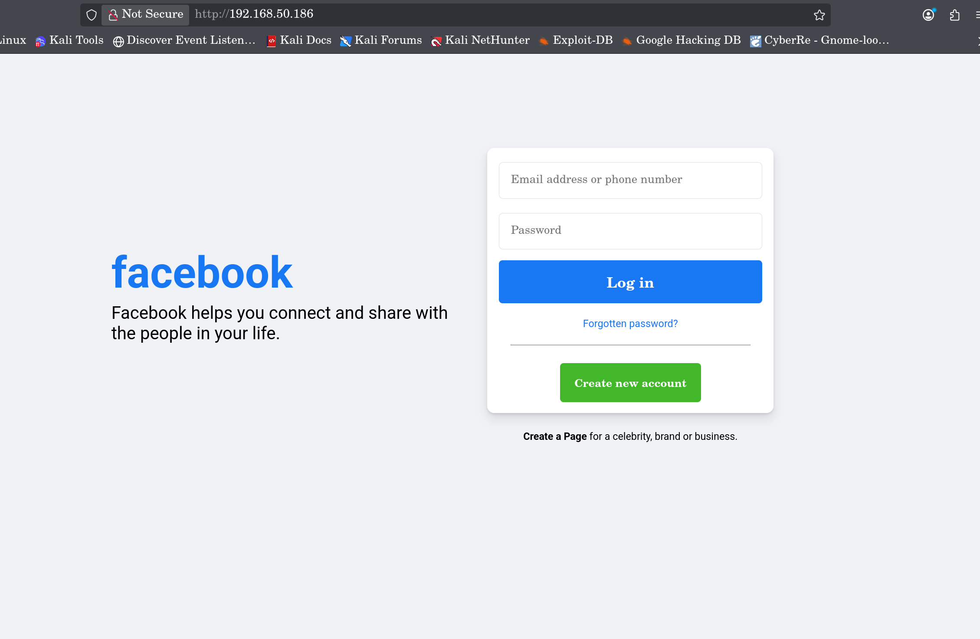
5. Credential gathering
