PENETRATION TESTING
PROJECT: VULNER

1. Command executed with the used parameters

2. Scanning results
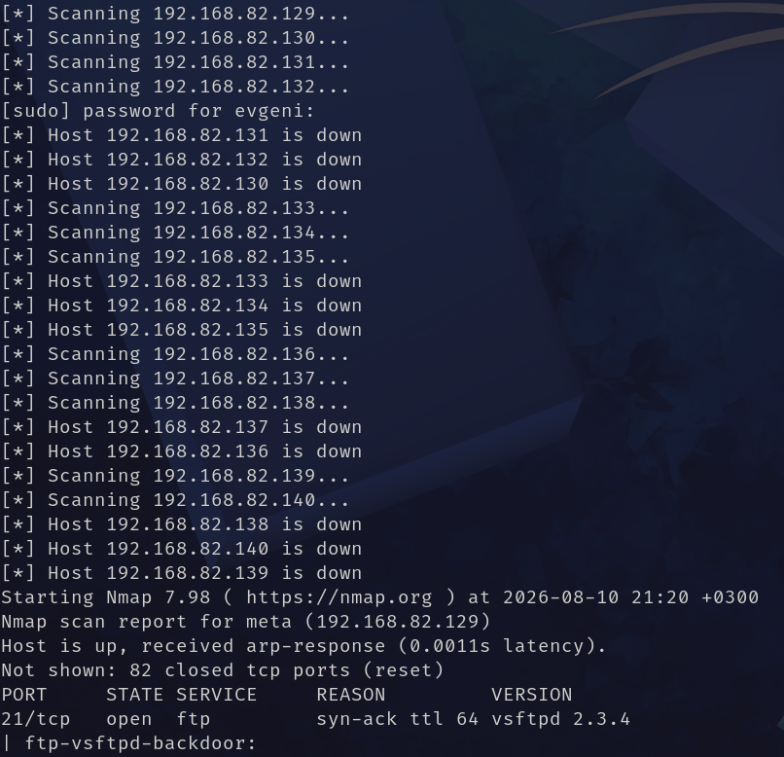

3. Vulnerabilities results
