GAME OF LIFE COURSEWORK REPORT
Evgenia Karnavou: dr19487@bristol.ac.uk
Katia Vasilonikolidaki: (bl19548@bristol.ac.uk)
STAGE 1
PARALLEL IMPLEMENTATION
Our program is a deterministic, real time display of the Game of Life in Go. It uses from one to sixteen different goroutines to calculate the state of the game board. A Distributor goroutine is responsible for assigning work to the other goroutines.

GO-ROUTINES AND HOW THEY INTERACT
The distributor function is primarily responsible for advancing the state of the board for each turn. It is given the input parameters at the start of the simulation, which determine the number of workers the distributor will use.

After the iterations for each turn of the game is finished, the final world is exported as an image in a PGM file.
The game rules are applied by the calculateNextState function.
Cell flipped events are sent through the events channel which enables the SDL to demonstrate the state of the board in real time.

Memory-Sharing

Since we have implemented parallel processing in order to concurrently determine the next state of the board we use 1-16 go routines, referred to as workers-threads. Their task is to work in parallel, on a different part of the image.
The part of the image assigned to each worker is defined by the distributor as it splits the image horizontally according to the thread parameter.

It is worth mentioning, that frequently the world will not be split into even pieces, as the height of the image may not always be divided evenly by the number of workers. In our implementation, the last thread on top of the worker height will be responsible for calculating the extra remaining rows as well. After each worker has executed the game of life logic on their part, it sends the resulting world as a slice back on a channel. The content of each channel is then appended back to a single world 2D-slice.

Core 2
Worker 2
Core 1
Worker 1
Core 0
Worker 0

Figure 1: Workers have access to the same memory
RAM
Threads can read and write from the memory, as threads share memory space among them.

The Ticker

Threads can write and read from the memory, as threads share memory space among them.

Ticker and Keypresses

The distributor also uses a ticker go routine that periodically reports the number of alive cells.
The switch statement receives a ticker every 2 seconds from the channel on which the ticks are delivered.
The user also has the choice to interact with the SDL console by using control rules, which are introduced with key presses.
While the program is running, the user has the choice to
- Pause the game by pressing “p”, and resume by pressing it again,
- press of “s”, which results in an image with the current state of the world to be generated while execution continues as normal, and
- Quit the game by pressing “q”, and output an image containing the current state of the board.

The distributor receives these key presses from a channel and implements the above logic in a switch statement. Also, an SDL visualisation of the game board is available in real time.

Testing and Analysis

To measure the performance of our code, we decided to create a benchmark test function. The test ran for various values of the worker goroutines, the turns, and image sizes.

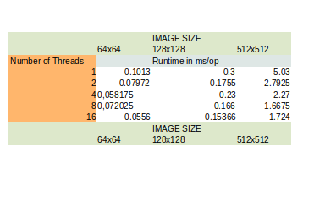
Table which demonstrates the run times for different number of threads and images sizes

The time complexity of our code depends on the image size, the number of turns that the game is executed and the number of workers working on the image. So, we observed the different run times with the varying inputs.

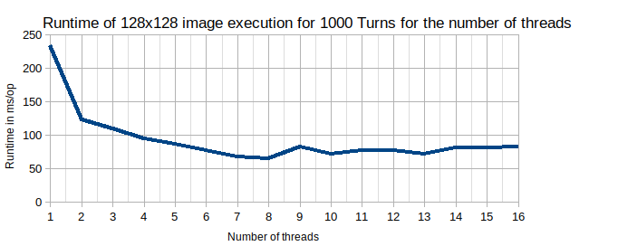
Figure 2: Benchmark graph for 128x128

The tests were run on an 8-core computer.
By observing the result of our benchmark test on a medium sized image for 1000turns, we arrive to the conclusion that the results are also dependent on the number of cores a computer has. In Figure 3, it is shown that the optimal or minimum runtime will be when the number of workers approaches the number of cores of the system (eight in this case). Runtime of the execution of the algorithm shows an important decrease as worker threads increase, until we reach the maximum number of cores we can use (Runtime decreases by 47% when using 2 worker threads instead of 1). However, after the number of cores is exceeded, there is not a notable change in the runtime of the algorithm.

STAGE 2

DISTRIBUTED IMPLEMENTATION
Connects to
Initialises
RPC Call
Server
Client-Controller
GoL

Commands
Engine
Distributor

Simulates GoL logic and returns the final world
Distributed Architecture

In our distributed implementation we have split our parallel solution into a clint-controller and a server-engine. Our client-controller is responsible for the user input while our server-engine manages to perform the calculation of the Game Of Life. For our communication between the Client and the server we have used remote procedure call(RPC).

COMPONENTS
The IO goroutine and the client are initialised via the GoL, which creates an RPC connection with the server. That allows the client to start a new simulation.
Our Client-Controller is responsible for managing all events, input and output. It reads the initial world from the given filename, and then completes an appropriate RPC call to the server.
Our server-engine is used as an interface, which enables client communication. It contains a single RPC function, which is given the appropriate parameters from the client. The engine is responsible for evolving the Game Of Life logic, and it does so by calling the distributor function, with the arguments it received from the client in the request.

Our Distributor function has similar functionality to the one we used in the parallel implementation, but it has been stripped of the ability to handle events and the reading of the initial world, as well as outputting it. It is primarily responsible for iterating through the turns of the Game Of Life and calculating the state of the given world. It receives the parameters it need from the engine function, and returns to it the final world, after all iterations are finished.

DATA TRANSFER
The data is sent from the client to the server via an RPC request. The world and the parameters are transferred to the engine, the world in an 2D slice, and the parameters in a struct, at the start of a simulation. Afterwards, the world is kept to the server- within the distributor- and only returns to the client once the world is updated and finalised.

DECISION-MAKING

We decided to strictly use RPC for our client-server interaction. This method provides design consistency, which helped to simplify the programming process.
The evolution of Game Of Life was modelled, for all cases but the one for 0-Turns, as a ‘request-response’, from the controller to the engine. Alternatively, if we had more time, an improved version of our solution would make use the publish-subscribe method. The way we would go about implementing this is the following: We would have a list of subscribers, and the server would add each client to it when they established a connection, and remove them when they disconnected.
The advantage of this method is that once the world was finalised and updated, the server would be able to send that final world over to all the subscribers. That, as a result, would decrease the number of calls made.

THE ADDITION OF NEW COMPONENTS
Our solution at the time operates on a single machine but, adding additional distributed components could scale our current implementation.
Particularly, more AWS EC2 instances could connect the server, all of them working together to compute the final world. The way we would have implemented that is by giving each instance an id, and keeping a list of all the connected instances to make RPC calls to them. We would create a Worker function, that would calculate the next state of any world it is give. Similarly to our parallel implementation, our engine would give each worker a specific part of the world to calculate, receive the final world of each instance, and then append them together in a single world. Then, the engine would send that world back to the controller, who then would be responsible for handling the events.
This approach could allow for faster processing than could be possible on a single machine solution, for significantly larger images. On the other hand, for smaller images such as the 16x16 used in tests, the overhead in communication between the components is not likely to provide many benefits overall.
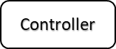
Engine
Distributor
Commands

