SELECT COUNT (CustomerID)

FROM Customers

WHERE Country='Germany';

SELECT COUNT (CustomerID)

FROM Customers

WHERE CustomerName LIKE '%e';

INSERT INTO Customers (CustomerName)

VALUES ('Evgenia');

SELECT \* FROM [Customers]

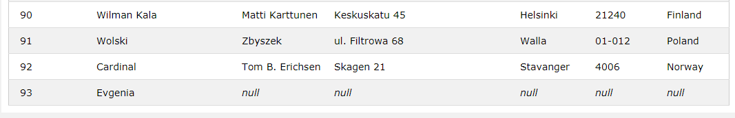

UPDATE Customers

SET CustomerName='Jane'

WHERE CustomerID=93;

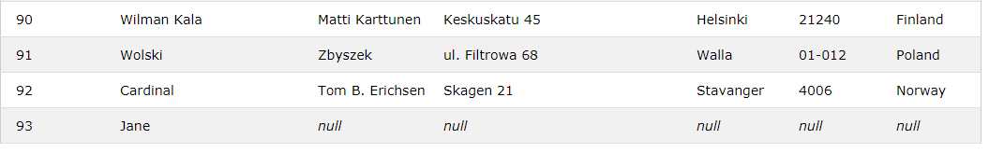 SELECT \* FROM [Customers]

DELETE FROM Customers

WHERE City='Nantes';

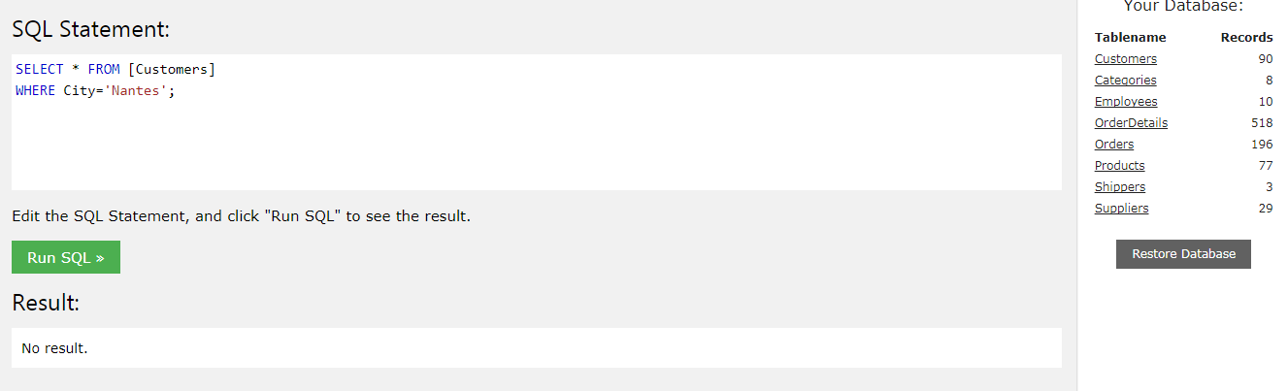

SELECT Orders.OrderID, Employees.FirstName

FROM Orders

INNER JOIN Employees ON Orders.EmployeeID = Employees.EmployeeID

WHERE FirstName='Steven';

