CachedofObjects
Software Design Description

Author | Revision | Comments | Date
References:
Title | Revision | File Name

Note: Text under ”‘What is this” and displayed in dark red italics (style=Comment) is included to provide guidance to the author and should be deleted before publishing the document. Blue text is example text that should be modified or removed.
To customize automatic fields (which display a gray background when selected), select File>Properties and replace the Title and Subject fields with the appropriate information for this document. After closing the dialog, automatic fields may be updated throughout the document by selecting Edit>Select All (or Ctrl-A) and pressing F9, or simply click on the field and press F9. This must be done separately for Headers and Footers. Alt-F9 will toggle between displaying the field names and the field contents
Note: The Software Design Description (SDD) captures the complete software design for the system, or a portion of the system. Following is a typical SDD outline for a project using only traditional natural-language style requirements.
1 Introduction 4
1.1 Purpose 4
1.2 Scope 4
1.3 References 4
1.4 Definitions and acronyms 4
1.4.1 General definitions and acronyms 4
1.4.2 Specific definitions and acronyms 6
1.5 Background 6
2 Decomposition description 6
What is this 6
Scope 6
Use 7
Representation 7
2.1 Top level decomposition 7
2.2 Hierarchical decomposition 8
2.2.1 Entity1 (should be replaced by an entity name) 8
2.2.1.1 Type 8
2.2.1.2 Purpose 8
2.2.1.3 Function 8
2.2.1.4 Subordinates 8
2.2.2 Entity2 (should be replaced by an entity name) 9
2.2.2.1 Type 9
2.2.2.2 Purpose 9
2.2.2.3 Function 9
3 Dependency description 9
What is this 9
Scope 9
Use 9
Representation 10
3.1.1 Top level dependency description 10
3.1.2 Entity1 10
3.1.2.1 Dependencies 10
3.1.2.2 Resources 10
3.1.3 Entity2 11
3.1.3.1 Dependencies 11
3.1.3.2 Resources 11
4 Interface description 11
What is this 11
Scope 11
Use 11
Representation 12
4.1.1 Entity1 12
4.1.1.1 Interfaces 12
4.1.2 Entity2 12
4.1.2.1 Interfaces 12
5 Detailed design 13
What is this 13
Scope 13
Use 13
Representation 13
5.1.1 Entity1 13
5.1.1.1 Processing 13
5.1.1.2 Data 14
6 Thread module 14
7 Data dictionary 14
8 Packaging module 14
9 Requirement coverage table 14

Introduction
Overview of the development goal

Purpose
Describe the purpose of the document. Who is the intended audience?

Scope
Describe what parts of the development are covered by this design and what is not.

References
List the documents that base this document. Document name, title and possibly comments.

Definitions and acronyms

General definitions and acronyms
- Identification - The name of the entity. Two entities shall not have the same name. The names for the entities may be selected to characterize their nature. This will simplify referencing and tracking in addition to providing identification.
- Type - A description of the kind of entity. The type attribute shall describe the nature of the entity. It may simply name the kind of entity, such as subprogram, module, procedure, process, or data store. Alternatively, design entities may be grouped into major classes to assist in locating an entity dealing with a particular type of information. For a given design description, the chosen entity types shall be applied consistently.
- Purpose - A description of why the entity exists. The purpose attribute shall provide the rationale for the creation of the entity. Therefore, it shall designate the specific functional and performance requirements for which this entity was created; see IEEE Std 830-1998. The purpose attribute shall also describe special requirements that must be met by the entity that are not included in the software requirements specification.
- Function - A statement of what the entity does. The function attribute shall state the transformation applied by the entity to inputs to produce the desired output. In the case of a data entity, this attribute shall state the type of information stored or transmitted by the entity.
- Subordinates - The identification of all entities composing this entity. The subordinates attribute shall identify the composed of relationship for an entity. This information is used to trace requirements to design entities and to identify parent/child structural relationships through a software system decomposition.
- Dependencies - A description of the relationships of this entity with other entities. The dependencies attribute shall identify the uses or requires the presence of relationship for an entity. These relationships are often graphically depicted by structure charts, data flow diagrams, and transaction diagrams. This attribute shall describe the nature of each interaction including such characteristics as timing and conditions for interaction. The interactions may involve the initiation, order of execution, data sharing, creation, duplicating, usage, storage, or destruction of entities.
- Interface - A description of how other entities interact with this entity. The interface attribute shall describe the methods of interaction and the rules governing those interactions. The methods of interaction include the mechanisms for invoking or interrupting the entity, for communicating through parameters, common data areas or messages, and for direct access to internal data. The rules governing the interaction include the communications protocol, data format, acceptable values, and the meaning of each value. This attribute shall provide a description of the input ranges, the meaning of inputs and outputs, the type and format of each input or output, and output error codes. For information systems, it should include inputs, screen formats, and a complete description of the interactive language.
- Resources - A description of the elements used by the entity that are external to the design. The resources attribute shall identify and describe all of the resources external to the design that are needed by this entity to perform its function. The interaction rules and methods for using the resource shall be specified by this attribute. This attribute provides information about items such as physical devices (printers, disc-partitions, memory banks), software services (math libraries, operating system services), and processing resources (CPU cycles, memory allocation, buffers). The resources attribute shall describe usage characteristics such as the process time at which resources are to be acquired and sizing to include quantity, and physical sizes of buffer usage. It should also include the identification of potential race and deadlock conditions as well as resource management facilities.
- Processing - A description of the rules used by the entity to achieve its function. The processing attribute shall describe the algorithm used by the entity to perform a specific task and shall include contingencies. This description is a refinement of the function attribute. It is the most detailed level of refinement for this entity. This description should include timing, sequencing of events or processes, prerequisites for process initiation, priority of events, processing level, actual process steps, path conditions, and loop back or loop termination criteria. The handling of contingencies should describe the action to be taken in the case of overflow conditions or in the case of a validation check failure.
- Data - A description of data elements internal to the entity. The data attribute shall describe the method of representation, initial values, use, semantics, format, and acceptable values of internal data. The description of data may be in the form of a data dictionary that describes the content, structure, and use of all data elements. Data information shall describe everything pertaining to the use of data or internal data structures by this entity. It shall include data specifications such as formats, number of elements, and initial values. It shall also include the structures to be used for representing data such as file structures, arrays, stacks, queues, and memory partitions. The meaning and use of data elements shall be specified. This description includes such things as static versus dynamic, whether it is to be shared by transactions, used as a control parameter, or used as a value, loop iteration count, pointer, or link field. In addition, data information shall include a description of data validation needed for the process.

Specific definitions and acronyms
List the definitions and acronyms that are used in the SDD

Background
Specify technical background information that is needed to understand the design

Decomposition description

Project has three major entity : client, server and cache.

Top level decomposition

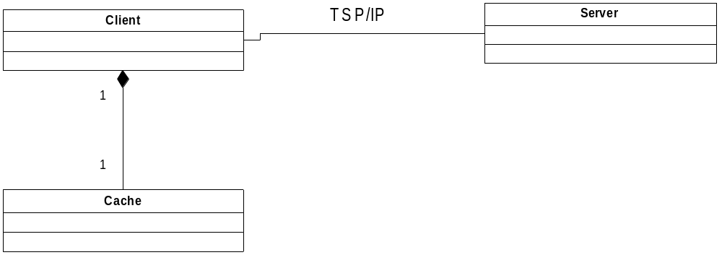
UML Diagram Top level decomposition

- Client generates requests, monitors the cache
- Server controls of the connection, returns on object by index
- Cache saves elements, transmits them to the client and updates list of element

Hierarchical decomposition

Entity1 Client

Type
Client is module, its main task to request objects from server and to create a copies of objects in cache.

Purpose
Client is major element of project, which receives objects from server. Must be successfully established a connection between client and server. Client (user) must know id of object.

Function
Main functions of client :
- to establish connection with server;
- to request of object from server;
- to request of object from cache;
- verification versions (or the cache object has the latest version);
- to transfer copies of object in the cache.

Client generates a request of object. Checks whether the object is in cache :
if not, sends the request to server, receives the object and transmits a copy (clone) in the cache.
if yes, sends request to the server for receive last date of updating this object, checks the date object that is in the cache. if necessary, updates the data.
Also client establishes and terminates a connection to the server.

Subordinates
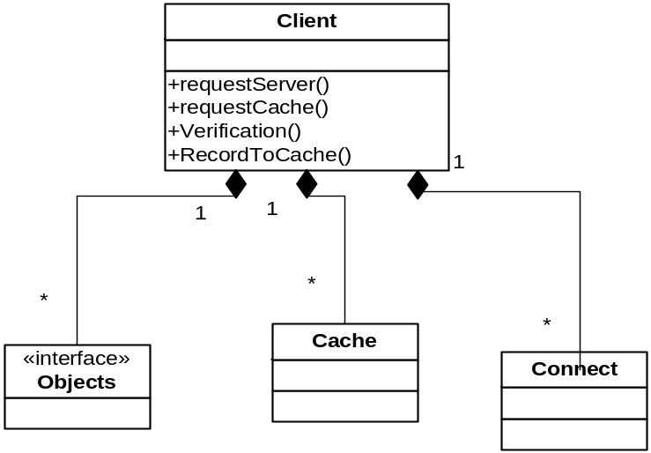

Entity2 Cache

Type
Cache is subsidiary module. Its main purpose is to reduce the load on the connection between client and server. Cache stores objects which are often requested by client.

Purpose

Function
Main functions of cache:
- to process request from a client;
- add object;
- update the object;
- update all;
- remove object;
- give the object.

Subordinates

Entity2 Server

Type
Server is a module. The server awaits request from the client. Looking at object on a given id and passes to the client.

Purpose
The server allows the client to obtain the necessary objects on. Must be connection with client. Client must know what kind objects are on server.

Function
Main functions of server:
- to establish connection with client;
- to process request from a client;
- give the object;
- update objects.

The server must send:
- object, if one exists (in the cache of the object yet)
- a special message with the date of update (to check object in cache)

Subordinates

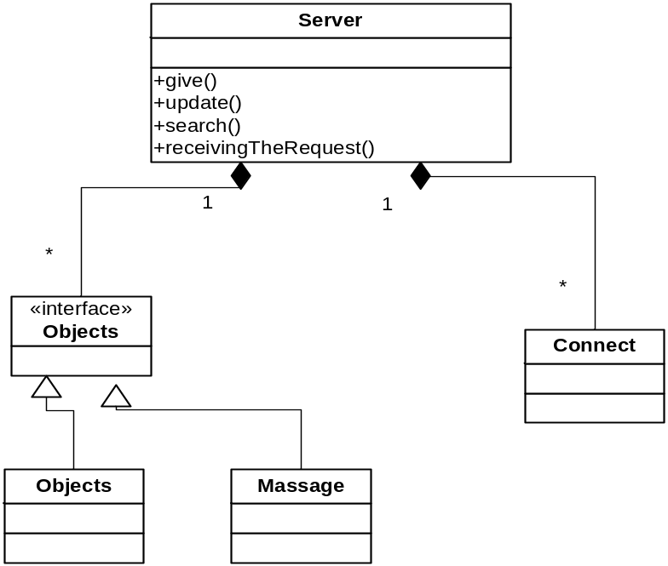

Dependency description

What is this

Scope
The dependency description specifies the relationships among entities. It identifies the dependent entities, describes their coupling, and identifies the required resources. This design view defines the strategies for interactions among design entities and provides the information needed to easily perceive how, why, where, and at what level system actions occur. It specifies the type of relationships that exist among the entities such as shared information, prescribed order of execution, or well-defined parameter interfaces. The attribute descriptions for identification, type, purpose, dependencies, and resources should be included in this design view. This attribute information should be provided for all design entities that we listed in the hierarchical decomposition section.

Use
The dependency description provides an overall picture of how the system works in order to assess the impact of requirements and design changes. It can help maintainers to isolate entities causing system failures or resource bottlenecks. It can aid in producing the system integration plan by identifying the entities that are needed by other entities and that must be developed first. This description can also be used by integration testing to aid in the production of integration test cases.

Representation
Formal specification languages provide for the specification of system functions and data, their interrelationships, the inputs and outputs, and other system aspects in a well-defined language. The relationship among design entities is also represented by data flow diagrams, structure charts, or transaction diagrams.

Top level dependency description
Use the same UML diagram from the top level decomposition part and add dependency information. Including association, Aggregation, generalization, dependency and realization

Entity1
For each entity describe the dependencies and resources regarding this entity. Use UML and free text.

Dependencies
A description of the relationships of this entity with other entities. The dependencies attribute shall identify the uses or requires the presence of relationship for an entity. These relationships are often graphically depicted by structure charts, data flow diagrams, and transaction diagrams.
This attribute shall describe the nature of each interaction including such characteristics as timing and conditions for interaction. The interactions may involve the initiation, order of execution, data sharing, creation, duplicating, usage, storage, or destruction of entities.

Resources

A description of the elements used by the entity that are external to the design. The resources attribute shall identify and describe all of the resources external to the design that are needed by this entity to perform its function. The interaction rules and methods for using the resource shall be specified by this attribute.
This attribute provides information about items such as physical devices (printers, disc-partitions, memory banks), software services (math libraries, operating system services), and processing resources (CPU cycles, memory allocation, buffers).
The resources attribute shall describe usage characteristics such as the process time at which resources are to be acquired and sizing to include quantity, and physical sizes of buffer usage. It should also include the identification of potential race and deadlock conditions as well as resource management facilities.

Entity2

Dependencies

Resources

Interface description

What is this

Scope
The entity interface description provides everything designers, programmers, and testers need to know to correctly use the functions provided by an entity. This description includes the details of external and internal interfaces not provided in the software requirements specification. This design view consists of a set of interface specifications for each entity. The attribute descriptions for identification, function, and interfaces should be included in this design view. This attribute information should be provided for all design entities.

Use
The interface description serves as a binding contract among designers, programmers, customers, and testers. It provides them with an agreement needed before proceeding with the detailed design of entities. In addition, the interface description may be used by technical writers to produce customer documentation or may be used directly by customers. In the latter case, the interface description could result in the production of a human interface view. Designers, programmers, and testers may need to use design entities that they did not develop. These entities may be reused from earlier projects, contracted from an external source, or produced by other developers. The interface description settles the agreement among designers, programmers, and testers about how cooperating entities will interact. Each entity interface description should contain everything another designer or programmer needs to know to develop software that interacts with that entity. A clear description of entity interfaces is essential on a multiperson development for smooth integration and ease of maintenance.

Representation
The interface description should provide the language for communicating with each entity to include screen formats, valid inputs, and resulting outputs. For those entities that are data driven, a data dictionary should be used to describe the data characteristics. Those entities that are highly visible to a user and involve the details of how the customer should perceive the system should include a functional model, scenarios for use, detailed feature sets, and the interaction language.

Entity1

Interfaces
Specify the exported methods and events elaborate on parameters

A description of how other entities interact with this entity. The interface attribute shall describe the methods of interaction and the rules governing those interactions. The methods of interaction include the mechanisms for invoking or interrupting the entity, for communicating through parameters, common data areas or messages, and for direct access to internal data. The rules governing the interaction include the communications protocol, data format, acceptable values, and the meaning of each value.

This attribute shall provide a description of the input ranges, the meaning of inputs and outputs, the type and format of each input or output, and output error codes. For information systems, it should include inputs, screen formats, and a complete description of the interactive language.

Entity2

Interfaces

Detailed design

What is this

Scope
The detailed design description contains the internal details of each design entity. These details include the attribute descriptions for identification, processing, and data. This attribute information should be provided for all design entities.

Use
This description contains the details needed by programmers prior to implementation. The detailed design description can also be used to aid in producing unit test plans.

Representation
There are many tools used to describe the details of design entities. Program design languages can be used to describe inputs, outputs, local data and the algorithm for an entity. Other common techniques for describing design entity logic include using metacode or structured English, or graphical methods such as UML.

Entity1

Processing
A description of the rules used by the entity to achieve its function. The processing attribute shall describe the algorithm used by the entity to perform a specific task and shall include contingencies. This description is a refinement of the function attributes. It is the most detailed level of refinement for this entity.
This description should include timing, sequencing of events or processes, prerequisites for process initiation, priority of events, processing level, actual process steps, path conditions, and loop back or loop termination criteria. The handling of contingencies should describe the action to be taken in the case of overflow conditions or in the case of a validation check failure.
Use UML state charts and activity Diagrams to describe this

Data
A description of data elements internal to the entity. The data attribute shall describe the method of representation, initial values, use, semantics, format, and acceptable values of internal data.
The description of data may be in the form of a data dictionary that describes the content, structure, and use of all data elements. Data information shall describe everything pertaining to the use of data or internal data structures by this entity. It shall include data specifications such as formats, number of elements, and initial values. It shall also include the structures to be used for representing data such as file structures, arrays, stacks, queues, and memory partitions. The meaning and use of data elements shall be specified. This description includes such things as static versus dynamic, whether it is to be shared by transactions, used as a control parameter, or used as a value, loop iteration count, pointer, or link field. In addition, data information shall include a description of data validation needed for the process

Thread module
Describe the thread module including blocking situations and the relationship between threads

Data dictionary
This is an optional view for developments that are Data oriented. The Data structure should be organized here.

Packaging module
Describe the software packages including exes, DLLs, COM / DCOM objects Corba Installs and similar. It is important to specify what components run on which hardware.

Requirement coverage table
Show that were every requirement is addressed in the design
 | SRS Requirement | SDD paragraph
1.
2.
3.

