# Redux Test project

## Goal

By creating simple event calendar app using react/redux/express/mongo stack you should demonstrate your awareness of how to work with related technologies.

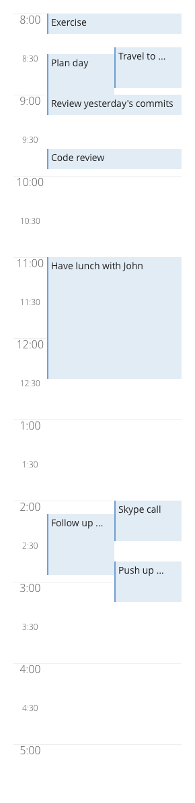

***Image 1*** *- Calendar layout*

## Requirements

1. User should be able to view calendar with layout similar to one displayed on image 1
   1. Conflicting events should be the same width, and should not overlap
   2. Max event width is 200px
   3. Event background color is #E2ECF5 with #6E9ECF border color
   4. Event font is Open Sans, 14px
   5. Calendar time font is Open Sans with around 200 font weight, 16px large, 12px small.
   6. Titles should be 1 line and should not overflow outside the calendar-event box. If the title is too long to fit, ellipsis (“…”) should be used.
   7. Events will be between 8am to 5pm (there’s a label for 5pm but events will not exceed 5pm)
   8. Calendar will cover only one same day
2. User should be able to add/remove events from his calendar
3. User should be able to export his calendar in JSON as follows:  
   
4. User should be able to login and persist his inputs between logins
5. Solution should be provided as a link to git repository