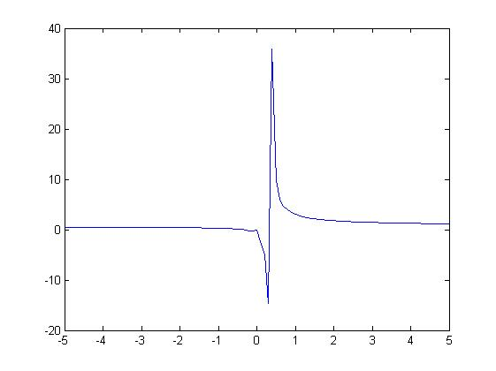syms Y t at x

ax=-5:0.1:5;

Y=dsolve('Dy==y^2*log(x)/(3*x)-y/x','y(1)==3','x')

pretty(simplify(Y));

plot(ax,subs(Y,ax));

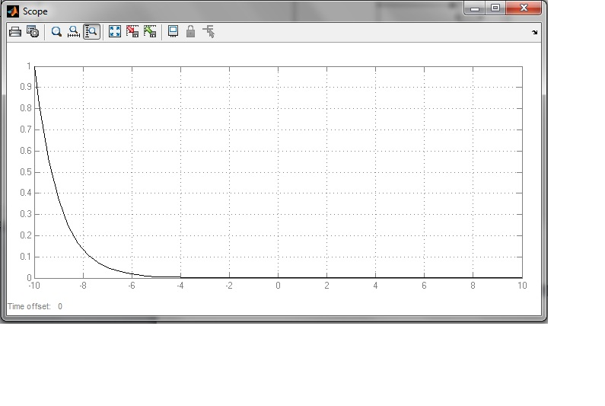

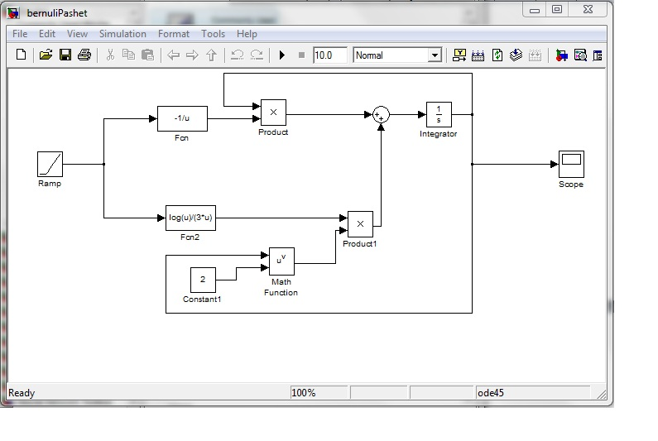

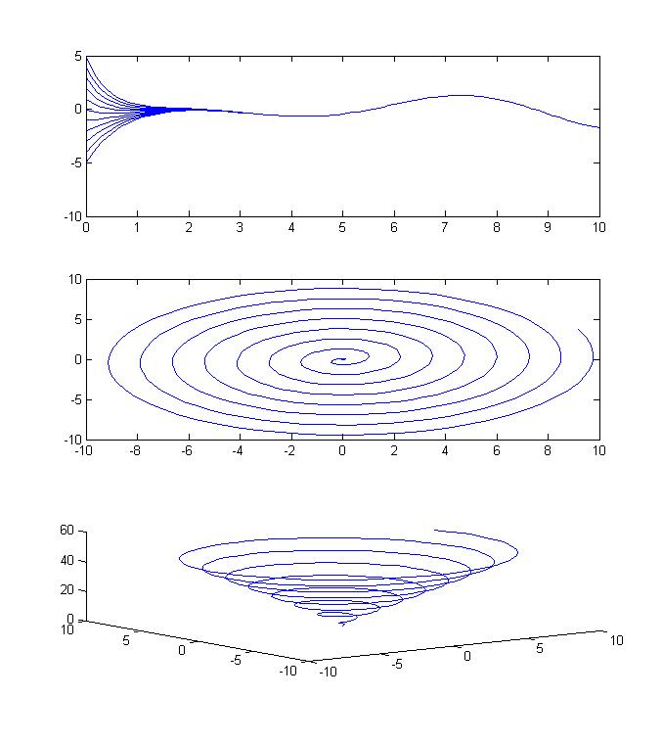syms x y

syms x y Left Right

syms x_new y_new real;

Left='D2y+4*Dy+4*y=x*cos(x)';

y=simplify(dsolve(Left,'x'));

pretty(y);

subplot(3,1,1);

x_new=0:0.1:10;

for cycle1=-5:1:5;

y_new=subs(y,'C6',cycle1);

for cycle2=-2:1:2

y_new=subs(y_new,'C7',cycle2);

y_new=((subs(y_new,x_new)));

plot(x_new,y_new);

hold on

end;

end;

at=0:0.1:50;

y=subs(y,'C6',0);

Y=subs(y,'C7',0);

dY=diff(Y);

subplot(3,1,2);

plot(subs(dY,x,at),subs(Y,x,at));

subplot(3,1,3);

plot3(subs(dY,x,at),subs(Y,x,at),at);

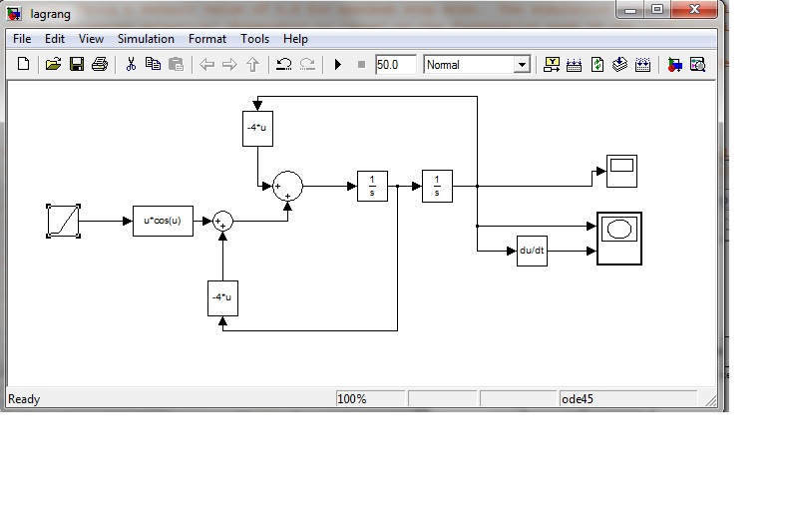

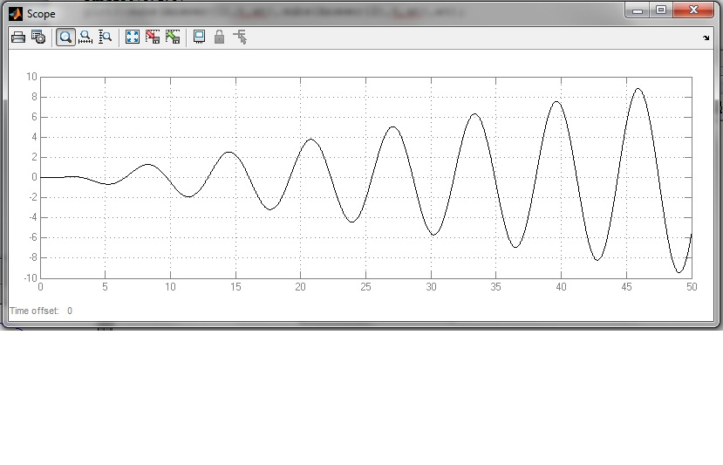

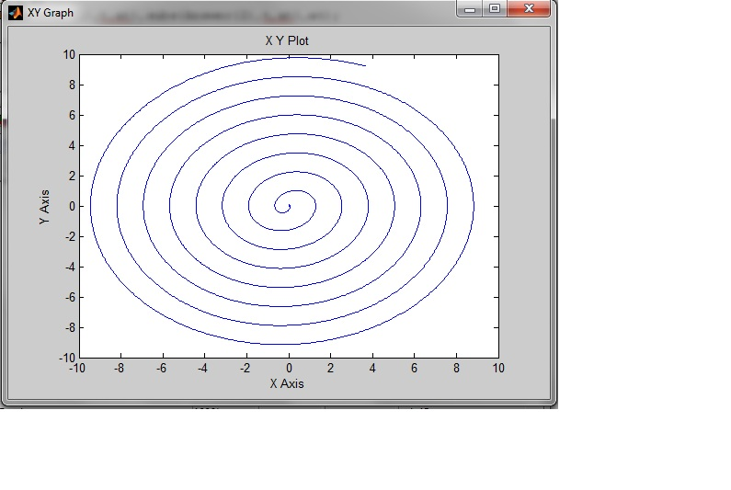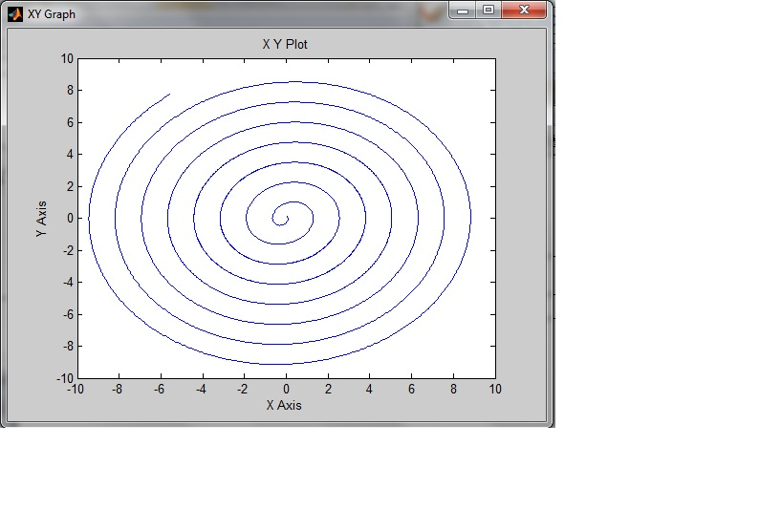

syms y12(t) y11(t) y21(t) y22(t) W(t) W1 W2 tau Y X

at=0:0.01:50;

A=[0 1;-4 -4];

W(t)=[y11(t) y12(t); y21(t) y22(t)];

Result=dsolve(diff(W,t)==A*W(t),W(0)==[1 0;0 1]);

W(t)= simplify([Result.y11, Result.y12; Result.y21,Result.y22]);

Answer=W(t)*W(0)^(-1)*[0;0]+W(t)*int(W(tau)^(-1)*[0;tau*cos(tau)],tau,0,t)

fprintf('Answer=');

pretty(simplify(Answer));

subplot(3,1,1);

plot(at,subs(Answer(1),t,at))

subplot(3,1,2);

plot(subs(Answer(1),t,at),subs(Answer(2),t,at))

subplot(3,1,3)

plot3(subs(Answer(1),t,at),subs(Answer(2),t,at),at);

