WEEKLY QA REPORT

## Contents

Contents 1

Summary 2

Projects Status 3

Maya RPR 3

Maya USD 4

Blender RPR 5

Blender USD 6

hdRPR 7

Houdini 7

Render Studio 8

SolidWorks 9

Web Material Library 9

QA Team Members 10

## Summary

* **Main tasks**:
* Checked new AMD driver 22.11.1 for Maya
* Added HybridPro autotests for Maya RPR
* Started setup internal hdRPR testing process
* Updated the spreadsheet with information about MaterialX nodes support and test coverage
* Testing new core 2.2.16 patch 3 with plugins and hdRPR
* **Blocker issues**:
  + [[RS-310](https://amdrender.atlassian.net/browse/RS-310)] Materials are displayed brighter than they should be
  + [[RS-309](https://amdrender.atlassian.net/browse/RS-309)] Render Studio web version doesn't work
  + [[RS-294](https://amdrender.atlassian.net/browse/RS-294)] Some objects change position after mouse click on them
  + [[RS-293](https://amdrender.atlassian.net/browse/RS-293)] Some materials crash streamer in develop
  + [[RS-276](https://amdrender.atlassian.net/browse/RS-276)] Properties in desktop version works unpredictable

### Projects Status

|  |  |  |  |  |
| --- | --- | --- | --- | --- |
| Project | Date | Report Link | Status | Comment |
| Maya RPR | 18-Nov-2022 | [3.4.0](https://cis.nas.stvcis.com:5443/RPR-MayaPlugin-Weekly/140/Test_Report_Northstar/test_report.html) | **Stable** | Testing new core |
| Blender RPR | 22-Nov-2022 | [3.5.2](https://cis.nas.stvcis.com:5443/RPR-BlenderPlugin-Weekly/152/Test_Report/test_report.html) | **Stable** | Testing new core |
| Maya USD | 19-Nov-2022 | [0.1.9](https://cis.nas.stvcis.com:5443/USD-MayaPlugin-Weekly/47/Test_Report/test_report.html) | **Stable** | Testing new core |
| Blender USD | 19-Nov-2022 | [1.1.8](https://cis.nas.stvcis.com:5443/USD-BlenderPlugin-Weekly/86/Test_Report/test_report.html) | **Stable** | Testing new core |
| Render Studio | 19-Nov-2022 | [0.1.13](https://cis.nas.stvcis.com:5443/RenderStudio-Weekly/9/Test_Report_Desktop/test_report.html) | **Failed** | Blocker issues |
| Houdini | 17-Nov-2022 | [2.3.1](https://cis.nas.stvcis.com:5443/USD-HoudiniPlugin-Manual/1102/Test_Report_19.5.368_Northstar/test_report.html) | **Unstable** | Critical issues |
| hdRPR | - | - | **Unstable** | Manual testing, automation planned, critical issues |
| SolidWorks | - | - | **Stable** | Manual testing |
| USD Viewer/Inventor | 19-Nov-2022 | [1.118](https://cis.nas.stvcis.com:5443/USD-InventorPlugin-Weekly/78/Test_Report/test_report.html) | **On hold** | Waiting for the new PRs |
| Anari | 18-Nov-2022 | [1.0.3](https://cis.nas.stvcis.com:5443/RPR-Anari-Weekly/62/Test_Report/test_report.html) | **On hold** | Project on hold |
| Blender HIP | 18-Nov-2022 | [CUDA](https://rpr.cis.luxoft.com/view/Weekly%20Jobs/job/BlenderHIP/job/BlenderHIP-WeeklyHIP_CUDA/54/Test_20Report/) [CPU](https://rpr.cis.luxoft.com/view/Weekly%20Jobs/job/BlenderHIP/job/BlenderHIP-WeeklyHIP_CPU/50/Test_20Report/) | **On hold** | Project on hold |

## 

## Projects Status

## Maya RPR

### Completed Tasks

* Added HybridPro autotests in Jenkins jobs
* Checked new AMD driver 22.11.1

### Planned Activities

* Check PR-350 with new core 2.2.16 patch 3
* Finish review autotests cases for HybridPro
* Review fixes for TMS group
* Add autotests assets for new NParticles test suite

### Pull Requests Status

|  |  |  |
| --- | --- | --- |
| Pull Request | Comments | Status |
| PR-342: Fix animated textures export | Approved by QA | Merged |
| PR-345: Add HybridPro parameters to UI | Rejected by QA | Pending |
| PR-346: Remove old hybrid modes | Approved by QA | Merged |
| PR-349: UI for linking light in Toon Shader reworked | Approved by QA | Merged |
| PR-350: SDK 2.2.16 patch3 | Approved by QA | Merged |

[New bugs (7)](https://amdrender.atlassian.net/issues/?jql=project%20%3D%20RPRMAYA%20AND%20issuetype%20%3D%20Bug%20AND%20created%20%3E%3D%202022-11-07%20AND%20created%20%3C%3D%202022-11-24%20ORDER%20BY%20created%20DESC)

### Unresolved issues Issues Updates in 2 weeks

[View issues](https://amdrender.atlassian.net/issues/?jql=project%20%3D%20RPRMAYA%20AND%20issuetype%20%3D%20Bug%20AND%20status%20in%20(Assessment%2C%20Blocked%2C%20%22In%20Progress%22%2C%20%22In%20Review%22%2C%20%22In%20Test%22%2C%20Open%2C%20Reopened)%20ORDER%20BY%20summary%20ASC)

## Maya USD

### Completed Tasks

* Checked PR-27 with CPU, GPU support
* Checked new AMD driver 22.11.1

### Planned Activities

* Check PR-30 with new core 2.2.16 patch 3
* Add autotests about MaterialX nodes using Houdini scenes
* Add new WML autotests
* Add regression test suite in Jenkins

Pull Requests Status

|  |  |  |
| --- | --- | --- |
| Pull Request | Comments | Status |
| [PR-619: Make a fix for vertex color in geomsubset](https://github.com/GPUOpen-LibrariesAndSDKs/RadeonProRenderUSD/pull/619) |  | Closed |
| [PR-616: Core 2.2.17](https://github.com/GPUOpen-LibrariesAndSDKs/RadeonProRenderUSD/pull/616) |  | Open |
| [PR-612: Orthographic camera tiling implementation](https://github.com/GPUOpen-LibrariesAndSDKs/RadeonProRenderUSD/pull/612) |  | Open |
| [PR-615: profile output](https://github.com/GPUOpen-LibrariesAndSDKs/RadeonProRenderUSD/pull/615) |  | Open |

[New bugs (6)](https://amdrender.atlassian.net/issues/?jql=project%20%3D%20MAYAUS%20AND%20issuetype%20%3D%20Bug%20AND%20created%20%3E%3D%202022-11-07%20AND%20created%20%3C%3D%202022-11-24%20ORDER%20BY%20created%20DESC)

### Unresolved issues Issues Updates in 2 weeks

[View issues](https://amdrender.atlassian.net/issues/?jql=project%20%3D%20MAYAUS%20AND%20issuetype%20%3D%20Bug%20AND%20status%20in%20(Assessment%2C%20Blocked%2C%20%22In%20Progress%22%2C%20%22In%20Review%22%2C%20%22In%20Test%22%2C%20Open%2C%20Reopened))

|  |  |  |
| --- | --- | --- |
| Pull Request | Comments | Status |
| [PR-263: BLEN-169: Update plugin with latest USD](https://github.com/GPUOpen-LibrariesAndSDKs/BlenderUSDHydraAddon/pull/263) |  | Open |

## Blender RPR

### Completed Tasks

* Prepared test cases about Doublesided node

### Planned Activities

* Check new AMD driver 22.11.1
* Test new features implementation in Blender 3.3
* Check backlog in JIRA, after new core merge
* Automate cases about Doublesided node

### Pull Requests Status

|  |  |  |
| --- | --- | --- |
| Pull Request | Comments | Status |
| PR-557: RAM leak with multiple material set with Displacement only | Waiting for core 2.2.16 | Draft |

[New bugs (0)](https://amdrender.atlassian.net/issues/?jql=created%20%3E%3D%202022-11-07%20AND%20created%20%3C%3D%202022-11-24%20AND%20project%20%3D%20RPRBLND%20AND%20issuetype%20%3D%20Bug%20ORDER%20BY%20created%20DESC)

### Unresolved issues Issues Updates in 2 weekS

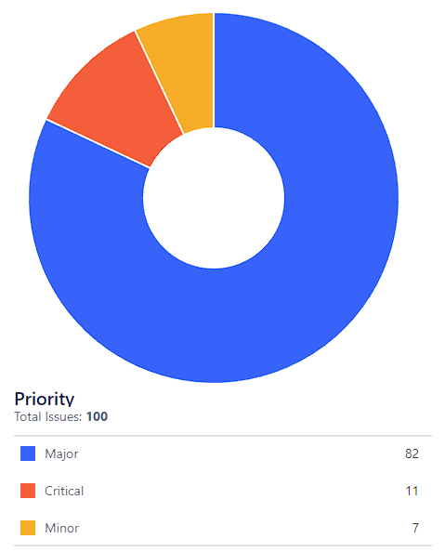

[View issues](https://amdrender.atlassian.net/issues/?jql=project%20%3D%20RPRBLND%20AND%20issuetype%20%3D%20Bug%20AND%20status%20in%20(Assessment%2C%20Blocked%2C%20%22In%20Progress%22%2C%20%22In%20Review%22%2C%20%22In%20Test%22%2C%20Open%2C%20Reopened))­­­­

## Blender USD

### Completed Tasks

* Updated the spreadsheet with information about MaterialX nodes support and test coverage

### Planned Activities

* Check new AMD driver 22.11.1
* Finish updating USD version to 22.05.b, PR-263
* Migrate from Blender 3.2 version to Blender 3.3 version
* Test new workflow for USD integration
* Test hdRPR update

### Pull Requests Status

|  |  |  |
| --- | --- | --- |
| Pull Request | Comments | Status |
|  |  |  |

[New bugs (4)](https://amdrender.atlassian.net/issues/?jql=created%20%3E%3D%202022-11-07%20AND%20created%20%3C%3D%202022-11-24%20AND%20project%20%3D%20BLEN%20AND%20issuetype%20%3D%20Bug%20ORDER%20BY%20created%20DESC)

### Unresolved issues Issues Updates in 2 weekS

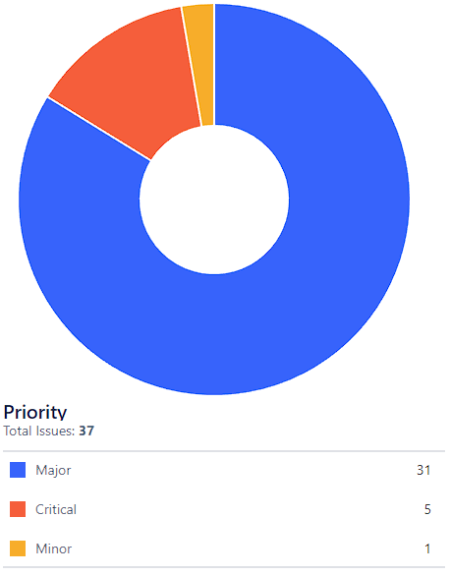

[View issues](https://amdrender.atlassian.net/issues/?jql=project%20%3D%20BLEN%20AND%20issuetype%20%3D%20Bug%20AND%20status%20in%20(Assessment%2C%20Blocked%2C%20%22In%20Progress%22%2C%20%22In%20Review%22%2C%20%22In%20Test%22%2C%20Open%2C%20Reopened))

## hdRPR

### Completed Tasks

* Started setup internal hdRPR testing process
* Created Windows setup documentation

### Planned activities

* Finish internal hdRPR testing process
* Created Linux and Mac OS setup documentation
* Review hdRPR update with core 2.2.16 patch 3
* Check issue US-119 for Microsoft

## Houdini

### Completed Tasks

* Updated the spreadsheet with information about MaterialX nodes support and test coverage
* Approved PR with fix for Instance AOV
* Finished task for Microsoft about shadow catcher

### Planned activities

* Add autotests with using HybridPro and MaterialX
* Add complex scenes to autotests after optimization

### Pull Requests Status

|  |  |  |
| --- | --- | --- |
| Pull Request | Comments | Status |
| PR-592: Implemented setting to deactivate gpu rendering | Approved by QA | Pending |
| PR-602: Add some render statistics | Approved by QA | Merged |
| PR-604: RPR SDK 2.2.16_patch3 | Approved by QA | Pending |
| PR-605: Fix nogpu issue | — | Pending |
| PR-606: Cmake viewer fix | — | Pending |

[New bugs (1)](https://amdrender.atlassian.net/issues/?jql=created%20%3E%3D%202022-11-07%20AND%20created%20%3C%3D%202022-11-24%20AND%20project%20%3D%20RPRHOUD%20AND%20issuetype%20%3D%20Bug%20ORDER%20BY%20created%20DESC)

## Render Studio

### Completed Tasks

* Checked PR-99 with sharing feature, found issue with materials
* Review and baselines update

### Planned activities

* Check PR-110, PR-111, PR-112, PR-113, PR-114, PR-115
* Check PR-105 interop
* Add new autotests in Scenes, Final Render and Viewport groups
* Change scene for Materials group
* Add autotests for demo assets (new studio/museum scene, 7800 GPU card)
* MaterialX nodes test coverage extension

### Pull Requests Status

|  |  |  |
| --- | --- | --- |
| Pull Request | Comments | Status |
| [PR-619: Make a fix for vertex color in geomsubset](https://github.com/GPUOpen-LibrariesAndSDKs/RadeonProRenderUSD/pull/619) |  | Closed |
| [PR-616: Core 2.2.17](https://github.com/GPUOpen-LibrariesAndSDKs/RadeonProRenderUSD/pull/616) |  | Open |
| [PR-612: Orthographic camera tiling implementation](https://github.com/GPUOpen-LibrariesAndSDKs/RadeonProRenderUSD/pull/612) |  | Open |
| [PR-615: profile output](https://github.com/GPUOpen-LibrariesAndSDKs/RadeonProRenderUSD/pull/615) |  | Open |
| [PR-623: macos build fix](https://github.com/GPUOpen-LibrariesAndSDKs/RadeonProRenderUSD/pull/623) |  | Closed |
| [PR-622: IES light direction adjustment](https://github.com/GPUOpen-LibrariesAndSDKs/RadeonProRenderUSD/pull/622) |  | Closed |
| [PR-617: Fix assigning materials per face](https://github.com/GPUOpen-LibrariesAndSDKs/RadeonProRenderUSD/pull/617) |  | Closed |
| [PR-620: MPlay UV AOV fix](https://github.com/GPUOpen-LibrariesAndSDKs/RadeonProRenderUSD/pull/620) |  | Closed |
| [PR-618: Additional settings for toon shader](https://github.com/GPUOpen-LibrariesAndSDKs/RadeonProRenderUSD/pull/618) |  | Closed |
| [PR-606: cmake viewer fix](https://github.com/GPUOpen-LibrariesAndSDKs/RadeonProRenderUSD/pull/606) |  | Closed |
| [PR-614: amd](https://github.com/GPUOpen-LibrariesAndSDKs/RadeonProRenderUSD/pull/614) |  | Open |

[New bugs (15)](https://amdrender.atlassian.net/issues/?jql=project%20%3D%20RS%20AND%20issuetype%20%3D%20Bug%20AND%20status%20in%20(Backlog%2C%20%22In%20Progress%22%2C%20%22Selected%20for%20Development%22%2C%20%22Selected%20For%20Development%22%2C%20%22Selected%20for%20development%22%2C%20%22Testing%20%2F%20QA%22)%20AND%20created%20%3E%3D%202022-11-07%20AND%20created%20%3C%3D%202022-11-24%20ORDER%20BY%20created%20DESC)

[View issues](https://amdrender.atlassian.net/jira/software/projects/RS/issues/?jql=project%20%3D%20%22RS%22%20AND%20type%20%3D%20%22Bug%22%20AND%20status%20IN%20%28%22Backlog%22%2C%22In%20Progress%22%2C%22Selected%20for%20development%22%2C%22Testing%20%2F%20QA%22%29%20ORDER%20BY%20created%20DESC)

## SolidWorks

[New bugs (1)](https://amdrender.atlassian.net/issues/?jql=project%20%3D%20SV%20AND%20issuetype%20%3D%20Bug%20AND%20created%20%3E%3D%202022-11-07%20AND%20created%20%3C%3D%202022-11-24%20ORDER%20BY%20created%20DESC)

### Unresolved issues

No issues were updated last two weeks

[View issues](https://amdrender.atlassian.net/issues/?jql=project%20%3D%20SV%20AND%20issuetype%20%3D%20Bug%20ORDER%20BY%20created%20DESC)

## Web Material Library

[Weekly report](https://stalwart-dieffenbachia-462452.netlify.app/)

[View issues](https://luxproject.luxoft.com/jira/browse/MATLIB-271)

## QA Team Members

|  |  |
| --- | --- |
| Project | Employee |
| RPR Maya | Dwight David, Kornishova Evgeniya |
| USD Maya | Dwight David, Kornishova Evgeniya |
| RPR Blender | Rozghon Artur, Kornishova Evgeniya |
| USD Blender | Rozghon Artur, Kornishova Evgeniya |
| Render Studio | Arseniy Khodot, Kornishova Evgeniya |
| Solidworks | Dwight David, Rozghon Artur |
| Houdini / hdRPR | Rozghon Artur, Dwight David |
| HybridPro | Dwight David, Rozghon Artur, Kornishova Evgeniya |
| Inventor, USD Viewer | Dwight David |
| Web Material Library | Khodot Arseniy, Kornishova Evgeniya |
| Blender HIP | Kornishova Evgeniya, Khodot Arseniy |
| Anari | Kornishova Evgeniya |

For any information, please contact nikita.larionov@dxc.com.