Scott Farm Data

Simon Woodward

November 2, 2017

## Scott Farm Data

# file name  
file_name <- 'FD1004 Data For Modelling.xlsx'  
  
# seed rates in order  
seed_rate_levels <- c('6kg', '12kg', '18kg', '24kg', '30kg')

## Rising Plate Meter

# read and plot rpm data. There is some extra stuff in this sheet.  
data_rpm <- read_xlsx(file_name, sheet='Waikato RPM Height data')  
names(data_rpm) <- ensnakeify(names(data_rpm))  
  
# rename useful variables  
data_rpm <- data_rpm %>%  
 mutate(seed_rate = factor(seed_rate, levels=seed_rate_levels)) %>%  
 rename(  
 date_pre = date_pre_rpm_d,  
 mass_pre = pregrazing_mass_kg_dm_ha,  
 date_post = date_post_rpm_d,  
 mass_post = postgrazing_mass_kg_dm_ha,  
 date_grazed = date_grazed_d  
 ) %>%  
 select(date_grazed, block, cultivar, seed_rate, date_pre, mass_pre, date_post, mass_post)  
  
# plot pre and post mass by cultivar, seed_rate and block  
ybreaks <- seq(0, round_any(max(data_rpm$mass_pre, na.rm=TRUE), 2000, ceiling), 2000)  
xbreaks <- seq(floor_date(min(data_rpm$date_pre), "years"),   
 ceiling_date(max(data_rpm$date_post), "years"), by="1 year")  
data_rpm %>%  
 split(.$block) %>%  
 map(~ggplot(.) +  
 labs(x='Date', y='Plate mass (kgDM/ha)',   
 title=paste('Pre and post plate mass (to ground level), Block', unique(.$block))) +  
 theme(axis.text.x=element_text(angle=90, vjust=0.5, hjust=1)) +  
 geom_vline(mapping=aes(xintercept=date_grazed), colour='grey') +  
 geom_point(mapping=aes(x=date_pre, y=mass_pre), colour='red') +  
 geom_point(mapping=aes(x=date_post, y=mass_post), colour='blue') +  
 facet_grid(cultivar ~ seed_rate) +  
 scale_x_datetime(breaks=xbreaks, labels=year(xbreaks), limits=c(xbreaks[1], tail(xbreaks, 1))) +  
 scale_y_continuous(breaks=ybreaks, limits=c(ybreaks[1], tail(ybreaks, 1)))  
 )

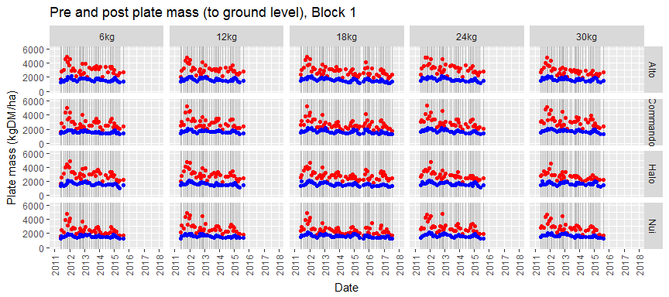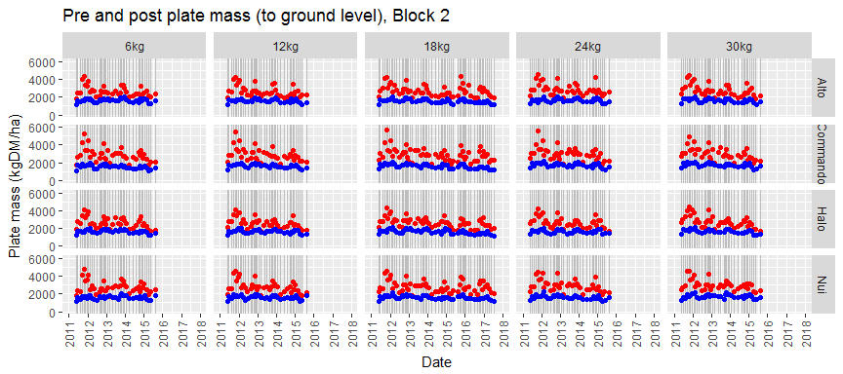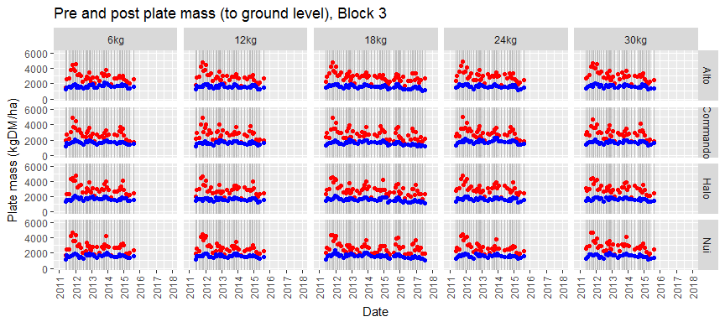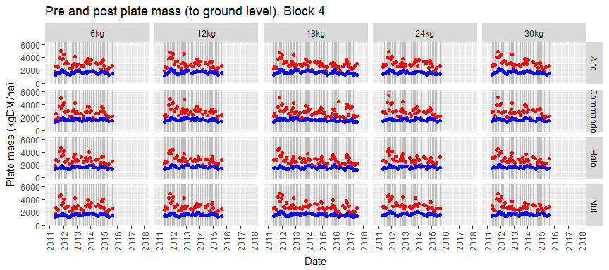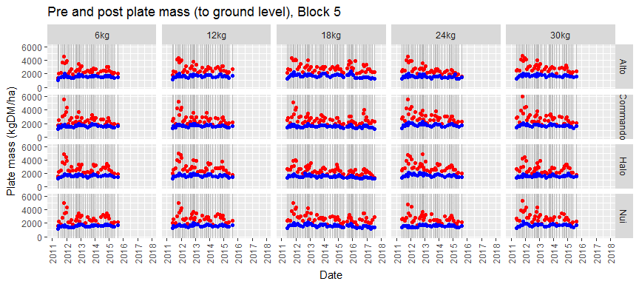

## Rising Plate Meter Growth Rate

# plot growth rate before grazing by cultivar, seed_rate and block.  
# daily dry matter growth rate is assumed to be constant between grazings.  
data_rpm <- data_rpm %>%  
 group_by(block, cultivar, seed_rate) %>%  
 arrange(date_grazed) %>%  
 mutate(  
 date_post_last = lag(date_post ,1),  
 mass_post_last = lag(mass_post ,1),  
 growth_days_pre = as.numeric(difftime(date_pre, date_post_last), units="days"),  
 growth_pre = mass_pre - mass_post_last,  
 growth_rate_pre = growth_pre / as.double(growth_days_pre),  
 growth_rate_post = lead(growth_rate_pre, 1),  
 )   
  
ybreaks <- seq(round_any(min(data_rpm$growth_rate_pre, na.rm=TRUE), 25, floor),   
 round_any(max(data_rpm$growth_rate_pre, na.rm=TRUE), 25, ceiling), 25)  
xbreaks <- seq(floor_date(min(data_rpm$date_pre), "years"),   
 ceiling_date(max(data_rpm$date_post), "years"), by="1 year")  
data_rpm %>%  
 split(.$block) %>%  
 map(~ggplot(.) +  
 labs(x='Date', y='Growth Rate (kgDM/ha/d)',   
 title=paste('Growth Rate (Previous), Block', unique(.$block))) +  
 theme(axis.text.x=element_text(angle=90, vjust=0.5, hjust=1)) +  
 geom_vline(mapping=aes(xintercept=date_grazed), colour='grey') +  
 geom_point(mapping=aes(x=date_grazed, y=growth_rate_pre), colour='magenta') +  
 facet_grid(cultivar ~ seed_rate) +  
 scale_x_datetime(breaks=xbreaks, labels=year(xbreaks), limits=c(xbreaks[1], tail(xbreaks, 1))) +  
 scale_y_continuous(breaks=ybreaks, limits=c(ybreaks[1], tail(ybreaks, 1)))  
 )

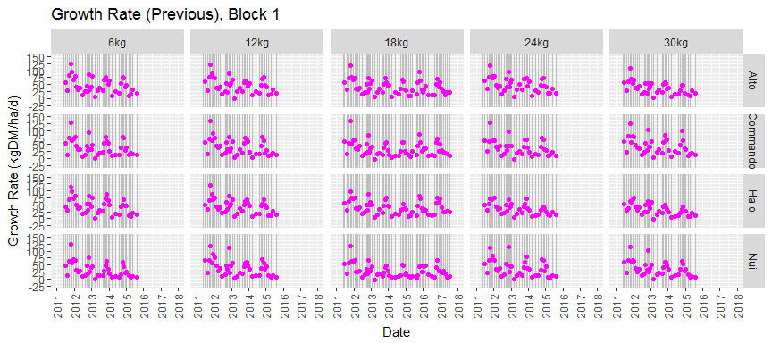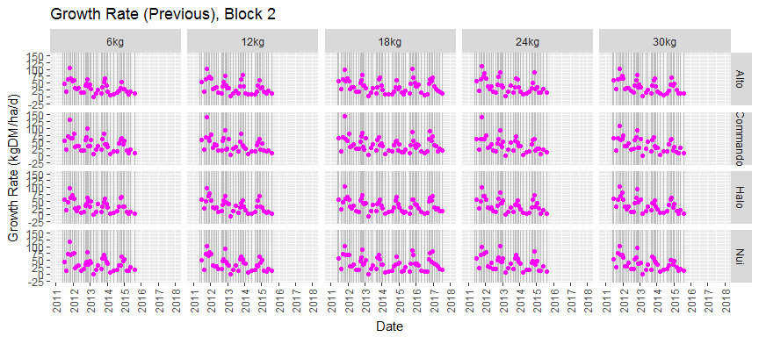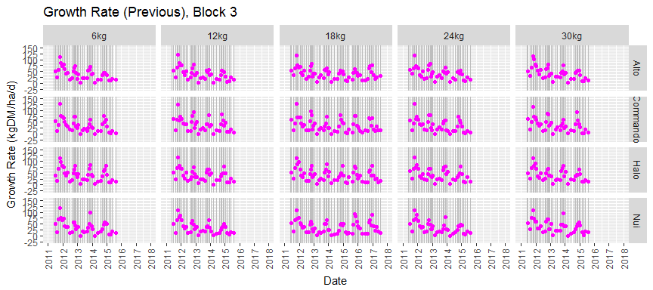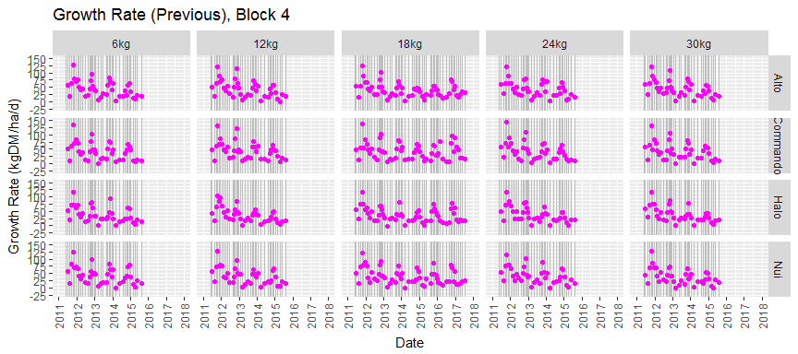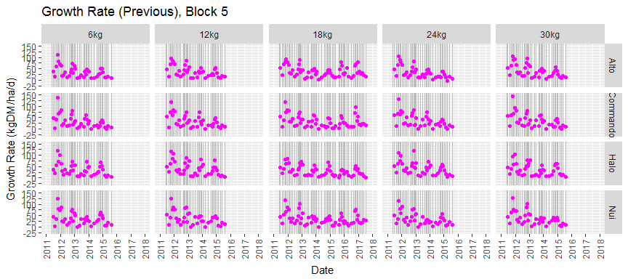

## Rising Plate Meter Harvest %

# plot harvest % by cultivar, seed_rate and block.  
# grazing and residual mass are estimated by linear extrapolation of growth rate  
data_rpm <- data_rpm %>%  
 group_by(block, cultivar, seed_rate) %>%  
 mutate(  
 delay_pre = as.numeric(difftime(date_grazed, date_pre), units="days"),  
 delay_post = as.numeric(difftime(date_post, date_grazed), units="days"),  
 mass_grazed = mass_pre + growth_rate_pre * delay_pre,  
 mass_resid = mass_post - growth_rate_post * delay_post, # assumes growth starts immediately  
 harv = (1 - mass_resid / mass_grazed) * 100 # proportion harvested  
 )  
  
ybreaks <- seq(0, round_any(max(data_rpm$harv, na.rm=TRUE), 20, ceiling), 20)  
xbreaks <- seq(floor_date(min(data_rpm$date_pre), "years"),   
 ceiling_date(max(data_rpm$date_post), "years"), by="1 year")  
data_rpm %>%  
 split(.$block) %>%  
 map(~ggplot(.) +  
 labs(x='Date', y='Harvest %',   
 title=paste('Harvest %, Block', unique(.$block))) +  
 theme(axis.text.x=element_text(angle=90, vjust=0.5, hjust=1)) +  
 geom_vline(mapping=aes(xintercept=date_grazed), colour='grey') +  
 geom_point(mapping=aes(x=date_grazed, y=harv), colour='purple') +  
 facet_grid(cultivar ~ seed_rate) +  
 scale_x_datetime(breaks=xbreaks, labels=year(xbreaks), limits=c(xbreaks[1], tail(xbreaks, 1))) +  
 scale_y_continuous(breaks=ybreaks, limits=c(ybreaks[1], tail(ybreaks, 1)))  
 )

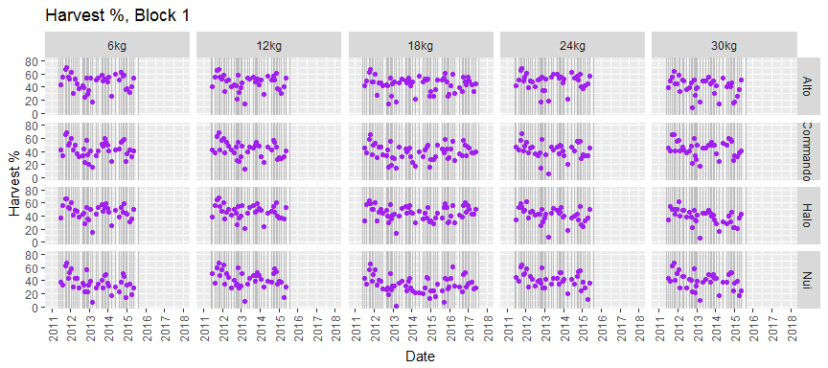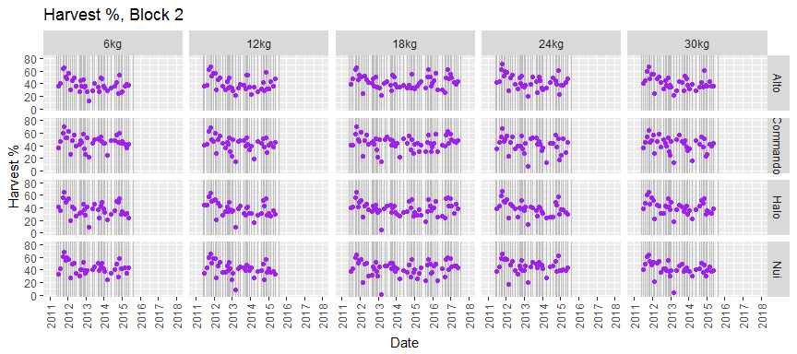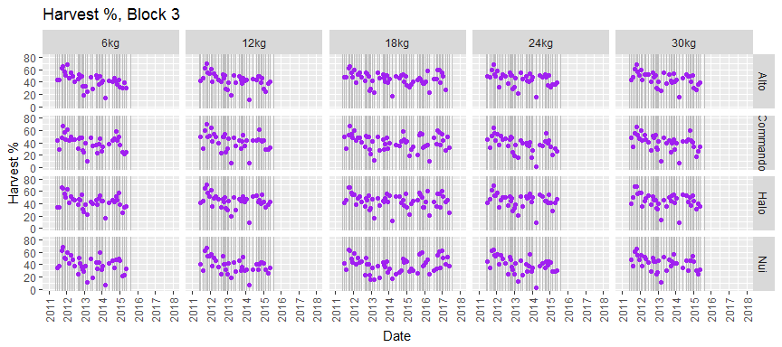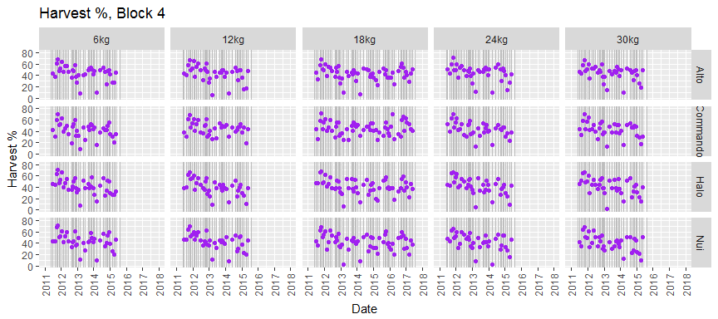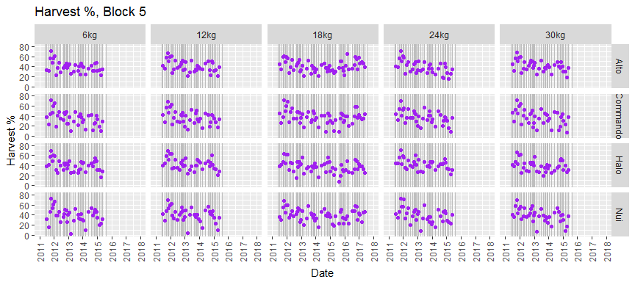

## Pasture Cut Mass

# read and plot cut mass data. Cuts were to 4-5 cm.  
data_cut1 <- read_xlsx(file_name, sheet='Cut Yield Data Year1 2011to12')  
data_cut2 <- read_xlsx(file_name, sheet='Cut Yield Data Year2 onwards')  
names(data_cut1) <- ensnakeify(names(data_cut1))  
names(data_cut2) <- ensnakeify(names(data_cut2))  
  
# rename useful variables  
data_cut1 <- data_cut1 %>%  
 mutate(seed_rate = factor(seed_rate, levels=seed_rate_levels)) %>%  
 rename(  
 date = date_d,  
 yield = yield_kg_dm_ha  
 ) %>%  
 mutate(  
 month = month(month)  
 ) %>%  
 group_by(date, block, seed_rate, cultivar) %>%  
 summarise(yield = mean(yield))  
  
# rename useful variables  
data_cut2 <- data_cut2 %>%  
 mutate(seed_rate = factor(seed_rate, levels=seed_rate_levels)) %>%  
 rename(  
 date = date_d,  
 yield = yield_kg_dm_ha,  
 dm_pc = mean_dm  
 ) %>%  
 mutate(  
 month = month(month)  
 ) %>%  
 select(date, block, seed_rate, cultivar, yield, dm_pc)  
  
# combine tables by row keeping common variables  
data_cut <- full_join(data_cut1, data_cut2)

## Joining, by = c("date", "block", "seed_rate", "cultivar", "yield")

# cutting dates for matching with other data sets  
date_cut <- unique(data_cut$date)  
closest_date_cut <- function(date){ # return index of closest date_cut  
 i <- which(abs(date-date_cut)==min(abs(date-date_cut)))[[1]]  
}  
  
# plot yield data  
ybreaks <- seq(0, round_any(max(data_cut$yield, na.rm=TRUE), 1000, ceiling), 1000)  
xbreaks <- seq(floor_date(min(data_cut$date), "years"),   
 ceiling_date(max(data_cut$date), "years"), by="1 year")  
data_cut %>%  
 split(.$block) %>%  
 map(~ggplot(.) +  
 labs(x='Date', y='Cut mass (kgDM/ha)',   
 title=paste('Pasture Cut mass (pregrazing, cut to 4cm), Block', unique(.$block))) +  
 theme(axis.text.x=element_text(angle=90, vjust=0.5, hjust=1)) +  
 geom_vline(data=data_rpm, mapping=aes(xintercept=date_grazed), colour='grey') +  
 geom_point(mapping=aes(x=date, y=yield), colour='red') +  
 facet_grid(cultivar ~ seed_rate ) +  
 scale_x_datetime(breaks=xbreaks, labels=year(xbreaks), limits=c(xbreaks[1], tail(xbreaks, 1))) +  
 scale_y_continuous(breaks=ybreaks, limits=c(ybreaks[1], tail(ybreaks, 1)))  
 )

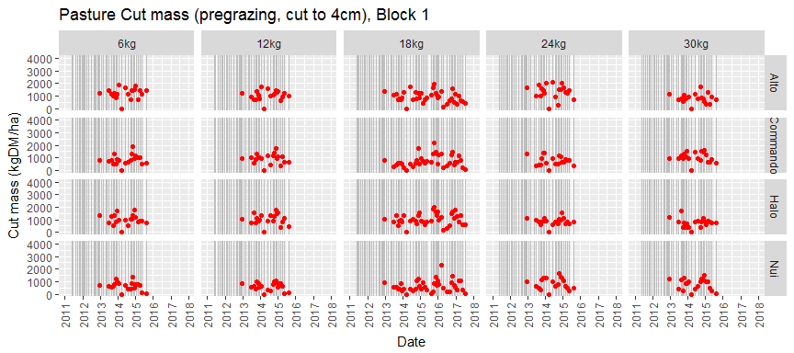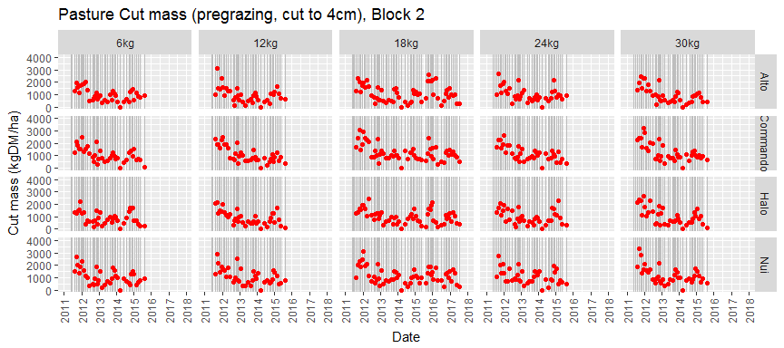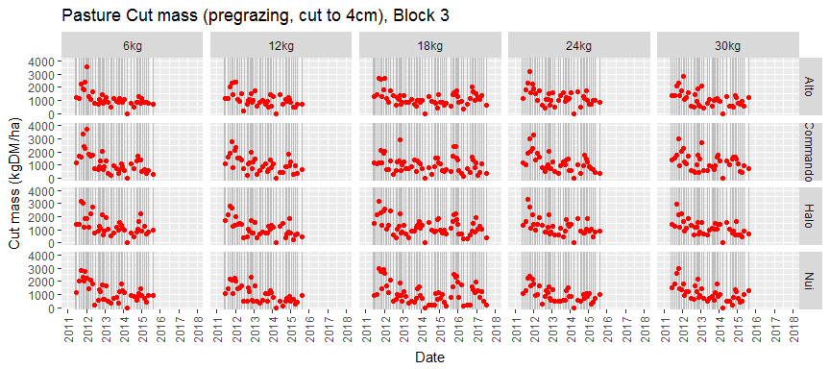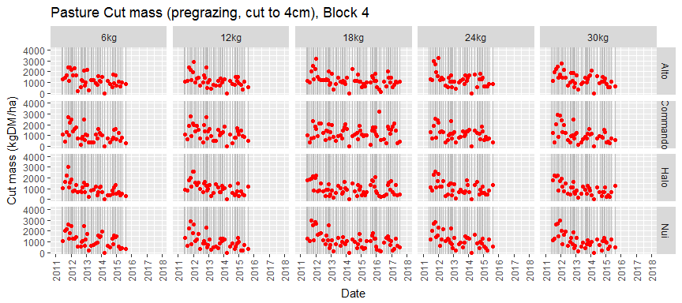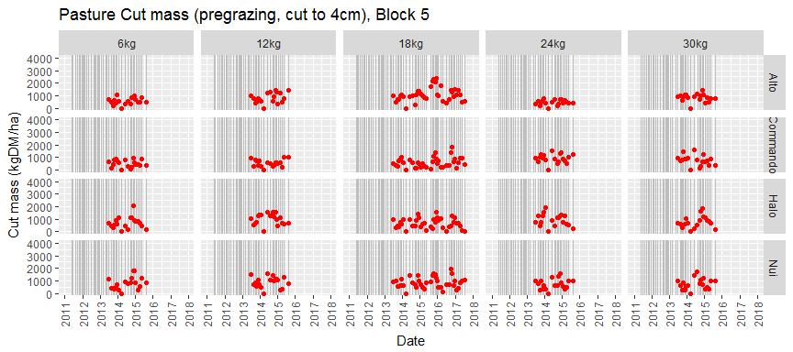

## Estimate Mass Below Cutting Height

# total mass at cutting is estimated by linear extrapolation of pregrazing rpm data  
# find cut matching rpm data  
data_rpm$date_cut_i <- lapply(data_rpm$date_pre, closest_date_cut)  
data_rpm$date_cut <- date_cut[unlist(data_rpm$date_cut_i)]  
  
# join cut and rpm data by date_cut and estimate mass on cutting date  
# mass below cutting height is this minus cut yield  
data_cut$date_cut <- data_cut$date  
data_bc <- data_rpm %>%  
 left_join(data_cut, by=c('date_cut', 'block', 'seed_rate', 'cultivar')) %>%  
 select(date_pre, date_cut, block, seed_rate, cultivar, mass_pre, yield, growth_rate_pre) %>%  
 mutate(delay = as.integer(as.Date(date_cut) - as.Date(date_pre))) %>%   
 filter(abs(delay)<4) %>%  
 drop_na() %>%  
 mutate(  
 mass_cut = mass_pre + growth_rate_pre * delay,  
 below = mass_cut - yield  
 )  
   
# copy below back into data_cut  
data_cut <- data_cut %>%  
 left_join(data_bc, by=c('date_cut', 'block', 'seed_rate', 'cultivar')) %>%  
 select(date, block, seed_rate, cultivar, yield.x, dm_pc, date_cut,   
 date_pre, mass_pre, delay, below, growth_rate_pre) %>%  
 rename(yield=yield.x)  
   
# plot below cutting mass  
ybreaks <- seq(0, round_any(max(data_bc$below, na.rm=TRUE), 1000, ceiling), 1000)  
xbreaks <- seq(floor_date(min(data_bc$date_pre), "years"),   
 ceiling_date(max(data_bc$date_pre), "years"), by="1 year")  
data_bc %>%  
 split(.$block) %>%  
 map(~ggplot(.) +  
 labs(x='Date', y='Dry weight (kgDM/ha)', fill='Species',  
 title=paste('Mass Below Cut (below 4cm), Block', unique(.$block))) +  
 theme(axis.text.x=element_text(angle=90, vjust=0.5, hjust=1)) +  
 geom_point(mapping=aes(x=date_pre, y=below), colour='brown') +  
 facet_grid(cultivar ~ seed_rate ) +  
 scale_x_datetime(breaks=xbreaks, labels=year(xbreaks), limits=c(xbreaks[1], tail(xbreaks, 1))) +  
 scale_y_continuous(breaks=ybreaks, limits=c(ybreaks[1], tail(ybreaks, 1)))  
 )

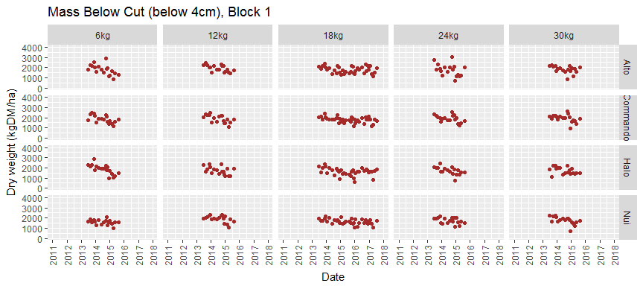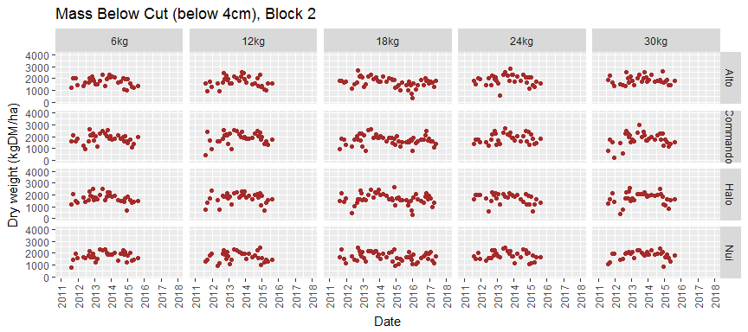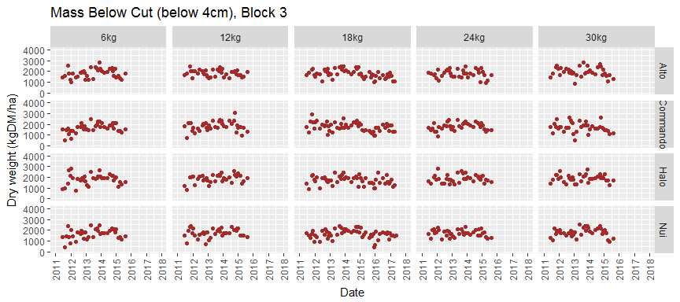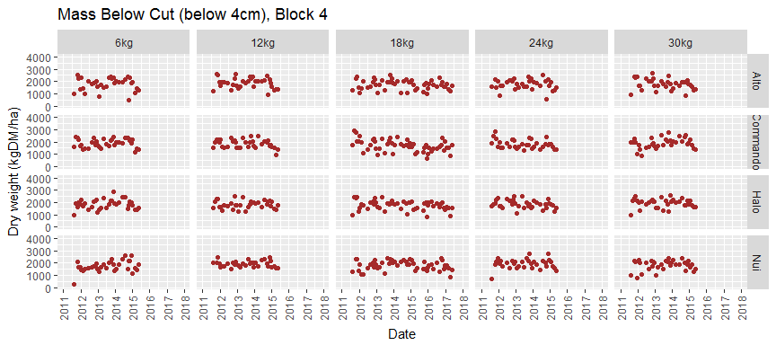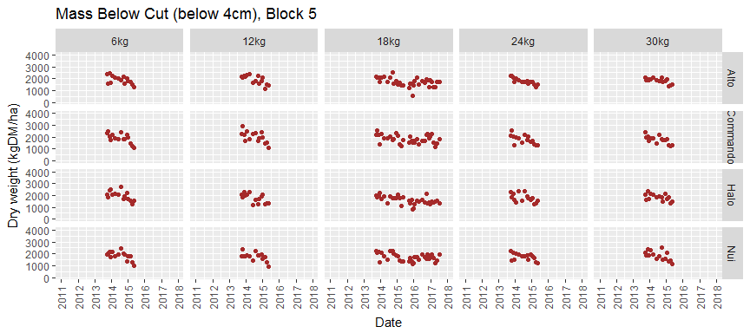

## Pasture Cuts DM%

# plot DM% data  
ybreaks <- seq(0, round_any(max(data_cut$dm_pc, na.rm=TRUE), 10, ceiling), 10)  
xbreaks <- seq(floor_date(min(data_cut$date), "years"),   
 ceiling_date(max(data_cut$date), "years"), by="1 year")  
data_cut %>%  
 split(.$block) %>%  
 map(~ggplot(.) +  
 labs(x='Date', y='Dry matter %',   
 title=paste('Pregazing Dry Matter % (cut to 4cm), Block', unique(.$block))) +  
 theme(axis.text.x=element_text(angle=90, vjust=0.5, hjust=1)) +  
 geom_vline(data=data_rpm, mapping=aes(xintercept=date_grazed), colour='grey') +  
 geom_point(mapping=aes(x=date, y=dm_pc), colour='purple') +  
 facet_grid(cultivar ~ seed_rate ) +  
 scale_x_datetime(breaks=xbreaks, labels=year(xbreaks), limits=c(xbreaks[1], tail(xbreaks, 1))) +  
 scale_y_continuous(breaks=ybreaks, limits=c(ybreaks[1], tail(ybreaks, 1)))  
 )

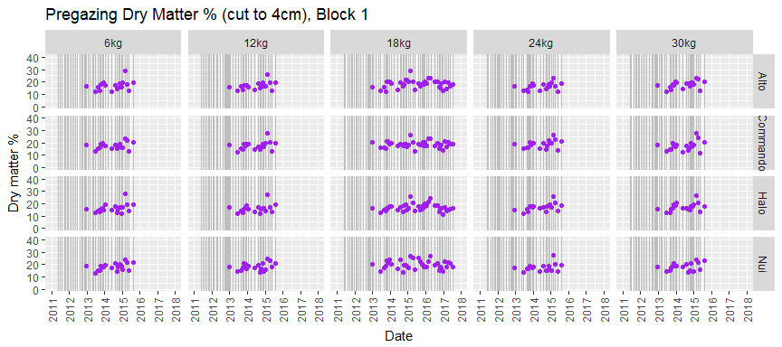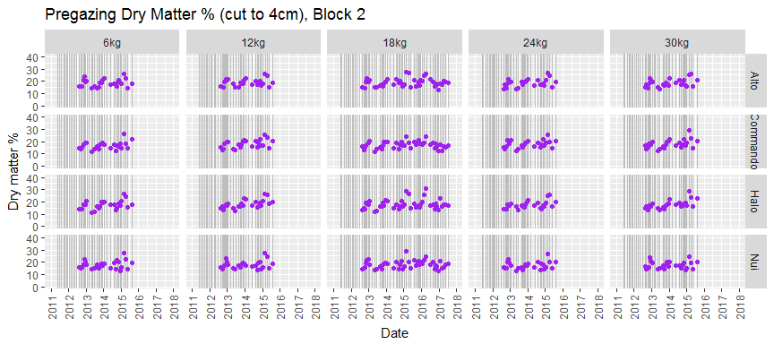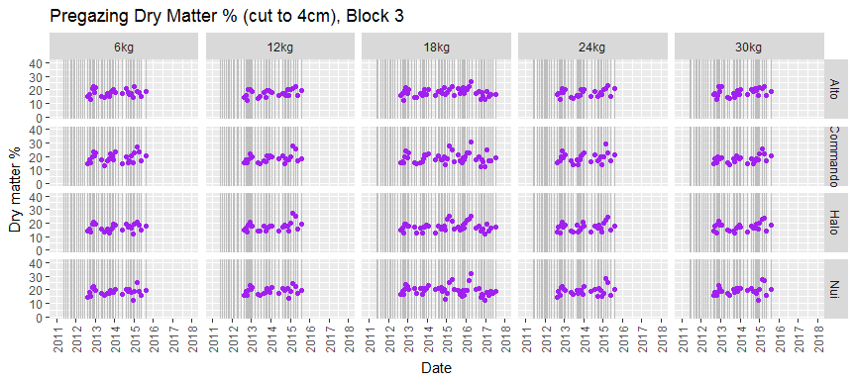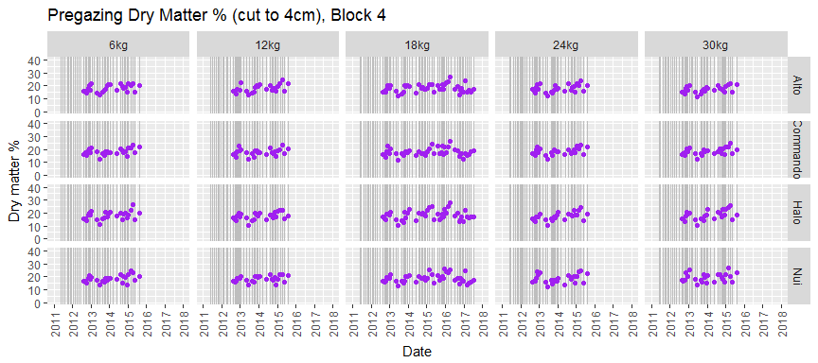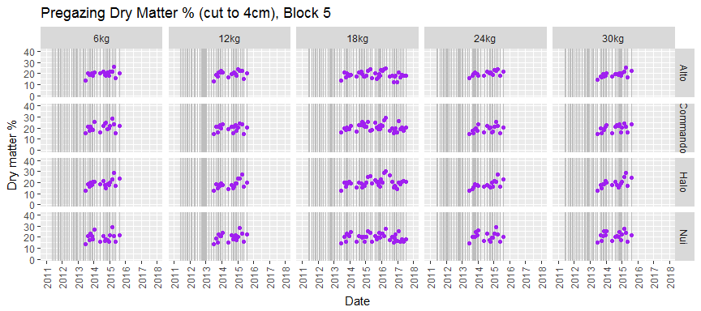

## Tiller Density

# read and plot tiller data  
data_till <- read_xlsx(file_name, sheet='Tiller density data Waikato')  
names(data_till) <- ensnakeify(names(data_till))  
  
# rename useful variables  
data_till <- data_till %>%  
 mutate(seed_rate = factor(seed_rate, levels=seed_rate_levels)) %>%  
 rename(  
 date = date_d,  
 tillers = ryegrass_tiller_density_tillers_m2  
 ) %>%  
 group_by(block, cultivar, seed_rate, date) %>%  
 summarise(mean_tillers = mean(tillers))  
  
# plot tiller data ~(mg~L^{-1})  
ybreaks <- seq(0, round_any(max(data_till$mean_tillers, na.rm=TRUE), 2500, ceiling), 2500)  
xbreaks <- seq(floor_date(min(data_till$date), "years"),   
 ceiling_date(max(data_till$date), "years"), by="1 year")  
data_till %>%  
 split(.$block) %>%  
 map(~ggplot(.) +  
 labs(x='Date', y='Tiller density'~(tillers~m^{2}),   
 title=paste('Tiller Density, Block', unique(.$block))) +  
 theme(axis.text.x=element_text(angle=90, vjust=0.5, hjust=1)) +  
 geom_vline(data=data_rpm, mapping=aes(xintercept=date_grazed), colour='grey') +  
 geom_point(mapping=aes(x=date, y=mean_tillers), colour='darkgreen') +  
 facet_grid(cultivar ~ seed_rate ) +  
 scale_x_datetime(breaks=xbreaks, labels=year(xbreaks), limits=c(xbreaks[1], tail(xbreaks, 1))) +  
 scale_y_continuous(breaks=ybreaks,   
 limits=c(ybreaks[1], round_any(max(data_till$mean_tillers, na.rm=TRUE), 1000, ceiling)))  
 )

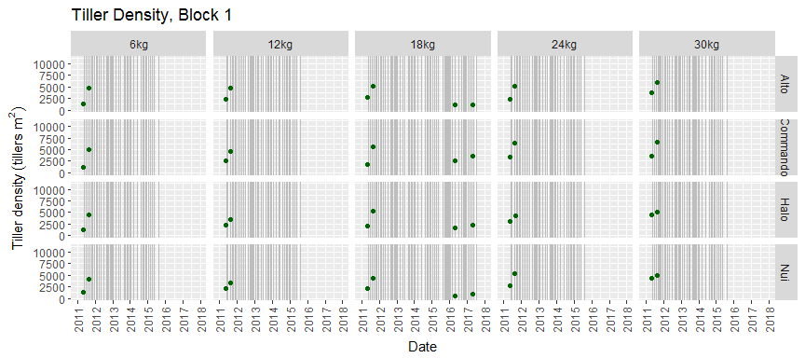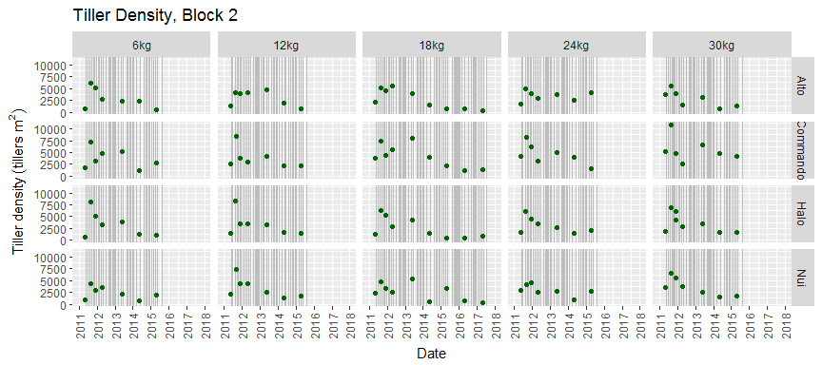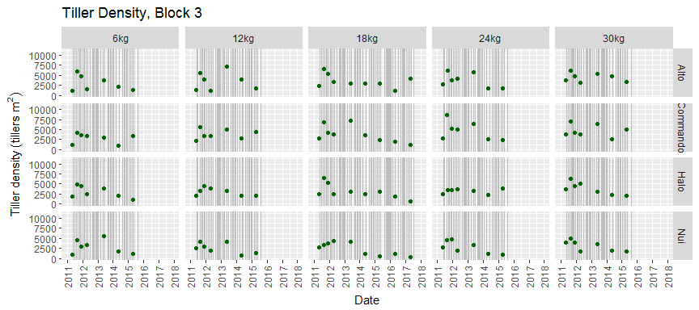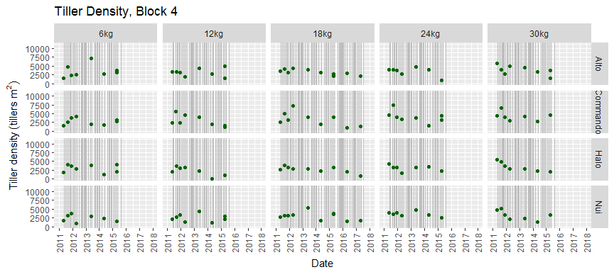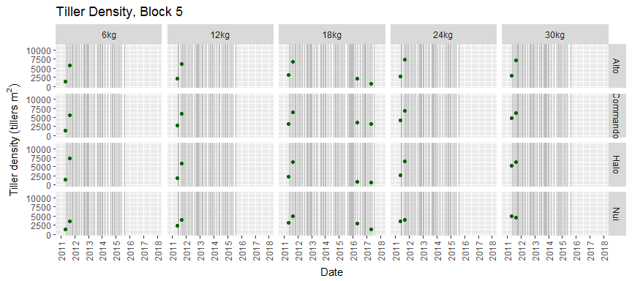

## Botanical Composition

# read botanical data. Skip blank line at top  
data_bot <- read_xlsx(file_name, sheet='Botanical Composition data ', skip=1)  
names(data_bot) <- ensnakeify(names(data_bot))  
  
# rename useful variables  
data_bot <- data_bot %>%  
 mutate(seed_rate = factor(seed_rate, levels=seed_rate_levels)) %>%  
 rename(  
 date = date_d,  
 leaf = perennial_ryegrass_leaf,  
 stem = perennial_ryegrass_reproductive_stem,  
 ann = annual_ryegrass,  
 wc = white_clover,  
 poa = poa_sp,  
 ogx = other_grasses_excluding_poa,  
 og = other_grasses_including_poa,  
 weed = weeds,  
 dead = dead  
 ) %>%  
 mutate(  
 total = leaf + stem + ann + wc + og + weed + dead, # should always be 100  
 month = month(dmy(paste('01', month, '2011')))  
 ) %>%  
 select(leaf, stem, ann, wc, og, weed, dead, date, total, block, seed_rate, cultivar)   
   
# gather  
data_bot2 <- data_bot %>%  
 gather(leaf, stem, ann, wc, og, weed, dead, key='species', value='fraction') %>%  
 mutate(species = factor(species,   
 levels=c('leaf', 'stem', 'ann', 'og', 'wc', 'weed', 'dead')))  
  
# plot botanical data  
ybreaks <- seq(0, 100, 20)  
xbreaks <- seq(floor_date(min(data_bot2$date), "years"),   
 ceiling_date(max(data_bot2$date), "years"), by="1 year")  
data_bot2 %>%  
 split(.$block) %>%  
 map(~ggplot(.) +  
 labs(x='Date', y='Dry weight %', fill='Species',  
 title=paste('Botanical composition (cut to 4cm), Block', unique(.$block))) +  
 theme(axis.text.x=element_text(angle=90, vjust=0.5, hjust=1)) +  
 geom_bar(mapping=aes(x=date, y=fraction, fill=species), stat='identity') +  
 scale_fill_brewer(palette='Paired') +  
 facet_grid(cultivar ~ seed_rate ) +  
 scale_x_datetime(breaks=xbreaks, labels=year(xbreaks), limits=c(xbreaks[1], tail(xbreaks, 1))) +  
 scale_y_continuous(breaks=ybreaks, limits=c(ybreaks[1], tail(ybreaks, 1)))  
 )

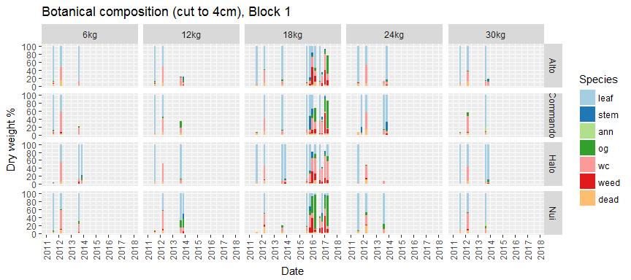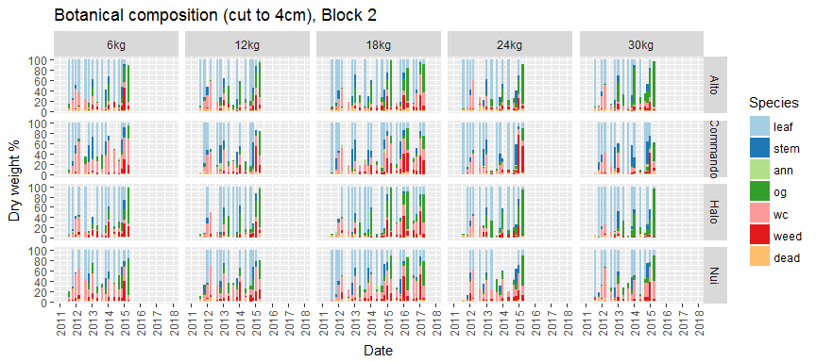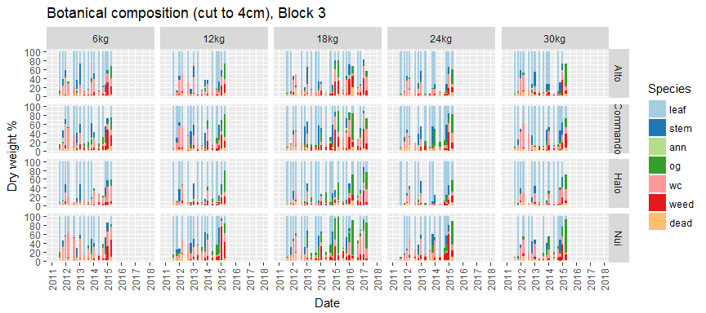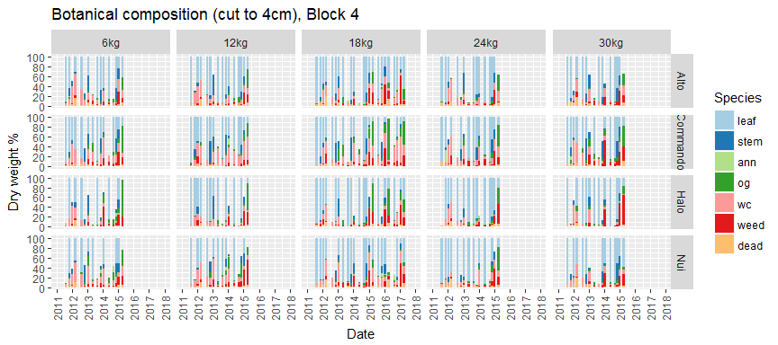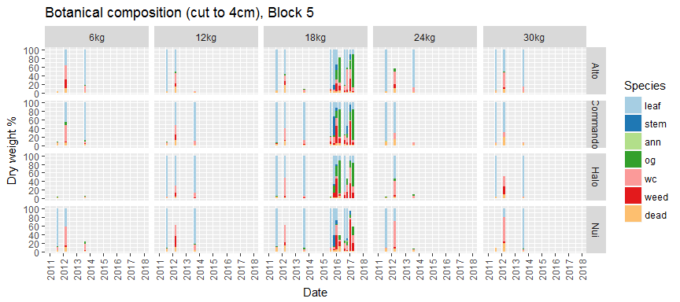

## Estimate Botancial Mass

# total mass on botanical date is estimate by linear extrapolation of rpm data  
# it's not clear how best to extrapolate botanical % above 4 cm to botancial mass above ground  
# find cut matching botanical data  
data_bot$date_cut_i <- lapply(data_bot$date, closest_date_cut)  
data_bot$date_cut <- date_cut[unlist(data_bot$date_cut_i)]  
  
# join cut and botanical data by date_cut  
data_cut$date_cut <- data_cut$date  
data_bm <- data_bot %>%  
 rename(date_bot = date) %>%  
 left_join(data_cut, by=c('date_cut', 'block', 'seed_rate', 'cultivar')) %>%  
 select(date_bot, date_cut, block, seed_rate, cultivar, leaf, stem, ann, wc, og, weed, dead,   
 yield, below, growth_rate_pre) %>%  
 rename(yield_cut = yield) %>%  
 mutate(  
 delay = as.integer(as.Date(date_bot) - as.Date(date_cut)),  
 yield_bot = yield_cut + below + growth_rate_pre * delay # assumed on date_bot, including below mass?  
 )  
   
# gather  
data_bm2 <- data_bm %>%  
 gather(leaf, stem, ann, wc, og, weed, dead, key='species', value='fraction') %>%  
 mutate(  
 species = factor(species, levels=c('leaf', 'stem', 'ann', 'og', 'wc', 'weed', 'dead')),  
 species_mass = fraction / 100 * yield_bot # include mass below cutting?  
 )   
  
# plot botanical data  
ybreaks <- seq(0, round_any(max(data_bm2$yield_bot, na.rm=TRUE), 1000, ceiling), 1000)  
xbreaks <- seq(floor_date(min(data_bm2$date_cut), "years"),   
 ceiling_date(max(data_bm2$date_cut), "years"), by="1 year")  
data_bm2 %>%  
 split(.$block) %>%  
 map(~ggplot(.) +  
 labs(x='Date', y='Dry weight (kgDM/ha)', fill='Species',  
 title=paste('Herbage Mass Fractions (above 4cm), Block', unique(.$block))) +  
 theme(axis.text.x=element_text(angle=90, vjust=0.5, hjust=1)) +  
 geom_point(mapping=aes(x=date_cut, y=yield_bot), colour='grey', size=2, shape=1) +  
 geom_bar(mapping=aes(x=date_cut, y=species_mass, fill=species), stat='identity') +  
 scale_fill_brewer(palette='Paired') +  
 facet_grid(cultivar ~ seed_rate ) +  
 scale_x_datetime(breaks=xbreaks, labels=year(xbreaks), limits=c(xbreaks[1], tail(xbreaks, 1))) +  
 scale_y_continuous(breaks=ybreaks, limits=c(ybreaks[1],   
 round_any(max(data_bm2$yield_bot, na.rm=TRUE), 100, ceiling)))  
 )

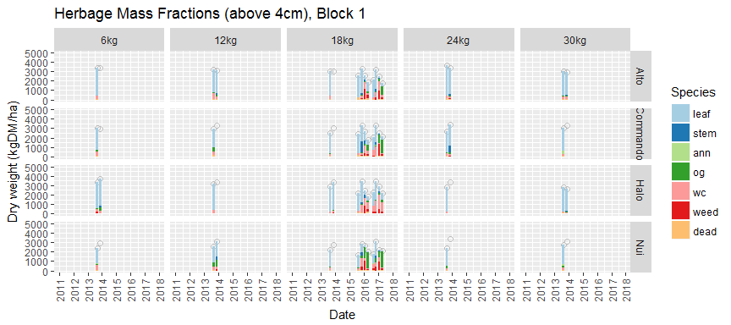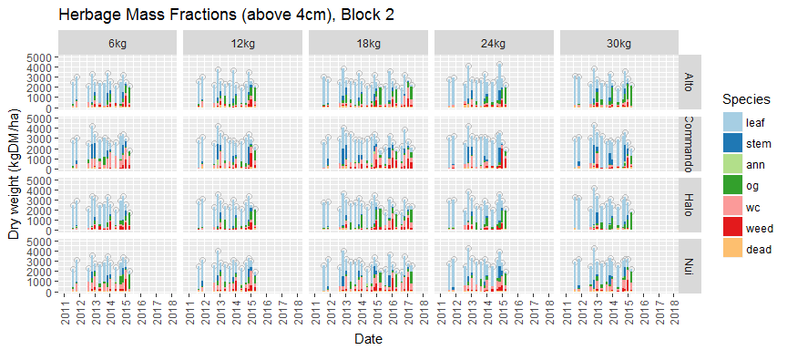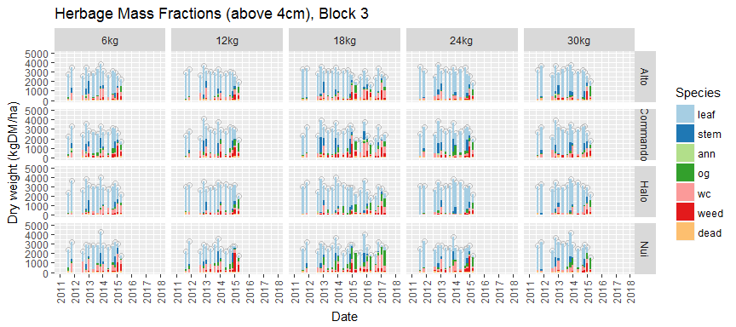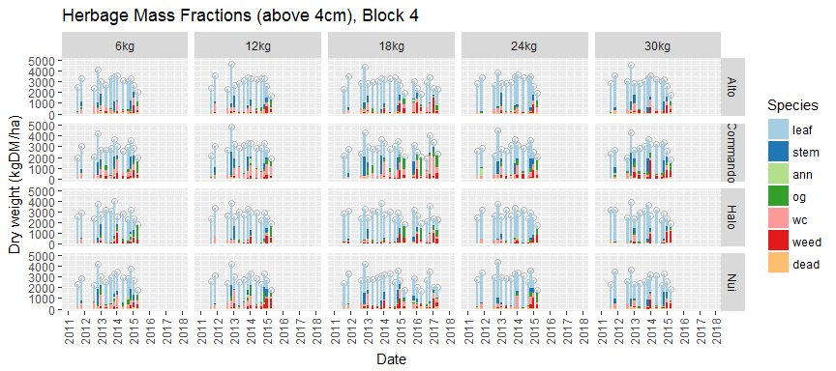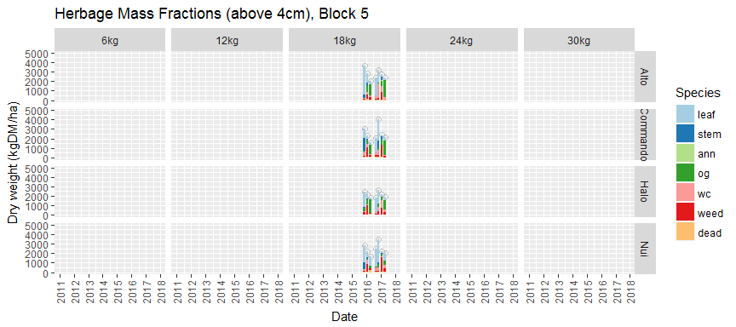

## Light Interception

# read and plot li data  
data_li <- read_xlsx(file_name, sheet='Waikato LightInterception')  
names(data_li) <- ensnakeify(names(data_li))  
  
# rename useful variables  
data_li <- data_li %>%  
 mutate(  
 block = floor((plot-1)/20)+1, # this needs to be checked   
 seed_rate = factor(seed_rate, levels=seed_rate_levels)  
 ) %>%  
 rename(  
 date = date,  
 date_grazed = date_last_grazed,  
 li = light_interception  
 ) %>%  
 select(date, block, seed_rate, cultivar, li, date_grazed)  
  
# plot light interception data  
ybreaks <- seq(0, round_any(max(data_li$li, na.rm=TRUE), 25, ceiling), 25)  
xbreaks <- seq(floor_date(min(data_li$date), "months"),   
 ceiling_date(max(data_li$date), "months"), by="1 month")  
data_li %>%  
 split(.$block) %>%  
 map(~ggplot(.) +  
 labs(x='Date', y='Light interception %',   
 title=paste('Light Interception 2011, Block', unique(.$block))) +  
 theme(axis.text.x=element_text(angle=90, vjust=0.5, hjust=1)) +  
 geom_vline(data=data_rpm, mapping=aes(xintercept=date_grazed), colour='grey') +  
 geom_point(mapping=aes(x=date, y=li), colour='magenta') +  
 facet_grid(cultivar ~ seed_rate ) +  
 scale_x_datetime(breaks=xbreaks, labels=format(xbreaks, "%b-%Y"), limits=c(xbreaks[1], tail(xbreaks, 1))) +  
 scale_y_continuous(breaks=ybreaks, limits=c(ybreaks[1], tail(ybreaks, 1)))  
  
 )

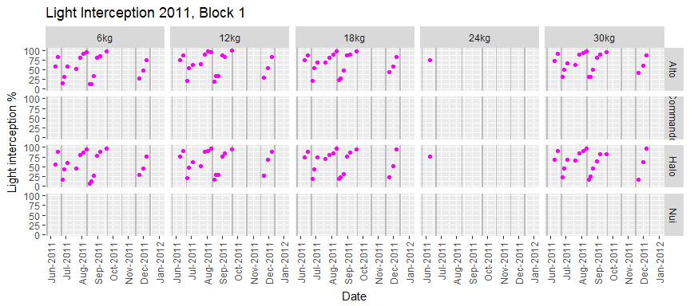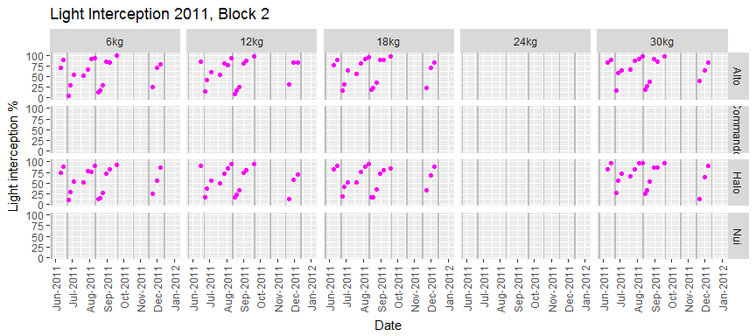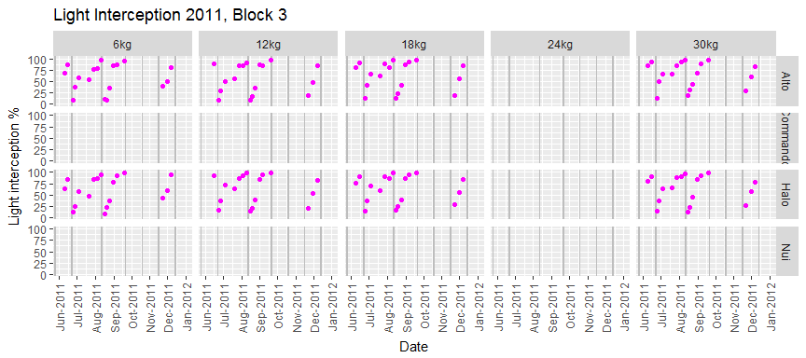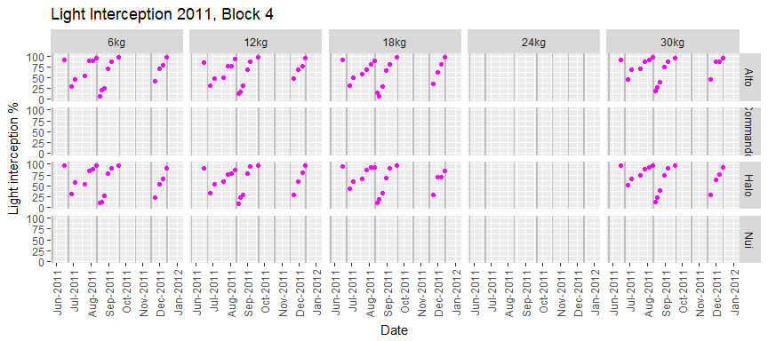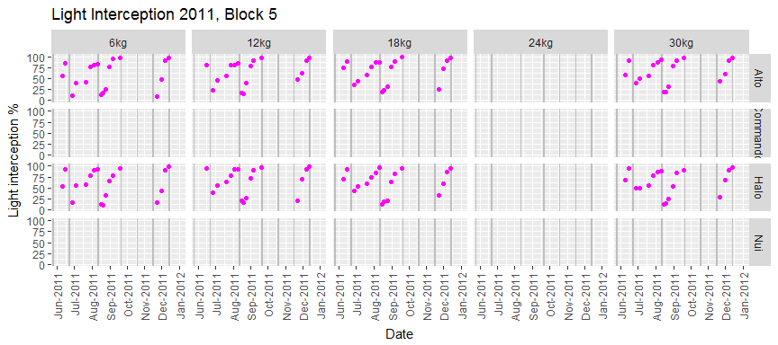

## Soil Moisture

# read and plot soil moisture data  
data_sm <- read_xlsx(file_name, sheet='Soil moisture data')  
names(data_sm) <- ensnakeify(names(data_sm))  
  
# rename useful variables  
data_sm <- data_sm %>%  
 mutate(seed_rate = factor(seed_rate, levels=seed_rate_levels)) %>%  
 rename(  
 date = date_measured_d,  
 sm = soil_moisture  
 ) %>%  
 group_by(block, cultivar, seed_rate, date) %>%  
 summarise(mean_sm = mean(sm))  
  
# plot sol moisture data  
ybreaks <- seq(0, round_any(max(data_sm$mean_sm, na.rm=TRUE), 20, ceiling), 20)  
xbreaks <- seq(floor_date(min(data_sm$date), "months"),   
 ceiling_date(max(data_sm$date), "months"), by="1 month")  
data_sm %>%  
 split(.$block) %>%  
 map(~ggplot(.) +  
 labs(x='Date', y='Soil Moisture %',   
 title=paste('Soil Moisture 2017, Block', unique(.$block))) +  
 theme(axis.text.x=element_text(angle=90, vjust=0.5, hjust=1)) +  
 geom_vline(data=data_rpm, mapping=aes(xintercept=date_grazed), colour='grey') +  
 geom_point(mapping=aes(x=date, y=mean_sm), colour='blue') +  
 facet_grid(cultivar ~ seed_rate ) +  
 scale_x_datetime(breaks=xbreaks, labels=format(xbreaks, "%b-%Y"), limits=c(xbreaks[1], tail(xbreaks, 1))) +  
 scale_y_continuous(breaks=ybreaks, limits=c(ybreaks[1], tail(ybreaks, 1)))  
  
 )

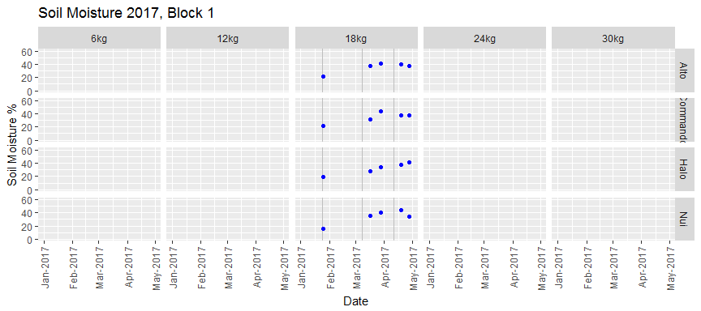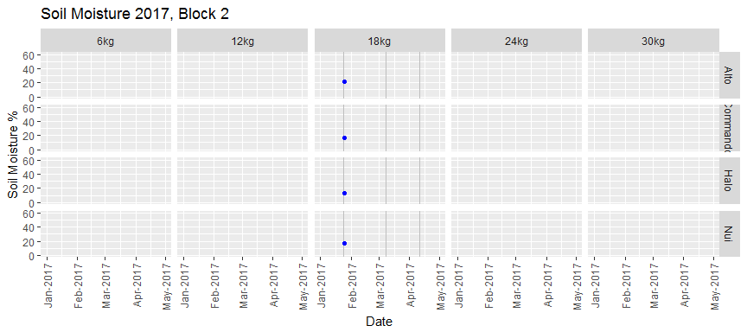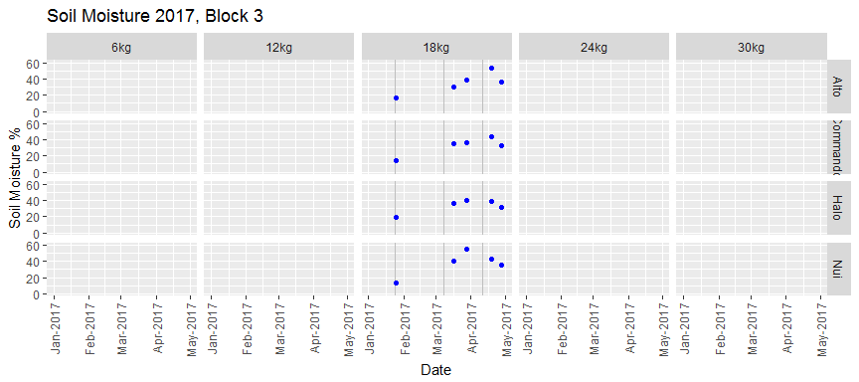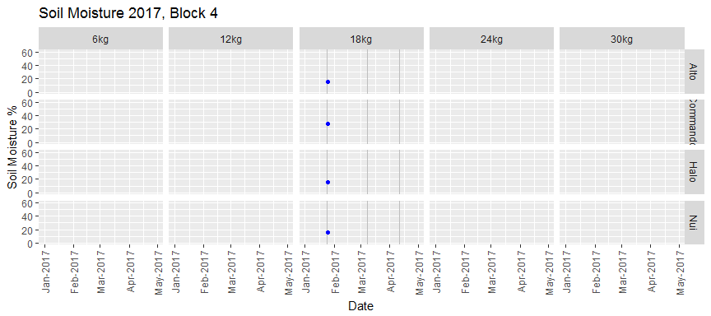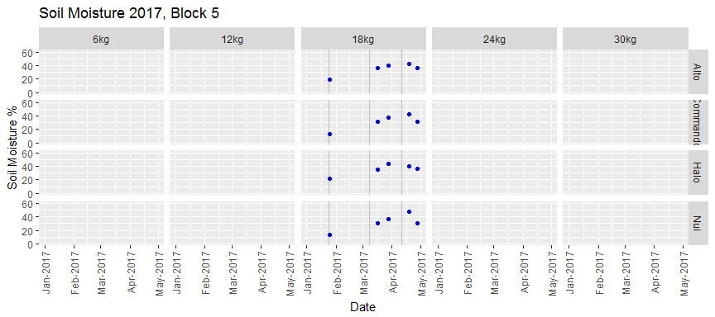

## Calculations

# additional calculations to prepare data for model calibration  
# move post harvest measurements if on grazing day  
data_rpm$date_post2 <- as.Date(with(data_rpm,  
 ifelse(date_post > date_grazed,   
 as.Date(date_post),   
 as.Date(date_post) + 1)  
 ), origin="1970-01-01")  
  
# some calculations  
data_rpm <- data_rpm %>%  
 mutate(  
 year_pre = year(date_pre),  
 doy_pre = yday(date_pre),  
 year_post = year(date_post2),  
 doy_post = yday(date_post2),  
 year_grazed = year(date_grazed),  
 doy_grazed = yday(date_grazed),   
 days_pre = difftime(date_grazed, date_pre),  
 days_post = difftime(date_post2, date_grazed)  
 )  
  
# choose data  
acultivar <- 'Alto' # only Alto and Halo have light interception data  
aseed_rate <- '18kg'  
ablock <- 3

## Write Harvest Dates

# write harvest dates and harvest % for selected series  
data_h <- data_rpm %>%  
 select(block, seed_rate, cultivar, year_grazed, doy_grazed, harv) %>%  
 filter(block==ablock & seed_rate==aseed_rate & cultivar==acultivar) %>%  
 drop_na()  
days_harvest <- matrix(as.integer(-1), nrow=100, ncol=3) # up to 100 harvests  
days_harvest[1:nrow(data_h),] <- c(data_h$year_grazed, data_h$doy_grazed, data_h$harv)  
write.table(days_harvest, file="harvest_Scott.txt",   
 row.names=FALSE, col.names=FALSE, sep='\t')

## Write Calibration Data

# collect the data in this list  
data_c <- vector("list", 6)   
  
# pre and post mass (but this includes other species!)  
temp <- data_rpm %>%  
 select(block, seed_rate, cultivar, mass_pre, year_pre, doy_pre,   
 mass_post, year_post, doy_post) %>%  
 filter(block==ablock & seed_rate==aseed_rate & cultivar==acultivar)   
# data_c[[1]] <- with(temp, tibble(var='DM', year=year_pre,   
# doy=doy_pre, data=mass_pre/10) %>% drop_na())  
# data_c[[2]] <- with(temp, tibble(var='DM', year=year_post,   
# doy=doy_post, data=mass_post/10) %>% drop_na())  
  
# ryegrass tillers  
temp <- data_till %>%  
 select(block, seed_rate, cultivar, mean_tillers, date) %>%  
 filter(block==ablock & seed_rate==aseed_rate & cultivar==acultivar)   
data_c[[3]] <- with(temp, tibble(var='TILTOT', year=year(date),   
 doy=yday(date), data=mean_tillers) %>% drop_na())  
  
# ryegrass fraction  
temp <- data_bot %>%  
 select(block, seed_rate, cultivar, leaf, stem, date) %>%  
 filter(block==ablock & seed_rate==aseed_rate & cultivar==acultivar)   
# data_c[[4]] <- with(temp, tibble(var='CSTP', year=year(date),   
# doy=yday(date), data=stem/(leaf+stem)*100) %>% drop_na())  
  
# ryegrass mass (total or above cutting height? depending on definition of yield_bot)  
temp <- data_bm %>%  
 rename(date = date_cut) %>%  
 select(block, seed_rate, cultivar, leaf, stem, yield_bot, date) %>%  
 filter(block==ablock & seed_rate==aseed_rate & cultivar==acultivar)   
data_c[[4]] <- with(temp, tibble(var='CLV', year=year(date),   
 doy=yday(date), data=leaf/100*yield_bot/10) %>% drop_na())  
data_c[[5]] <- with(temp, tibble(var='CST', year=year(date),   
 doy=yday(date), data=stem/100*yield_bot/10) %>% drop_na())  
  
# light interception (but this includes all species!)  
temp <- data_li %>%  
 select(block, seed_rate, cultivar, li, date) %>%  
 filter(block==ablock & seed_rate==aseed_rate & cultivar==acultivar)   
# data_c[[5]] <- with(temp, tibble(var='LINT', year=year(date),   
# doy=yday(date), data=li) %>% drop_na())  
  
# soil moisture  
temp <- data_sm %>%  
 select(block, seed_rate, cultivar, mean_sm, date) %>%  
 filter(block==ablock & seed_rate==aseed_rate & cultivar==acultivar)   
data_c[[6]] <- with(temp, tibble(var='WCL', year=year(date),   
 doy=yday(date), data=mean_sm) %>% drop_na())  
  
# bind list and write file  
data_calib <- bind_rows(data_c)  
data_calib <- arrange(data_calib, var, year, doy)  
write.table(data_calib, file="data_calibration_Scott.txt",   
 row.names=FALSE, col.names=FALSE, sep='\t', quote=FALSE)