Northland Data

Simon Woodward, DairyNZ 2018

## Lincoln Data

# file name  
file_name <- 'FD1004_N Data For Modelling.xlsx'  
  
# seed rates in order  
seed_rate_levels <- c('6kg', '12kg', '18kg', '24kg', '30kg')

## Rising Plate Meter

Average pre-graze mass = 2765

Average post-graze mass = 1592

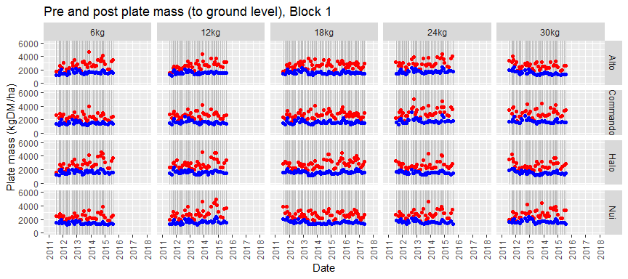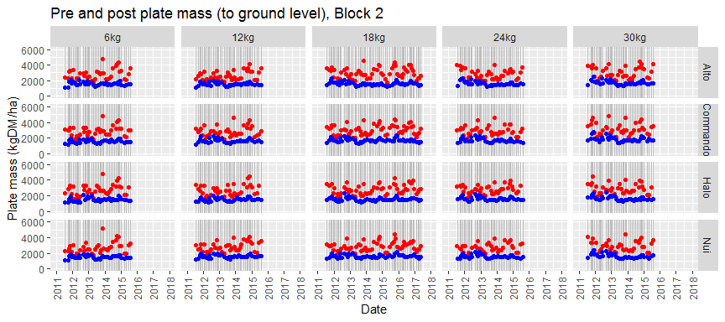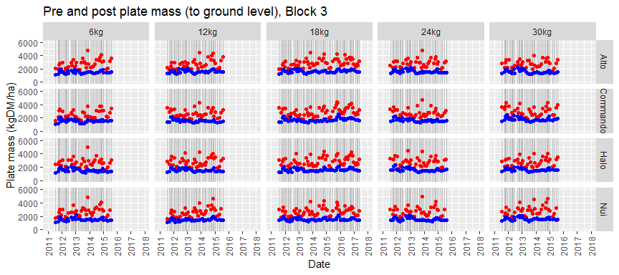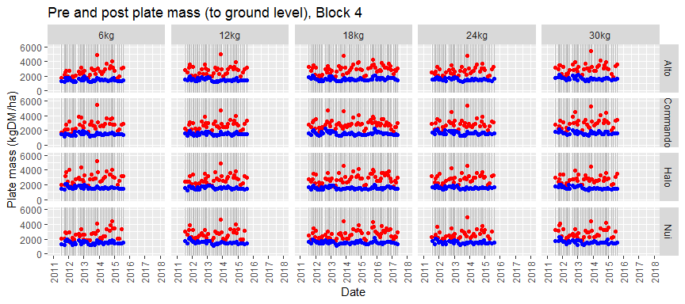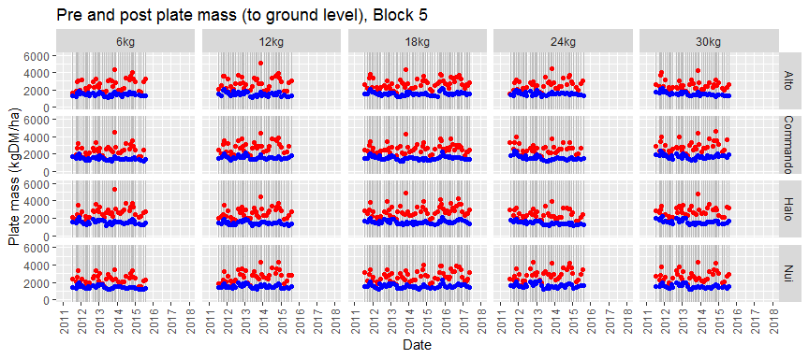

## Rising Plate Meter Growth Rate

### Assumptions

* Growth rate calculated from RPM data and assumed constant between grazings.

Average growth rate = 37

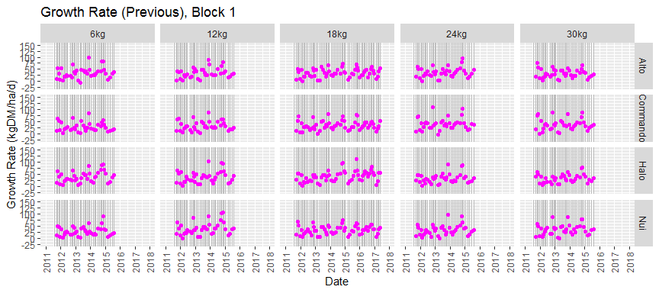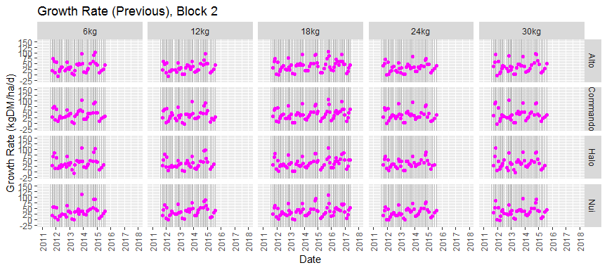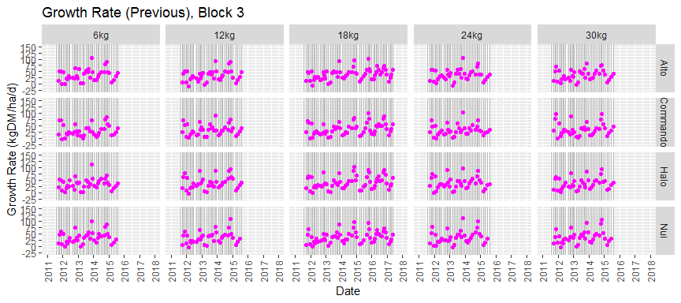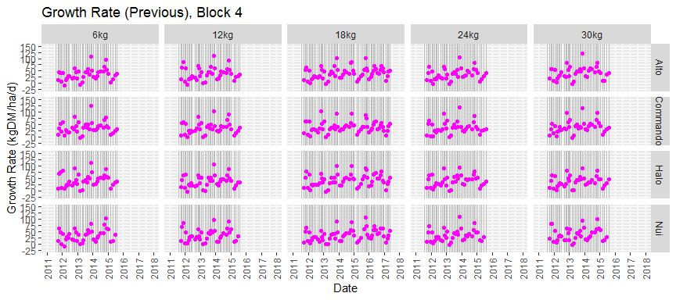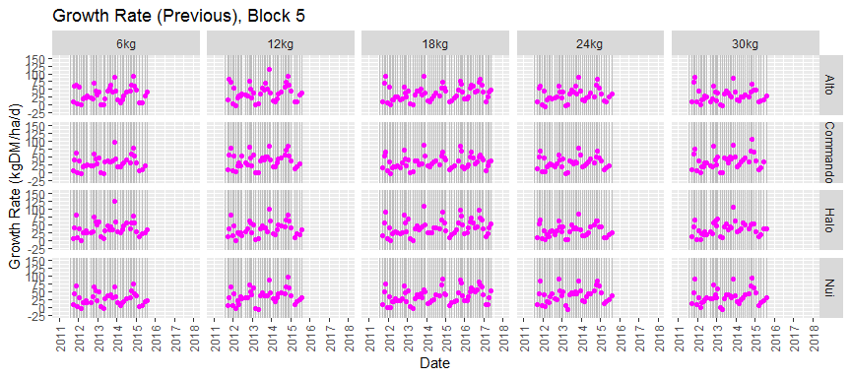

## Rising Plate Meter Harvest %

### Assumptions

* Assume no pasture growth between pre and post RPM.

Average harvest % = 39

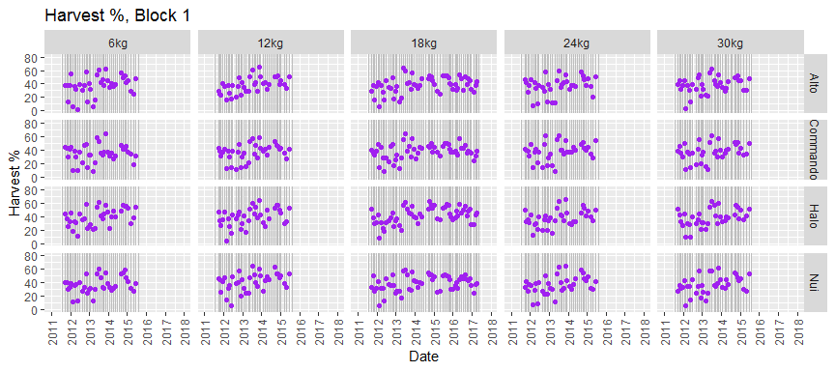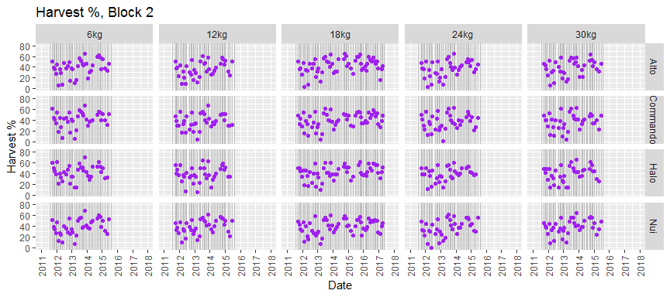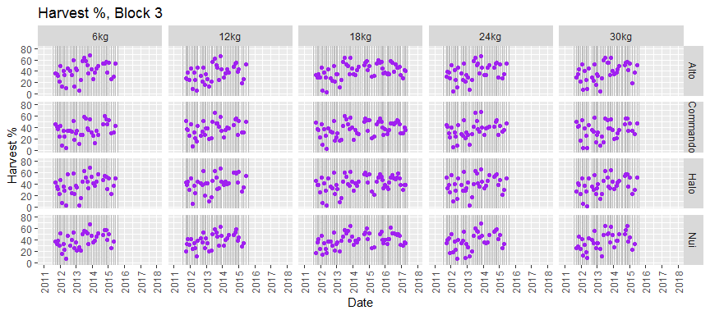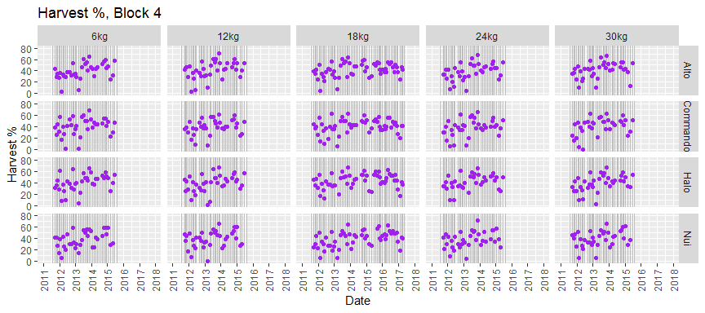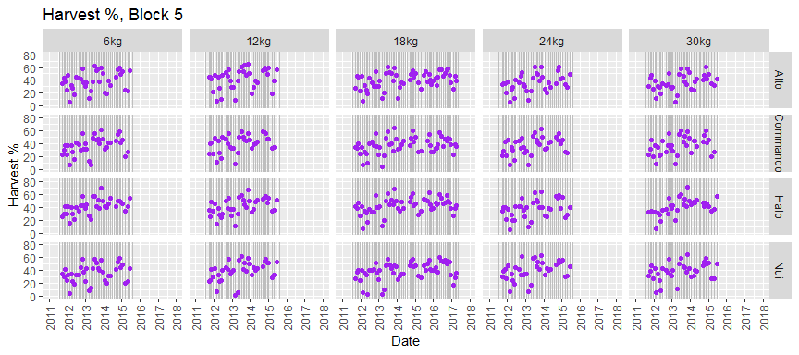

## Pasture Cut Mass

Average cut mass = 1557

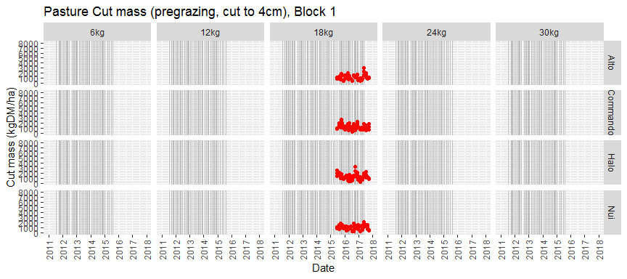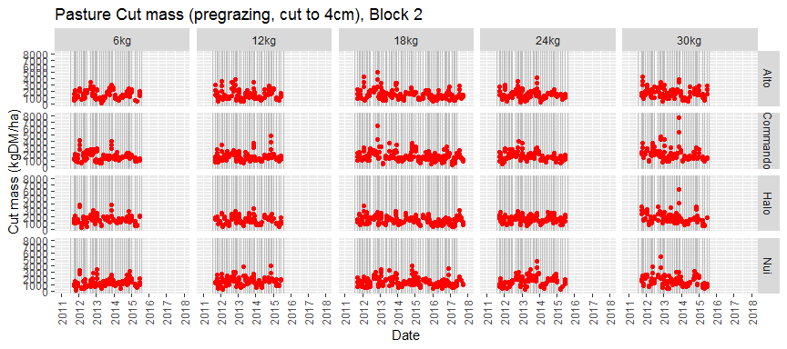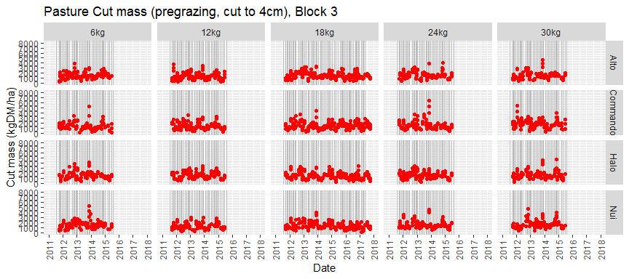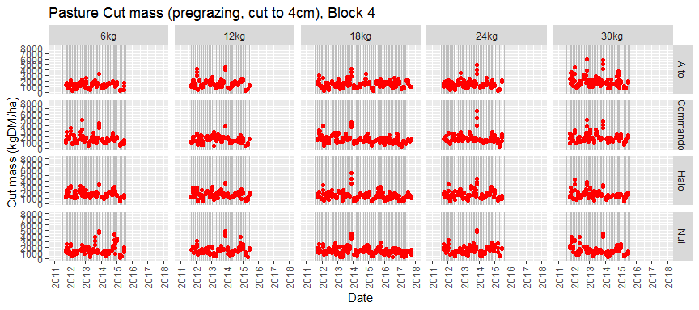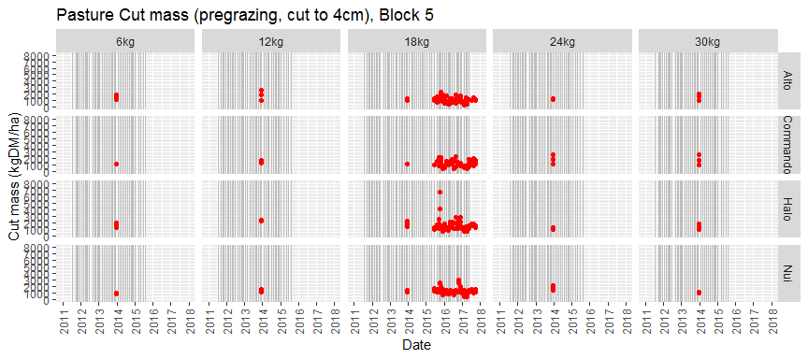

## Estimate Mass Below Cutting Height

### Assumptions

* Total mass at cutting assumed to be equal to pregraze RPM.

Average mass below cutting estimate = 1262

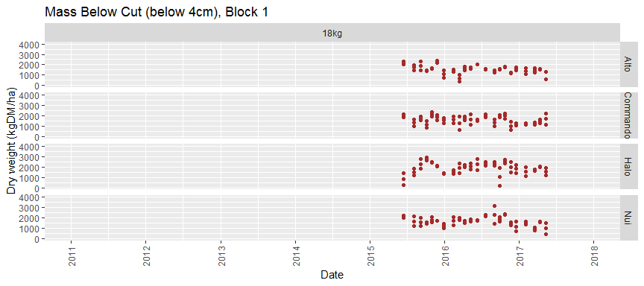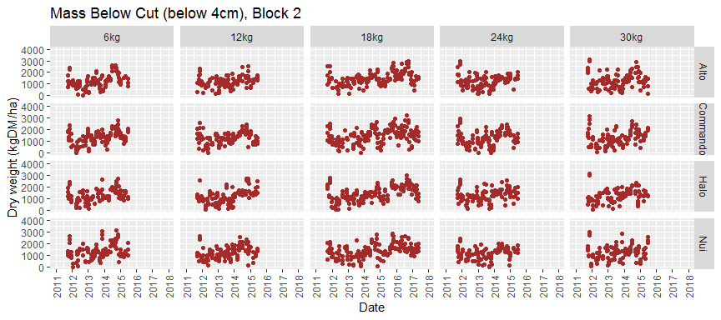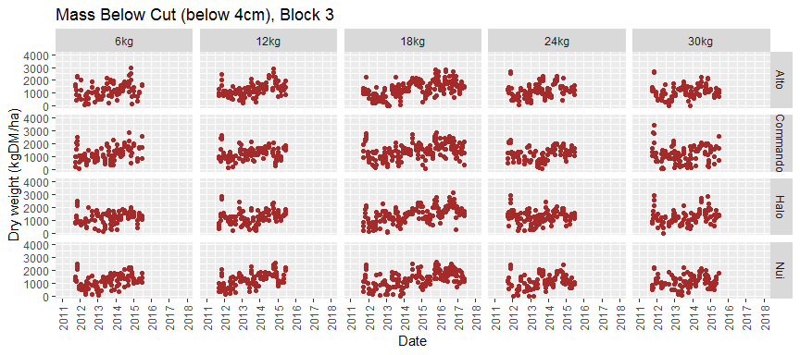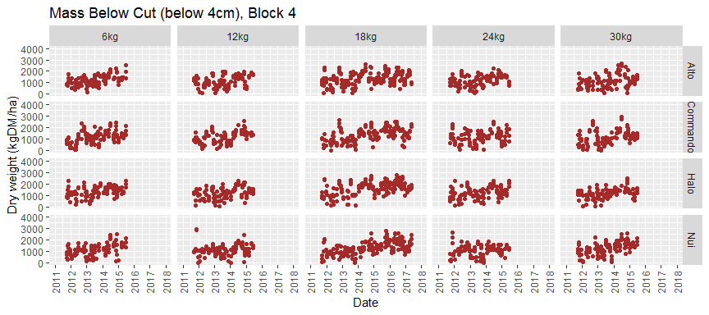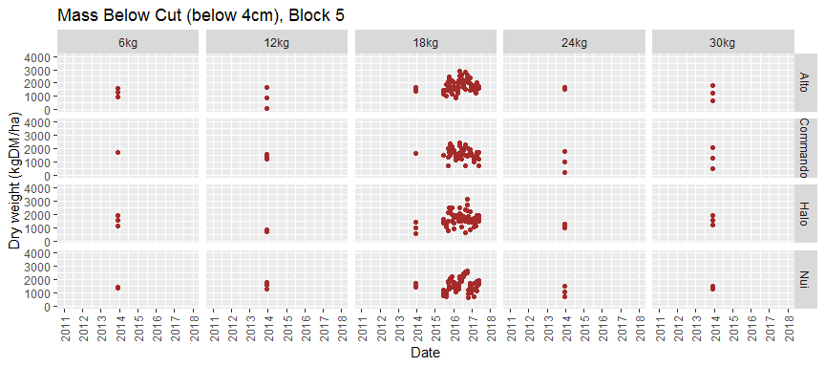

## Pasture Cuts DM%

Average cut dry matter % = 20

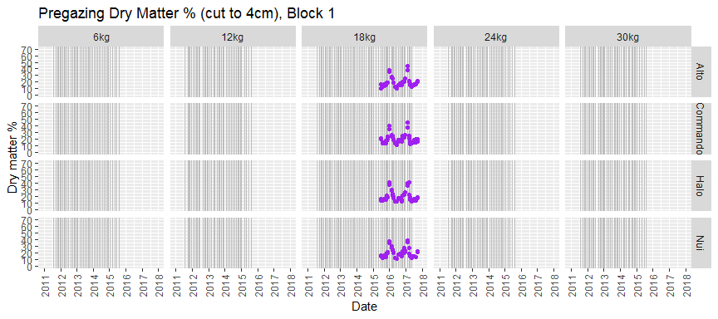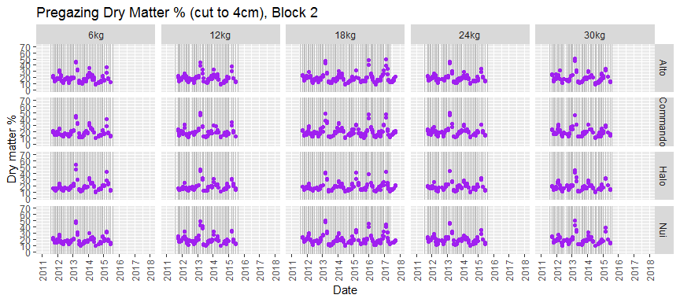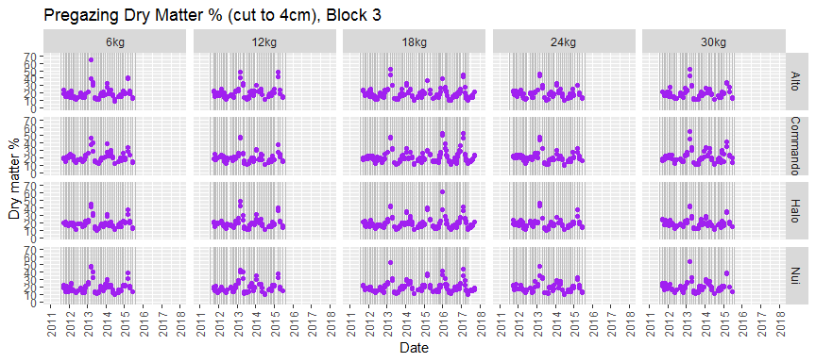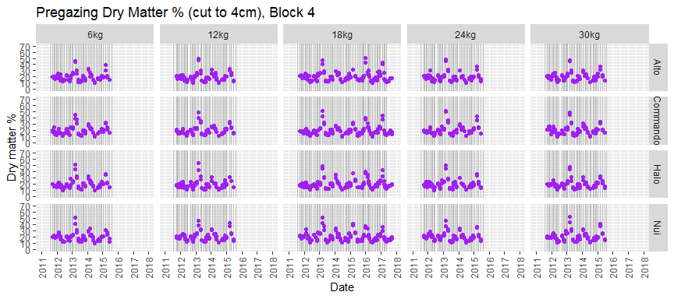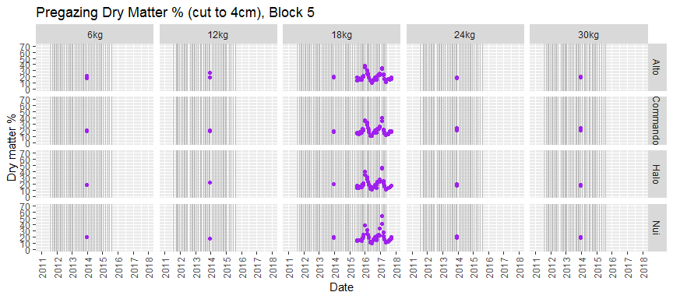

## Tiller Density

Average tiller density = 3688

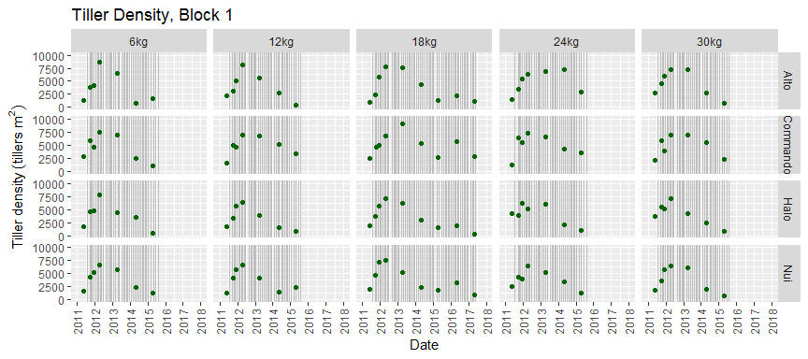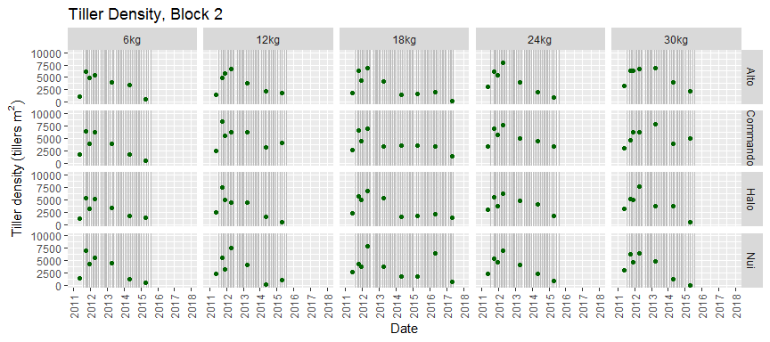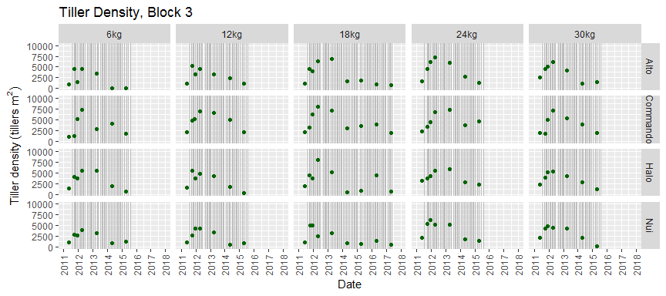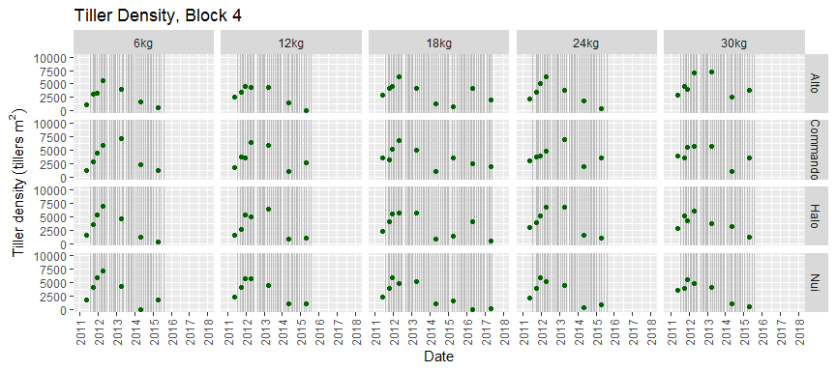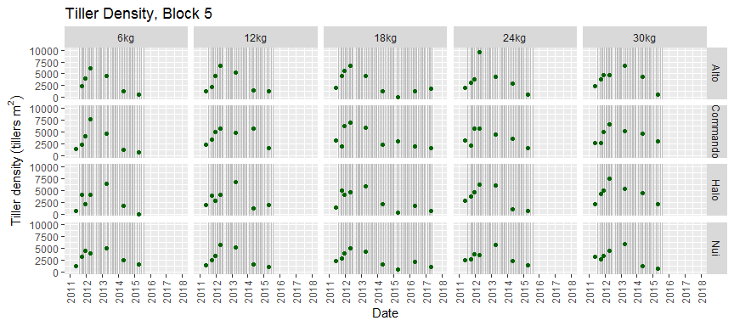

## Botanical Composition

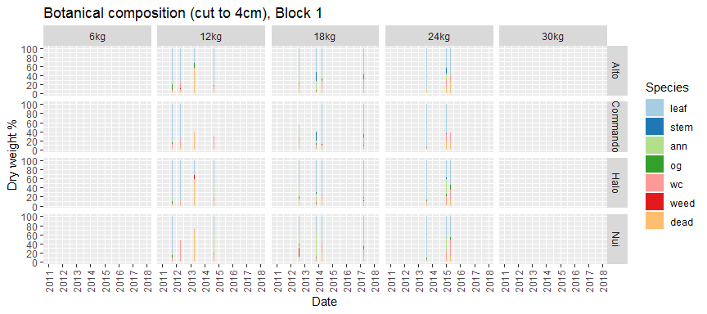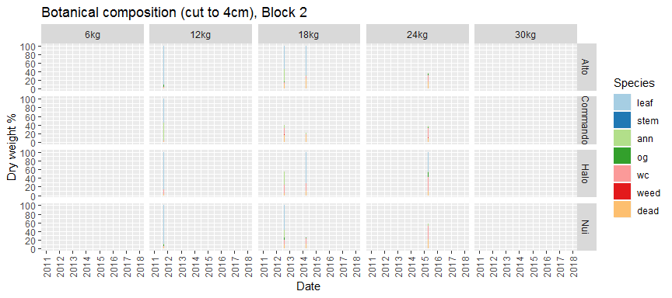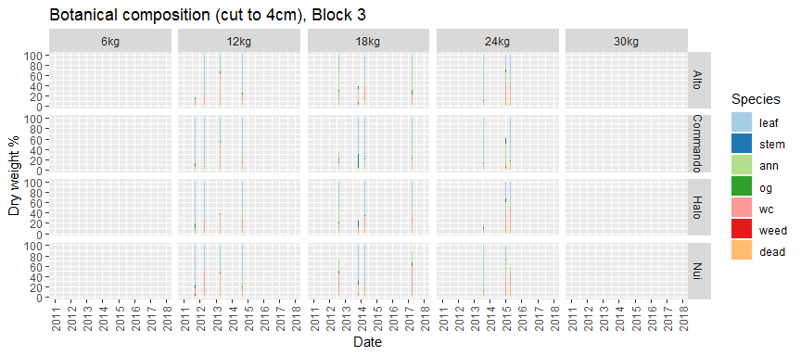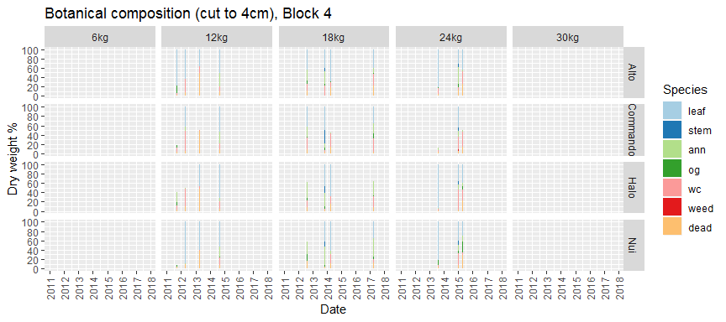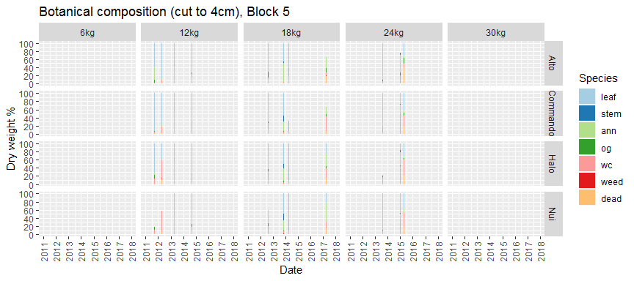

## Ryegrass Fraction

### Assumptions

* Ryegrass fraction calculated on green mass only.

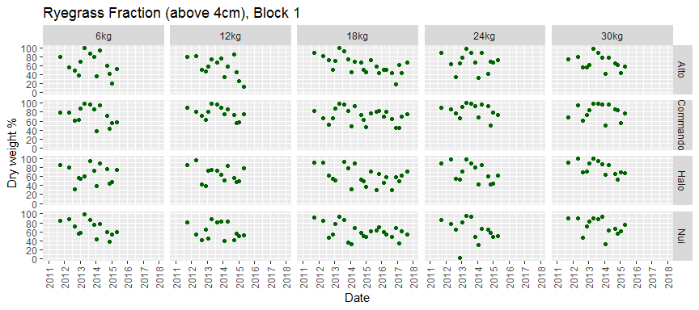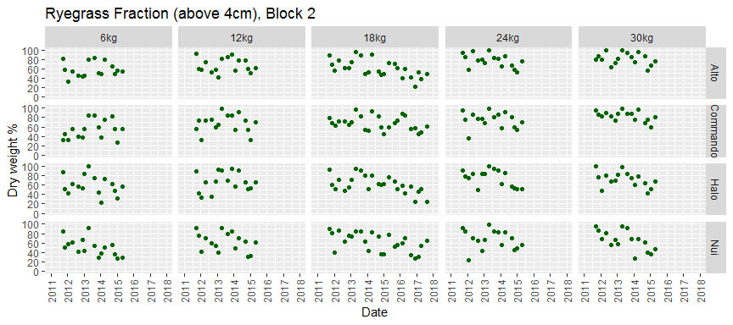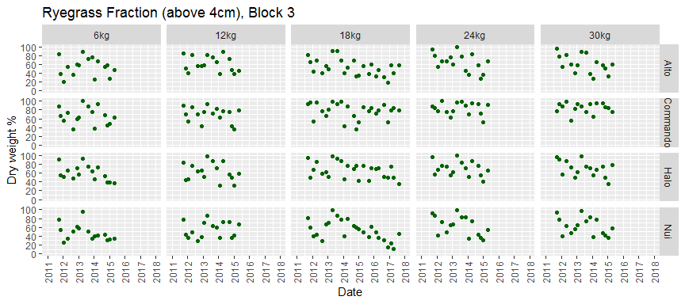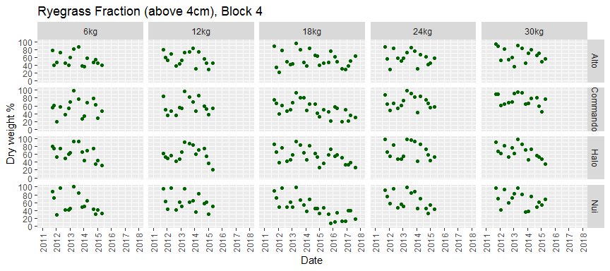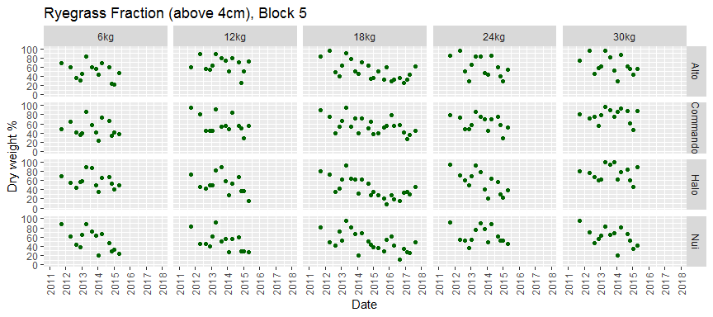

## Estimate Botancial Mass

### Assumptions

* Total mass at botanical date assumed to be equal to pregraze RPM.
* Botanical composition below cutting height estimated from Tozer data.

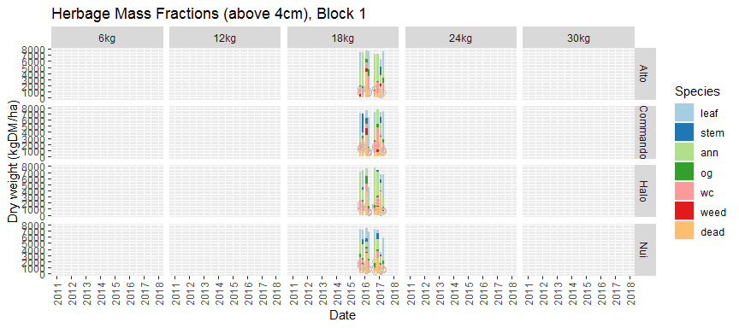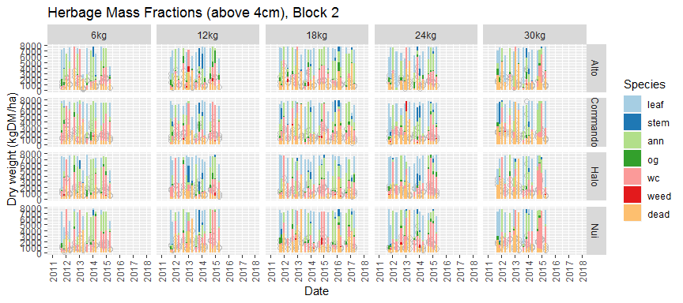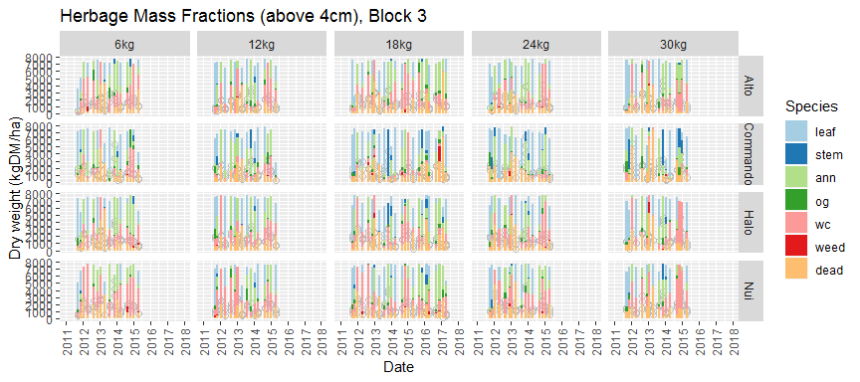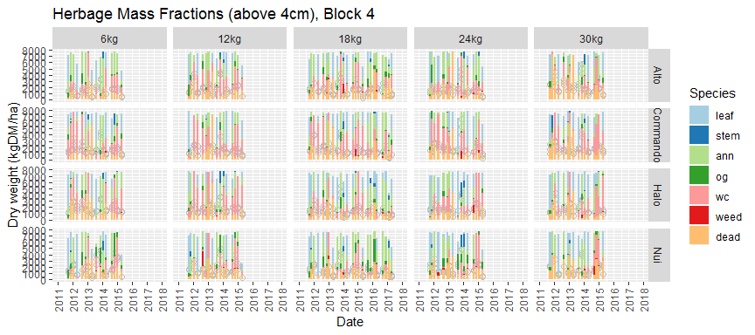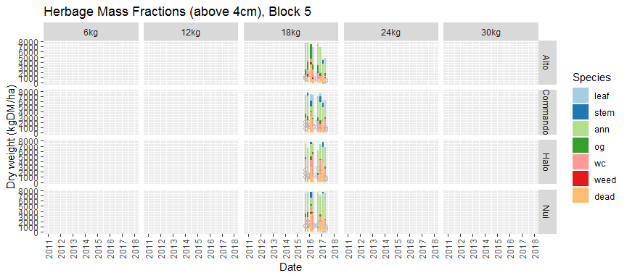

## Write Harvest Dates

# choose data  
acultivar <- 'Alto' # only Alto and Halo have light interception data  
aseed_rate <- '18kg'  
calib_start <- ymd("20110101") # period for data weight = 1  
calib_end <- ymd("20140531") # period for data weight = 1  
ablock <- 3  
  
for (ablock in c(1,2,3,4,5)) { # loop through data sets  
  
# write harvest dates and harvest % for selected series  
file_name <- paste("harvest_Northland_", ablock, ".txt", sep="")  
data_h <- data_rpm %>%  
 select(block, seed_rate, cultivar, year_grazed, doy_grazed, harv) %>%  
 filter(block == ablock & seed_rate==aseed_rate & cultivar==acultivar) %>%  
 drop_na()  
days_harvest <- matrix(as.integer(-1), nrow=100, ncol=3) # up to 100 harvests  
days_harvest[1:nrow(data_h),] <- c(data_h$year_grazed, data_h$doy_grazed, data_h$harv)  
write.table(days_harvest, file=file_name, row.names=FALSE, col.names=FALSE, sep='\t')  
  
# write calibration data  
file_name <- paste("data_calibration_Northland_", ablock, ".txt", sep="")  
  
# collect the data in this list  
data_c <- vector("list", 6)   
  
# pre and post mass (but this includes other species!)  
# temp <- data_rpm %>%  
# select(block, seed_rate, cultivar, mass_pre, year_pre, doy_pre,   
# mass_post, year_post, doy_post) %>%  
# filter(block==ablock & seed_rate==aseed_rate & cultivar==acultivar)   
# data_c[[1]] <- with(temp, tibble(var='DM', year=year_pre,   
# doy=doy_pre, data=mass_pre/10) %>% drop_na())  
# data_c[[2]] <- with(temp, tibble(var='DM', year=year_post,   
# doy=doy_post, data=mass_post/10) %>% drop_na())  
  
# ryegrass tillers  
temp <- data_till %>%  
 select(block, seed_rate, cultivar, mean_tillers, date) %>%  
 filter(block==ablock & seed_rate==aseed_rate & cultivar==acultivar)   
data_c[[3]] <- with(temp, tibble(var='TILTOT', year=year(date),   
 doy=yday(date), data=mean_tillers, sd=400, type="sd",  
 weight=ifelse(((date>=calib_start)&(date<=calib_end)), 1, 0)) %>% drop_na())  
  
# ryegrass mass (total or above cutting height? depending on definition of yield_bot)  
temp <- data_bm %>%  
 rename(date = date_cut) %>%  
 select(block, seed_rate, cultivar, leaf, stem, leaf_below, stem_below, yield_bot, below, date) %>%  
 filter(block==ablock & seed_rate==aseed_rate & cultivar==acultivar)   
data_c[[4]] <- with(temp, tibble(var='CLV', year=year(date),   
 doy=yday(date), data=leaf/100*yield_bot/10*0.45+leaf_below/100*below/10*0.45,   
 sd=10, type="sd",  
 weight=ifelse(((date>=calib_start)&(date<=calib_end)), 1, 0)) %>% drop_na())  
data_c[[5]] <- with(temp, tibble(var='CST', year=year(date),   
 doy=yday(date), data=stem/100*yield_bot/10*0.45+stem_below/100*below/10*0.45,   
 sd=4, type="sd",  
 weight=ifelse(((date>=calib_start)&(date<=calib_end)), 1, 0)) %>% drop_na())  
  
# light interception (but this includes all species!)  
# temp <- data_li %>%  
# select(block, seed_rate, cultivar, li, date) %>%  
# filter(block==ablock & seed_rate==aseed_rate & cultivar==acultivar)   
# data_c[[5]] <- with(temp, tibble(var='LINT', year=year(date),   
# doy=yday(date), data=li) %>% drop_na())  
  
# soil moisture  
# temp <- data_sm %>%  
# select(block, seed_rate, cultivar, mean_sm, date) %>%  
# filter(block==ablock & seed_rate==aseed_rate & cultivar==acultivar)   
# data_c[[6]] <- with(temp, tibble(var='WCL', year=year(date),   
# doy=yday(date), data=mean_sm, sd=2, type="sd",  
# weight=1) %>% drop_na())  
  
# bind list and write file  
data_calib <- bind_rows(data_c)  
data_calib <- arrange(data_calib, var, year, doy)  
write.table(data_calib, file=file_name, row.names=FALSE, col.names=FALSE, sep='\t', quote=FALSE)  
  
} # end data set loop