Meeting Notes
Pillar Deck: Comparing Vic's V4 and Jake's V2
Item | Detail
Meeting date | Tuesday, October 13, 2026 (recording started about 10:24 PM)
Format | Evening working session, walking both deck versions side by side
Attendees | Vic and Jake
Purpose | Compare Vic's V4 deck with Jake's V2 deck after the afternoon review with Kevin, decide what to keep from each, and set up tomorrow's finalization

Note on the transcript
Auto-generated transcript; speakers aren't labeled, but most of it is Vic walking through slides. Slide numbers refer to Vic's V4 unless noted as Jake's. Readings used: RDMGR intake (transcribed "RGMGR"/"RTMGR"), ADA, ORM AI, EGRC, "4 blocker" (Kevin's tracker format).

1. Summary
Vic walked through his V4 deck against Jake's V2 and was happy with where both landed ("I think tomorrow we can bang this out"). Most decisions are deferred to a working session tomorrow, where the goal is to get the messaging, terms, and headlines right, add Ryan's DPC timeline, and check the deck against the second iteration of the meeting notes.
Agreed so far: Pillar 2 takes Jake's name, RDS rationalization (baseline, reconcile, migrate). Pillar 1 needs a clearer name around foundation, tooling, and data plane enablement. Pillar 3 stays demand intake and sourcing. The four sourcing categories should show that legacy sourcing goes to Pillar 2 while strategic, justified tactical, and escalate stay in Pillar 3. From V4, keep the "4 blocker" tracker example; confirm with Kevin whether Jake's ORM roadmap slide stays. Internal slides (rules, staffing) stay hidden at the end.

2. Pillar names
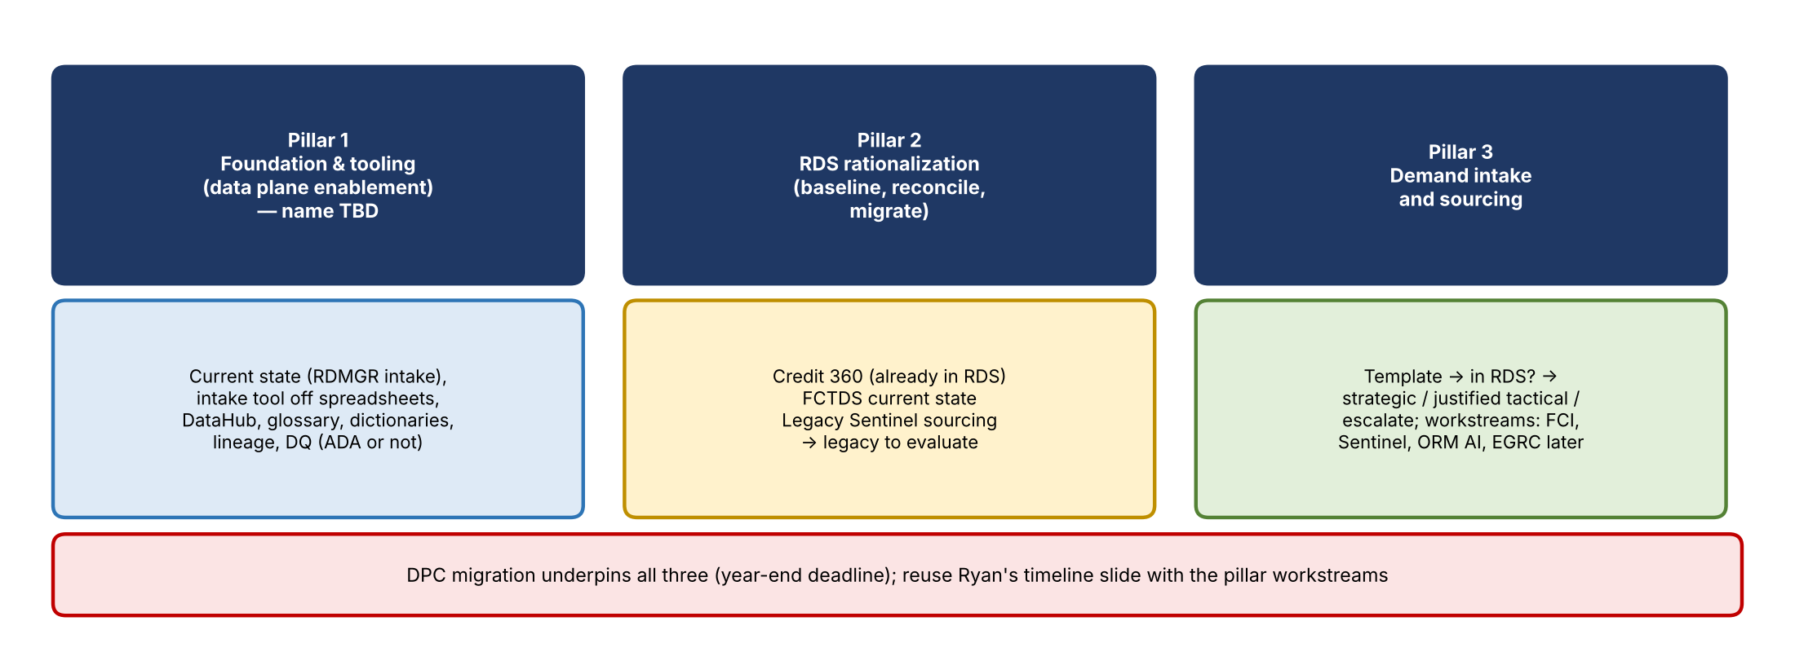
Figure 1. Pillar names and scope as discussed
Pillar | Name direction | What it covers
Pillar 1 | Foundation and tooling / data plane enablement; find a clearer, crisper name | Current state (the RDMGR intake and how it gets updated); bring the Pillar 3 intake request and template into it; intake tool to get off spreadsheets; DataHub, glossary, dictionaries, lineage; DQ capability (ADA or not)
Pillar 2 | Use Jake's: RDS rationalization (baseline, reconcile, migrate) | What's already in RDS
Pillar 3 | Demand intake and sourcing (keep) | New requests through the template; route decisions

3. Slide-by-slide comparison
Topic | Discussion | Outcome
Pillars overview (V4 slide 5 vs. Jake's) | Names as above; "how they connect" is the same in both | Good; update names
Order of work (V4 slide 4) | AI is the last step; data readiness comes first. Check the flow against Jake's version | Revisit tomorrow
Pillars across five phases (V4 slide 6 vs. Jake's slide 5) | Equivalent content | Good
Pillar 1, slide 1 (Jake's 6 / V4 7) | Both say "the tools we need to do the work." "How it works today": requests come through RDMGR intake and Excel; RDS extracts matched with Copilot in Excel; no shared glossary, dictionaries, or lineage, so each analyst starts over. Some lines may not be needed | Revisit tomorrow
Pillar 1, slide 2 | "Pillar 1 starts by assessing what we have today": current tooling, what exists | Revisit tomorrow
Pillar 2, slide 1 | In scope now: Credit 360 (already in RDS), FCTDS current-state analysis, plan moves to strategic sources. Questioned why Sentinel is listed. "One body of work one owner can drive; can start now; Pillar 1 tools make it faster." Jake shows these as examples, which Vic prefers | Update "in scope now"; check the notes on whether to state scope
Pillar 2, slide 2 | Covers Credit 360, FCTDS, and legacy Sentinel. FCTDS's 98 sources aren't the main Pillar 2 coverage. V4's four sourcing categories and the "legacy to evaluate" framing work well | Rework the story; see Section 4
Pillar 3, slide 1 | Template captures elements, purpose, timing; in RDS → map and reuse; not in RDS → identify authoritative source and route. "The lead tells the story"; Kevin decides conditionally justified tactical; "not needed, decline it"; ad hoc asks without a story stay out of future state | Liked
Pillar 3, slide 2 | Requirements must say why and when, not just which elements; requirements carry the scenario so AI pulls only what it needs; identify an authoritative source and validate before use | Clean up tomorrow
Pillar 3, slide 3 | Workstreams per priority use case: FCI, Sentinel, ORM AI, EGRC later; Pillar 2 workstreams; open question for Jacqueline. Jake's bottom "how it works" messaging is better | Use Jake's messaging
Pillar 3, slide 4 / ORM roadmap (Jake's 13) | Jake has the ORM roadmap (baseline now, prioritize, deliver in 2027) inside Pillar 3. V4 separates tracking | Confirm with Kevin whether to keep the roadmap
Tracking the work (V4) | Example ORM AI workstream status in Kevin's "4 blocker" format: summary, progress since last meeting, next steps and due dates, blockers and risks; overall status amber. Also an ORM AI workstream tracker (Jake has one too) | Add the 4-blocker
Proposed use case data sourcing tracker (V4 slide 16) | New in V4 | Decide tomorrow
DPC migration | Underpins all three pillars; year-end deadline; same before and after DPC; how it's tracked; the tools that need to be built go to technology | Jake adapts Ryan's timeline slide with the pillar workstreams
Next steps (Jake's 17–18) | Both decks have them | Keep
Appendix | Where risk data lives today (Kevin liked: ORCAP most control, BUSCRT moving to Credit 360, FCTDS, GenAI); source from the strategic ADS vs. one hop back; open questions | Keep in appendix
Internal hidden slides | Rules, staffing every pillar, etc., struck through at the end of Vic's deck for reference | Keep hidden

4. Sourcing categories and the Pillar 2 story
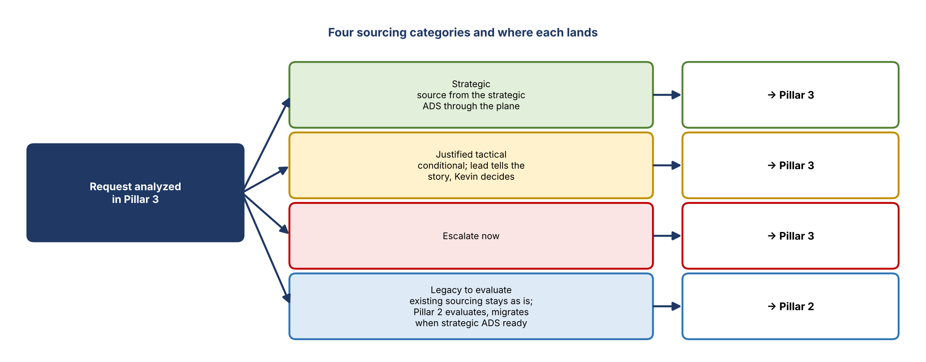
Figure 2. Sourcing categories and where each lands
- V4 lists four sourcing categories: strategic (source from the strategic ADS through the data plane), justified tactical (conditional), escalate now, and legacy to evaluate.
- Legacy to evaluate: existing sourcing stays as is for now; Pillar 2 evaluates it and migrates when a strategic ADS is ready.
- Examples: Credit 360 is already in RDS, so Pillar 2 asks whether the data is still needed and whether it's sourced from the right place. Most Sentinel data was already sourced by financial crimes and is moving into FCTDS, so that existing sourcing is legacy to evaluate.
- Whenever a Pillar 3 request turns out to be existing sourcing being re-plumbed, Pillar 3 routes it to Pillar 2 as legacy to evaluate.
- Vic was unsure about V4's outcome line ("we're not sourcing from System A; here's a plan to source from System B, the strategic ADS"), which may get ahead of itself.
- Tomorrow: rework Pillar 2's second slide so it tells how Pillar 3 hands work to Pillar 2, then how the remaining requests go strategic, justified tactical, or escalate.

5. Working deck outline
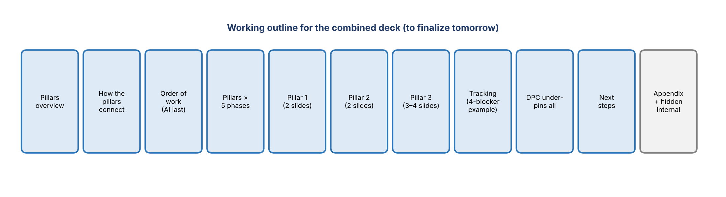
Figure 3. Working outline for the combined deck

6. Plan for tomorrow
- Finalize messaging, terms, and headlines across both decks.
- Settle Pillar 1's name.
- Revisit the order-of-work slide, both Pillar 1 slides, and Pillar 2's slides (in-scope examples and the sourcing-category story).
- Clean up Pillar 3's second slide; use Jake's "how it works" messaging on the third.
- Add the 4-blocker tracker example; decide on V4's use case data sourcing tracker; confirm the ORM roadmap with Kevin.
- Jake adapts Ryan's DPC timeline slide to show the pillar workstreams.
- Walk the deck against the second iteration of the meeting notes to make sure nothing is missing.

7. Action items
Action | Owner | Notes
Work session to finalize the combined deck | Vic and Jake | Tomorrow; check schedules
Adapt Ryan's DPC timeline slide with pillar workstreams | Jake | Make it more readable
Propose a clearer Pillar 1 name | Vic and Jake | Foundation / tooling / enablement
Rework Pillar 2 slide 2 around the sourcing categories | Vic and Jake | Legacy → Pillar 2
Confirm whether the ORM roadmap slide stays | Vic / Jake with Kevin | Jake's slide 13
Cross-check the deck against the notes | Vic and Jake | Second iteration of notes

