Meeting Notes
Data Strategy Workshop Planning: Operating Model, Intake and Agenda
Item | Detail
Meeting date | Friday, November 6, 2026, in two parts: part 1 started about 3:00 PM (Jacqueline joined 37 minutes late); part 2 was the 4:00 PM follow-up on the agenda
Format | Working sessions. Before Jacqueline joined, the group debriefed on an earlier call. Jake shared the intake tool mock-up and the draft agenda (Word document)
Attendees | Jacqueline (lead), Kevin, James, Jake
Referenced | Gwen, Manav, Eric (Bland), Jeff Goldsmith, Gina, Jordan, Megan Forbes, Sean Murphy, Mike Tota, Moshin, Steve Brown, Chris, Varun, Vic, Mike, Scott, Dana Parks, MA
Purpose | Agree what the data strategy workshop (Nov 17–18) needs to cover: how risk will organize and own data on DPC, how intake works, and the two-day agenda

Note on the transcript
Two auto-generated transcripts combined; speakers aren't labeled, so attributions come from context. The bank's name, a named former client, and personal or office small talk are left out. Readings used: FCRM ("Fikram"), BUSCRT ("Buscard"), CIMADS ("SIM ADS"), Moshin ("Mosin"), GCP ("GPC"), Thanksgiving ("Gobble Day"), SAS ("SaaS"). Unsure: who led the pre-meeting debrief (read as James); "Microsoft" in the list of things not moving to DPC (possibly Actimize); "EPSIM", "gala IDs", "CARB", "PIGI", "Vincent" (possibly FinCEN), "iHub ADS"; and Mann-Yen Chin, Arthur Williams and Marjan.

1. Summary
- Strategy is risk's to drive. Technology is asking how risk wants things done. So far everything on DPC has been built from a finance lens, and risk's intake requirements haven't been picked up. Jacqueline will take that to Manav, with requirements due to him on Nov 23 (after the Nov 19 cutover).
- Organizing the data plane: Jacqueline proposed starting with four buckets (customer, transaction, account, risk). Each bucket is an ADS, so aim for under ten. Kevin's concern: placing each data element needs the landed data and SME knowledge, and the current operating model doesn't put risk in charge of sourcing.
- Two phases, run in parallel: (1) clean up and sort the existing data, targeted for Thanksgiving to Valentine's Day; (2) all new sourcing goes through central intake for visibility, even while teams still source for themselves. Central sourcing takes over later.
- People: Jacqueline would rather tell teams what to do than move people over early. Move two people rather than seven, and only once the need is clear.
- Intake tool: the mock-up by Jake and Mike was reviewed. "Approval" becomes "acknowledgement"; bulk upload is a requirement; intake is the pipeline, while DataHub is the inventory.
- Workshop agenda: Day 1 covers DPC and tooling, what's migrated and what's left, and each group's priorities (30-minute spotlights). Day 2 covers organizing the data plane, the two phases, ownership, intake requirements and dates.
- Project name: Helix ("our DNA") or Halo. Jacqueline will clear it with Gwen.
- Materials: send them Monday evening; review Tuesday at 9:30 AM ET; clean up Thursday.

2. Pre-meeting debrief (before Jacqueline joined)
While waiting, James walked Kevin and Jake through the call with Megan Forbes that came before, plus background relevant to the workshop.

Which business group offered a product
- FCRM can't tell which business group offered a customer a given product.
- Consumer and WIM: easy. There's no overlap except one Hogan subproduct code shared by small business cards and small business lines of credit (an FDR card type code splits them). WIM's deposit products have their own exclusive subproduct codes.
- Commercial and CIB: almost every product can be offered by either, with a few carve-outs (equipment finance leasing, cash vault). Wholesale has had to solve this the longest. Megan (deep in CPL codes and Wholesale Datamart) says they've already solved it, "sort of". Sean Murphy had to learn the consumer side, including Hogan.

Business groups and the corporate functions AUs
- There are four business groups: WIM, CBL, commercial banking and CIB. Finance counts about six.
- Finance moved AUs into corporate functions, which acts like a quasi-business group. Merchant services (from consumer lending) and treasury management services (ACH, wires, FX) now sit under global payments and liquidity.
- Impact: it nearly broke the enterprise customer list. Customers lost their primary line of business; their ECNs were there but unmapped, because the AUs moved without notice and came through the Wholesale Datamart feed mapped to corporate functions. Gwen escalated it. Corporate functions' position was "we don't have customers": they don't onboard customers or manage their financial crimes due diligence.
- Treasury management products carry CPL codes because commercial banking offers them, while ACH, Zelle and wires are Hogan product codes anyone can have.

Transaction monitoring and SAS
- Almost all transaction monitoring (TM) models run in SAS because of the volume of transactions. Actimize is the alert management tool; SAS and Actimize historically sold together until SAS built its own case management.
- Mike Tota (tech lead for TM) had brought in an Oracle product (possibly GAMLP) to move TM models off SAS to standard SQL. It's unclear whether that happened. There are roughly 14–20 TM models.
- Ad hoc law enforcement inquiries are also transaction-heavy and urgent, e.g. needing to know overnight whether the bank banks a specific criminal enterprise.
- SAS exit risk: TM hasn't been looked at from the survey angle yet but may need to be. Its code is often "duct tape and bubble gum", and the original authors are gone. The AVA rewrite was spaghetti code with comments from six developers. The new AVA now covers consumer customers; the old one ran only about 3,000 consumer customers.

Google Cloud and customer risk ratings
- James's understanding: Google Cloud holds historical data, and BigQuery is what's readily accessible. He wants a diagram of where the data starts, what it passes through, where it lands and what software handles each step.
- Flowmaster is how data moves into RDS today. The plan was to switch to FDLZ (finance's version), but both will be kept.
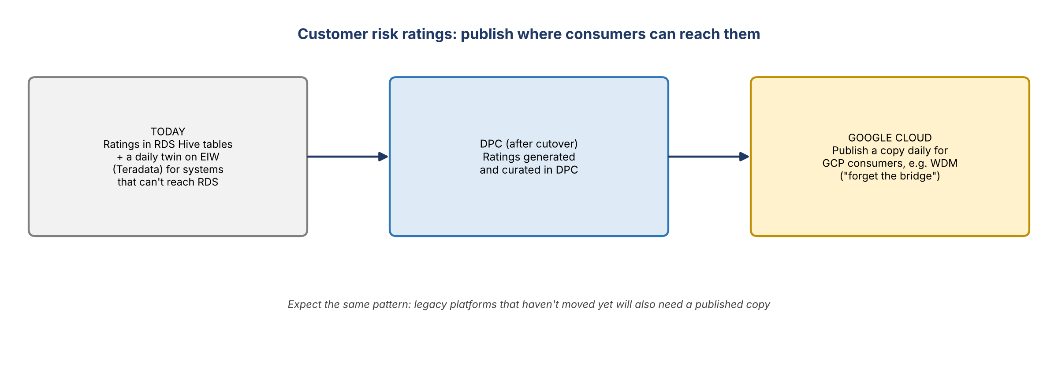
Figure 1. Publishing customer risk ratings to where consumers are
- Precedent: when the eCRM model was built, older systems (mainframes, an old WIM Oracle ODS) couldn't connect to RDS's Hive tables. So risk ratings are published in two places: RDS Hive tables, and a twin on EIW (Teradata) refreshed daily.
- Going forward: if Wholesale Datamart is in Google Cloud and needs ratings from DPC, risk will likely curate in DPC and publish a copy daily to Google Cloud. Other platforms that haven't moved will also need copies.
- Frustration that the bank has two cloud strategies. CIB, the most profitable group (cards second), built its own Wholesale Datamart and product codes.

Testing with realistic data
- James asked what migrations are actually tested with: big, complex relationships (one past private bank relationship had about 489 linked entities and broke systems if ECNs were truncated), or dummy data ("Mickey Mouse has a checking account")?
- The Wholesale Datamart team tests rigorously because it answers to CIB. Elsewhere it's unclear.

DPC work streams from the earlier call
- On the call with Chris, Moshin and Steve Brown described what are likely work streams for getting DPC off the ground. These include: build the infrastructure; migrate the data (in parallel); communications; and business readiness. There were about six in total, and nobody wrote them down.

3. Who drives the data strategy
- The deep-dive meetings with Eric (scheduled by MA) are next week. They're meant to ground everyone on DPC before the workshop in two weeks.
- Jacqueline: the strategy and how it's done is in risk's hands. Technology is reacting and calling her to ask how risk wants it done; there are several correct ways, and they need one decision. "That's on us."
- Kevin: everything built so far has been from the finance lens, because nobody drove it from the risk lens. Jake and Mike built an intake tool mock-up and wrote requirements for intake and metadata, but technology doesn't seem to be acknowledging them.
- Jacqueline: she'll take care of the intake requirements. What's not yet defined is where data lands and how it's organized.

4. Organizing the data plane
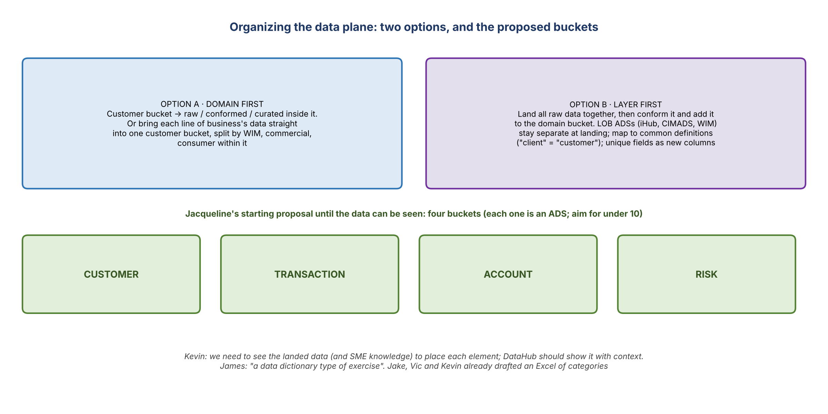
Figure 2. Two ways to organize, and the proposed starting buckets
- The question: the data plane has raw, conformed and curated layers. Organize by domain first (e.g. customer, with layers inside), or land all raw data together and then conform and curate it into domain buckets? Kevin's thought was to look at the landed data and plan from there.
- Jacqueline: it's not hard to start with "customer, transaction, account, risk" until the data can be seen. When people object, ask for the facts.
- The line-of-business cut: data is sourced by line of business today (iHub, CIMADS and WIM ADSs have different columns). Either keep them separate when onboarding and build a conformed common set, or bring them straight into one bucket and split within it. Jacqueline: map to common definitions ("client" and "customer" are the same identifier), add unique fields as new columns, and leave them null where they don't apply.
- Each bucket counts as an ADS, so fewer is better: "under 10". Jake, Vic and Kevin already have an Excel of proposed categories.

The operating model concern
- Kevin: the operating model doesn't support this yet. Risk doesn't source credit risk data; Goldsmith's team sources commercial and consumer loan data into the common data plane (BUSCRT). Risk only supports ORCAP and eGRC data. Kevin isn't the SME for that data, and changing everything at a workshop in two weeks is a lot.
- Jacqueline: the people stay where they are; risk tells them what to do. "We're going to dump it all out on the table and sort: the red Legos go over there, the blue Legos over here." She doesn't want to move seven people, find them redundant, and lay them off. Better to work through it, then move two people and let the other five be redeployed.
- Kevin: the politics will be a problem, and he's not sure how to operationalize it right now. It's "pretty pie in the sky" but workable. The immediate step is cleaning up legacy data and finding what risk consumers actually use, with technology's tools. Net new sourcing is easier to centralize.
- James: this sounds like a data dictionary exercise: what is the data, how do we categorize and group it? Jacqueline: yes. Data dictionaries are a business requirement: go to the customer bucket, see the 12 things available, and pick what you need.

5. Two phases
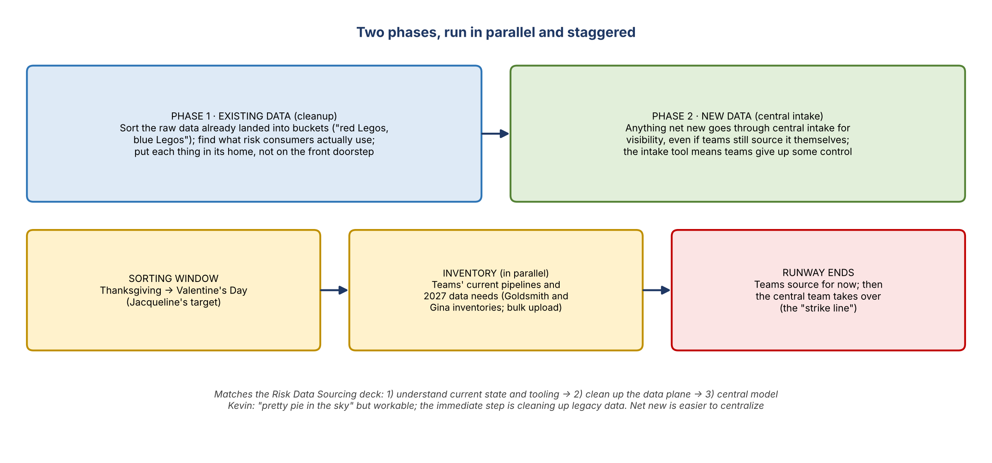
Figure 3. Phase 1 (existing data) and phase 2 (new data)
- Phase 1, existing data: sort the landed raw data with the owning groups in working sessions, ideally between Thanksgiving and Valentine's Day. Jacqueline will help teams clear other priorities to make room.
- In parallel: inventory current pipelines and needs. Goldsmith's team already has inventories; Gina's team has its own and can't slow down. Teams keep sourcing for now, but the runway ends and central sourcing takes over (the "strike line").
- Phase 2, new data: anything net new comes through central intake so there's visibility, even if the team sources it themselves.
- Kevin: this matches the Risk Data Sourcing (pillars) deck. Step 1, understand the current state and tooling; step 2, clean up the current data plane; step 3, move to the central model.
- Intake should also capture existing data, so tracking isn't on the back of a napkin.

What the workshop is for
- To present the strategy: this is the new world, and everyone will own pieces of it. People will ask how it affects them, which is normal, and they'll get answers in due time. Some people may move to the central team; some roles may no longer be needed. Probably a bit of both.
- Jacqueline needs phases and a timeline with dates to get people moving.
- Show visually where we are today and where we're headed, with no more than five changes (intake, sourcing, how data lands, how it's conformed, and so on) and a timeline. Then walk through each, including letting attendees weigh in on the intake requirements.
- Cap the requirements session at 60 minutes (James will raise every edge case).
- Jacqueline's education: she wants to really understand DPC and BigQuery and will ask a lot of questions in the tech deep dives.

6. The intake tool mock-up
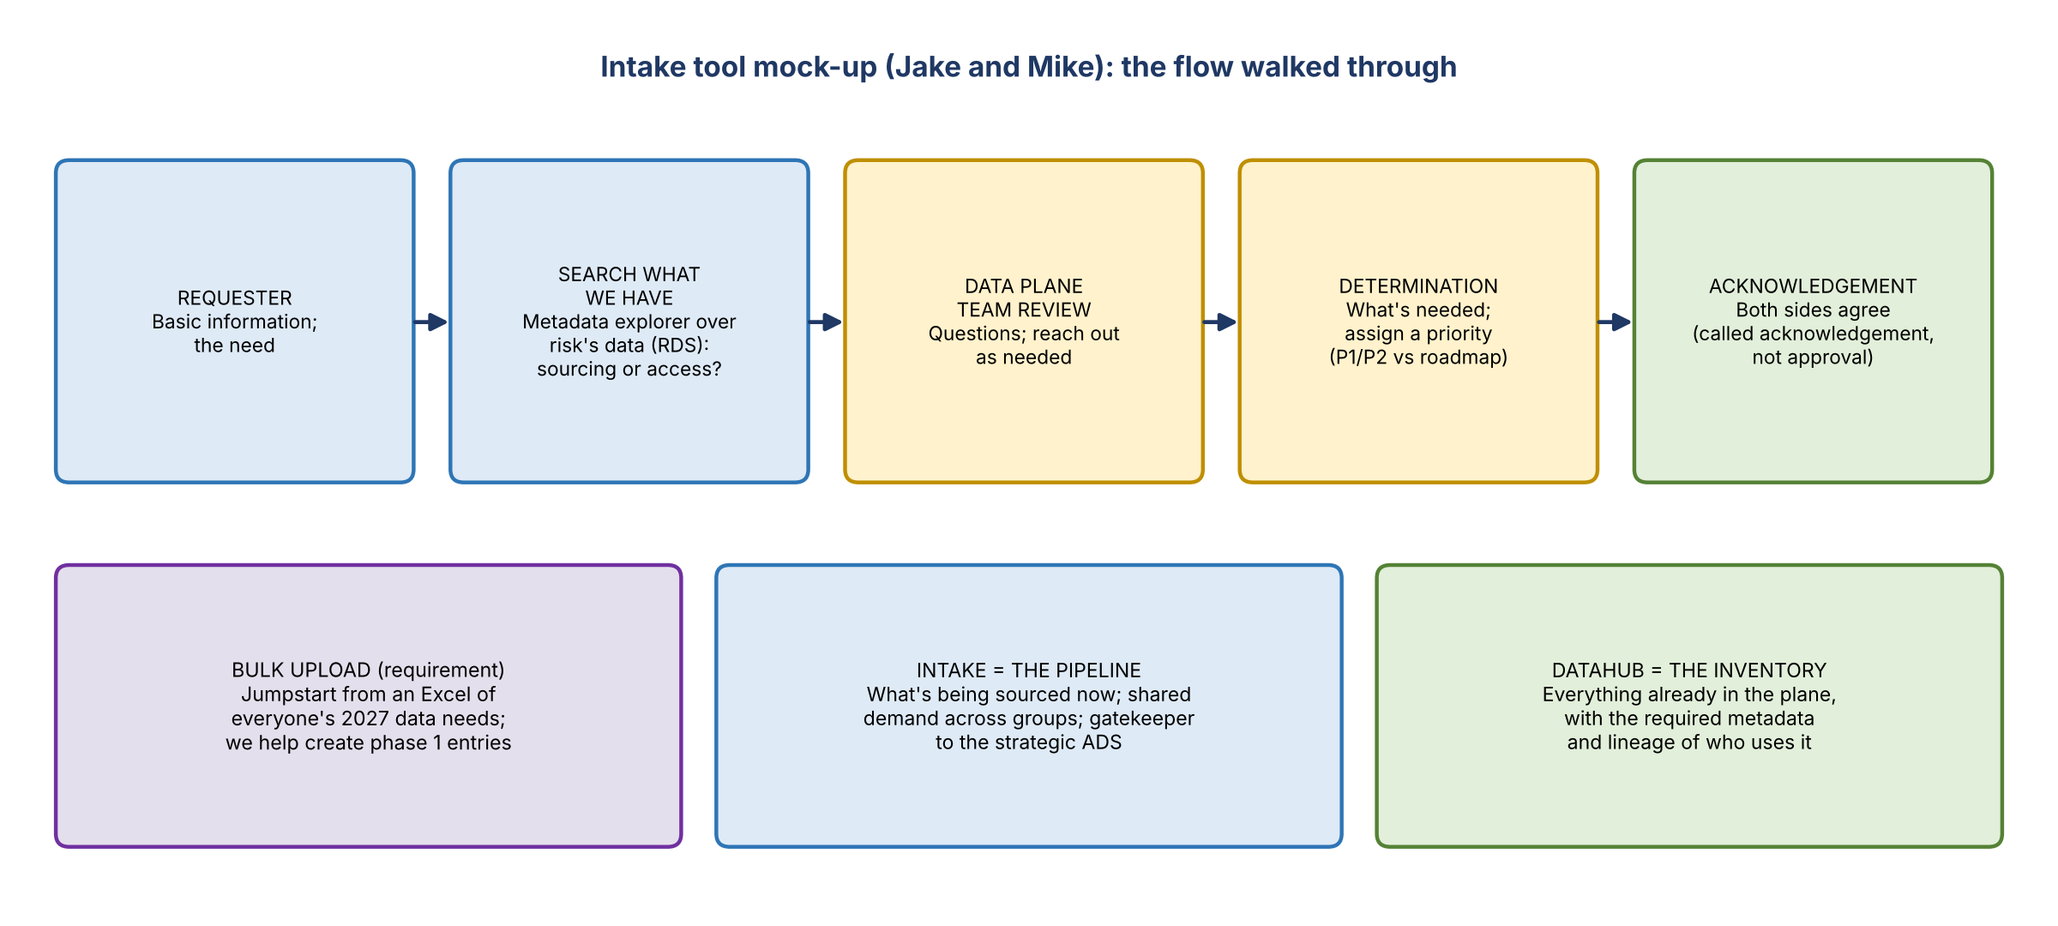
Figure 4. The intake flow walked through in the mock-up
- Jake and Mike's mock-up was praised; it was built with a handful of AI prompts and would have taken a couple of days otherwise.
- Applications: will application data integrate with BAM, or be keyed in manually and cleaned up later? Not settled.
- Metadata explorer: a requester types what they need (e.g. customer name and address for certain customers), and the tool profiles what risk already has. This works within risk's own data (RDS), not the whole enterprise. It answers whether the need is a sourcing request or an access request.
- Transformation team: an integration point. Intake lets the team recalibrate the pipeline (P1 vs P2) against the overall roadmap.
- The approver step: Jacqueline is torn because removing it usually backfires. Keep it simple: call it an acknowledgement, not an approval.
- The flow: requester inputs basic information; search what's available (nothing yet, growing over time); the data plane team reviews and asks questions; determination and priority; agreement from both sides.
- At the workshop: a click-through, explaining what's input and what auto-populates, and asking what else to collect or what shouldn't be collected.

Intake vs DataHub
- DataHub is the inventory: everything in the data plane, with required metadata and lineage of who uses it.
- Intake is the pipeline: everything being sourced now. It shows when several groups need the same element, and lets the team steer requesters to the strategic ADS instead of the wrong SOR.
- Phase 1 entries: the team will help create them. Requirement: bulk upload, so everyone's 2027 data needs can be loaded from an Excel and tracked with pipeline reporting.
- Even when credit risk sources something itself, it goes into intake for visibility. The central team is the "nosy neighbor" at first, and teams come to it naturally over time.
- Until the tool is built, the team keeps handholding people through the Excel intake.

7. Data contracts, missing capabilities and permissions

Data contracts
- Jeff Goldsmith saw "data contract" on a draft investment slide and told Jacqueline that rules are better than contracts.
- Explained: a data contract is like an SLA: what will be delivered and by when, documented so it can be held to account. The difference is that it's built into the JSON file that moves the data, not a Word document nobody updates.
- Kevin and Jake think it's a misunderstanding of terms: Jeff probably calls the same thing a data rule. Both are needs statements.
- The CDO is building a utility that turns a business requirements document (BRD) into a technical data contract.

What RDS was missing (Jeff's part B)
- When teams were first told to land data in RDS, it "wasn't ready": a building with floors but no rooms, plumbing or electricity. Goldsmith's team had to build capabilities such as manual upload (which ORCAP never needed) and data permissioning.
- Some of those capabilities have moved to DPC and finance will use them. Another example is a subscription service that delivers whatever a contract specifies on a schedule.
- Jeff is scheduling a call in about two weeks to walk through them. Jacqueline will include the team.

Permissions
- Risk will likely define the permissions schema for the data plane. Entitlements today are "a disaster".
- Access needs layers that mirror data classification: PII, financial data (e.g. GL entries), and highly sensitive financial crimes data (e.g. SAR data). Risk won't define PII, but it would tag elements and set which spaces allow which access. One person may hold several entitlements.
- Role-based LDAP (as with AIMS) can't be assumed; it has to be delivered.
- For next week's tech sessions: what permission controls come out of the box with DPC, for humans, agents and service accounts? Will each agent get its own service account?

8. The workshop agenda (part 2, 4:00 PM)
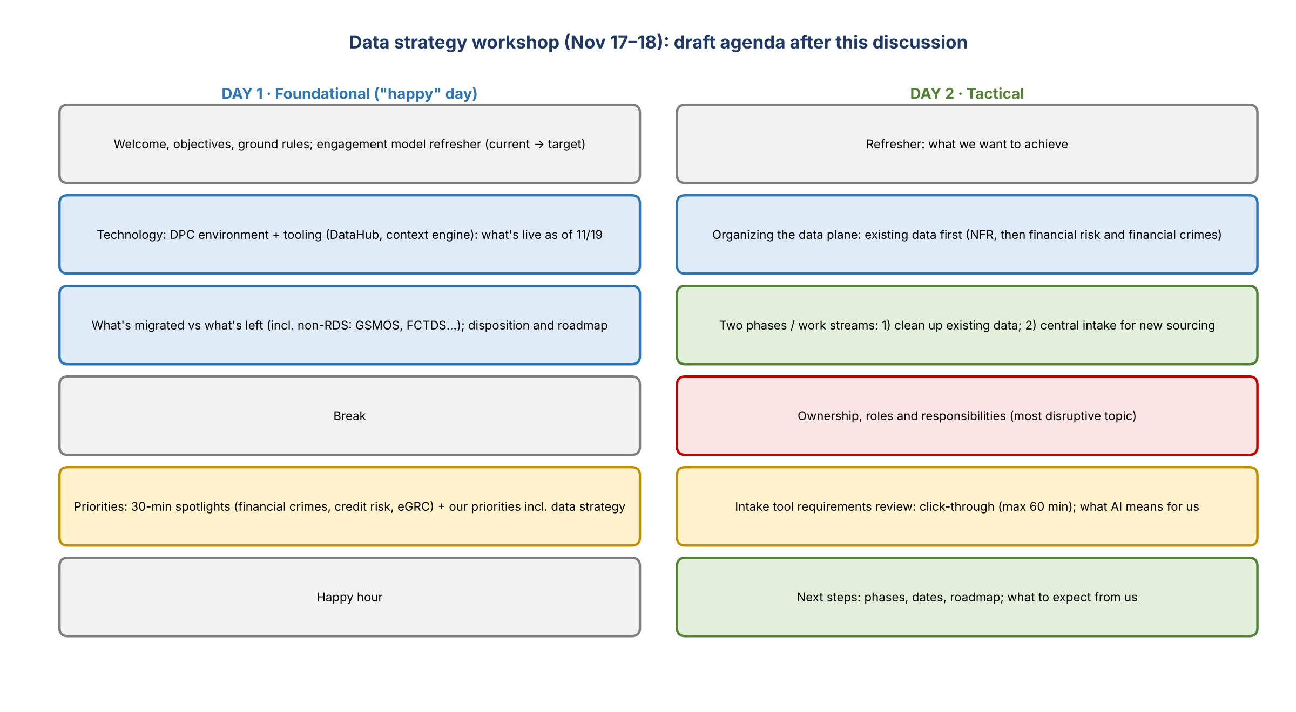
Figure 5. Draft two-day agenda

Opening concerns
- James: his fear is that this creates another data lake, a "data swamp" for perhaps the fifth time at the bank. The answer: no, this will be done better.
- DataHub, explained to James: a metadata repository tool. It doesn't exist today and is being built only in DPC, on purchased software.

Day 1: foundational
- Welcome, objectives and ground rules. Jacqueline's framing: everyone says "DPC", some understand it and some want to learn, so get everyone on the same page.
- An engagement model refresher like last time: current state to target.
- Technology on DPC and tooling: the environment as of 11/19, DataHub, the context engine, and when the tools on top of DPC will be enabled. Ask technology for their materials.
- What's migrated and what's left: RDS moves over, but much more than 40% of corporate risk's data isn't in DPC, with no plan yet (e.g. GSMOS, "Microsoft" (possibly Actimize), FCTDS, which feeds them separately). The non-RDS roadmap may not exist. From the governance work, list everything (e.g. 100 things: 50 moving with RDS, 50 needing a disposition). Then say: this is what's done, this is what's left, these should move, and we need your help.
- These two blocks take a few hours. Then a break.
- Priorities: a 30-minute spotlight from each group (financial crimes, credit risk and eGRC, i.e. Jeff, Gina and Jordan) on their priorities for next year in the context of data sourcing. Corporate risk's own priorities follow, including the data strategy (about two hours, so maybe three hours total). eGRC moved from day 2 to day 1. Asked whether it would feel like a snub to give each group 30 minutes and then take a whole day for risk's agenda, the group agreed everyone should present together on day 1.
- Day 1 stays positive, ending in a happy hour. Ownership moves to day 2.
- Varun's wholesale overview (CIB) is for the internal team only, not the workshop.

Day 2: tactical
- A refresher on what the group wants to achieve. Then what to do with existing data, then intake.
- Two phases or work streams, staggered and in parallel: phase 1 cleans up existing information, which helps migrate the remaining things into their home rather than "dropping them on the front doorstep and touching them again". Phase 2 introduces the intake tool, which nobody will love because it means giving up control. Cover the timeline, what's needed from attendees, and what they can expect.
- How to organize the data plane: start with risk and compliance (non-financial risk) data the team knows well ("pineapples, kiwis, bananas"). Build the foundations before moving to financial risk and financial crimes data: land in DPC, assess and sequence, prioritize, group.
- Roles and responsibilities: central governance and enablement, data plane rationalization, then intake and sourcing. Kevin's biggest worry is ownership: other teams own the data today, and risk owns it in the target state. This is the most disruptive part.
- What AI means for us: data foundation, business context and traceability, fit for use, certified for AI, then the intelligence layer. The central team owns raw and conformed data; business groups own AI use cases and reporting downstream.
- Finance and risk data overlap: discuss internally with Eric and team first. It will be a hot topic for the Goldsmith crew.
- Intake requirements review stays on day 2.
- Next steps: phase 1 steps and a roadmap with dates (already in another deck).
- Socializing: Jacqueline will preview the plan with likely champions so they're ready to support it in the room. Closer to the date, she'll give the likely disruptors a quick overview to take the sting out.

Project name
- Two candidates: Helix and Halo (Jake's suggestions).
- Halo: also a military term, high altitude, low opening. It would need to stand for something, and it shouldn't upset anyone.
- Helix: "this will become our DNA in corporate risk, the building blocks of our data ecosystem." Jacqueline favors it.
- Jacqueline will clear it with Gwen (who likes Marvel references) and come back with alternatives if needed. A name is needed before the workshop.

9. Context: Article 7 workload
Internal only: regulatory exam context
Shared to explain Jacqueline's limited availability; don't circulate.
Article 7 was declared business complete on 9/25, with sustainability through year end and testing planned for next year. Audit was brought in from July for a seven-month validation, and a pop-up exam that was meant to finish in early October is still running.
The regulator has now accelerated the annual exam (due to start Q1) with transactional testing in November: a population within days, samples, and packages with about a day's turnaround. Questions over timeliness standards have escalated to legal. The outcome is too early to tell.

- Gwen was out, so Jacqueline was fielding calls (e.g. from Scott on something due that day) and joined late.

10. Logistics and action items
Action | Owner | Notes
Prepare workshop materials (repurpose existing slides; refresh the "overall goal" slides) | Kevin, Jake, James | Spend Monday; don't derail the SAS exit work
Ask technology for their DPC and tooling materials for the deep dives and workshop | Kevin / Jake | Review at next week's tech session
Send materials to Jacqueline | Kevin / Jake | Monday evening (she prints and marks them up)
Review materials (just the core group) | Jacqueline + team | Tuesday 9:30 AM ET; clean up Thursday (Wednesday everyone's out)
Ask Gina, Jordan and Jeff who should prepare their one-pager priority spotlights | Jacqueline
Talk to Manav about the ignored intake requirements | Jacqueline
Deliver intake tool requirements (likely Eric Bland's team) | Kevin, Jake, Mike | Meeting set for Nov 23, 1 PM
Clear the project name (Helix or Halo) with Gwen | Jacqueline
List what's migrating with RDS vs what needs a disposition | Kevin / team | From governance work
Add the requirements for bulk upload and capturing existing data to intake | Jake / Mike
Ask tech what permissioning DPC provides (humans, agents, service accounts) | Team | Next week's deep dives
Join Jeff Goldsmith's call on the capabilities RDS lacked | Jacqueline + team | ~2 weeks out
Bring Varun in for a wholesale overview (internal only) | Jacqueline
Get a GCP ↔ DPC data flow diagram (start, path, landing, software at each step) | Team (owner TBD) | James asked for it

11. Open questions
- Domain first or layer first? Are customer, transaction, account and risk the right starting buckets?
- How will ownership move to the central team, and at what pace?
- What happens to the non-RDS data (GSMOS, FCTDS and others) that has no DPC plan?
- Will customer risk ratings be published daily to Google Cloud, as with EIW today?
- Will transaction monitoring models be affected by the SAS exit?
- What were Moshin and Steve Brown's DPC work streams?
- Who defines the permissions schema, and what does DPC provide?

