Meeting Notes
Google Cloud and DPC: Moving Data Both Ways, and the Nov 19 Cutover
Item | Detail
Meeting date | Friday, November 6, 2026 (recording started about 2:09 PM; the recording joins mid-discussion)
Format | Working call on how risk data will move between Google Cloud (GCP) and DPC
Attendees (from context) | Jacqueline, Anant (data architecture), Kathy, James, Kevin, Jake
Referenced | WDM (Wholesale Datamart), FCRM, Brian's team (ECRLT), Anya (WDM), Krishna (architect), Richa, Lizzie, the CDO data movement team
Purpose | Make sure risk applications won't break as data moves to Google Cloud and DPC, understand how data moves each way, and pick use cases to build patterns

Note on the transcript
Auto-generated transcript with no speaker labels; attributions come from context. The bank's name is left out. Readings used: GCP ("GPC"), BigQuery, Flowmaster, Hortonworks ("Hot OnWorks"), GSMOS ("Gizmo"), ECRLT, AVA, Kathy ("Catholic"), "in parallel" ("plot parallel"), lower lanes ("lower links"), on-prem ("OnTron"), CDO (the data movement framework team; "CTO" was also heard), IT&V ("IT and V"). Unsure: "risk grading" vs "risk rating"; Anya; who asked each question. WDM's GCP timing was said as "Q1 of next year… like April", read as early 2027.

1. Summary
- GCP → DPC is straightforward: risk pulls from BigQuery using Flowmaster's connector. Once it's enabled for one pipeline, other use cases just need a new pipeline definition.
- DPC → GCP uses controlled data movement: a reusable CDO framework scans and audits all data leaving on-prem for the cloud. A finance application already does this in production (on-prem S3 to BigQuery).
- Open question: how a GCP application would pull data from DPC (probably risk publishes it and they pull). Anant will follow up.
- Pilot use cases: customer risk rating, GSMOS screening, AVA and transaction monitoring. Wholesale Datamart (WDM), an early GCP adopter involved in all of them, is the "guinea pig".
- Cutover: legacy RDS moves from Hortonworks to DPC on Nov 19; it's running in parallel now. ECRLT is included; GSMOS is not. ECRLT's go/no-go is this week. WDM is in the testing; for them it's just a repoint.
- Broader view: add a topic to the data strategy workshop: what every team is doing with GCP, their roadmaps, and their stakeholders' roadmaps.

2. Testing before anything is turned off
- First question: is testing on the roadmap before things are turned off, so nothing gets migrated and declared done before anyone checks?
- Anant: WDM is moving from Teradata to GCP. WDM is reaching out to each consuming tenant with the date it stops loading data into Teradata, so tenants can cut over. As long as that communication path exists (Anant believes it does), there shouldn't be surprises.
- The risk: new data or applications stood up directly in GCP. There, risk needs to be engaged early and test in dev in parallel, not discover it in UAT.

Flowmaster, explained
- Jacqueline asked for an explanation (she had already looked up BigQuery).
- Most data pipelines on the RDS platform use Flowmaster, a reusable framework with connectors to many data sources. BigQuery is one more source.
- Enable the connection for one pipeline, and other use cases only need a separate pipeline definition. Jacqueline: "a bunch of pipes that are connected together"; once connected into the network, it's fine.

3. How data moves each way
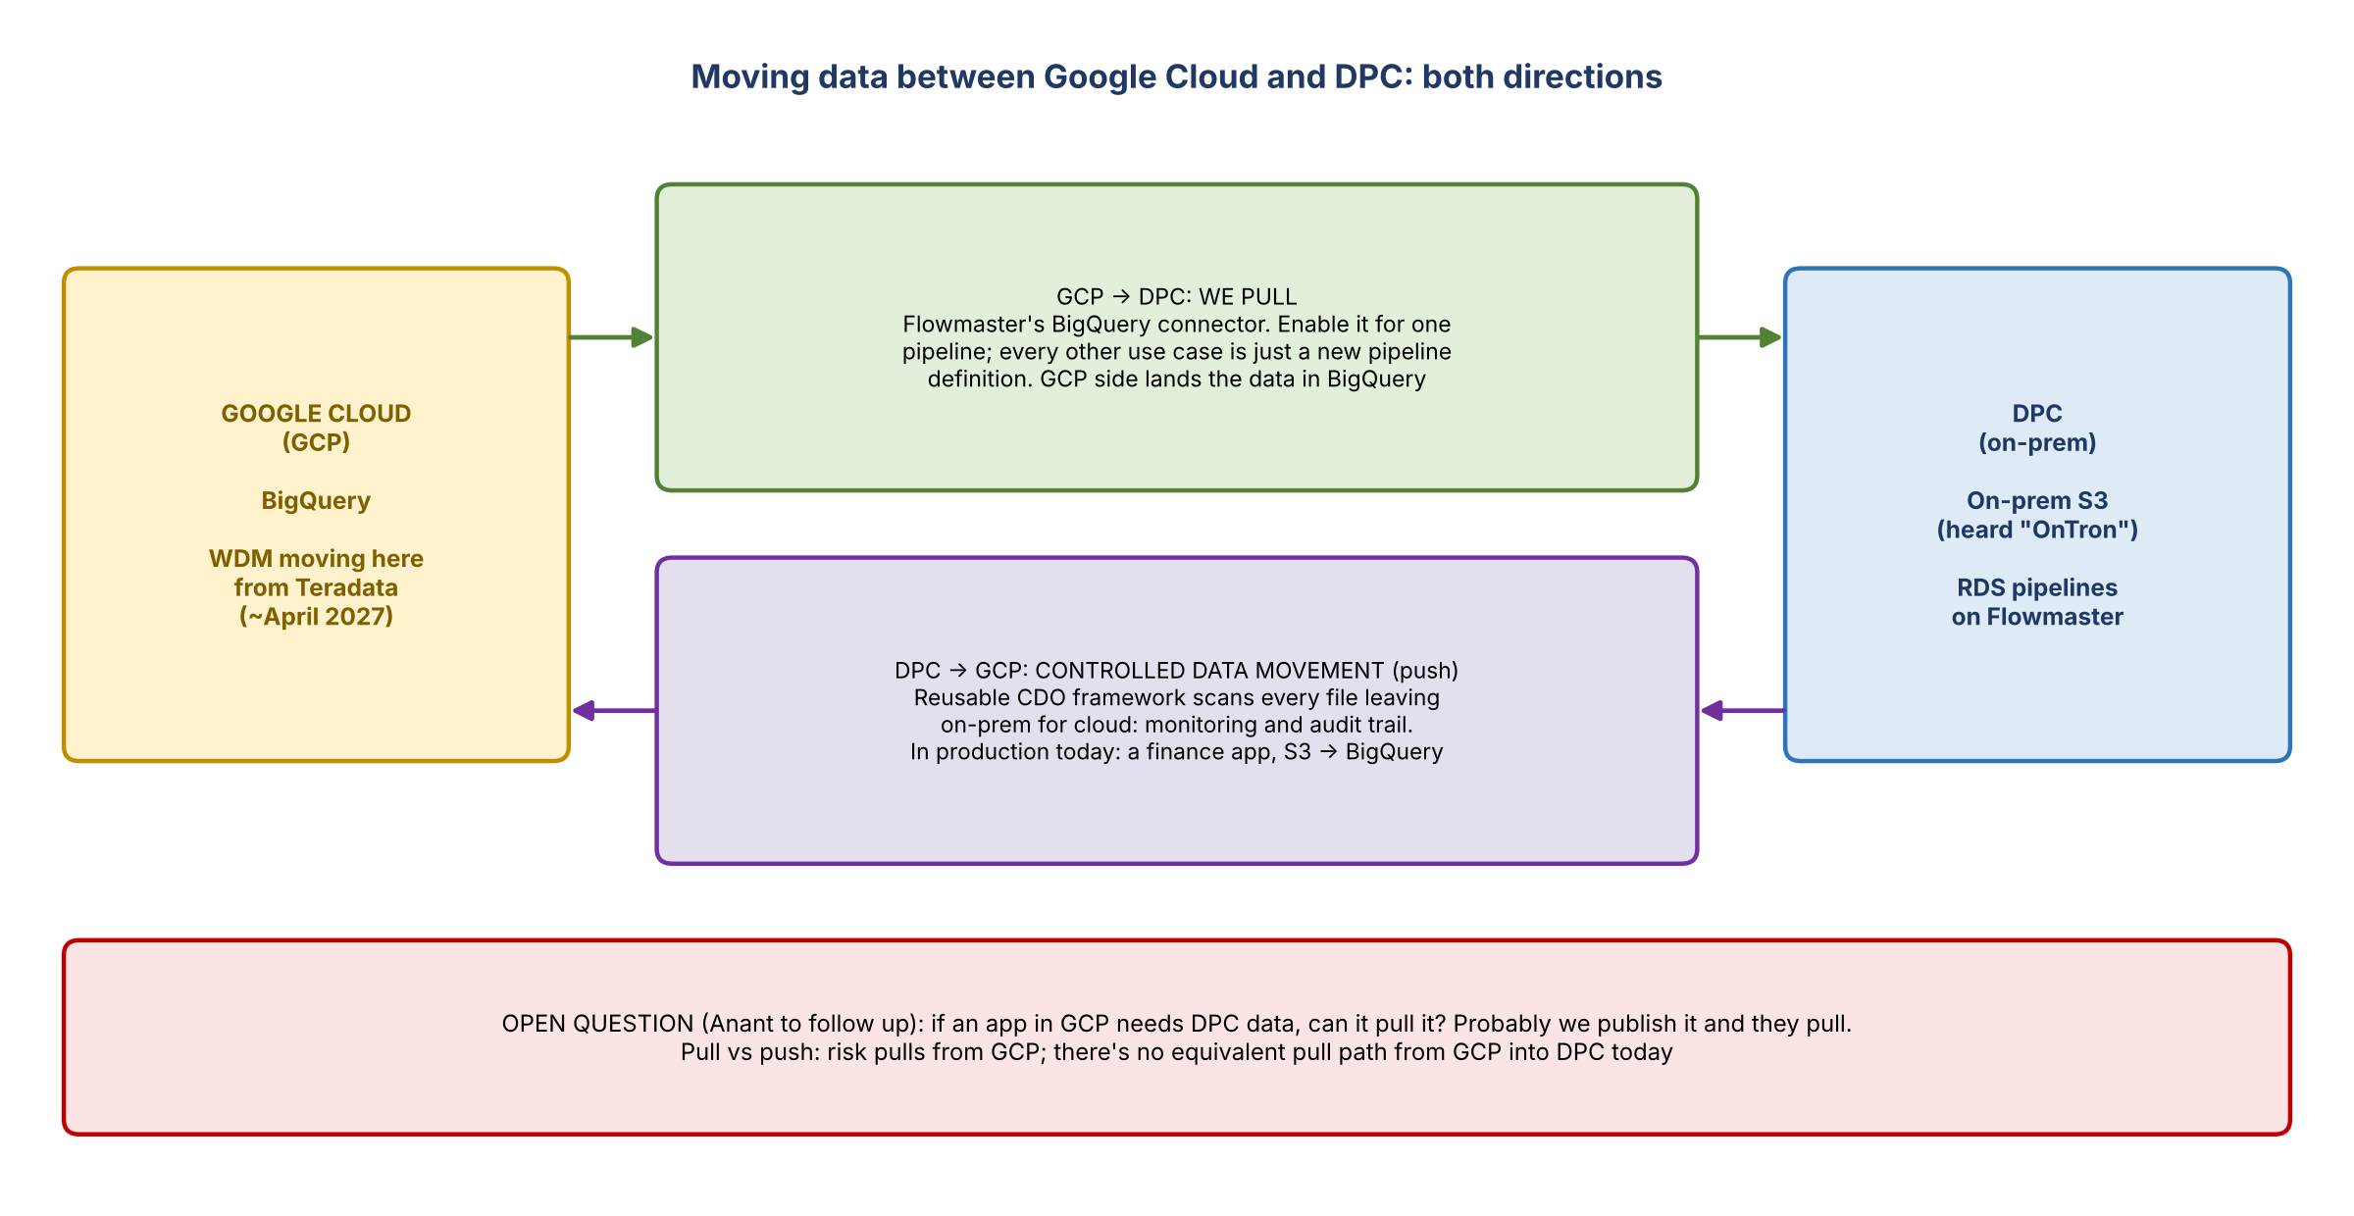
Figure 1. GCP to DPC and DPC to GCP

GCP → DPC: risk pulls
- Whoever owns the data in GCP lands it in BigQuery. Risk then pulls it through Flowmaster. Nobody pushes to risk.

DPC → GCP: controlled data movement
- Data moving from on-prem to Google Cloud must be monitored. The CDO team provides a reusable controlled data movement component.
- It combines the application's code with central code that scans all data crossing from on-prem into the cloud before placing it in the target location. That gives monitoring and visibility of what data is moving.
- A finance application is actively pushing data from on-prem S3 to BigQuery this way, in production, not just in lower lanes. So the bank knows what it takes.
- Anant: this already happens both ways at the bank; risk just hasn't explored it yet.

The gap: a GCP app that needs DPC data
- Normally it's pull, not push: risk pulls what it needs from GCP. An application in GCP needing DPC data should likewise be able to pull it. But today's default is controlled data movement, a push.
- Anant will follow up. Likely risk would have to publish the data, and the GCP application would then come and pull it.
- Jacqueline: risk needs to understand better what it's impacting. A strong use case to pilot would help.

4. Pilot use cases
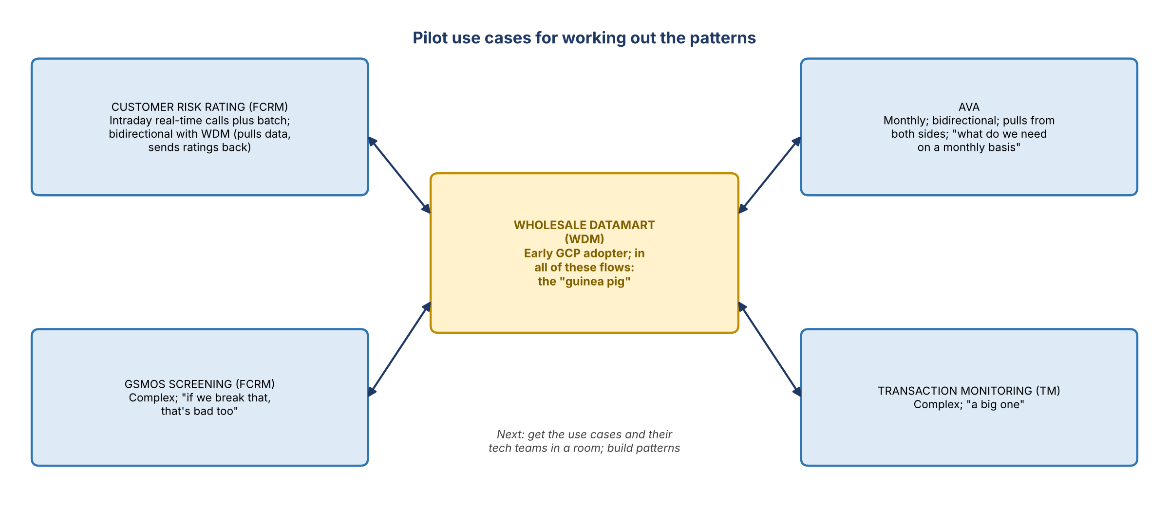
Figure 2. The four pilot use cases, all connected to WDM
Use case | Owner | Why it's a good test
Customer risk rating | FCRM | Consumed in GCP intraday through a real-time call, plus batch jobs. Bidirectional and dynamic: risk pulls a lot of data from WDM for ratings, and WDM pulls the ratings back in
GSMOS screening | FCRM | Complex; "if we break that, that's bad too"
AVA |  | Runs monthly, so it shows what's needed on a monthly basis. Bidirectional; needs to pull from both sides
Transaction monitoring (TM) |  | Complex and "a big one"
- Jacqueline wanted a simple third case alongside the complex ones (risk rating, GSMOS and TM aren't simple). James suggested AVA. In the end the group kept all four.
- WDM as the guinea pig: WDM will be one of the early GCP adopters and is involved in all of these processes.
- Next: get the actual use cases and their technology teams together. Anant will work through what each is trying to solve and create patterns.

5. The DPC cutover
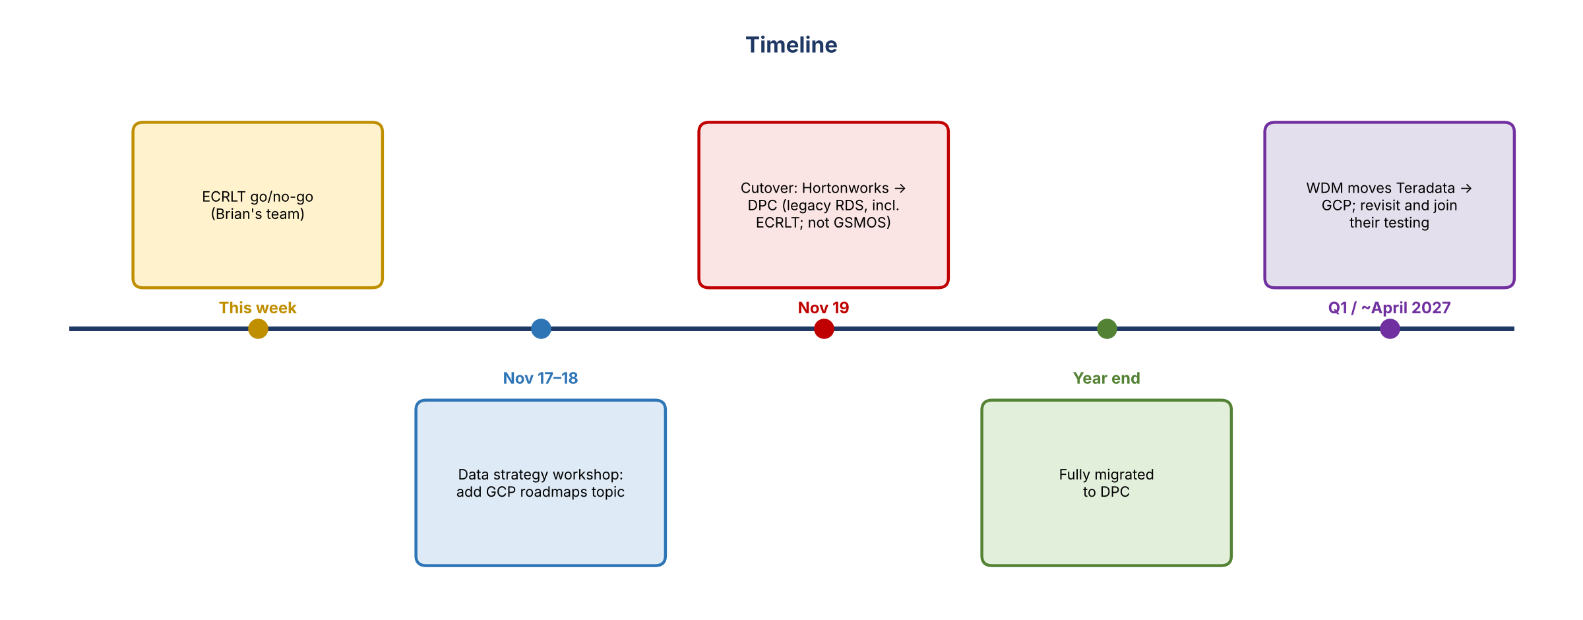
Figure 3. Timeline
- "Fully migrated to DPC by year end": Jacqueline asked whether that just means data landed. It's more: the cutover from Hortonworks to DPC is planned for November 19. Systems are running in parallel now, and Kevin has been involved.
- Scope: legacy RDS only. GSMOS is not part of this cutover. ECRM is, through ECRLT.
- ECRLT: needs a solution as soon as possible. Brian's team says they've been testing along the way; their go/no-go decision is this week.

Testing upstream and downstream
- Jacqueline asked whether testing covers the flows to and from other systems, not just landing the data in DPC. Answer: yes, upstream and downstream activities are being validated.
- When the team got involved, Jacqueline and a team member (likely Kevin) immediately reached out to WDM, which is part of the testing effort.
- WDM isn't in GCP yet. It's planned for Q1 of next year, around April. For now WDM is on Teradata, testing that its environment and connectivity still work after the DPC migration. Anya confirmed it's really just a repoint, and WDM is helping verify that.
- Jacqueline: kick the tires on everything else that's cutting over. Make sure nothing is also moving to GCP in parallel by accident. For WDM, testing against Teradata is fine for now; revisit and join their testing in Q1 when they go to GCP.

6. Is everyone using the same approach?
- Kathy: the Article 7 work Jacqueline and James are doing connects to this, but it's broader. Are other efforts already piloting this, e.g. Richa's IT&V work, Lizzie's generative AI, or the FCI investigations work? Are others asking the same questions?
- Anant: those teams are probably working with their own architects (e.g. Krishna). For a specific use case, bring that space's architect in. Anant covers the data side, not individual use cases.
- What matters is that everyone uses a consistent approach. Jacqueline: history says there will be outliers. Some will make sense, others will be "we were given a menu and we picked this one".
- Anant: as long as teams use the framework, the patterns should be consistent. He doesn't recall a Google integration from the RDS side, but there might be one.
- Agreed: add this to the data strategy workshop. What is everyone doing, what are the roadmaps, and have teams talked with their stakeholders about theirs? The aim is a full view.

7. Action items
Action | Owner | Notes
Find out how a GCP application can get DPC data (publish and pull?) | Anant
Gather the four pilot use cases and their tech teams to work out patterns | Jacqueline / James, Anant | Customer risk rating, GSMOS, AVA, TM; WDM as pilot
Confirm ECRLT's go/no-go for the Nov 19 cutover | Brian's team | This week
Check every system cutting over on Nov 19 isn't also moving to GCP | Kevin / team
Join WDM's GCP testing in Q1 | Kevin / team | WDM moves ~April 2027
Add GCP approaches and roadmaps to the data strategy workshop agenda | Jacqueline / team | Workshop Nov 17–18
Bring in other spaces' architects (e.g. Krishna) for specific use cases | As needed

8. Open questions
- How will GCP applications pull data from DPC, and who publishes it?
- Are any other risk systems already moving to GCP that haven't surfaced?
- Are Article 7, FCI investigations and the AI efforts using the same GCP integration approach?
- What exactly changes for GSMOS, which is outside the Nov 19 cutover?

