Meeting Notes
PC SAS Impact Survey and Communications
Item | Detail
Meeting date | Thursday, November 5, 2026 (meeting started 12:29 PM; 11 participants)
Format | Teams call with the SAS platform team; lists, reporting links and a diagram shared in the meeting chat
SAS platform team | Shalini Carney (reporting and lists), Mary (desktop scan, cheat sheet, communications)
Business and program side | Kevin Moody, James Contrino, Kelly Comack, Matt Mcconeghy, Dave Wrenn (chat notes), Noor Bombaywala (architecture; drew the diagram), Steve, Jake
Referenced | Sue (communications), Anand (SAS-only Power BI report), Michael and Elizabeth (largest user counts), the EUC team, desktop packaging, the CIOs
Purpose | Work out which users could be hit when locally installed PC SAS stops working on Nov 29, how to find them quickly, and how communications should go out

Note on the transcript
Auto-generated transcript with no speaker labels; attributions come from context and the meeting chat (screenshots). Spellings come from the chat where possible. The bank's name, logo and email addresses are left out; the diagram in Section 2 is redrawn from the one shared in the chat. Unsure: "Astrid" at the very start (possibly a name for the survey contact), who facilitated the call (it may have been Kelly or someone on James's side), and that the speaker on licensing was Shalini. "SaaS" in the transcript means SAS.

1. Summary
SAS desktop licenses for PC SAS 9.4M8 expire. Expiry warnings start on Nov 14, and on Nov 29 locally installed PC SAS and local Enterprise Guide stop working. Anyone running work only on their PC, or remote-submitting to the grid from the PC client, is affected. Enterprise Guide connected to the server or grid, and SAS Studio in the browser, keep working.
- The gap: the workspace owner survey went only to file system owners on the grid. PC-only users never got it, so nobody yet knows who in corporate risk runs anything important locally.
- The data: the platform team shared three lists: (1) server workspaces and owners by LOB, (2) server entitled and active users, (3) PC desktop installs from last week's EUC scan.
- Kevin's ask: compare list 3 against list 2 to find corporate risk people who have PC SAS but aren't server users. That's the group to check before 11/29.
- Licensing: the goal is no outage. A new enterprise contract is close, and desktop packaging is on standby. If there is an outage, critical users can get early licenses.
- Communications: Mary and Shalini will work with Sue on a clarifying message, using a generic version of Noor's diagram, with an executive-level note first. A second message follows once the contract and timeline are known.
For Jake: Kevin's requests (noted, not done)
1. The comparison (Kevin, 12:41 in the meeting chat and 12:58 directly): "figure out who from the installed list from corporate risk aren't on the list of users for the server." Jake replied he would after the deep dive discussion.
2. Workspace access (Kevin, 1:10 PM): Antoine Le Saux needs access to, and alignment with, /workspace2/gerr. The reporting shows the workspace owner as Devin Henry, with Antoine already listed as the assigned responder (extract environment 1SAS).

2. What changes on Nov 14 and Nov 29
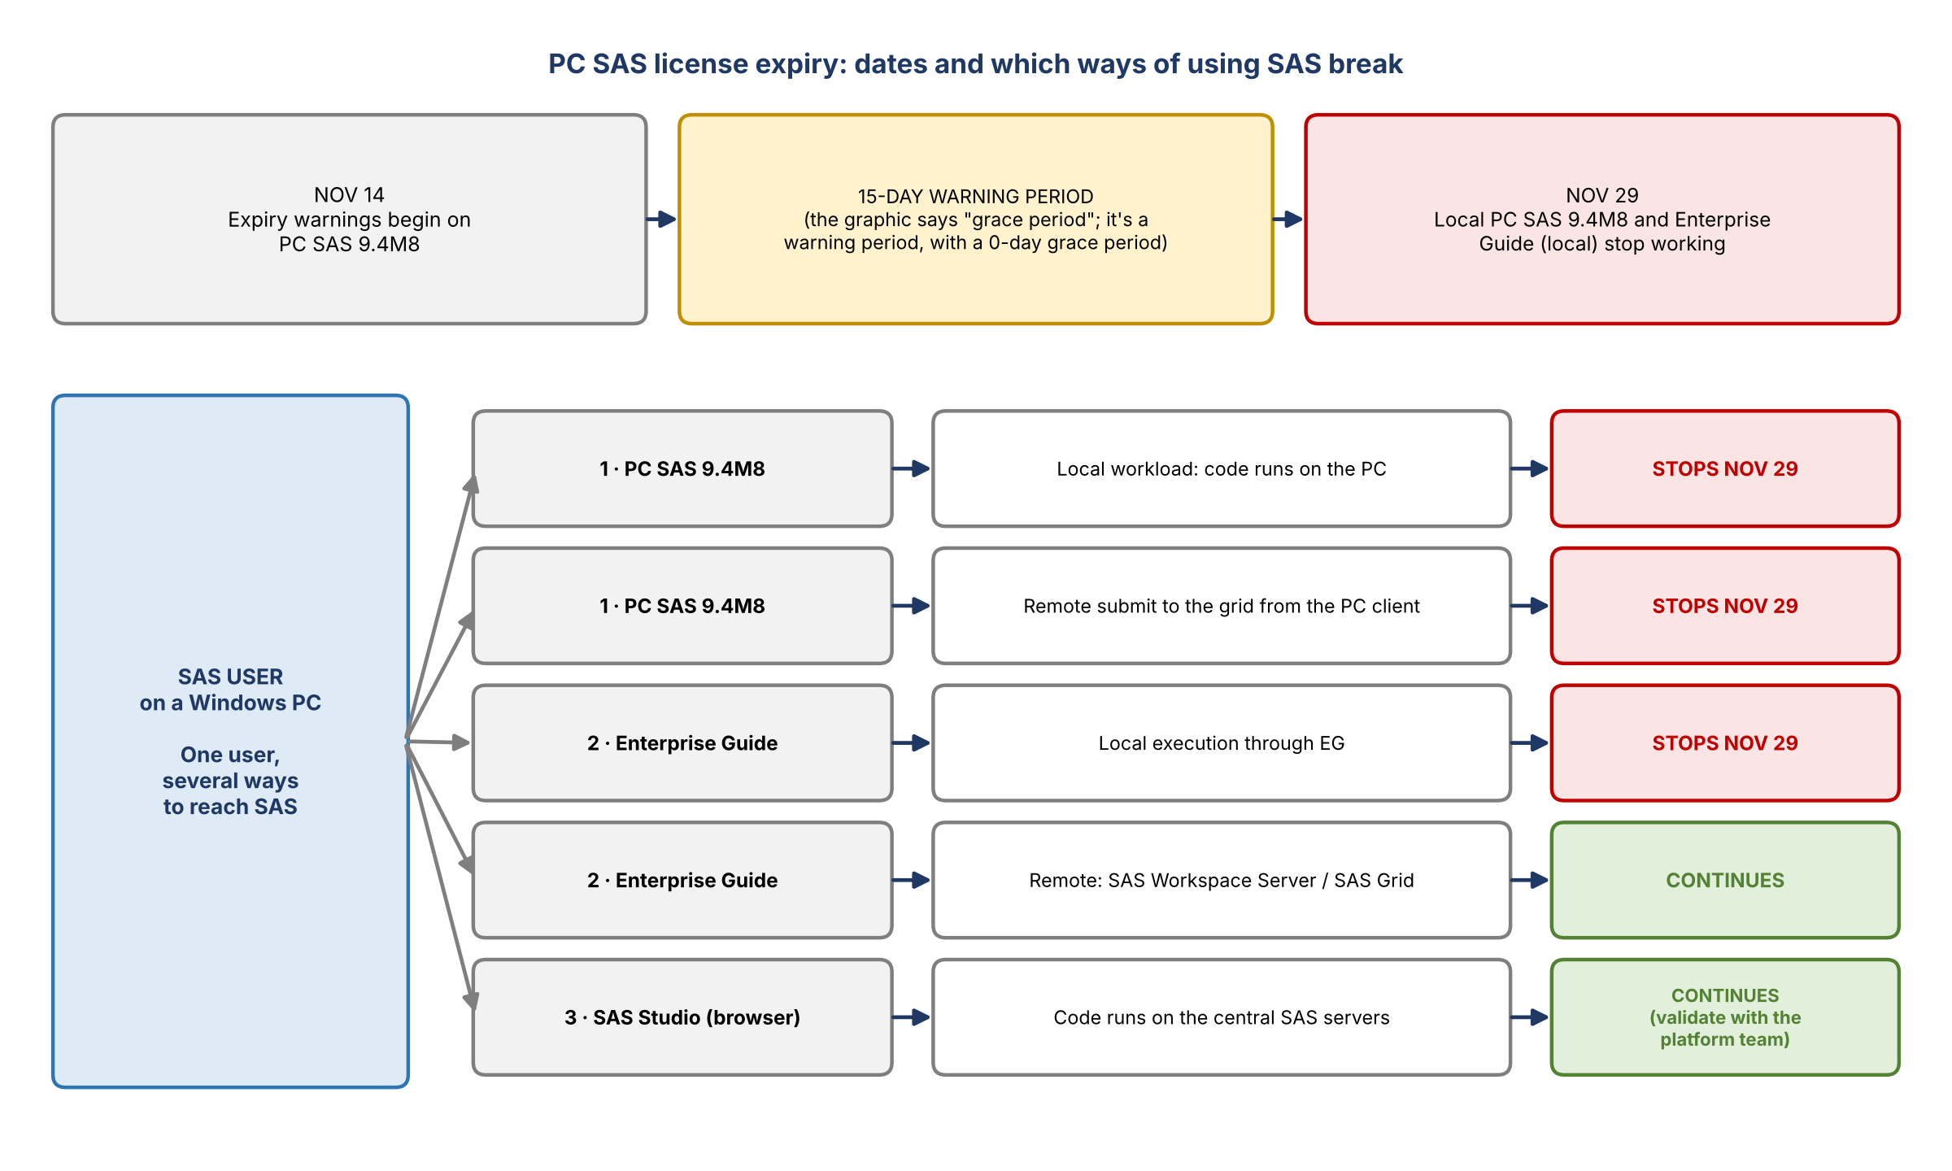
Figure 1. Dates and impact by access path (redrawn from Noor's diagram)
- Nov 14: PC SAS 9.4M8 starts showing license expiration warnings.
- 15 days: the diagram calls it a grace period. Dave noted in the chat that it's really a warning period: SAS now gives a 0-day grace period and a 15-day warning period. In the past it was 45 days of each (90 in total). Users can keep running during it, but downtime is expected after, for an unknown length of time.
- Nov 29: locally installed PC SAS 9.4M8 and Enterprise Guide stop working locally.

Who is affected
Tool | How it's used | On Nov 29
PC SAS 9.4M8 | Local workload: code runs on the PC | Stops working
PC SAS 9.4M8 | Remote submit: jobs run on the grid but are sent from the PC client | Stops working
Enterprise Guide | Local execution | Stops working
Enterprise Guide | Connected to SAS Workspace Server or SAS Grid | Continues
SAS Studio (browser) | Code runs on the central SAS servers | Expected to continue; confirm with the platform team
- Mary: most SAS users with a grid presence also have a desktop client, so having PC SAS installed doesn't mean someone is affected.
- Moving someone running entirely locally isn't quick. Once a user has grid IDs and a file system, moving the work is probably not hard. But users not yet onboarded to the grid have to go through onboarding first.

3. Finding the affected users

Why the survey doesn't cover it
- The survey was driven purely by file system owners on the grid. Users who only use PC SAS, with no presence on the grid, didn't get it.
- The team has a separate workspace owner initiative already; this ask is specifically about PC SAS, for corporate risk only.
- Mary had earlier been asked for the distribution list for the license expiry email. That went to the platform's standard distribution lists, so those people could be in any of the three lists.

The three lists
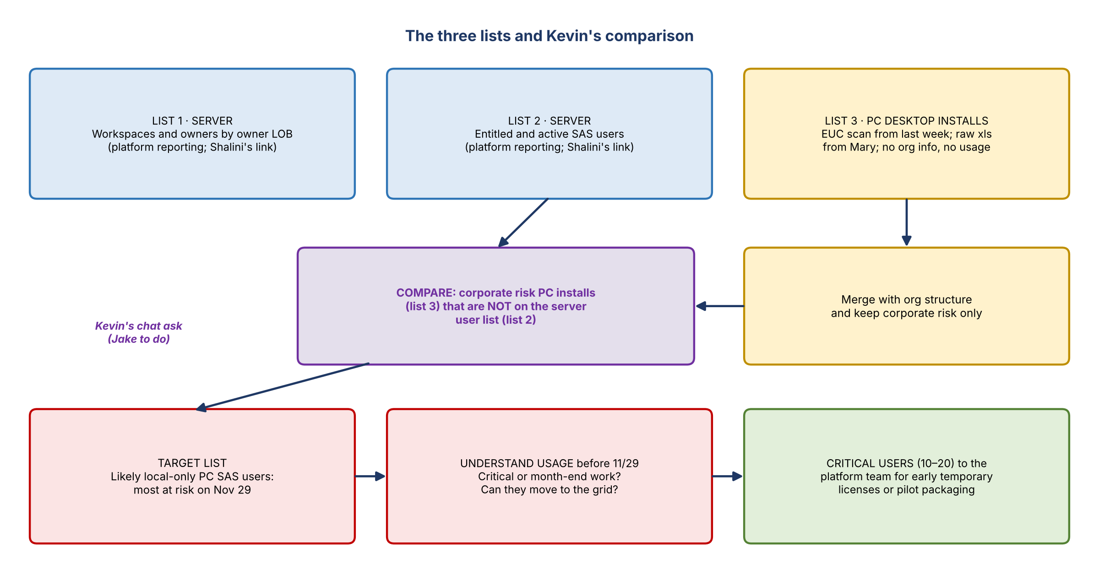
Figure 2. The three lists and the comparison Kevin asked for
List | What it holds | How to get it
1. Server: workspaces and owners by owner LOB | Workspace owners with their LOB, joined to entitled users; also active users and storage | Enterprise Analytic Platform Reporting (Shalini's link); needs the DTCA_CFG_TECH_EAPR_PIBI_APP entitlement
2. Server: entitled and active SAS users | Who is entitled to and actively using the SAS server | Same reporting
3. PC desktop installs | Everyone with PC SAS installed, from last week's EUC scan; no org info and nothing on how they use it | Not in a report; Mary sent the raw xls in the meeting. Kevin's group merges in org structure
- Mary will also post the list in the shared location, expecting more requests for it.

James's three-way compare
- Licenses cost money, so even a small gap between installs and server users matters, and the list is still needed.
- It isn't a simple two-way match. Some people have a license but no workspace of their own because they use one owned by their manager or someone else, yet they are SAS users.
- Questions for each user: PC SAS, non-PC SAS, or both? If PC SAS, does it support critical analytics or business functions? (It shouldn't.) How can they move off it on a very quick timeline?
- Risk: SAS shuts down at November month end for some period. Month-end critical jobs on PC SAS would mean a "month end reporting debacle". Depending on how long the move and the new licensing take, year-end reporting could be hit too.

Kevin's comparison
"I think comparing #3 and #2 to determine who isn't a user on the server would give us a good target to understand their usage before 11/29 so we know if anything important breaks." (Kevin, meeting chat, 12:41 PM)
- Dave summarized in the chat: Shalini provides links to reports 1 and 2; Mary sends the xls for 3; Kevin and group merge the data to get org structure.
- Kevin then asked Jake directly to do it for corporate risk (see the box in Section 1).

Reporting notes
- The facilitator had already pulled a breakdown from this reporting the day before, covering corporate risk, internal audit and finance users. Michael's and Elizabeth's areas have the highest user counts, so they're likely the key people to work with. They'll send the spreadsheet after the call; Kevin agreed it can be shared with the group. Steve didn't need to be copied.
- There are two versions of the reporting. Shalini's link is the central enterprise platform report, covering all the analytics tools with a deeper dive per platform. Anand's version is SAS-only and has a few things not yet moved into the central one. Both use the same underlying data. Counts differ slightly (by three or four here and there) because one checks HR for whether a person is still active and the other doesn't. The goal is to move everything into the central report.
- Mary is writing a cheat sheet on which link to click for what, which may take the rest of the day.
- For technical teams: a file inventory exists for each workspace, and crontab scheduling information is being prepared for all lines of business.

4. Licensing and outage plan
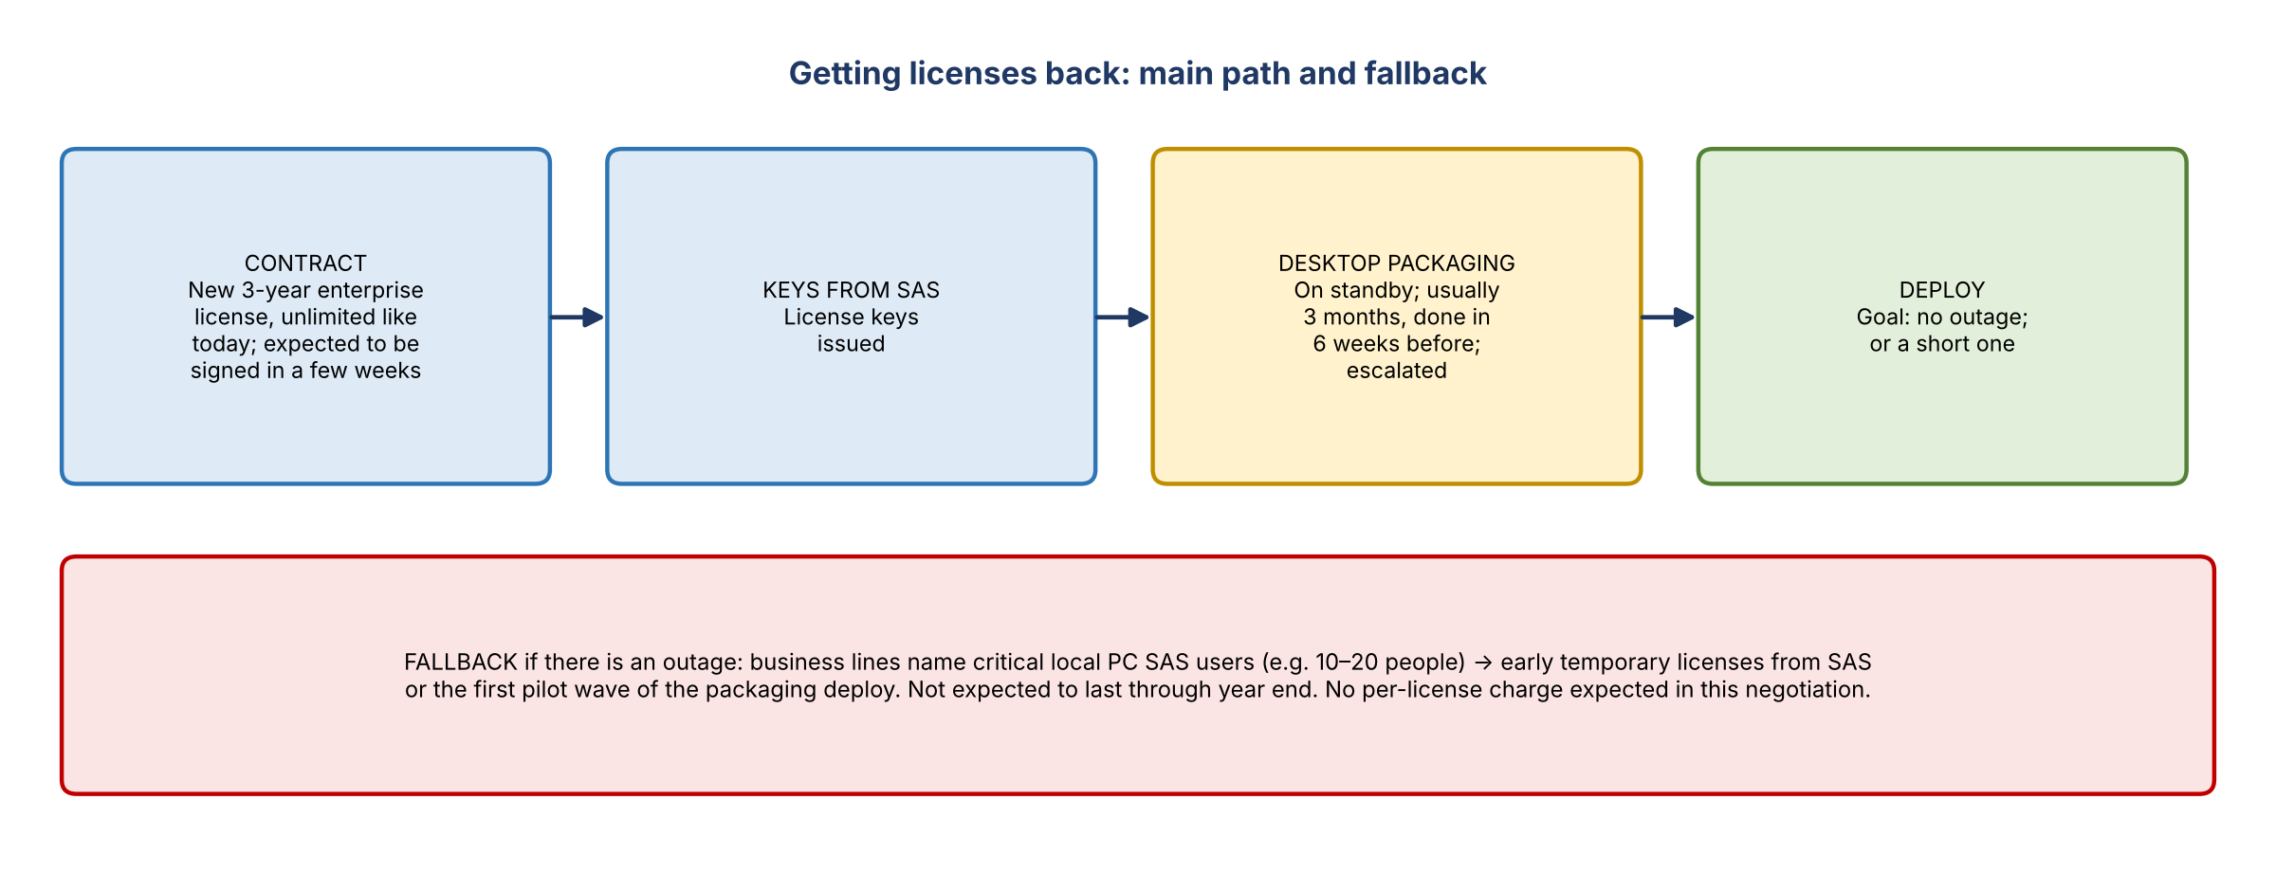
Figure 3. Getting licenses back, and the fallback
- Goal: no outage at all. Desktop packaging is on standby to turn licenses around as soon as they arrive. It's usually a three-month process, has been done in six weeks before, and has been escalated high.
- If there is a short outage: the platform team wants a list from each line of business of users with critical local PC SAS processes (e.g. 10–20 people). They would ask SAS for early temporary licenses or put those users in the pilot phase of the packaging deploy. Other LOBs are being asked the same.
- Mary doesn't expect any outage to last through the end of the year.
- After the contract: a strategy for what stays on SAS, what moves to other tools, and what has other solutions, with suggestions from the platform team. Longer-term remediation will come through the CIOs once the contract is final.
- The platform team plans white-glove support, as far as possible, for people who need to do something while SAS is unavailable.
Internal only: contract status
Shared in the meeting; not for wider distribution while the negotiation is open.
The SAS contract negotiation is ongoing. The expectation is a new 3-year enterprise license, unlimited like today, signed in the next few weeks.
SAS is not expected to charge per license under this negotiation. License numbers won't be limited yet.

5. Communications
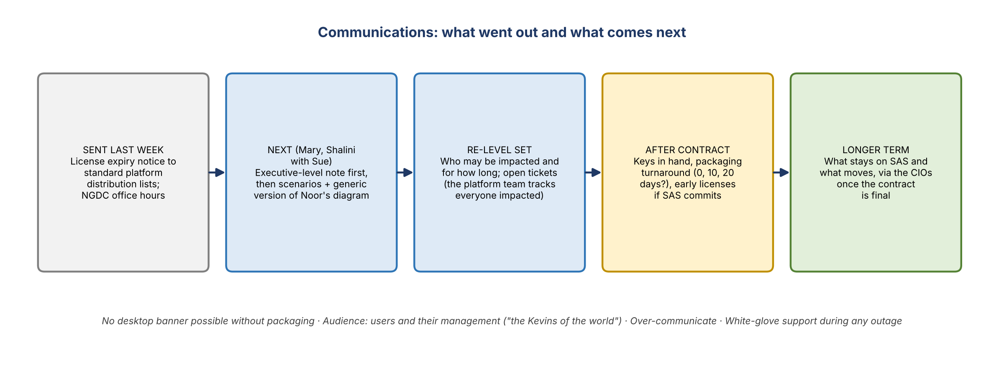
Figure 4. Communications sequence

What has happened
- The initial notice went out last week to the platform's standard distribution lists. People have been coming to office hours (the existing NGDC office hours).
- No banner is possible: a desktop application can't show one without going through packaging.
- Many conversations like this one are happening, so word is getting out.

The concern
- People may panic thinking SAS is going away entirely, even when they only use Enterprise Guide against the server, or aren't affected at all.
- Noor's diagram shows clearly who is affected and who isn't. Everyone agreed a visual with short pointers on what stops and what continues would help. It will be sent to Shalini and Mary to adapt; they can update it as needed (e.g. the grace period wording) and make it generic.
- Enterprise change management usually steps in to make sure communications are coordinated: is there a plan, who is it going to, does senior leadership understand it? It depends on what's impacted, which isn't known yet.

Agreed next steps
- Who sends it: asked directly whether the business or the platform team sends the clarifying message. Mary and Shalini will connect with Sue and decide when and how.
- First message: clarify the specific scenarios with the genericized diagram, preceded by an executive-level communication. Re-level set everyone, with the ability to open tickets. The platform team is tracking everyone who says they may be impacted.
- Second message: once keys are in hand and packaging gives an expected turnaround (0, 10 or 20 days). It will include early licenses if SAS commits to them. Likely more messages after that.
- Audience: not just impacted users but their management too, the leaders who need to champion the move ("the Kevins of the world"). Over-communicating is fine here.
- The most important thing now is to quickly find who uses PC SAS and what the impact would be.

6. Action items
Action | Owner | Notes
Compare PC installs (list 3) with server users (list 2) for corporate risk; find who isn't on the server | Jake | Kevin's ask; after the deep dive. Noted, not started
Give Antoine Le Saux access to /workspace2/gerr and align him to it | Jake | Kevin's ask (1:10 PM); owner shown as Devin Henry
Merge the desktop install list with org structure | Kevin's group | Raw xls from Mary
Use the target list to understand usage before 11/29; name critical users | Corporate risk | Feeds early licenses or pilot
Provide links to reports 1 and 2 | Shalini | Done in chat
Send the desktop install xls; post it in the shared location | Mary | Sent in meeting
Write the reporting cheat sheet | Mary | In progress
Send Noor's diagram to Shalini and Mary | Dave | Posted in chat 12:59 PM
Plan the clarifying and executive communications with Sue | Mary / Shalini
Send the corporate risk, audit and finance user breakdown to the group | Facilitator | Kevin agreed

7. Open questions
- How many corporate risk users are PC-only, and does any of them run month-end critical work?
- When will the contract be signed and keys issued, and how long will packaging take?
- Will SAS provide early temporary licenses?
- Who sends the clarifying message: the business or the platform team?
- Does SAS Studio in the browser definitely keep working? (The diagram says to confirm.)

