Meeting Notes
Risk Data Management Tooling Forum: DataHub in Production and the FDLZ Contract Portal
Item | Detail
Meeting date | Friday, November 6, 2026 (recording started about 1:04 PM)
Format | First monthly tooling update for risk (about 30 minutes), then a live demo of the FDLZ data contract portal
CDO data management tooling | Yashica (host), Nirav (FDLZ contract portal; ran the demo)
Risk data plane team | Mike (asked for the demo), Jake, and others asking questions
Referenced | Bo (built the treasury metadata connectors), Benny (helped with DPC UAT access), the architecture team, treasury business users
Purpose | Introduce the monthly tooling forum, share that DataHub is live in production, and demo the FDLZ contract portal

Note on the transcript
Auto-generated transcript with no speaker labels; attributions come from context. Readings used: Nirav (heard "Ineeram"/"Niravad"), Yashica (heard "Ishika", "Kirish", "Yakusha"), ART and AIMS entitlement requests ("art"/"aims"), UAT ("UAD"), Liquibase ("Aliquibase"), YAML file ("EML file"), Autosys, FDLZ (also heard "FDNC"), Flowmaster, DataHub ("DatHub"). Unsure: Lars (the treasury system); "Atlas" (the name being given, apparently to DataHub or its research agent); Bo and Benny; who asked the detailed questions during the demo (not Mike); and "Mike, so that is DVD" (unclear).

1. Summary
- Monthly forum: Yashica is starting a monthly 30-minute risk data management tooling update: the focus for the next three to four months, what's happening this month and which tools are in progress (including POCs). Risk and finance have separate sessions for now; they'll merge once things are more standardized.
- DataHub is live in production. The treasury research agent (on Lars data) went live Wednesday. A demo for about 80–100 treasury business users is this Thursday, and a version for risk will follow.
- Access: Yashica pinged the link and which entitlement to request. Production is likely an AIMS request; DPC UAT access was an ART request.
- FDLZ contract portal: replaces the multi-step translator framework with one governed UI. Users upload a business template, fix flagged gaps, submit and get approval. The portal works only up to UAT; contracts reach production through the normal SDLC release (Liquibase DML, Jira, change request). Production is view-only.
- DataHub and Flowmaster: contract metadata loads into DataHub (done for CADS today). DataHub is also exploring ingesting Flowmaster JSONs, so risk doesn't need to migrate to FDLZ contracts to get into DataHub. Standardizing on one contract tool stays on the longer-term roadmap; nothing changes immediately.

2. The monthly tooling forum
- Risk will get a monthly invite for the risk data management tooling update: 30 minutes on what's happening everywhere, even if it's a POC.
- Risk and finance are separate for now. Once things are standardized and everyone has better insight, there will be a combined session.
- Asked if risk would hear the same topics as finance, Yashica joked that risk are "the pioneers of the data management tooling".

3. DataHub in production
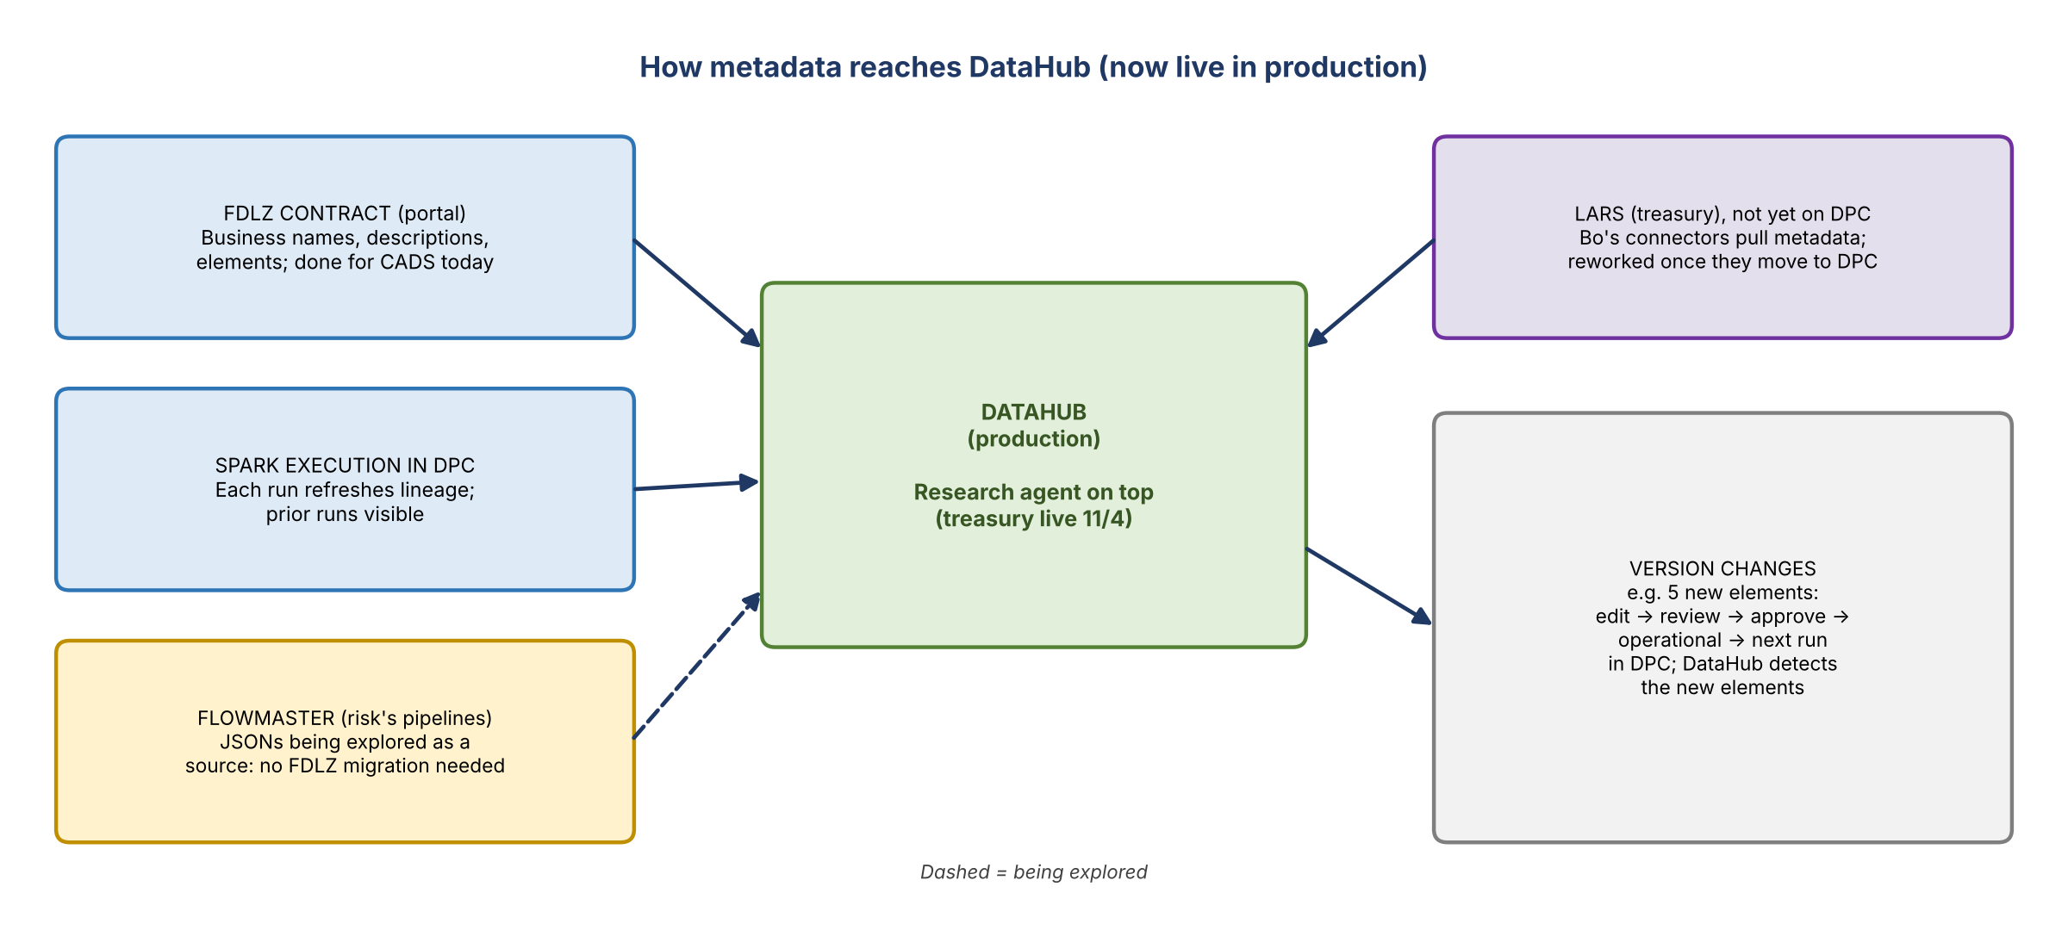
Figure 1. How metadata reaches DataHub

Treasury research agent
- The treasury research agent on Lars data went live Wednesday (11/4).
- A demo this Thursday for about 80–100 treasury business users will show how they can use it day to day. One for risk will follow, sharing where and how treasury is using it.
- Is treasury on DPC? Not yet, but almost. Bo had built connectors to ingest the whole metadata, and the architecture team reused some of them. Metadata is ingested from wherever Lars is into DPC just to run DataHub. It will be converted to the normal process once treasury moves to DPC, which means one more update for them.
- The goal was to hit production with an agent on top to show the art of the possible and how it makes people's lives easier.

Access
- Asked whether risk can access production DataHub now: Yashica pinged the link and the access to request.
- One team member is still waiting on an ART request for DPC UAT ("taking forever"). Another just got in that day, after working with Benny on some odd errors.
- Production access is probably an AIMS request; ART was for the UAT version.
- "Atlas": the name being given, "because Atlas guides the world".
- Yashica offered to share the UAT Excel files: how UAT was run, the scoring, and the questions asked.

The risk demo to come
- Confirmed at the end: Yashica will bring the full material to one of these calls. It covers the problem statement, how DataHub solves it, which teams use it, how their processes improved (e.g. skipping five steps), how feedback improves the research agent, and the research agent's capabilities.

4. FDLZ data contract portal demo
Mike asked for a quick demo of the FDLZ contract portal (the one Yashica had shared a link to the week before, not the agent). Nirav walked through it with a sample contract.
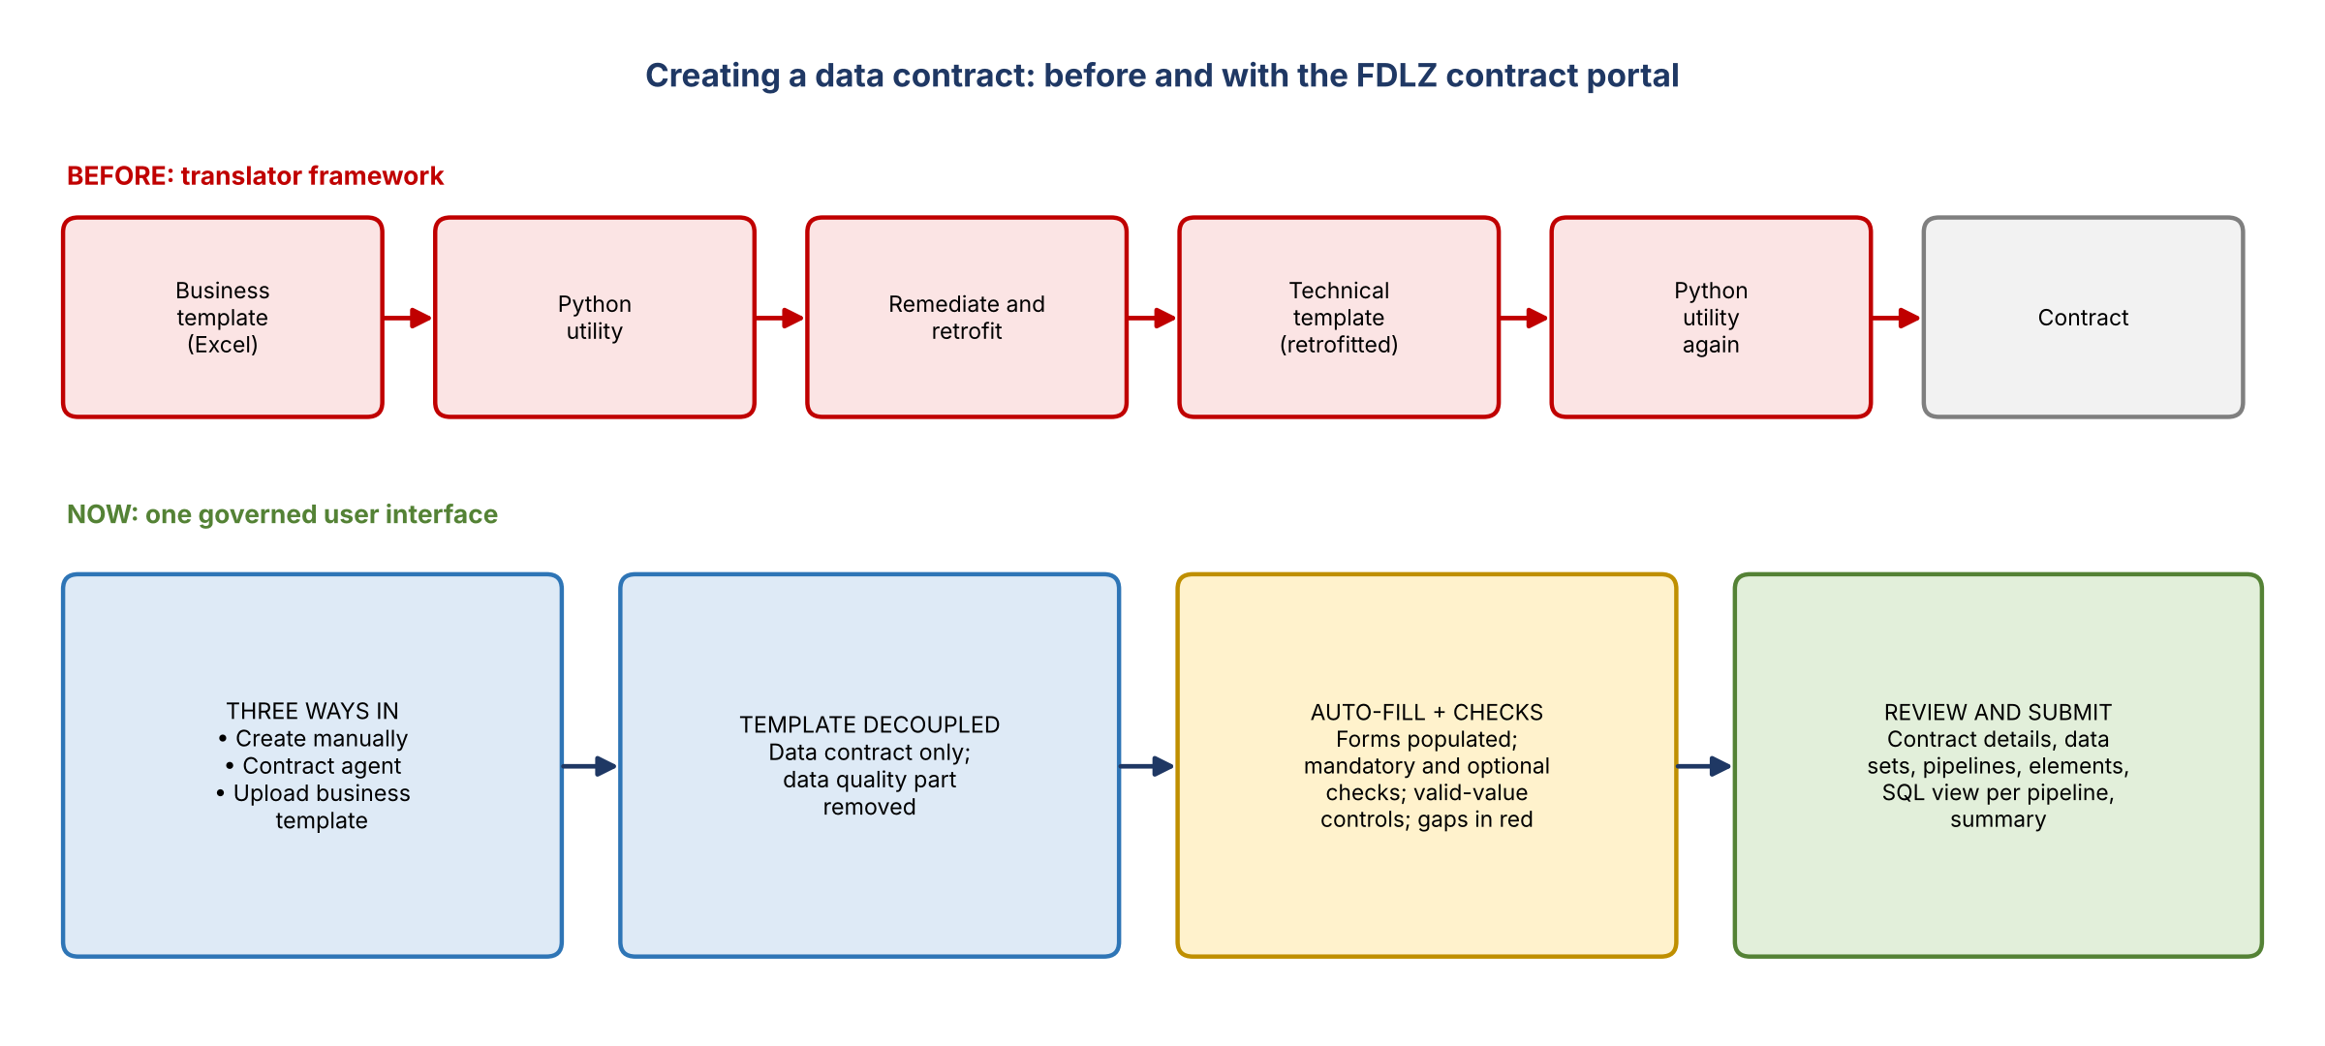
Figure 2. Contract creation before and with the portal

Why it exists
- Before, users created contracts through the translator framework: build a business template, run the Python utility, remediate and retrofit, create a technical template (also retrofitted), then run the Python utility again.
- The portal puts all of this in one governed user interface.
- Ways to create a contract: create manually, use the contract agent, or upload a business template.
- Template change: the old template was decoupled. It now covers the data contract only; the data quality part was removed.
- After upload, all the data sets and information fill in automatically. Mandatory and non-mandatory checks and controls make sure only valid values are allowed. Anything missing or wrong shows in red and must be fixed.

What a contract holds
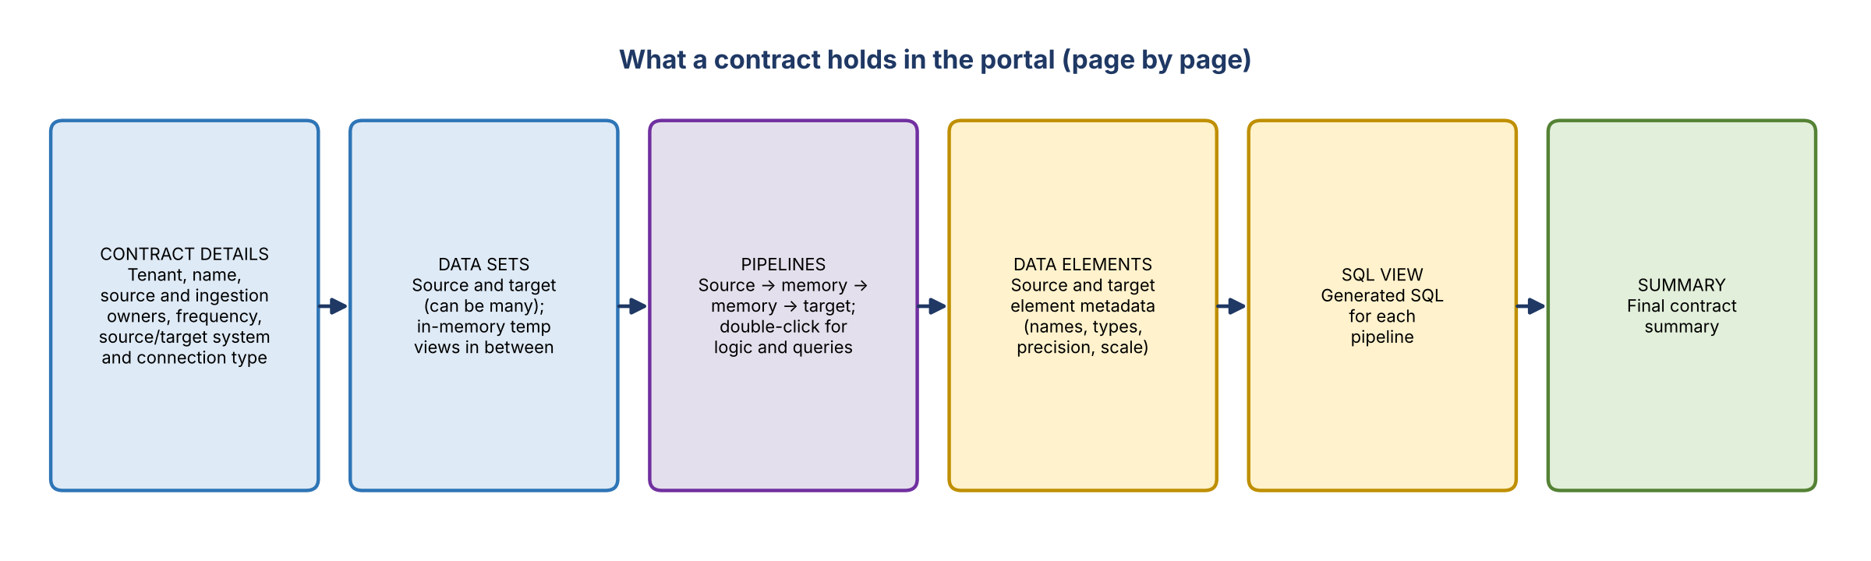
Figure 3. The portal's pages for one contract
- Contract details: tenant, contract name, source owner, ingestion owner, frequency, source connection type and system, target connection type and system, description.
- Data sets: source and target data sets, which can be many. The sample was one-to-one; memory-to-memory steps also appear.
- Pipelines: typically several sources load into temporary in-memory views, transformations run memory to memory, and everything ends in one final target data set. Double-clicking a pipeline shows its description, source information and transformation queries.
- Data elements: the source and target element metadata.
- SQL view: the SQL for each pipeline, then a final contract summary.

Where the metadata comes from
- New pipeline: the user provides it in the template: data set names and connection strings; source and target data elements (logical names, types, precision, scale; data set names must match); transformation logic; and the data dictionary mapping, with transformation IDs mapped to source and target.
- Existing pipeline: search for the contract and edit it directly.
- Business or tech? Today mostly tech, through the template, to keep the existing workflow. DataHub opens up future opportunities. The business user fills out the tabs, uploads, and the portal splits the data into forms and flags gaps.

Workflow and versioning
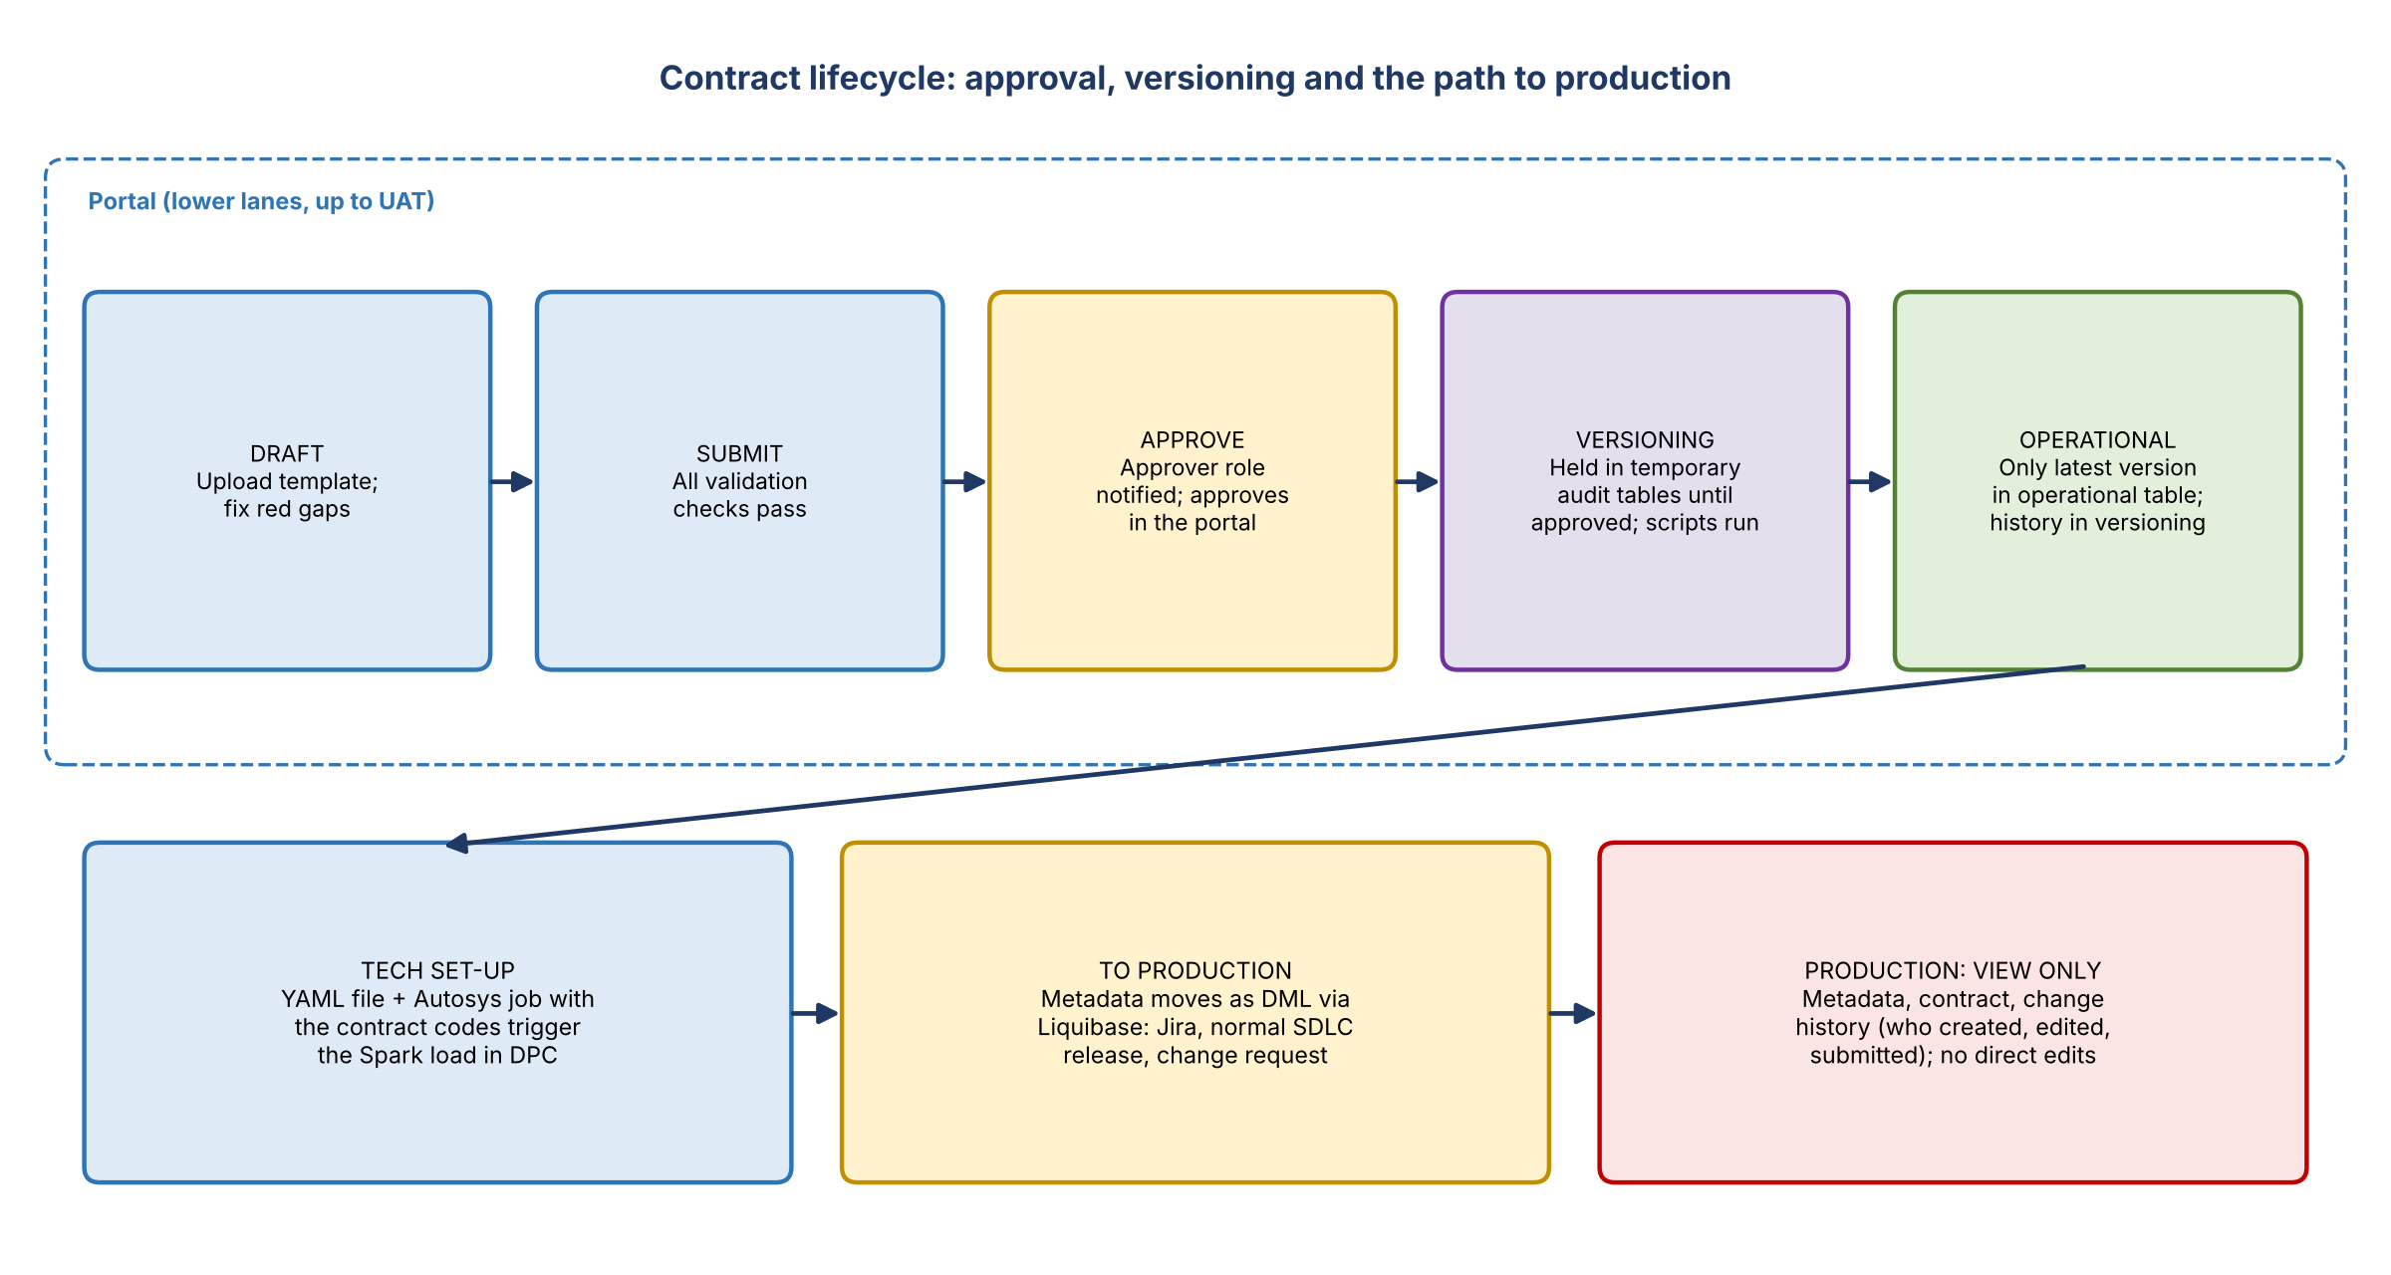
Figure 4. Contract lifecycle and the path to production
- The contract starts in draft. Once all validation checks pass, the user submits it.
- Business users with the approver role get a notification, review in the portal and approve (or reject).
- Until approval, the data is held in temporary audit tables. On approval, automated versioning scripts move it into a versioning table and an operational table, so only the latest version is operational. A confirmed approval means the back-end process completed.
- Tech then sets up the YAML file and Autosys job with the contract codes, which triggers the data load.

Getting to production
- A team member asked about the handshake and SLA between business and tech: is it a day, or padded by the SDLC?
- The portal allows creating or changing contracts only up to UAT. Changes happen in lower lanes first, are tested, and evidence is attached to show the release introduces a new or changed contract.
- The data and metadata then move into production as DML (Liquibase) through the normal SDLC release: Jira, then a change request. It's the same flow as taking code to production. Nothing goes to production directly from the UI.
- In production: limited visibility only. You can see the metadata, the contract and the change history (who created, edited, submitted, updated), but can't act on it, so the SDLC process isn't bypassed.

5. DataHub, Flowmaster and the future
- Contract metadata in DataHub: all contract metadata, including business names and descriptions, loads into DataHub. That's being done for CADS now.
- Lineage: comes after execution. The loads are Spark-based, which DataHub supports well, so each run refreshes DataHub and previous runs are visible.
- Version changes: if a new version adds, say, five elements, it goes through edit, review, approve and operational. When it runs in DPC, DataHub automatically detects the five new elements.
- Flowmaster: risk uses Flowmaster. The DataHub team is exploring ingesting Flowmaster JSONs directly, so risk doesn't depend on migrating to FDLZ contracts to get into DataHub.
- Was FDLZ migration about DataHub? It was one of the most critical discussions (whether only one contract type should load into DataHub), but that dependency has been removed.
- Longer term: for standardization, one contract tool should be on the roadmap. You wouldn't want the same capability maintained in two tools, and engineers are better spent enhancing one. Migration wouldn't block any data management capability, and the aim is to keep it seamless with no pause for risk. Nothing immediate; Yashica will share the finalized strategy and plan. For now both Flowmaster and FDLZ feed DataHub.

6. Action items
Action | Owner | Notes
Request access to production DataHub (link and user group in the chat) | Risk team | Likely AIMS for production
Send the DataHub link and the entitlement to request | Yashica | Pinged in the chat
Share the treasury UAT Excel files (approach, scoring, questions) | Yashica
Run the DataHub and research agent demo for risk | Yashica | After the treasury demo this Thursday
Share a sample business template | Nirav | Not ready in the meeting
Share the finalized contract tool strategy (Flowmaster vs FDLZ) | Yashica | Nothing immediate
Monthly tooling forum invite | Yashica | Recurring

7. Open questions
- Exactly which entitlement gives production DataHub access?
- When will Flowmaster JSON ingestion into DataHub be ready?
- What is the expected turnaround from approved contract to production through the SDLC?
- Will risk eventually be asked to move from Flowmaster to FDLZ contracts, and on what timeline?

