Meeting Notes
Minerva Data Risk Tab and Best Available Certification (BDL and RFAM Sessions)
Item | Detail
Date | Thursday, October 8, 2026
Session 1: BDL | About 9:30 AM. Led by Alex (CDO) for business data leaders and DUOP admins. Questions from Michelle, Denise, and Kathy
Session 2: RFAM | About 11:06 AM. A 20-minute slot at the start of the RFAM team meeting (model developers), introduced by the RFAM lead. Led by David (MRM). Questions from Brian, Ryan, Mike, and others
Presenters (both) | Alex (chief data office), David (model risk management), Joe Schaefer (Harold's team; ran the Minerva demo)
People referenced | Kevin Moody (BDL for corporate risk), Karen (agreed gating approach), Tom Hansen (data management policy), Ahmad (audit; source of the finding)
Purpose | Preview the new Minerva data risk tab, the Best Available Certification by BDLs, the retirement of DUOP, and requirements for model data sources and PDEs

Note on the transcripts
Two auto-generated transcripts of the same presentation to different audiences, combined here; where a point came from only one session it's labeled [BDL] or [RFAM]. The RFAM meeting's internal agenda after MRM left (self-evaluation reminder, the stress test sensitivity request) isn't part of this topic and is left out. Speakers aren't labeled, so attributions are inferred. Readings used: Minerva ("Inerva"), DUOP (also "DoWop," "DUAP"), Vesta ("Vesta Vue"), RAU (transcribed "REU"), BACO (business compliance officers). Confirmed: AIRR (transcribed "AIR"/"air"), EUCT (transcribed "ECT"), and DUOP admins (transcribed "PDU admins"). Unclear: "GPQ" (a privacy questionnaire).

1. Executive summary
The chief data office and model risk management are adding a data risk tab to Minerva, next to the model risk rank. Model owners and developers will list every one-hop-back data source a model uses or plans to use, using structured fields tied to BAM, Minerva, and ADMF instead of free text. Submitting it creates a Best Available Certification task for the BDL of the model's domain, who confirms the sources are the best available or requests a change, within a 14-day SLA. For corporate risk, the BDL is Kevin Moody.
This replaces DUOP. Its 13 questions were split: compliance-type questions move into the compliance questionnaire owned by business compliance officers (with privacy as a gate), and data questions move to the data risk tab. The DUOP task is eliminated. For high and moderate risk-ranked models, a second phase requires a physical data element template by source in Vesta, built with BDL support and included in the MDD package to MRM.
The tab goes live October 22, 2026; AIRR models must comply immediately. Non-AIRR models see it but don't have to comply until January 1, 2027 (new models), with existing models picked up at their annual risk rank assessment. A compliance task for non-AIRR models follows in Q1 2027, and in 2027 CDO plans APIs from Minerva to ADMF. The driver is an audit finding about the disconnect between data management policy and model risk management policy.

2. Key terms
Term | Meaning from the sessions | Note
Minerva | Model inventory and workflow system | Hosts the new tab
Data risk tab | New Minerva task listing a model's one-hop-back data sources | Live Oct 22
Best Available Certification | BDL task confirming the sources are the best available for the model's use | Replaces DUOP; 14-day SLA
BDL | Business data leaders: sit in each line of business or domain, own sourcing strategy, sources, quality, and risk mitigants | Formerly DUOP admins
DUOP | Prior data use review: 13 questions plus panel meetings | Being eliminated
BACO | Business compliance officers; assess models and sources against laws, rules, and regulations | Compliance task
MRM | Model risk management | —
MDD | Model development document, submitted to MRM | Gets the PDE template
Vesta | Tool used to capture PDEs by source | Like other use cases' PDE capture
AIRR | Review process that AI models (AI, GenAI, agentic) go through; "AIRR models" vs. "non-AIRR models" | Confirmed spelling
Best available | Best source available for the model's use, not necessarily best controlled or highest quality | Per David

3. Why this is happening
- An audit finding (Ahmad) highlighted the disconnect between data management policy and model risk management policy. Model teams often call sources ADSs without knowing what an ADS is or where it's inventoried, while also complaining about poor data pipelines. [RFAM]
- Alex and David have worked together for about two to three months to integrate how model sources, and their quality, are assessed, and to identify planned sources up front in the model lifecycle.
- They found DUOP duplicated other risk teams' work. Compliance asked about personal information in its own process and then again in DUOP; many questions were "re-litigated" by several groups. [BDL]
- Under data management policy, the sources and data sets models use must be implicated, and use is now assessed the same way in model risk and DMP; the team spent the last two weeks aligning the frameworks. [BDL]

4. DUOP is being replaced
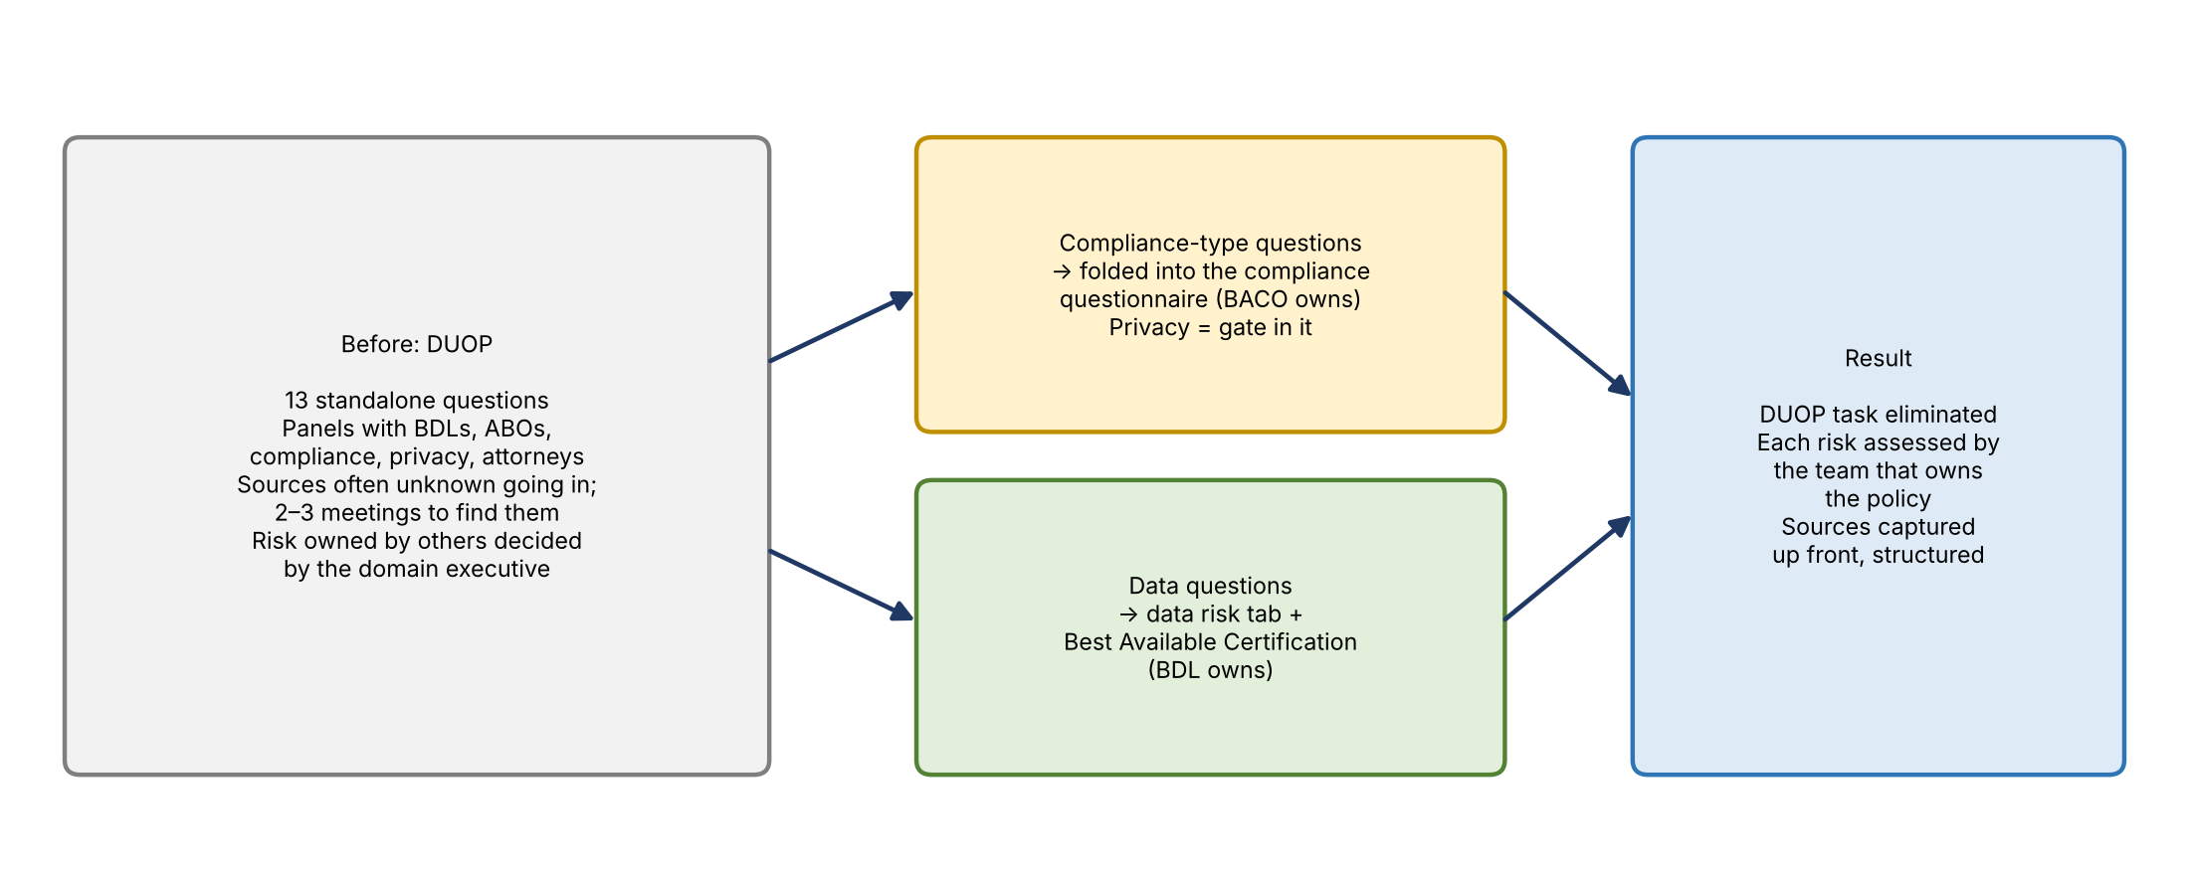
Figure 1. How DUOP's questions are being redistributed
- The 13 DUOP questions were consolidated. Where they duplicated compliance, they moved into the compliance questionnaire, and assessing them is compliance's job.
- What remains is data risk: are the sources best available given the known facts and the model's use?
- The DUOP task itself is eliminated and replaced by the Best Available Certification. The BDL group (the former DUOP admins) receives the task.
- Privacy is now a gate inside the compliance risk questionnaire, triggered by the data types selected. A later version will fold the GPQ privacy questionnaire into compliance. [BDL]
- For about a month after go-live, CDO will monitor and re-perform compliance's assessments to confirm they reach the same answers DUOP did and engage the same people. Privacy and compliance groups have been briefed; Alex will meet any other stakeholders the BDLs suggest. [BDL]

Concerns raised [BDL]
- HR and employment law (Michelle): HR has people who understand employment law; how will they still be engaged? Alex: compliance has a specific question on using models for HR decisions (a profiling question), and when HR data is used outside HR, the HR domain weighs in through the best available certification under its sourcing strategy.
- Losing visibility (Michelle): DUOP declined some uses in recent months and surfaced duplicate efforts across groups to executives, prompting strategy discussions. Alex agreed DUOP shouldn't be the place for strategic issues; it had become a forum where domain executives decide on risk owned by other groups. He expects more visibility now, since sources will be captured up front and back-end reporting can show which sources recur and which risk teams have discussed them.
- Alex's view of DUOP's value: he often couldn't see what was done differently or what risk was mitigated; the result was frequently awareness and then approval. The goal is to standardize assessments and send them to the teams that own the risks. This is version one.

5. End-to-end workflow
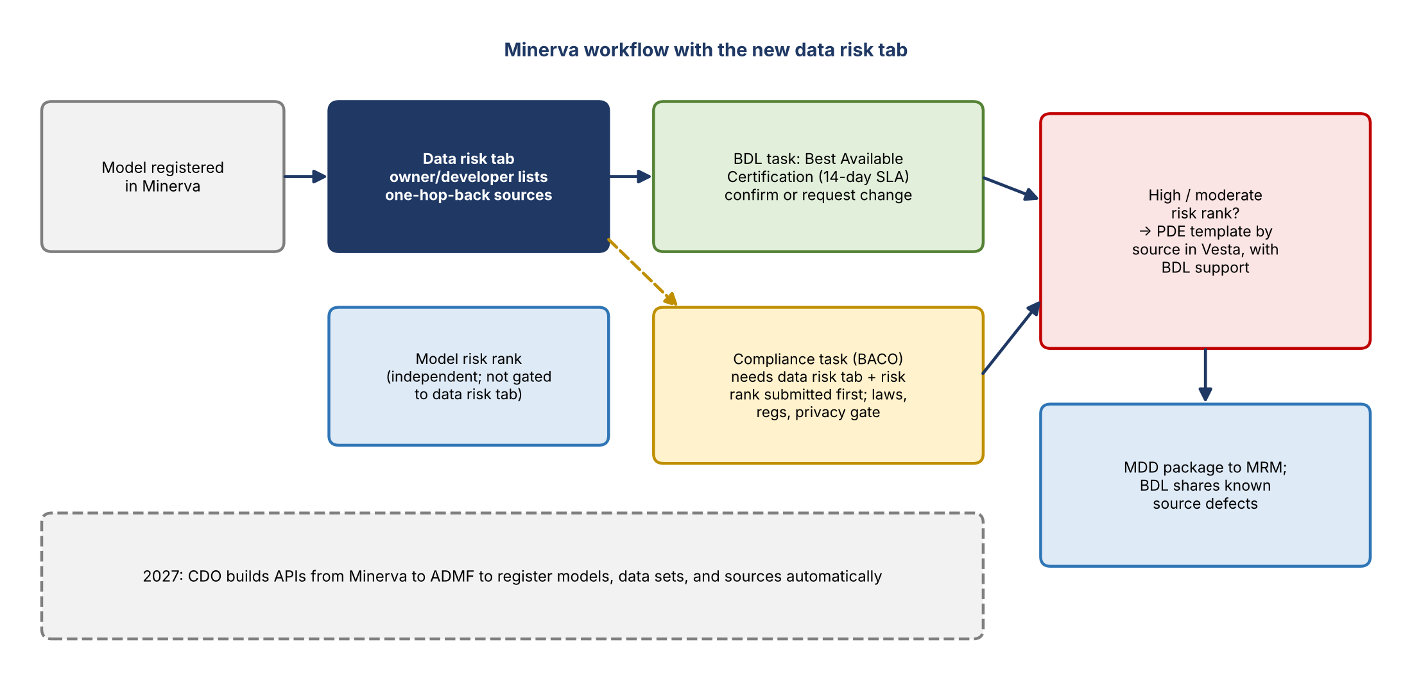
Figure 2. Minerva workflow
- Model owner or developer registers the model in Minerva.
- They complete the data risk tab, listing proposed or current data sources (one hop back, at the data source level).
- Submitting it routes a Best Available Certification task to the BDL, who confirms best available or requests a change (14-day SLA, matching compliance's SLA). The BDL considers sourcing strategy, quality, known defects, whether a better source exists, and cross-domain use.
- In parallel: model risk rank (independent), the compliance task (BACO), and for AIRR models the architecture/cyber screen.
- For high and moderate risk-ranked models: the PDE template by source in Vesta, completed with BDL support.
- The PDE template goes to MRM as part of the MDD package; validation reviews it much as it reviews sources and elements today, with a template for more precision.

Gating
- The data risk tab must be submitted (not approved) before the compliance task can be submitted, because compliance and cyber questions (for example, "do you use credit reporting agency data?") can't be answered without knowing the sources.
- The model risk rank must also be submitted (not approved) before compliance, and for AIRR models before the architecture/cyber screen.
- The model risk rank and the data risk tab are not gated to each other; this was agreed with Karen the week before. [RFAM] This addressed a question about early-stage development, when sources may not be final.
- The BDL and compliance reviews can run at the same time.
- The architecture/cyber screen's data sources section becomes read-only and pulls directly from the data risk tab, so the data is consistent.

Routing to the right BDL
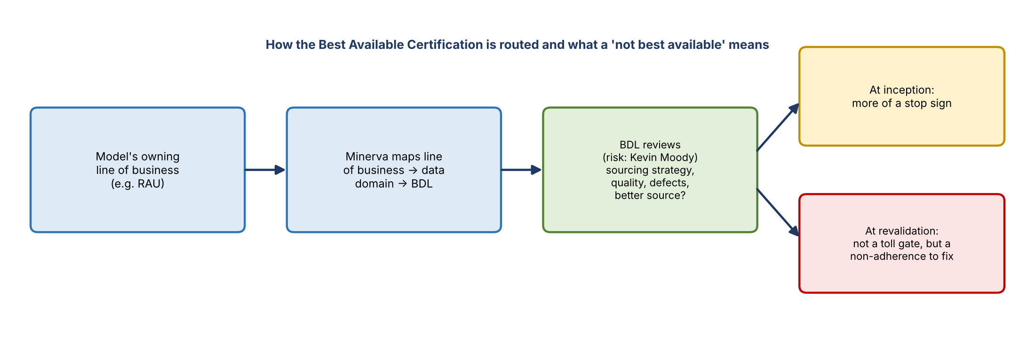
Figure 3. Routing and outcomes
- BDLs sit in each line of business or domain, loosely aligned to the CDO, and own the domain's sourcing strategy, sources, and data quality and risk mitigants.
- Minerva maps model lines of business to data domains, so tasks go automatically to the right BDL based on the model's owning RAU or line of business. Corporate risk has several lines of business rolling up to one domain.
- For risk models, the BDL is Kevin Moody, who has worked with RFAM on its annual data lineage exercise (the yearly request to confirm a PDF of data sources). [RFAM]

What a "not best available" conclusion means [RFAM]
- At model inception, it's more of a stop sign.
- At revalidation, it isn't a hard toll gate, but it creates a non-adherence that must be resolved, likely at the next model change.

6. The data risk tab (demo)
Joe walked through the tab in both sessions.
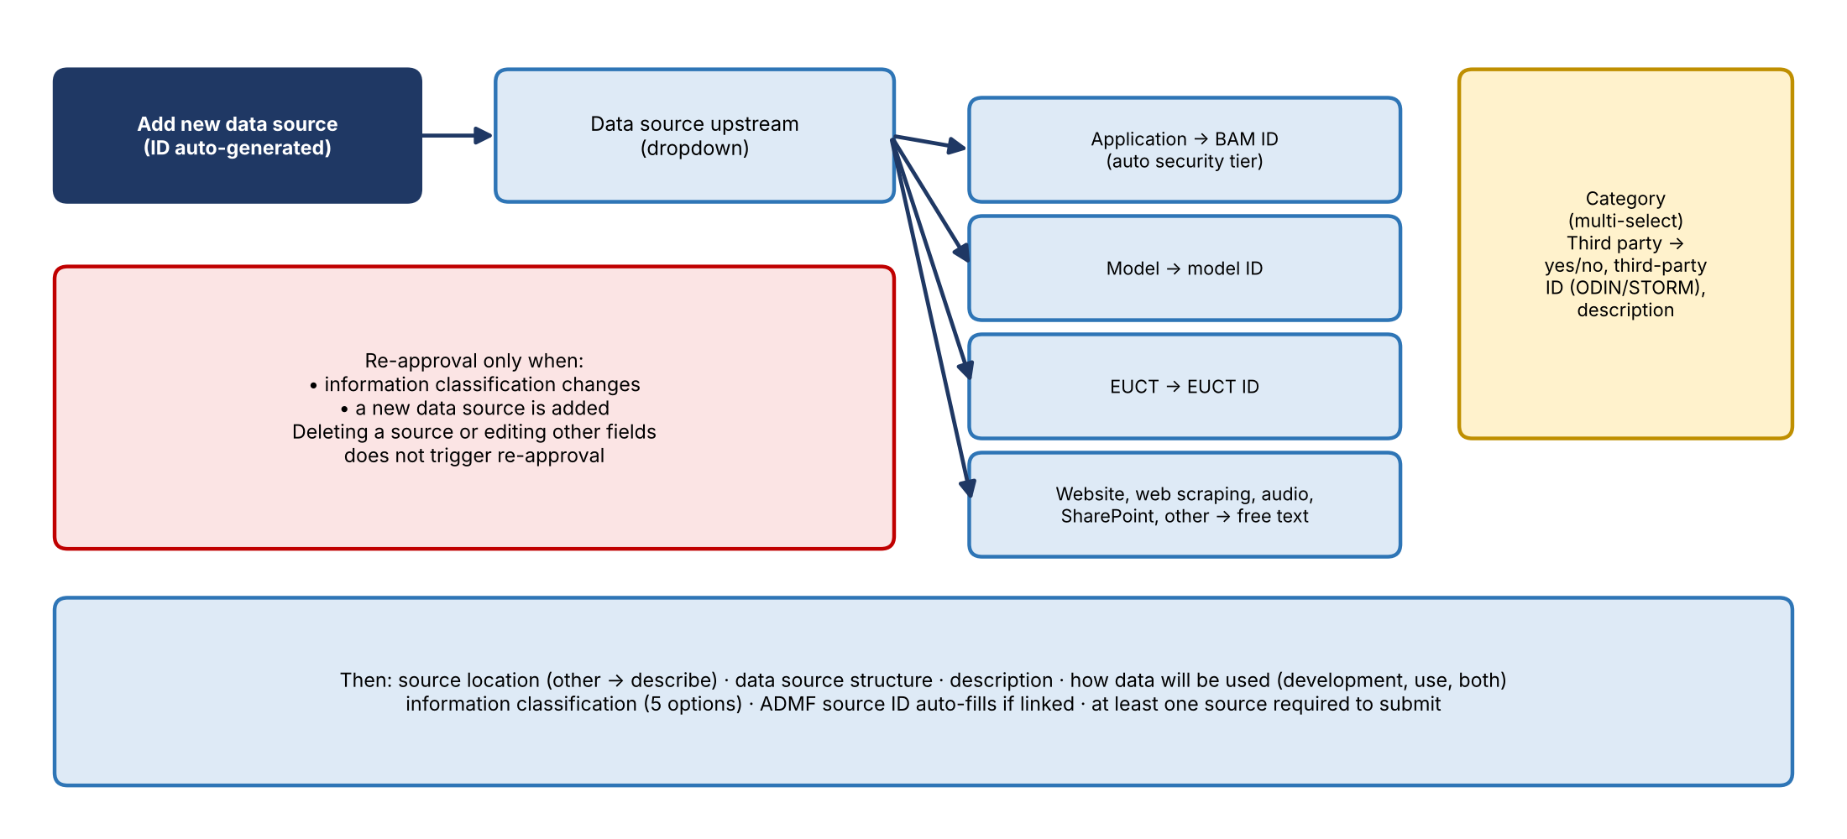
Figure 4. Data risk tab form logic
Field | Behavior
Source ID | Auto-generated by Minerva
Data source upstream | Dropdown. Application → select BAM ID (pulled in, not free text), which fills the application security tier. Model → model ID. EUCT → EUCT ID. Website, web scraping, audio, SharePoint, or other → required free text
Data source category | Multi-select. Third party adds a yes/no question, a third-party ID from ODIN (the STORM ID), and a description
Source location | Multi-select; other requires a description
Data source structure | Multi-select
Description | Free text; help text on several fields
How data will be used | Model development, model use (business use), or both
Information classification | Five options
ADMF source ID | Auto-fills, read-only, when the model ID, BAM ID, or EUCT ID is linked in ADMF

- At least one data source is required to submit, and you can never delete down to zero.
- The BDL can confirm best available or request change; request change sends it back to the submitter.
- After confirmation, anything can be edited. Only two changes trigger re-approval: changing the information classification or adding a data source. Deleting a source or changing other fields doesn't.
- Some fields appear only on the form, not in the grid; click the source ID to see them.
- Guidance text on the tab will be updated to say to list every internal and external upstream data source.
- No data risk rating is planned for now. [BDL]
- The design grounds sources in BAM, ADMF, Minerva, and dropdowns, since sources used to be captured through free text throughout the process. [BDL]

7. Phase 2: PDEs for high and moderate models
- After the risk rank, high and moderate models must capture the physical data elements planned as inputs, by source, in a template in Vesta, to meet data management policy.
- PDEs were partly in the MDD before; this standardizes the process.
- The BDL supports populating and QA-ing the template and shares known defects or issues in those sources. The goal is to inform model design and any mitigants or calibrations, not to make developers document every source defect.
- Responsibility is shared among model owner, developer, and BDL; Alex noted development to identify elements can take around three months, so this isn't a short-SLA task. [BDL]
- Both model estimation (development) data and production data must be covered. [RFAM]

Concerns raised [BDL]
- BDL workload: this puts responsibility on BDLs for something data management policy doesn't require for models. DMP requires implicating the sources and data sets (and showing strategic sources rather than someone's Excel file), not full PDEs. Kathy noted it's new, driven by the audit finding.
- Four-part keys may be impossible (Denise): for an AI model built inside a SaaS product, or a model using vendor sources (one tier 1 HR model uses 11 vendor sources). Answer: like regular PDE documentation, these would be marked not applicable; Alex and Denise will discuss further.
- Lower-risk models feeding tier 1/2 use cases (Kathy): only high and moderate models need PDEs, but a low-risk model could feed a tier 1 or 2 report. Alex: CDO is standing up a detective monitoring control to identify those cases; building it into the model process could come in a future version. Kathy sees use-case context as more critical than the model in isolation; they'll follow up.

8. Model developer questions [RFAM]
- Missing history in ADSs (Brian): some ADSs don't have enough history, so developers keep their own copy of the best historical data (a "patch file"). David: the guidance CDO and MRM wrote will accommodate scenarios like this.
- Upstream models: this differs from Minerva's existing upstream model list; only direct one-hop-back sources go here, with one model ID per row.
- Adjusted model outputs (Ryan): if an upstream origination or balance forecast is adjusted by a person and arrives as an Excel file, is that a model source or user-provided? David: think in data hops, not models; whatever sits in the middle (an application, SharePoint, a file) is what gets listed, possibly as an EUCT. Joe: user-provided data can be entered as other. The specifics will be clarified.
- Benchmark data (Ryan): data pulled only for benchmarking (for example, FRED industry delinquency series) that isn't used on an ongoing basis or to set parameters doesn't need listing. David agreed but said it's ultimately a CDO conclusion. Ryan wants it written into guidance and shown to audit up front to avoid issues later.
- Edge cases: David asked RFAM to nominate someone to help outline edge cases for the guidance document.
- Different source recommended: changes won't be immediate; they'd likely be handled at the next model change (see Section 5).
- Interconnected models: models on the same platform (PyFarm) can be linked by listing model A as an upstream source of model B.

9. Timeline and rollout
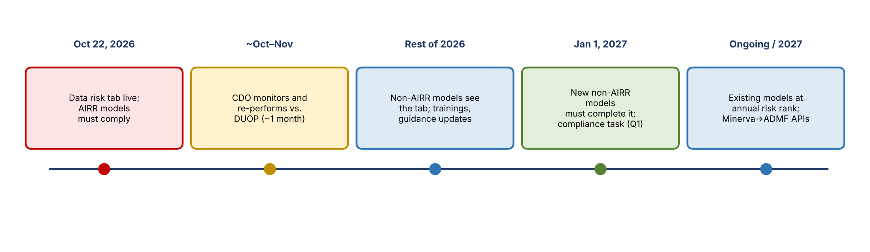
Figure 5. Rollout timeline
When | What
October 22, 2026 | Data risk tab goes live. AIRR models must comply immediately
About a month after | CDO monitors and re-performs compliance's work against what DUOP would have concluded
Rest of 2026 | Non-AIRR models see the tab but aren't required to use it; time to work out issues and update guidance
January 1, 2027 | Newly registered non-AIRR models must complete the data risk tab
Q1 2027 | Compliance task introduced for non-AIRR models, gated with the data risk tab
Ongoing | Existing models complete it at their annual risk rank assessment; it becomes a requirement for future validations
2027 | CDO builds APIs from Minerva to ADMF to register models, data sets, and sources automatically

- Training will come through frontline model governance sessions and joint CDO–MRM trainings over the coming months, plus written guidance.
- David will share the presentation materials. Alex offered one-on-one follow-ups.

10. What this means for our team
- Kevin Moody is the BDL for corporate risk models, so Best Available Certification tasks for risk models will route to Kevin's team, likely starting October 22 for AIRR models.
- The PDE template support for high and moderate models adds BDL workload.
- CDO's detective control for low-risk models feeding tier 1/2 use cases connects to the team's use-case and ADS work.

11. Action items
Action | Owner | Notes
Share presentation materials | David | With RFAM
Nominate someone to help define edge cases for the guidance | RFAM | Benchmark data, adjusted model outputs, patch files
Document edge cases in the guidance and review with audit | CDO and MRM | Avoid future findings
Follow up on vendor/SaaS models and PDE applicability | Alex with Denise | Not applicable handling
Follow up on low-risk models feeding tier 1/2 use cases | Alex with Kathy | Monitoring control; possible v2
Talk with HR about employment law coverage | Alex with Michelle / compliance | Profiling question
Monitor and re-perform compliance outcomes after go-live | CDO | About one month
Suggest any other stakeholders to brief | BDLs | Alex will meet them
Update tab guidance text | Joe's team | List every internal and external source

12. Open questions
- How should adjusted upstream model outputs and user-provided data be classified?
- Which supporting data (benchmarks, exploratory analysis) is out of scope?
- How will PDEs be handled for SaaS and vendor-sourced models?
- Will models below moderate risk that feed tier 1/2 use cases be brought in?
- Will the new process keep the cross-group visibility DUOP gave executives?
- Can BDLs absorb the PDE support work and the 14-day SLA?
- When will GPQ be folded into compliance?

