Meeting Notes
RADAR DPC Migration Status: Pre-Prod, Prod Parallel, and Cutover
Item | Detail
Meeting date | Thursday, October 8, 2026 (recording started about 10:32 AM)
Format | Recurring migration status meeting
Ran the meeting | Jen (Jennifer; project manager, runs the agenda and testing tracker)
Tech | Prasanta (tech lead), Krishna
Business / BAs | Stacey, Michelle, Jeff (asked the status questions; likely Jeff Goldsmith), Jeff (owner of the edits and uploads tool and entitlements), Jeff Gu, Ben
Also present | James (corporate risk; asked about downstream consumers), Thon (spelling unclear)
People referenced | Kyle (signed off CMAST), Hannah (GL issues), Shrivari, Nicole, Tammy, Sam, Safra's team, Rao, Kali and Parta (RAR MongoDB testing), Bill Harms and Jim Marks (RAR MongoDB owners)
Purpose | Status of RADAR's (Credit 360) migration from RDS to DPC: pre-prod validation, prod readiness, prod parallel testing, entitlements, and cutover

Note on the transcript
Auto-generated transcript; speakers aren't labeled, so attributions are inferred. Several people named Jeff spoke (Jeff, Jeff G, Jeff Gu, Jeff Wise), and it isn't always clear which is which. Readings used: CMAST (also "CMASS," "DMAST"), IHUB ("IHOP"), Dremio, VDS (Dremio virtual data sets), ECRLT, WDM (wholesale data mart), RAR MongoDB (also "rare Mongo," "red application"), RAG status ("yellow"). Unclear: "MANOPS exception," "ALCA" (who is fixing the S3 pop-ups), "Ogil," "Thon/Sarathon," and "my core model." Dates are 2026.

1. Executive summary
RADAR's move from RDS to DPC is on a tight but intact schedule. Phase 2 pre-prod business validation now ends October 13 (pushed from October 8), with prod environment prep running in parallel. Tech validates prod through October 16; prod parallel testing runs October 19 to November 16, led by the business with tech supporting; go/no-go is November 16; cutover is November 19.
Good news: edits and uploads DPC testing is complete for GL, Consumer, and CMAST (Kyle signed off CMAST the night before). The project stays yellow because of the many unexpected issues, a tight timeline with little recovery room, a program-level yellow on the DPC platform, and BA capacity strained by quarter-end. Jeff questioned whether that justifies yellow; the team agreed it does.
Two concerns came up. First, the RAR MongoDB and SSIS package validations are behind (RAR is about 15% complete) with an October 13 deadline. Second, downstream consumers such as the wholesale data mart haven't been told about the move and may need to change connections; Jeff called this an alarm. Jen will set up a meeting and office hours to inventory downstream users.

2. Timeline
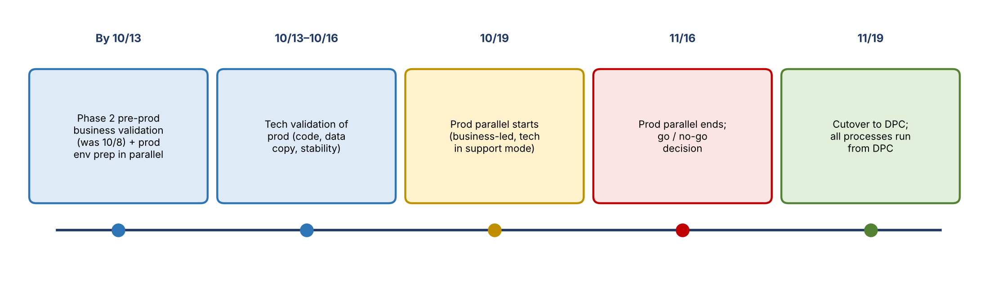
Figure 1. Migration timeline
Date | Milestone
By 10/13 | Phase 2 pre-prod business validation complete (originally 10/8). Tech prepares DPC prod in parallel: copying data, moving code and jobs
10/13–10/16 | Tech validates prod: platform stable, code and data copied, jobs running
10/19 | Prod parallel testing begins. One combined phase (not tech then business): the business compares RDS vs. DPC prod while tech supports issues
11/16 | Prod parallel ends; go/no-go decision
11/19 | Cutover (if no major issues): all processes run from DPC

- Only about four weeks for prod parallel validation.
- In DPC prod, daily jobs will be validated daily. Monthly jobs won't be triggered manually; the scheduler will run them on schedule, which also tests that scheduled jobs start on time. Prasanta will share any changes to the monthly job approach.

3. Status and RAG
- Phase 2 pre-prod: validation continues with no major issues Prasanta knows of. CMAST validation was a watch item until Kyle's sign-off.
- Overall status is yellow. Jeff asked whether yellow on the slide meant RAG yellow or just "in progress." Prasanta: the yellow cells mean in progress, but he's calling the overall migration yellow because of the number of unknown issues so far and the risk of unknowns in prod.
- Jeff's challenge: teams usually go yellow when they're behind the pace needed to hit the timeline, not because they're nervous.
- Team's response: yellow is justified by the combination of issues and a timeline with no room for error. Stacey cited ongoing problems with edits and uploads; consumer issues lasted until two days earlier, and Hannah is still seeing issues on GL. The DPC platform team is also reporting yellow at the program level (RADAR is one of many tenants).
- Vulnerabilities: tech addresses them where it can; when a fix would conflict with the DPC timeline, it requests an exception (transcribed "MANOPS exception") to defer it a few days. Assuming exceptions keep coming, vulnerabilities shouldn't affect timelines or tech capacity.
- BA capacity: juggling DPC testing with quarter-end has been brutal. Jeff asked whether there was an ask; Stacey said it's an acknowledgment, and she'll push back if testing ever overlaps quarter-end again.

4. Edits and uploads
- All edits and uploads DPC testing is complete: GL, Consumer, and CMAST. Some people worked late to finish.
- Kyle signed off CMAST, so edits and uploads can use the current production process.
- Intermittent pop-ups when hitting the S3 bucket are being fixed by tech; annoyances only.
- The tool has only one instance and can point to RDS or DPC, not both, so it can't be compared in parallel. Stacey and Michelle will agree with Jeff on when testing switches it to DPC so he can change the configuration.
- Cutover timing for the tool: Jeff wants to support month end in early November before switching from RDS; he and Michelle will discuss.

5. Entitlements and access
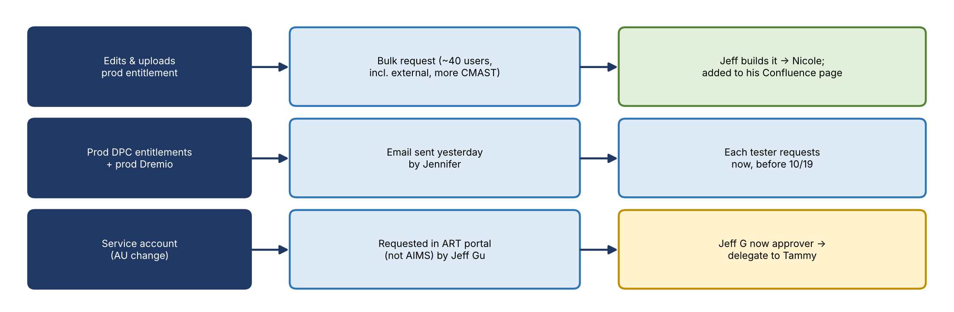
Figure 2. Entitlement requests
- Edits and uploads prod entitlement: Shrivari communicated it the night before. It's not in AIMS yet. Jeff is building a bulk request (roughly 40 users, including external users and more CMAST users than in UAT) to send to Nicole. He asked that no one else submit requests, to avoid duplicates, and will add it to his Confluence page for future users. Jen won't send a separate note.
- Prod DPC entitlements: Jen emailed the group the day before with the entitlements needed for prod parallel testing and the prod Dremio link. Everyone should request them now.
- Service account: because of an AU change, Jeff G now owns approval for the service account's entitlements, which come through the ART portal (not AIMS). Jeff Gu submitted the request and asked Jeff G to delegate approval to Tammy or someone else. Other groups with the same AU will see similar requests.
- Power BI connections: last round, Safra's team spent a long time finding the server name and port; the old port (32020) failed. Jeff asked tech to include connection details in communications. Jen will get the current details and email the whole group.

6. Prod parallel testing
Jen asked the business to be ready with test cases. The scope is confirming that what's in RDS is reflected exactly in DPC as of the same date, across use cases and data sets.
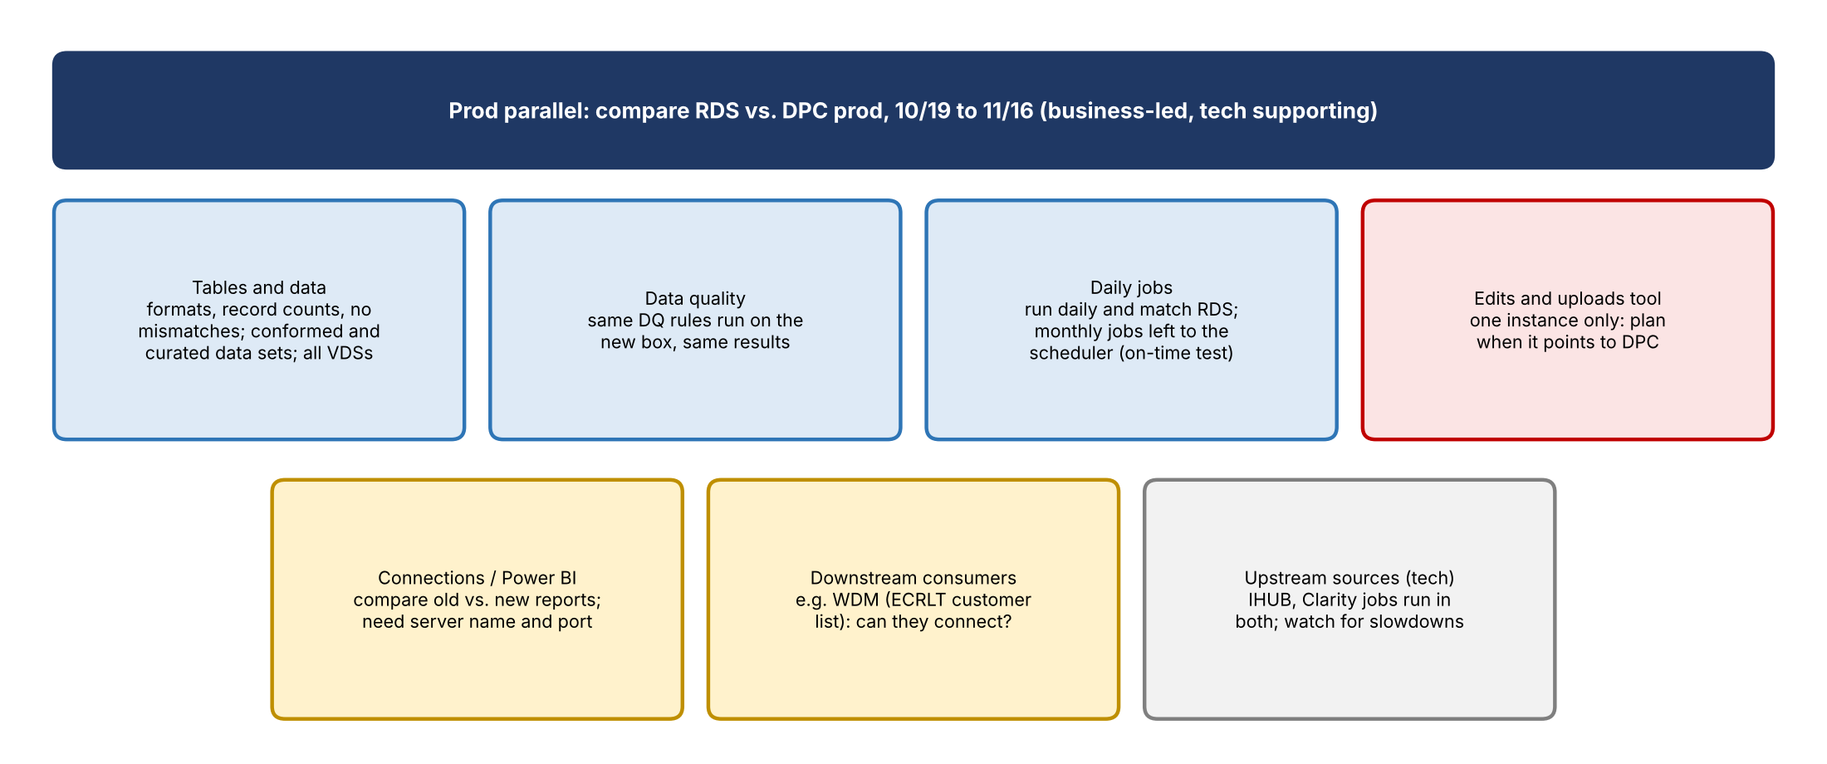
Figure 3. Prod parallel test scope
Component | How it's tested
Tables and data | Compare RDS and DPC: formats, presence of data, record counts; no mismatches. All conformed and curated data sets; confirm all VDSs appear in prod
Data quality | DQ rules run on the new environment and produce the same results
Edits and uploads | Functionality against prod; timing coordinated since only one instance exists
Connections and Power BI | Reports pointing to Credit 360 must be ready to compare old vs. new
Downstream consumers | Confirm they can connect and get the same data (after the data checks pass)
Upstream sources | Tech monitors whether running sourcing jobs in both environments slows or disrupts upstream systems such as IHUB or Clarity
Daily and monthly jobs | Daily jobs validated daily; monthly jobs run by the scheduler

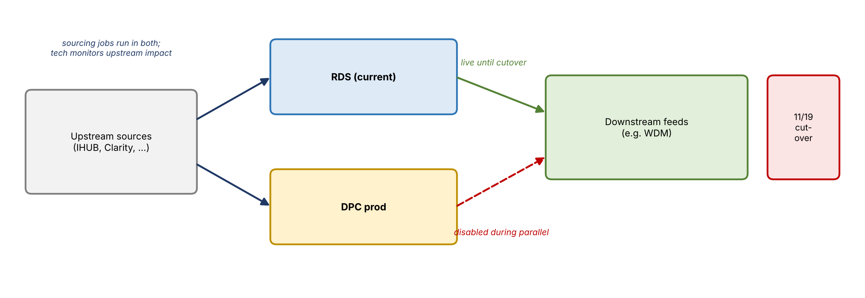
Figure 4. Data feeds during prod parallel
- During prod parallel, outbound feeds from DPC to downstream systems will be disabled so RDS and DPC don't send the same data and corrupt it. Downstreams keep getting data from RDS until cutover.

7. Downstream consumers
- James's question: who is "the business"? For example, the wholesale data mart (WDM) consumes the ECRLT enterprise customer list daily and feeds many financial crimes processes. WDM (CB/CIB) needs to confirm it can connect after the move and gets the same data. The answer was yes: downstreams are included, after the team first confirms the data is there and correct.
- Two layers of "business": RADAR represents its own downstreams to tech, but there are also the actual downstream users. Some, like users of the Moody's data, still consume it; others don't. It may help to separate enterprise functions (e.g., groups in COO) from business groups (e.g., CB/CIB).
- The gap: there hasn't been a forum to tell downstream users this is happening or that they may need to change connections. Service accounts may complicate it; individual users mostly just change the connection. The team acknowledged they're late.
- Plan: Jen will set up a meeting with Thon, Stacey, and Ben ASAP, then hold office hours and build an inventory of downstream users to drive communications. Jeff asked to be kept regularly updated, calling this a potential real problem.

8. Workstreams at risk: RAR MongoDB and SSIS
Workstream | Status | Notes
RAR MongoDB | Far behind on pre-prod validation; Krishna reported about 15% complete, 40 test cases done | Deadline 10/13. Owners: Bill Harms and Jim Marks. Kali and Parta haven't replied to daily update requests; consider a pull-up meeting. Some additional test cases are unclear
SSIS package | In progress | Rao moved it into Flowmaster; Michelle provided business testers. Validation: RDS minus DPC should be zero; any difference fails

- Prasanta is tracking these as a risk and will get updates later today.
- Jen tracks every test workstream daily in a burndown table: starting test count, current count, percent complete. She'll back into RAR's starting count (40 tests at 15%).

9. Decisions and agreements
- Pre-prod business validation deadline moves to October 13.
- Prod parallel is a single combined phase starting October 19, led by the business.
- Overall status stays yellow.
- Downstream feeds from DPC stay disabled until cutover.
- Edits and uploads won't cut over before early-November month end (to be confirmed by Jeff and Michelle).
- Jeff alone submits the bulk edits and uploads entitlement request.

10. Action items
Action | Owner | Notes
Finish phase 2 pre-prod validation | Business testers | By 10/13
Prepare and validate the prod environment | Tech (Prasanta) | Prep by 10/13; validate through 10/16
Submit bulk edits and uploads entitlement (~40 users) | Jeff | To Nicole; add to Confluence
Request prod DPC entitlements and prod Dremio access | All testers | Per Jen's email
Delegate service account approvals (ART) to Tammy | Jeff G | Requested by Jeff Gu
Send Power BI connection details (server and port) | Jen | Email to the whole group
Agree when edits and uploads points to DPC during testing | Stacey, Michelle, Jeff | Single instance
Decide edits and uploads cutover timing around month end | Jeff and Michelle | Early November
Prepare test cases for prod parallel | Business teams | Before 10/19
Meet to inventory downstream users; plan office hours and comms | Jen with Thon, Stacey, Ben | ASAP; update Jeff regularly
Get RAR MongoDB and SSIS status; consider a pull-up meeting | Jen / Prasanta | Kali, Parta, Krishna
Monitor upstream impact during parallel | Tech | IHUB, Clarity
Share any changes to the monthly job approach | Prasanta | —

11. Open questions and risks
- Will RAR MongoDB and SSIS finish pre-prod validation by 10/13?
- Which downstream users exist, and can they repoint connections before 11/19?
- Will remaining edits and uploads issues (S3 pop-ups) and GL issues be resolved in time?
- Will running sourcing jobs in both environments affect upstream systems?
- Can the BA team sustain testing through prod parallel after quarter-end?
- Will vulnerability exceptions continue to be granted?

