Meeting Notes
Working Session: Risk Data Sourcing Pillars and the ORM Roadmap
Item | Detail
Meeting date | Thursday, October 8, 2026 (recording started about 3:00 PM)
Format | In-person working session with a whiteboard and flip chart (photos in the appendix)
Participants | Jake and Vic (Kevin's team)
People referenced | Kevin, Jacqueline, Jennifer (ORM), Ryan, Mike G, Terry (ORCAP), Taylor (Tandems), Brian, Jared, Lauren, Scott Powell, Gwen, James Cantrino, Josh Farber, Jeff Goldsmith
Inputs reviewed | Vic's notes from yesterday's meeting (saved as the DPSO draft: data plane source onboarding), the pillars template, AI-generated detailed notes (numbered points 1–9), and Kevin's notes from today's meeting
Purpose | Turn the notes into a pillar structure and roadmap for a detailed deck for Jacqueline, and propose who works on what

Note on the transcript
Auto-generated transcript; speakers aren't labeled, so attributions are inferred, and non-work conversation has been left out. Confirmed spellings applied: ORCAP, BUSCRT (transcribed "BuzzCard"), FCTDS, CARET ("carrot"), IRP, Vera (transcribed "Vigora"), RADAR. Readings used: ORM (transcribed "ORF"; the whiteboard says ORM), IT&V ("ITMB"/"IT&D"), DPC, Dremio, FR 2590 ("FR2590"), FR Y-14 ("y14s"). Confirmed: DPSO (transcribed "DPSL") and Goldsmith (transcribed "Gold's"). Unclear: "BFA2" and "lrni." "Points" refer to the numbered sections of the AI-generated detailed notes.

1. Executive summary
Jake and Vic worked through the AI-generated notes from yesterday's and today's meetings with Kevin to shape a plan for Jacqueline. They agreed on a three-pillar structure plus a parallel DPC readiness workstream, captured on the whiteboard: Pillar 1, the risk data foundation (know what risk data is by knowing all its usage, starting with ORCAP and non-financial risk, with ORM as the first group); Pillar 2, existing RDS sourcing, lineage, and migration (needs BAs); and Pillar 3, net new sourcing (newer GenAI use cases and data not in RDS). An aside flags that the sourcing needs of the four EGRC applications are mostly unknown.
Their core principle: prioritization is use-case driven, because data alone can't say what matters. The ORM pilot shows the pattern: about 20 use cases, with 6 high-priority data sources feeding 3 of them, worked first and tracked with a RAG status. On the flip chart they sketched Note 8, an ORM roadmap/tracker: an October–November baseline, then assess and sequence, then 2027 work by priority (High = 6, Medium and Low to be determined).
The deck will be detailed (Jacqueline likes detail): a summary overview, a table of contents, then a detail section per pillar. They'll validate the roadmap with Kevin and aim to have the material ready by Tuesday.

2. How the session was run
- Saved the inputs together: Vic's notes from yesterday (the draft), the pillars template, and Kevin's notes from today.
- Agreed approach: first compare the documents, evaluate what's actually necessary, then consolidate, then build the template and formatting from the consolidated version.
- Walked through the AI-generated detailed notes point by point, mapping each point to a pillar on the whiteboard (Figure 1).
- Then reviewed today's Kevin-meeting notes for messaging and action items.
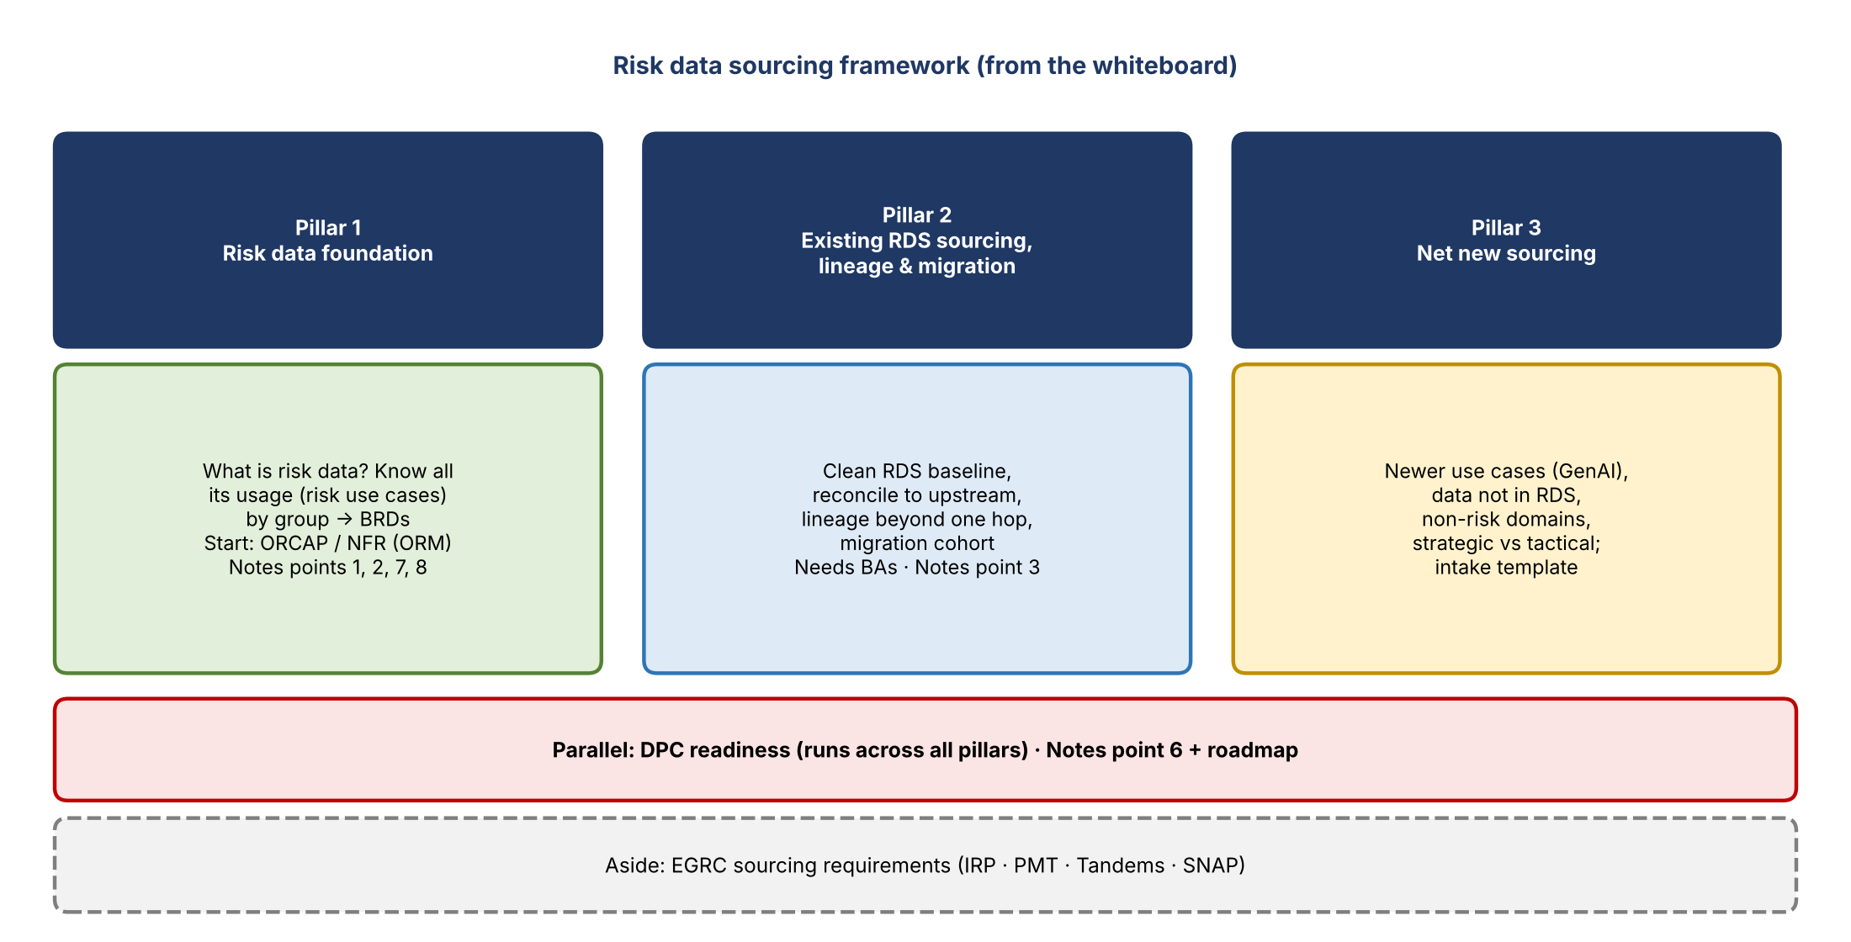
Figure 1. The pillar framework
Pillar | Notes points | What it covers
Pillar 1: Risk data foundation | 1, 2, 7, 8 | Purpose/direction, scope, process flows A, C, D, roadmap, prioritization, scorecard
Pillar 2: Existing RDS sourcing, lineage & migration | 3 | Current-state baseline, reconciliation, lineage, migration cohort, escalation evidence
Pillar 3: Net new sourcing | — | Newer use cases, data not in RDS, intake template
Parallel: DPC readiness | 6 + roadmap | Migration validation, access, dependencies
Parked (keep on radar) | 4, 5 | Data contracts and metadata; central vs. direct sourcing

3. Overall direction (from the notes)
- Move from "we need data from application X" to business requirements naming specific elements, meaning, intended use, timing, frequency, and historical coverage.
- Compare requirements with upstream approved data sources and build a prioritized migration roadmap. The ORM AI initiative is a test case for the process, not the whole corporate risk portfolio.
- Near-term goal: a credible plan through year end showing progress on AI and broader risk data enablement. Requirements, analysis, prioritization, and governance design can proceed despite engineering capacity limits; delivery commitments still depend on capacity and platform readiness.
- Don't wait for a perfect folder structure or future-state framework before analyzing priority needs, but don't confuse "already sourced" with "available, suitable, and authorized."
- Success in the near term: an evidence-based list of the next sourcing opportunities (value, current coverage, ADS readiness, gaps, dependencies), so leadership discusses capacity and investment instead of hearing that upstream sources aren't ready. Keep analysis readiness separate from delivery readiness.
- Enable data for risk AI initiatives without the sourcing team owning or judging every AI model.

4. Pillar 1: Risk data foundation
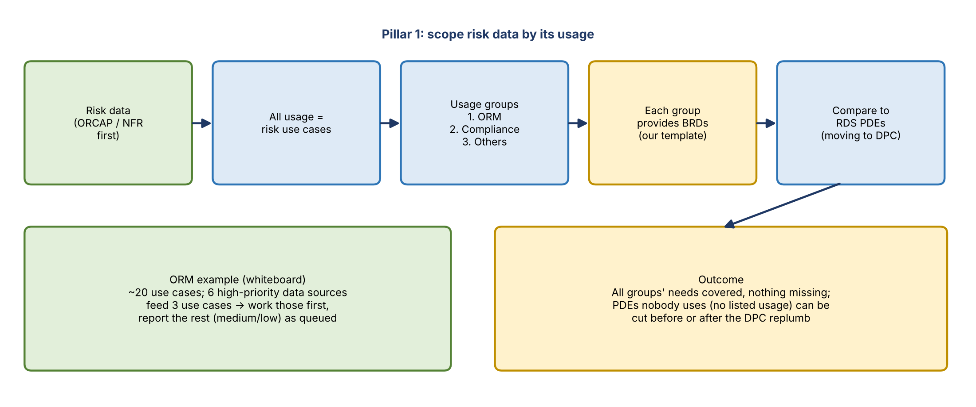
Figure 2. Scoping risk data by its usage

Why start with ORCAP and non-financial risk
- ORCAP: the de facto home of the bank's non-financial risk data (issues, RCSA, everything not used for financial reporting). ORCAP and EGRC are expected to combine at some point. It's the data the team controls most.
- BUSCRT: heavily reliant on upstream financial sources (home lending, consumer, CIB).
- FCTDS: risk owns the aggregators, not the data. Vic's earlier analysis for Jacqueline found about 98 financial crimes sources, all from outside the domain. Example: a transaction monitoring defect traces back through FCDS to sources like Newton and Hogan CIS.
- Starting with ORCAP/NFR data (issues management, RCSA) is the fastest path to a completed AI use case, gives Jacqueline visible progress (for example, to show Scott Powell), and builds a reusable framework without first solving the whole business data taxonomy.

Use-case-driven scoping
- To know what risk data is, know all its usage (risk use cases). Group the users (ORM, compliance, others); each group provides BRDs, the way ORM is doing now with the template.
- Compare against PDEs already in RDS. PDEs that no group lists can be cut. Kevin has already asked Brian whether anyone uses certain raw RDS data sets, since many seem unused.
- Future GenAI use cases from the same group still bring BRDs; because the data is already on the plane, their sourcing is faster, and only missing elements need new sourcing. This is "all at once" for one use case's requirements but piecemeal for the group overall, given capacity and upstream dependencies.
- ORM example: about 20 use cases; if Jennifer identifies 6 data sources feeding 3 high-priority use cases, work those first and show the remaining 17 (medium/low) as queued. Track with RAG status in leadership reporting (such as Jeff Goldsmith's report), as Vic did on the E1 project (high-priority, GL-driven items first).
- Prioritization must be use-case driven; senior leaders care about what can be automated and the riskiest items. Policy still requires sourcing requirements for all tier 1 and tier 2 use cases (models, analytics, reports).
- Tier 3 needs often reuse elements already sourced for tier 1 and 2 work, so cross-requests can be matched. For tier 3, knowing which data set is used may be enough; tier 1 and 2 need element-level detail.
- Some NFR data won't have a tier 1/2/3 tag (for example, a dashboard metric). It still needs to be logged. ORCAP data isn't tagged as general-use data sets yet; that was assigned to Jared but hasn't progressed.
- Vera will likely be logged as a model with a model use; until a use case exists, sourcing can be tied to the model (like models feeding models). Scott raised that risk and finance may source differently for ADA; focus on risk's needs and let finance or ERAFT attest to cross-requirements.
- Kevin suggested Jennifer review what CARET produces (outputs and dashboards); that list could become a checklist to tag as use cases. Identifying and rebuilding the important CARET dashboards is a later ask; Ryan likely knows CARET best.
- The existing analysis of 142 use cases (PDEs, sources, Copilot-proposed subject areas) is a reference starting point, not complete lineage. It may help Credit 360 more than ORM.

Strategic ADS vs. one hop back
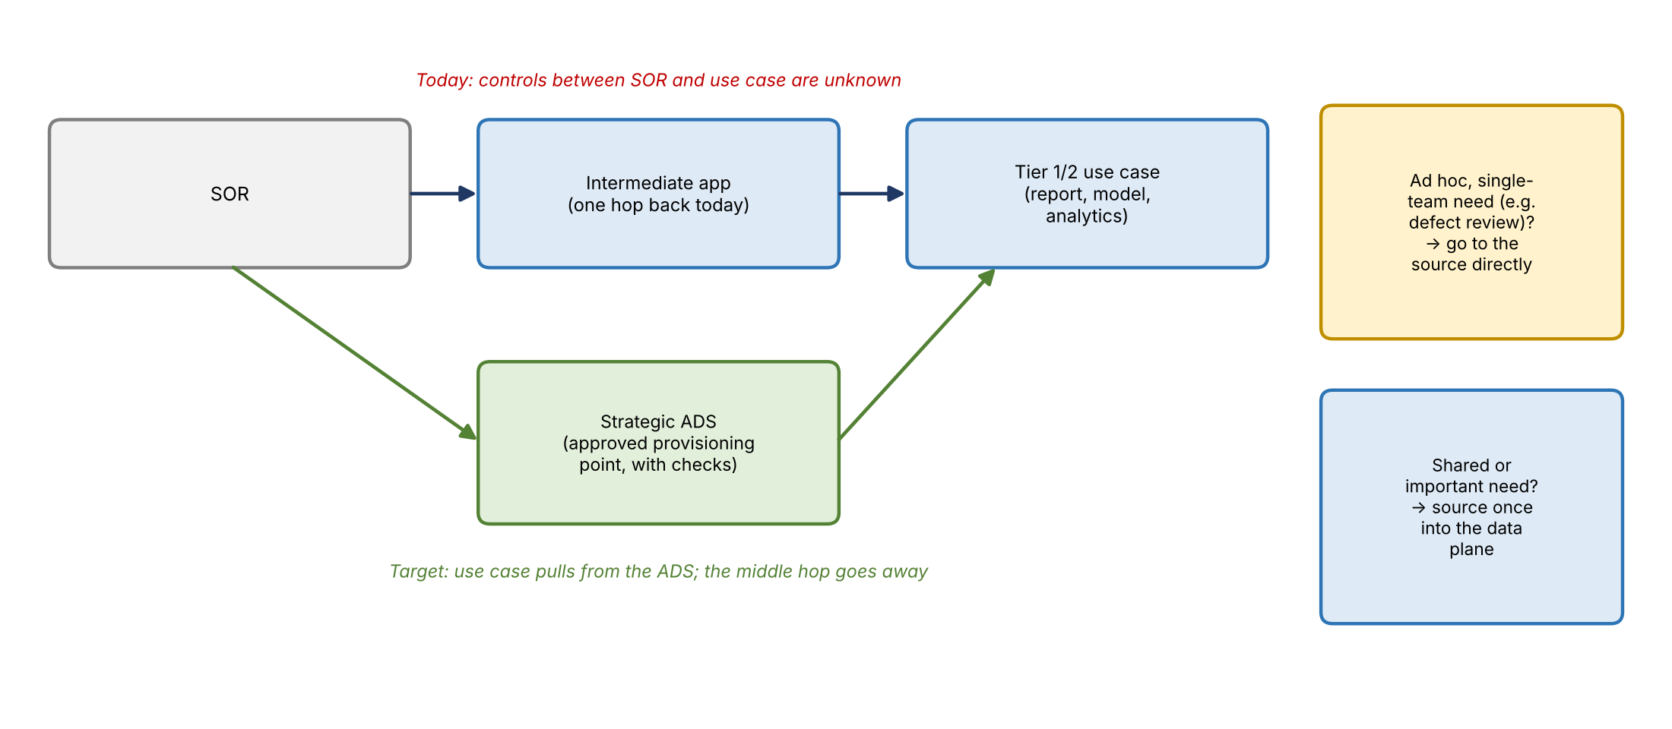
Figure 3. Sourcing logic
Data management documentation goes one hop back, but this work goes to the true owner. Once data is validated and provisioned through an approved ADS, the use case just needs to pull from that provisioning point, and the intermediate hop can go away. The ADS carries the checks (for example, an ID must be exactly eight digits, no invalid characters) that today's intermediate application may lack, and pulling from it simplifies sourcing across the enterprise.
- Subject areas, groups, and categories (and the CDO certification buckets, such as stand-up and provision-ready) need to be enforced, ideally by CDO. Example concern: IHUB passed stand-up certification with only about 10% of its intended checks.
- Proposal: use Copilot/AI on today's RDS risk data (issues, RCSA) to mock up a subject-area breakout early, before certification requires it.

Scope boundaries
- The data plane serves all risk needs (reporting, analytics, investigations), not just AI.
- Customer data can be shared, but BUSCRT and FCTDS may need different fields or derivations; if the upstream data is the same, source once and derive in each area.
- Ad hoc, single-team needs (for example, one team reviewing CIB CRO defects for a quick analysis) should go directly to the source rather than being sourced strategically onto the plane.
- Matching is not validation: Copilot can help find candidate matches and alternate names, but a business decision confirms them.

Finance and risk overlap
- Focusing on ORCAP/NFR first limits cross-domain work. BUSCRT and Credit 360 will be much harder.
- Pushing finance to own shared data needs a documented story; Jacqueline and Gwen would carry that conversation. Vic will build a diagram for Kevin comparing how another large bank splits finance and risk data ownership.
- Example: FR 2590 counterparty aggregation reporting may not belong in risk's book of work; finance was supposed to own it when FR Y-14 moved to their area.

Also in Pillar 1 (from points 7 and 8)
- Flow A (net new demand intake): capture the business outcome and deadline, clarify ambiguous apps and fields, search current RDS/DPC coverage, confirm meaning with the business, compare with the strategic ADS, then choose strategic, justified tactical, or escalation. This is Pillar 1.
- Flow B (raw RDS inventory to consumers): a nice-to-have for now, since there's no data dictionary or metadata showing who else uses an element.
- Flow C (sourcing route decision) and Flow D (shared element inventory): part of Pillar 1; D is future work once data is on the cloud.
- Prioritization lens: combine business criticality, strategic ADS fit, and existing connections. Many requesters alone shouldn't decide priority; a highly requested non-ADS app should prompt an element-level review.
- Scorecard: per subject or data set: requested, confirmed, covered, and missing elements, current and target source, validation status, dates, owner, blocker, next decision. Use separate statuses so an application-level green check isn't read as end-to-end readiness. Only possible once each group has templates; can be automated later.

5. Aside: EGRC sourcing requirements
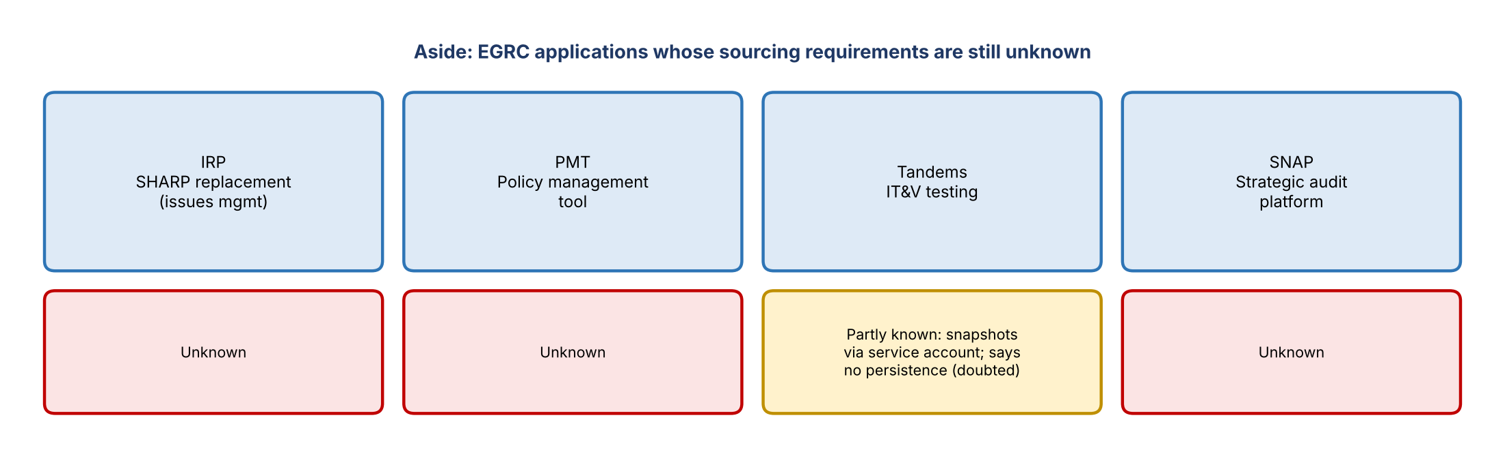
Figure 4. EGRC applications
- EGRC has four applications: IRP (the SHARP replacement, formerly ORP, for issues management), PMT (policy management tool), Tandems (IT&V testing), and SNAP (strategic audit platform).
- Only Tandems' needs are known: it reportedly uses snapshot data through a service account to test specific systems and doesn't persist it. The team doubts that's complete, since AI-driven testing likely needs persisted data to build SQL queries, and the details came secondhand.
- IT&V-type groups should get in line with the data plane: their snapshots may be several quarters old and may not meet other groups' needs.
- Kevin and Jacqueline need to find out the other three applications' requirements; Jacqueline reportedly wants to dig into this, and the team could help. Kevin may already know more about IRP, PMT, and SNAP.

6. Pillar 2: Existing RDS sourcing, lineage & migration
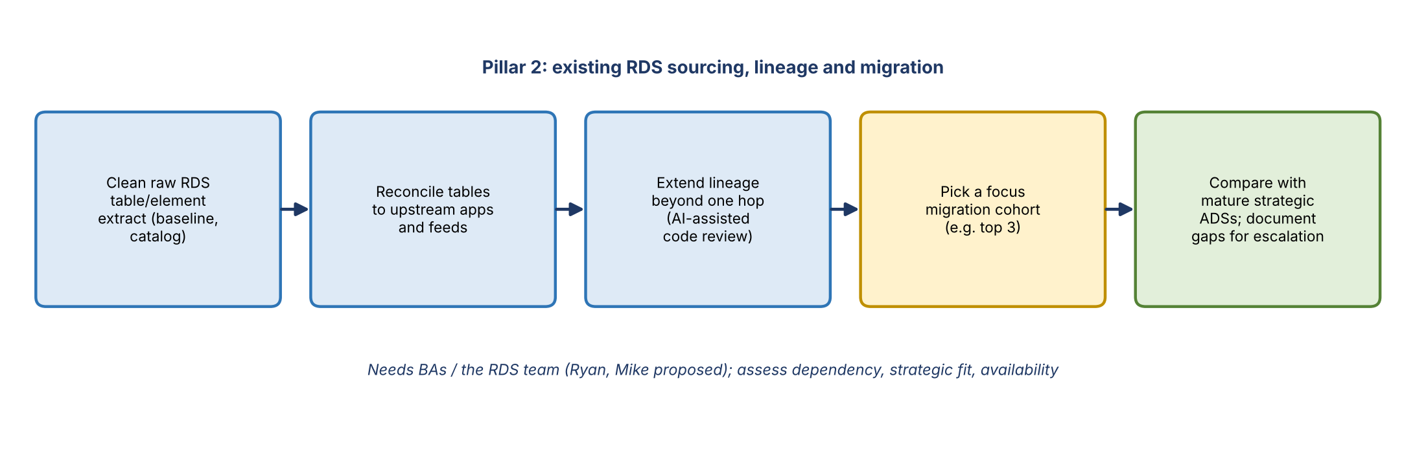
Figure 5. Pillar 2 steps
- Understand what already enters RDS, why it's used, whether there is strategic upstream ADS coverage, and how current feeds should migrate. ORM's requests won't start from scratch.
- Build a clean raw RDS table/element extract as a reusable baseline (part of the catalog Kevin wants), instead of ad hoc Copilot pulls. Table and schema names give clues to upstream apps, but need confirmation.
- Reconcile tables and elements to actual upstream applications and feeds; identify business subjects and current consumers.
- Extend lineage beyond one hop for selected tier 1 and 2 dependencies, tracing outputs back to raw inputs through transformation code (AI-assisted code review).
- Select a focus migration cohort (the notes suggest a top three) and compare with the most mature strategic ADSs, though few are mature.
- Evidence for escalation: documented requirements and owner-confirmed gaps (the branch data example: an ADS may exist but lack capacity to deliver on time).
- Staffing: this is BA work and a job in itself. Proposed owners: Ryan (framework owner) with Mike, as the RDS team. Vic suggested Jake could lead a scope as a product lead rather than do BA work; Jake was hesitant, and it was parked. Kevin decides.

7. Pillar 3: Net new sourcing
- Newer use cases, especially GenAI, needing data not in RDS today, including non-risk data from other domains.
- Use the ORM pilot to validate element-level intake, reuse existing coverage, and choose strategic sourcing or justified tactical (conditional) sourcing. Example: if the aligned ADS won't be ready until 2029 or 2030, keep sourcing tactically.
- Covers escalation to other domains and how it's tracked.
- Intake template: standardizing and automating the survey sent to Jennifer is a separate initiative used mainly by Pillars 1 and 3. Jacqueline wants it prioritized when she talks to technology, to move off Excel workbooks.

8. Parallel: DPC readiness
DPC readiness sits below the three pillars on the slide because it cuts across all of them. The migration is a lift and shift to meet the year-end deadline, and business validation isn't being assessed (seen today with Credit 360).
- Identify which tenants and data sets are in pre-production and who coordinates validation (Ryan).
- Confirm access to the new DPC Dremio instances; existing entitlements may not carry over.
- Get migration stories, test plans, results, and business review evidence (Ryan).
- Keep requirements analysis going from the RDS extract rather than waiting for all DPC data.
- Dependencies for the roadmap: platform readiness, upstream ADS readiness, consumer requirements, engineering capacity, and governance decisions.
- Proposed owner: Mike (involved in DCF, DataHub, and DPC readiness), with Ryan on tech/business deadlines. Kevin decides.
- Reuse what's already been discussed with Jacqueline, and Vic will add his notes from today's conversation with Goldsmith on BUSCRT issues and a view of what good DPC migration tracking looks like.

9. Parked items (keep on radar)
- Point 4, data contracts and metadata: Mike raised that current JSON artifacts may lack element-level business rules. Not a priority today.
- Point 5, architecture: a persistent common data plane that shields consumers from upstream changes vs. direct or transient access to upstream data. Pinned. IT&V-style connections are useful but aren't shared coverage.

10. Note 8: ORM project roadmap / tracker
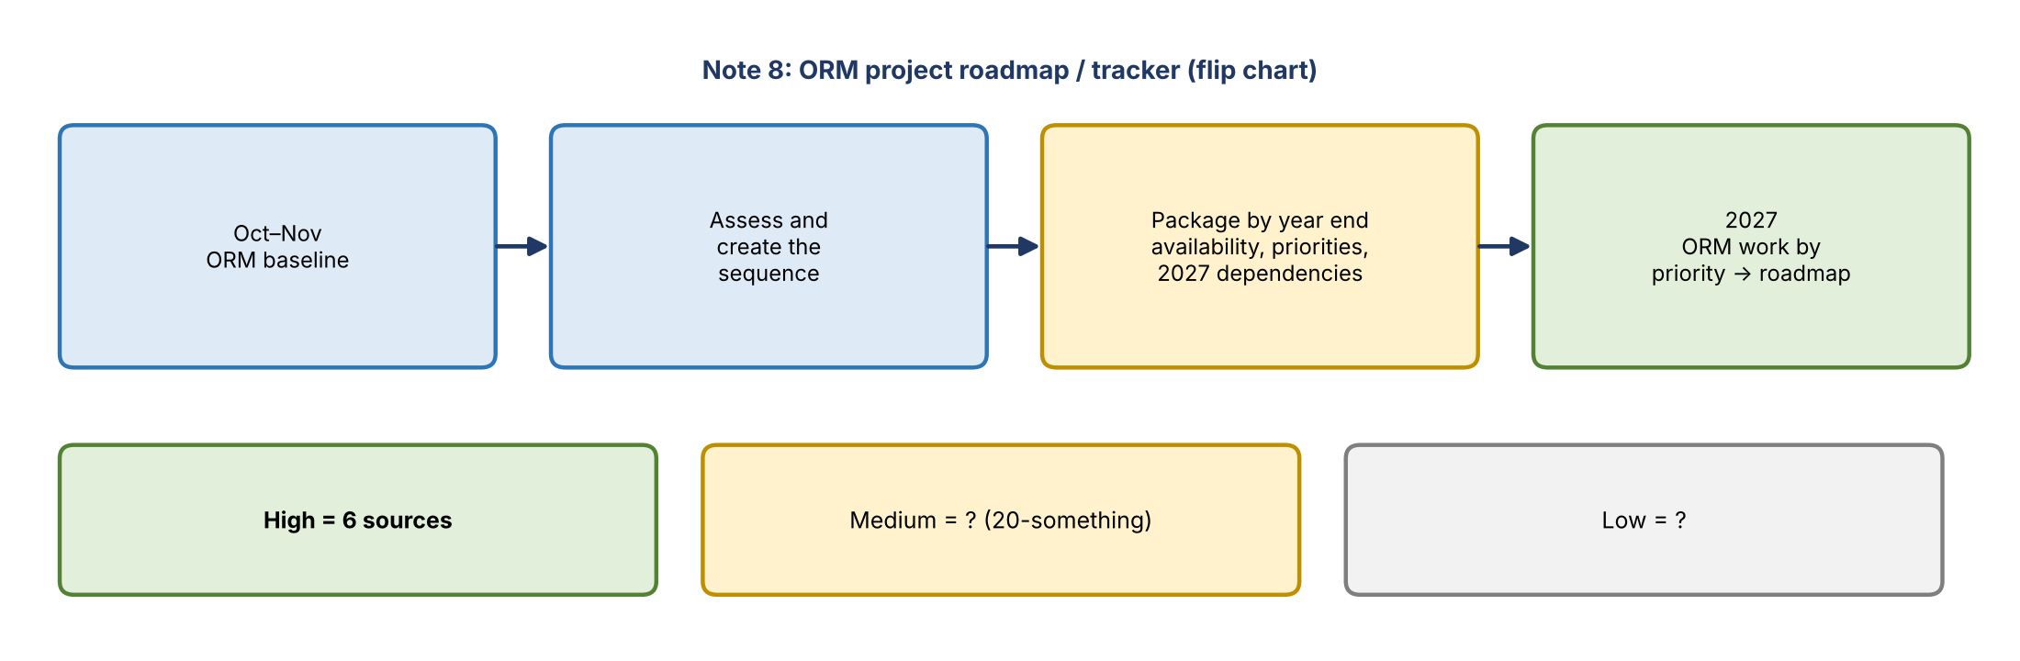
Figure 6. ORM roadmap / tracker (flip chart)
- October–November: ORM baseline (the current work with Jennifer).
- Assess and create the sequence: validate element coverage with Jennifer and ADS owners; select the first migration cohort (the 5 or 6 high-priority sources).
- Year-end package: availability, priorities, decisions, and 2027 dependencies.
- 2027: ORM work by priority (high, medium, low) as the leadership-ready roadmap. High = 6 sources; medium is about 20-something; low to be determined.
- The original 54 sources will likely be trimmed, since some are already clearly not needed. The tracker can then be reused for other projects.
- The AI-generated roadmap (October baseline/pilot, November assess/sequence, December package) is a starting point, not a roadmap: it assumes ORM finishes in October, and engaging the business to validate elements will take longer. Review with Kevin.

11. Review of today's notes with Kevin
- Framing for the deck: Jacqueline thinks like a program manager with a PMO background and wants a timeline, game plan, and strategy (step 1, 2, 3). Bringing a plan is good even if she redirects it.
- Two-horizon roadmap: separate what's achievable soon from high-impact sources that need other teams.
- The source-prioritization flow (strategic list, ADS maturity, element needs) belongs to the longer-term strategy.
- Keep action items scoped to ORM for now.
Horizon | Action items
Near term | Map ORM's required elements; map elements to CDO data subjects; select the first source to pursue (waiting on Jennifer); define the data plane landing approach (needs refinement with Ryan; set guardrails so data isn't sourced without a reason); continue supporting ongoing ORM AI work
Longer term | Identify re-sourcing candidates (other risk teams needing the same data); define how RCSA data is organized (talk to Mike and Kevin); build backlog asks for other teams

- The generated template document broke things out too much and wasn't useful; the team will keep the pillar structure from Vic's notes and add some of this messaging.
- The timeline is for Kevin's one-on-one on Friday.

12. Deck format
- Detailed, because Jacqueline wants detail.
- Structure: a summary overview of the pillars, a table of contents, then detail slides per pillar, modeled on the RADAR team's deck (a readiness snapshot across groups, then several slides per area).
- The detail sections double as guidance for whoever owns each pillar (for example, the BAs on Pillar 2).
- Use AI to draft the deck from the consolidated notes.
- Include a view of who does what (product leads, BAs, tech), so Jacqueline can see the team's buckets.

13. Decisions
- Three pillars plus a parallel DPC readiness workstream, with EGRC as an aside.
- Prioritization is use-case driven; start with ORCAP/NFR and the ORM high-priority sources.
- Ad hoc single-team needs go to the source directly instead of the data plane.
- Points 4 and 5 are parked.
- The deck is detailed: summary, table of contents, then pillar details.

14. Action items
Action | Owner | Notes
Consolidate the notes and build the pillar deck | Jake and Vic | Target Tuesday
Review the ORM roadmap/tracker and pillars with Kevin | Jake and Vic | Before or at Friday's one-on-one
Propose pillar owners (BAs, product leads, tech) for Kevin to confirm | Jake and Vic | Ryan/Mike for Pillar 2 and DPC readiness
Get Jennifer's high-priority sources and use cases | Jennifer | Drives the first cohort
Ask Jennifer to review CARET outputs and dashboards | Kevin / team | Candidate use case checklist
Find out IRP, PMT, and SNAP sourcing requirements | Kevin / Jacqueline (team can help) | Plus validate Tandems' approach
Build a finance vs. risk ownership comparison diagram | Vic | For Kevin
Mock up a subject-area breakout for RDS risk data using AI | Team | Issues and RCSA first
Add Goldsmith BUSCRT issue notes and DPC tracking view | Vic | For the DPC readiness section

15. Open questions
- Who owns each pillar, and do Ryan and Mike have capacity?
- What are IRP's, PMT's, and SNAP's sourcing requirements, and is Tandems really not persisting data?
- Which RDS raw data sets are unused and can be cut?
- Which strategic ADSs are complete or near complete (a question for Jennifer and the ADS owners)?
- Who will tag ORCAP's general-use data sets?
- Persistent common plane vs. direct access: when does each apply?
- How long will ORM's baseline really take?

Appendix: Session photos
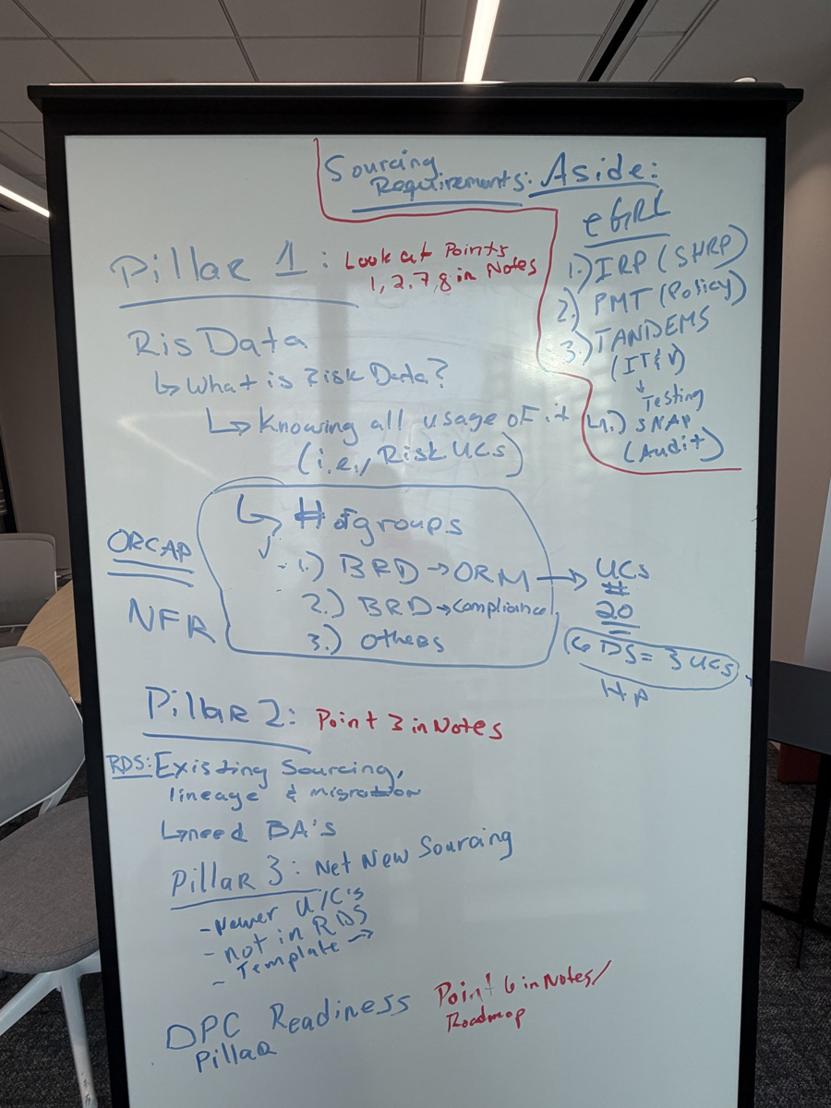
Whiteboard: pillars, the ORCAP/NFR groups, and the EGRC aside
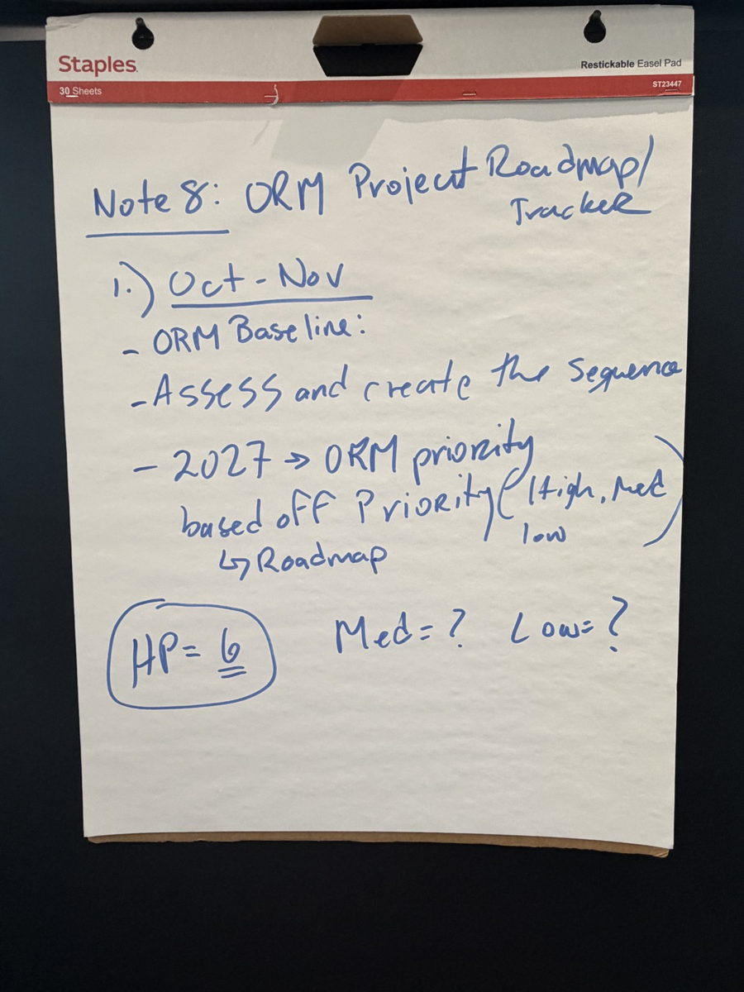
Flip chart: Note 8, ORM project roadmap / tracker

