Meeting Notes
AIDA Data Quality Status & Risk Workstream Update
Item | Detail
Meeting date | Monday, October 26, 2026 (recording started about 11:32 AM)
Format | Status call. Damian presented the AIDA progress slide; Yashica then shared her draft weekly status for risk.
Data management / AI team | Damian (AIDA delivery), Yashica (lead)
Risk side | Kevin, Mike, Vic, Jake
Referenced | Jordan (executive demo audience), Parul, Ashley, Terry, Brian Miller, Chitra (COO BDL), Vikram, Gwen, Eric, Jacqueline, Kathy
Purpose | Update risk on AIDA data quality progress and timelines, settle where AIDA stands next to Qualytics, and preview Yashica's weekly status of the work her team does with risk

Note on the transcript
Auto-generated transcript; speakers aren't labeled, so attributions come from context. Confirmed: AIDA (transcribed "ADA"/"IDA"/"Ida"/"IDETA"). Readings used: Yashica, FDLZ, DataHub, Tachyon, Qualytics, MRM, ORCAP, CARET (transcribed "CARIT"), SAR. Unsure: Damian (also "Damien"), Parul (also "Paril"), Jordan's surname ("Scott" was a guess on the call), Chitra, Vikram, "Nicole" (addressed near the end), "Paul" (sign-off), and "Art of Possible".

1. Summary
Damian reported solid progress on AIDA, the AI data quality capability: repos complete, FDLZ data sets tested, APIs being finished this week. Next come storing and retrieving rules (about two weeks) and contract table integration (by Nov 25), for a tactical go-live in the first week of December, with the UI targeted for the same time. The MVP targets Q1 2027.
Other points:
- Executive demo this week: risk will be represented, per Mike's ask.
- Qualytics: CDO is pursuing it enterprise-wide but has no contract, which is two to three quarters away. AIDA is already in production with MRM approvals.
- AIDA for risk: waits on DataHub, with ORCAP going first. There's no pilot left to run, since rules for risk were already generated. What's left is the UI and workflow.
Yashica previewed a weekly status covering all her team's risk workstreams; she'll send it to Kevin only. A side discussion on automated lineage confirmed that code access, not tooling, is the blocker, and that it's an enterprise problem.

2. AIDA progress and timeline (Damian)
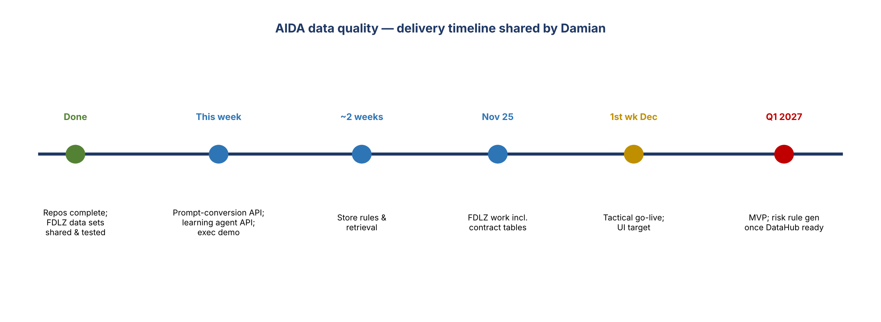
Figure 1. AIDA delivery timeline
Item | Status
Spark-based profiling | Solid progress
SQL and repo changes | Repos completed
FDLZ data sets | Data sets generated, shared, and tested; integration pieces still in progress
API testing with prompt conversion | Changes being made; hoped to finish today
Learning agent API | Testing to finish this week. The main API was last week's work.
Storing rules and retrieval | About two weeks
FDLZ contract table integration | Target Nov 25
Tactical go-live | First week of December
UI | Still in progress; target first week of December (some changes in approach)
MVP | Q1 2027

Executive demo
- Demo later this week for an executive audience to show completed work. Kevin isn't on it; it's for a different audience, including Jordan (surname uncertain).
- Mike asked whether risk is represented, since otherwise it's just finance. Damian will check with Yashica, who hasn't sent the invite yet. Yashica agreed risk should be included.
- Yashica: it's called a POC, but the back end is actually being implemented. Some handoffs need finesse, but it shows the end-to-end DQ capability using AIDA, with DataHub in the picture.

3. AIDA vs. Qualytics
- Mike asked whether AIDA and Qualytics are still being weighed, and whether CDO is waiting on a yes/no from domains.
- Kevin: CDO is working with Qualytics on a broader basis and isn't waiting on risk. Risk went with AIDA because Qualytics had no path to production: there's no contract, and one is two to three quarters away. If CDO solves it enterprise-wide, risk can adopt that and not build anything.
- Yashica: AIDA already has its agent established and available in production, so the painful steps (taking an agent to prod, MRM approvals) are done.
- AIDA isn't live for risk because of the DataHub dependency. ORCAP is finalized as risk's first DataHub app; once it's on DataHub, AIDA data quality follows. The back-end wiring is being built now so it's a quick follow-on.
- Business partners have seen Qualytics, so Yashica's team is comparing AIDA's roadmap to it: when AIDA can reach that level, and where it may not.

4. Pilot, rule approval and workflow
- Kevin asked whether there's still a pilot for risk. Rules were already generated from profiled risk data sets a while ago, so there's nothing left to pilot; it's ready for production.
- What risk still needs to see is the UI and the user workflow (who's involved and how it flows). Damian will regroup once those are done.
- Rule approval in semantic certification (Mike): the goal is a single pane. First, rule approval screens are enabled in AIDA; then the screens are linked (e.g. a hyperlink from semantic certification to rule approval).

5. How AIDA will use DataHub
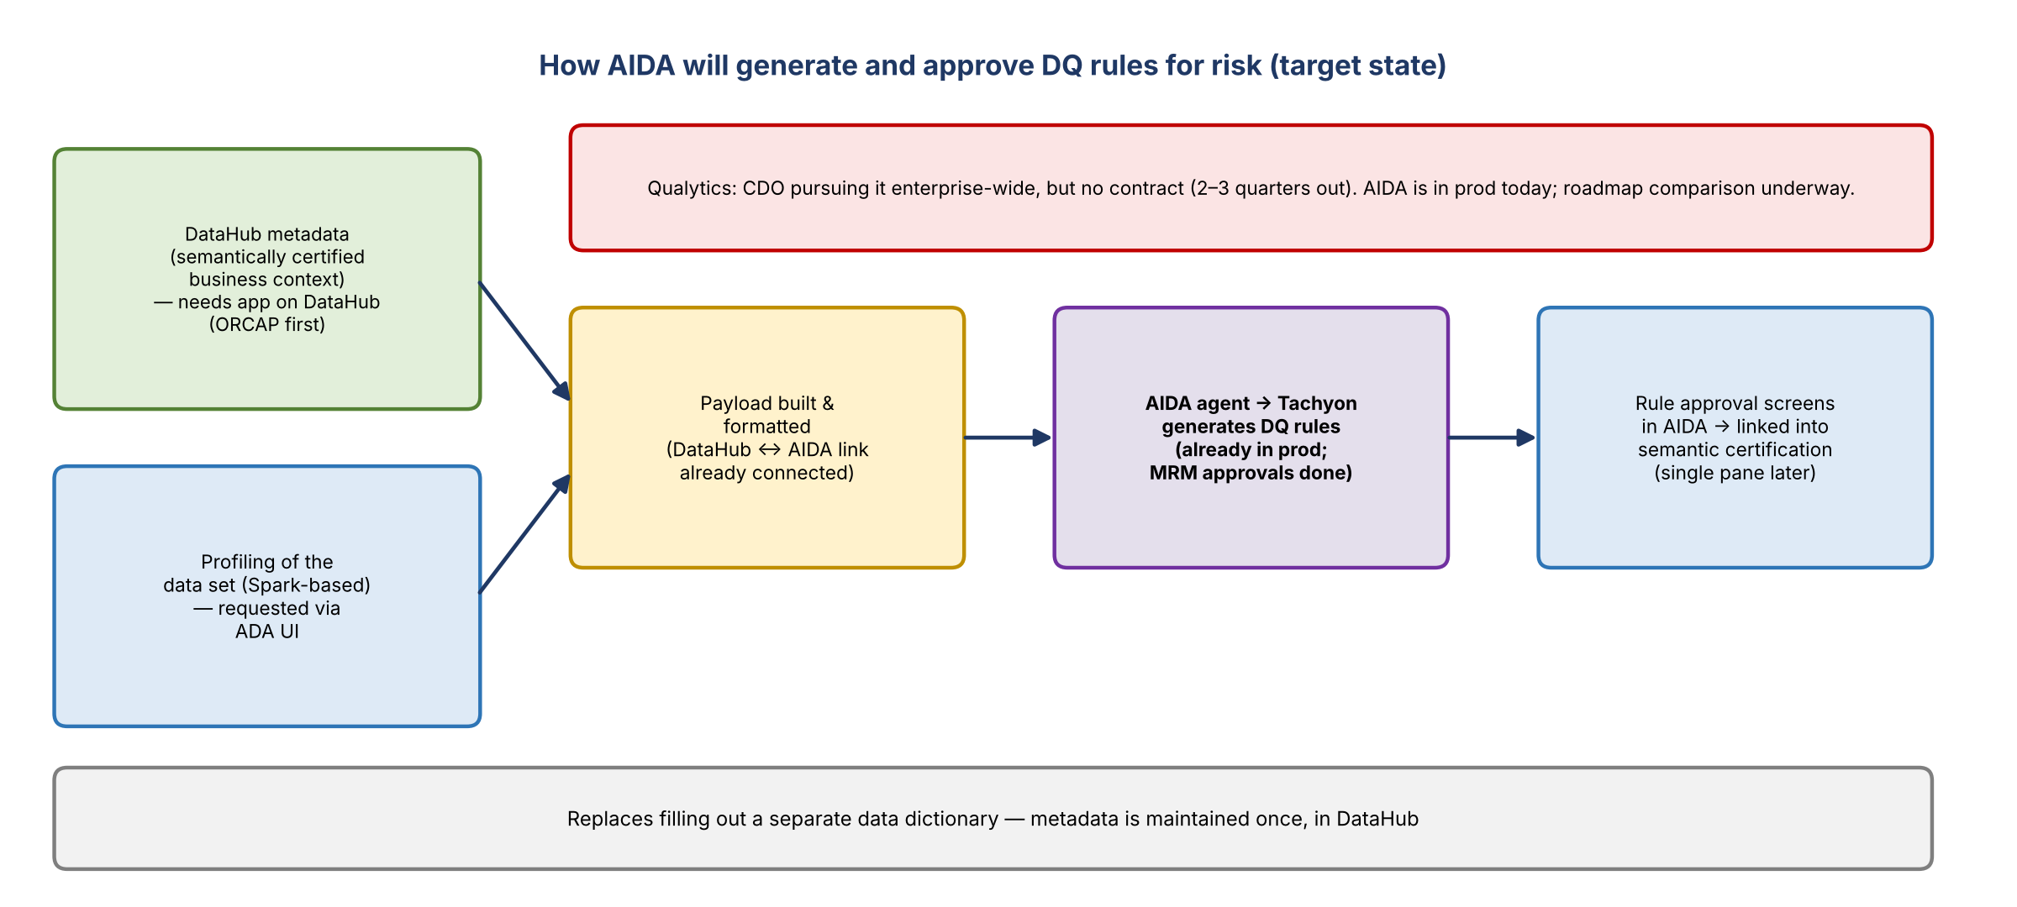
Figure 2. Target flow for DQ rule generation and approval
- Kevin asked whether AIDA can generate rules from the start of the year. Yes, pending DataHub availability. Metadata from DataHub goes into the payload sent to Tachyon to generate DQ rules.
- The POC work is sourcing and formatting that metadata, so when an app lands on DataHub the capability just plugs in. DataHub and AIDA are already connected; the payload work is in progress.
- Mike's question: aren't the results stored on DPC, and don't we already have access via DPC and DataHub? Clarified: when a user asks AIDA to generate rules for a data set, AIDA uses the profiling input plus the metadata and business context from DataHub. That replaces filling out a data dictionary and keeps metadata in one place.
- Because that metadata has been through semantic certification (data owners agree with it), it's a trusted input for rule generation.

6. Yashica's weekly status for risk
- Yashica wants to send a weekly status of everything her team does with risk, since many small meetings happen that the team can't attend. An AIDA slide will be added.
Workstream | Who | Notes
Risk data platform DevOps | Parul | Helping with DevOps tickets
Data frameworks and risk data pipeline | Ashley | Combining finance inputs into a more cohesive enhancement list; more work to do
CARET BAU support | Damian | CARET to be decommissioned by Q2; support continues until then
Data enablement / data warrior | Parul (with Terry's team) | Terry's team still runs intake. Future operating model (Terry, Jordan, Yashica's team) is undecided; no changes for now, just learning current processes.
AI data management, risk and governance | Yashica's team with risk | Data quality (AIDA), financial crimes automated lineage, semantic certification

- Distribution: Kevin said send it to him only; he'll loop in Kathy and others as needed.
- Kevin and Yashica will talk in a week or so about possible team organization changes. Yashica has suggestions and needs his input.

7. Financial crimes automated lineage (side discussion)
- Vic and Jake started this with Yashica's team. The use case is SAR filing. Today financial crimes teams document lineage manually, and it takes a long time to finish.
- The goal is to automatically generate documentation of transformations and lineage. This is different from lineage in DataHub.
- Brian Miller heard about it and wants an update. Kevin wants to be included, since risk has limited scope compared with its upstream sources.

Kevin's view
- Lineage isn't a risk problem to solve; it's an enterprise problem.
- The COO line-of-business BDL team (Chitra) says it has automated lineage by giving application code to Claude, which outputs the elements. That only works if you have the code. Not everyone has access to tools like that, and downstream SORs won't share their code.
- Yashica's understanding: COO's team is focused on filling 14 required templates per SOR (from DMP or regulators), not element-level lineage. She has told Eric the same.
- Kevin feels the capability is being overstated at senior levels and has raised it with Jacqueline: "this is not a silver bullet."
- It's not the same as what Vikram built using Devin; Yashica's team hasn't used Devin for this.
- Key risk: access to code repos. Yashica's team raised it with Gwen, who asked why access can't be granted and is pursuing it. "The tooling's not the issue; the access is."
- Yashica has materials on what's been done and will share them another time.

8. Action items
Action | Owner | Notes
Make sure risk is represented in this week's executive AIDA demo | Damian / Yashica | Invite not sent yet
Finish prompt-conversion API and learning agent API testing | Damian | This week
Complete rule storage and retrieval | Damian's team | ~2 weeks
Integrate FDLZ contract tables | Damian's team | Nov 25
Finish UI and user workflow; regroup with risk | Damian / Yashica | 1st week of December
Share the AIDA vs. Qualytics roadmap comparison | Yashica
Send the weekly status to Kevin (add the AIDA slide) | Yashica | Weekly
Pull Kevin into the automated lineage update with Brian Miller | Yashica
Share lineage materials with Kevin | Yashica | Another time
Discuss team organization changes | Kevin / Yashica | In about a week

9. Open questions
- When will ORCAP be live on DataHub so AIDA rule generation can start for risk?
- Will CDO's Qualytics effort replace AIDA for risk, and when?
- Who owns the future intake / data enablement operating model (Terry's team, Jordan, Yashica's team)?
- Can code access be secured for automated lineage across SORs?

