Meeting Notes
OCI Daily Estimate: Sourcing the Data After the Finance-Space Band-Aid
Item | Detail
Meeting date | Monday, October 26, 2026 (recording started about 2:01 PM, partway in)
Format | Working call; Tina walked through the finance space in Dremio, looking at views, lineage and query history
Finance / DPC | Tina (set up the call; supports the finance DPC side)
Business user | Danielle (runs the daily OCI daily estimate output)
Risk BDL / ADS | Vic, Jake (Kevin dropped for another meeting)
Referenced | Vanathi (heads the risk and finance DPC environments), Arpit, Nikhil, Deepen, Yogi, Junid (owns the CARD Power BI), Aditya
Purpose | Work out a long-term way to get Danielle's daily output now that the interim finance-space views won't carry into DPC: which inputs are really needed, and where to get them

Note on the transcript
Auto-generated transcript that starts mid-call. Speakers aren't labeled; attributions come from context. Readings used: Arpit (also transcribed "Garpet"), Danielle (also "Daniel"/"Jenny" once), EPM, FDLZ, DRM, ALRisk, Dremio, CARD. Unsure: Vanathi (also "Vonathy"/"Vanati"), Nikhil, Deepen, Yogi, Junid (also "Junin"), Aditya, EFTP, ERAS, LADIS and MARS, and "set seven" (the view checked in Dremio).

1. Summary
Danielle's daily OCI daily estimate output comes from curated views built in the finance space in Dremio. Tina stressed that this was a band-aid: it isn't productionized and uses no service accounts, and it won't carry into DPC as is. Several inputs are changing:
- EPM won't recreate its custom view in DPC and will only share through an API, which needs an application (app ID) the team doesn't have.
- CARD and DRM are each becoming their own tenants.
Danielle only needs the query and its output, not historical data, and Arpit confirmed the ALRisk historical data isn't needed. It will be retained but not carried forward.
Option on the table: CARD data already feeds a daily Power BI report owned by Junid. Danielle will check whether it can reproduce her output. She wants it automated, not manual.
The usage review showed the OCI daily estimate view runs daily, while the EPM combined view is a different use case with light use. Strategic ADS sourcing for this is paused for now.

2. Why the current setup can't continue
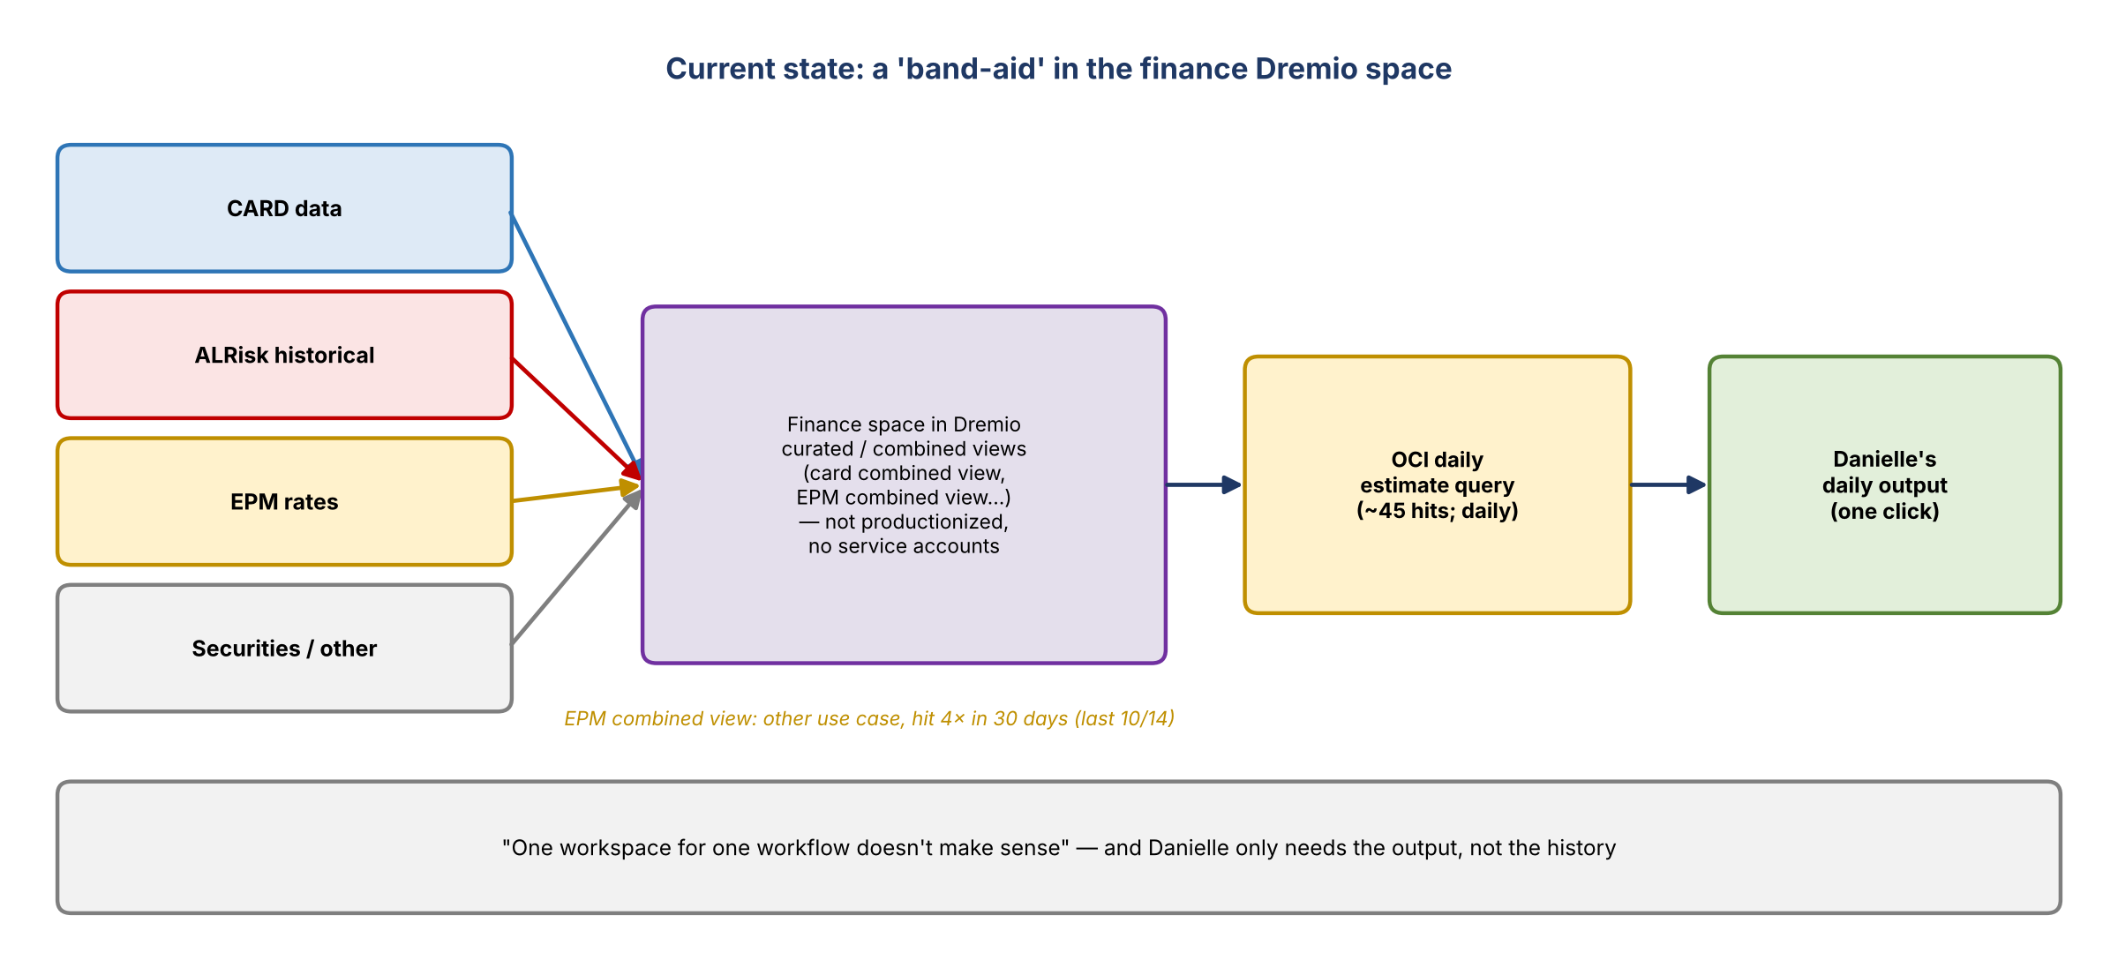
Figure 1. Current state: views in the finance Dremio space
- Interim fix: Tina was clear that what exists today was a quick fix. It isn't productionized and uses no service accounts. At minimum that has to change.
- Arpit had been emailing about it; Nikhil and Danielle had been handling more with Tina.
- EPM: EPM won't provide the view it built specifically for this team in DPC. It wants to share through an API, which most likely requires an application. This team doesn't have one.
- The team would also need to work with ERAS, which won't be providing this data any more, and be set up in one of the two DPCs. Vanathi is setting up the risk one now and leads both environments.
- Tina: having a workspace for a single workflow doesn't make sense.

3. Where each input is heading
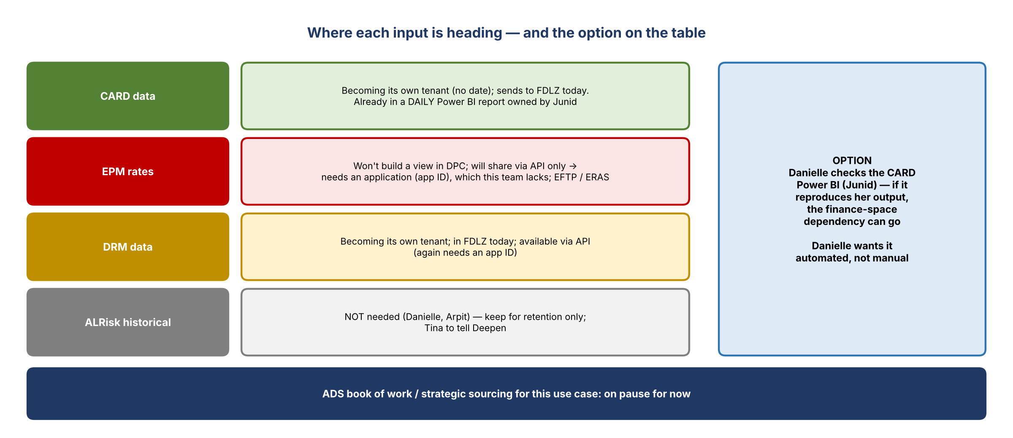
Figure 2. The future of each input and the Power BI option
Input | Status / direction
CARD | Becoming its own tenant (no timing). Currently sends to FDLZ. Daily data is already in a Power BI report (formerly OBIEE) owned by Junid. Yogi confirmed it's daily.
EPM (rates) | Not sourcing this in DPC. Would come from EFTP or ERAS, but the right view isn't there yet. The view built for this team was a combination; the team needs to define exactly what it needs from rates.
DRM | Becoming its own tenant. In FDLZ today. Available via API, but that needs an app ID.
ALRisk historical | Not needed. Danielle doesn't need history, and Arpit confirmed. Keep it for retention (it was kept in case someone asked; nobody has). Tina will tell Deepen.

- Tina noted ALRisk is technically an input to the view Danielle pulls, so it is "used", just not needed.

4. What Danielle needs
- Only the query she sent and its output. She doesn't need historical data or the details behind it.
- Any location works as long as the output is the same; folders can be moved or deleted.
- It must be automated. She can do it manually already; the value is clicking a button and having it ready.
- Power BI option: Tina pointed out the CARD data is in a Power BI report. If it reproduces the output, that works for Danielle. She'll contact Junid, who is based in India and has been converting the report over.

5. Usage review in Dremio (live)
View | What the history showed
OCI daily estimate ("set seven") | About 45 hits; looks like it runs daily. This is Danielle's daily view.
Card combined view | Pulled a lot; lineage is CARD plus ALRisk. Likely the same flow.
EPM combined view | Different use case, probably the one Arpit mentioned (oversight). Hit 4 times in the last 30 days, last on 10/14. Not a daily review; possibly one-off pulls.

- The usage around the OCI daily estimate still needs confirming with Aditya, who is out. Danielle will ask him tomorrow.

6. Vic's framing
- Vic and Jake (risk BDL and ADS) are new to this and are thinking about future-state data sourcing.
- Goal: understand each input folder (CARD, ALRisk historical, securities, EPM rates, LADIS and MARS joins) and which are actually needed for Danielle's use case.
- Simplify by dropping what isn't needed, keep an automated process for now, and document what's needed for the strategic route and who sources it (finance or risk).
- For now, the strategic ADS book of work for this can be paused. Tina agreed.

7. Decisions
# | Decision
1 | ALRisk historical data isn't needed for this use case; retain it, don't carry it forward
2 | Explore the CARD Power BI report (Junid) as the automated source for Danielle's output
3 | Strategic ADS sourcing for this use case is paused pending the Power BI check

8. Action items
Action | Owner | Notes
Contact Junid about the CARD Power BI report and check it reproduces the daily output | Danielle | Tina shared the name
Confirm OCI daily estimate usage with Aditya | Danielle | Tomorrow
Tell Deepen that ALRisk historical data isn't needed (retain only) | Tina
Define exactly what's needed from EPM rates, if still required | Danielle / Arpit
Stay available for help; document needed vs. not-needed inputs | Vic / Jake

9. Open questions
- Can the Power BI report deliver the output in an automated way?
- If EPM rates are still needed, how can this team get API access without an application ID?
- Who should own this use case's sourcing long term: finance or risk?

