Meeting Notes
SAS Workspace Owner One-on-One: Kent C. Lei (10 Workspaces, RMG)
Item | Detail
Meeting date | Monday, October 26, 2026 (recording started about 1:33 PM, just after the intro)
Format | Short one-on-one; Kelly shared the initiative deck and the SharePoint survey
BDL | Kelly (led), Jake, Vic
Workspace owner | Kent C. Lei (RMG group; owns 10 workspaces, including CPM0, CPM5, CPM12)
Purpose | Walk a multi-workspace owner through the SAS initiative and survey, and learn how his workspaces are used and managed

Note on the transcript
Auto-generated transcript that starts just after the introductions. SAS is transcribed "SaaS". Kelly calls the owner "Kent" at the close. Confirmed: Kent C. Lei; workspace names CPM0, CPM5, CPM12. Unsure: "the cabinet" (the archive location), and "approved data source" (transcribed "unapproved data source").

1. Summary
Kelly walked Kent C. Lei, who owns 10 SAS workspaces, through the two priorities: storage and access cleanup (already under way, including a separate bulk entitlement removal) and exit readiness. She also showed the SharePoint survey (one entry per workspace), due early November.
Kent's team is well along: they've moved model production from SAS to Python since 2022, and the rest moves next year. Most of his workspaces are under half used. CPM0 and CPM12 show zero usage and are quick wins: check what's there, move anything needed into an existing workspace, then retire the whole workspace. CPM5 is heavily used.
A partner team in RMG produces a monthly top-10 users report, because the SAS tech team didn't have the resources to. That team could be a source for the usage reporting BDL needs, and Kent will share the contact.
He also flagged a gap: owners can't remove users who have left the group, and the tech team can't either.

2. What Kelly covered
- Enterprise-wide, the bank is migrating away from SAS long term. It's not happening today or tomorrow.
- Priority 1, storage and access cleanup (under way): validate low usage, consolidate allocations, and run a separate bulk removal of entitlements. SAS is very expensive and the goal is to shrink the footprint.
- Priority 2, exit readiness (where BDL helps): who uses each workspace, for what purpose, and any downstream dependencies such as regulatory reports or models. Capture any exit path already planned. If there isn't one, BDL helps work out a better long-term source, ideally an approved data source.

The survey
- SharePoint site; Kelly sends the link after the call. When Kent logs in he'll see his 10 workspaces and fill out one entry for each.
- It captures the data in the workspace, number of users, who uses it and why, downstream models, regulatory reports and use cases, and the exit path.
- If he isn't sure of a detail, BDL can help research.
- Timing: a high-priority initiative from Gwen up the chain. The target is early November, about a week away. Kelly acknowledged 10 workspaces is a big ask and offered help.

3. Kent's workspaces
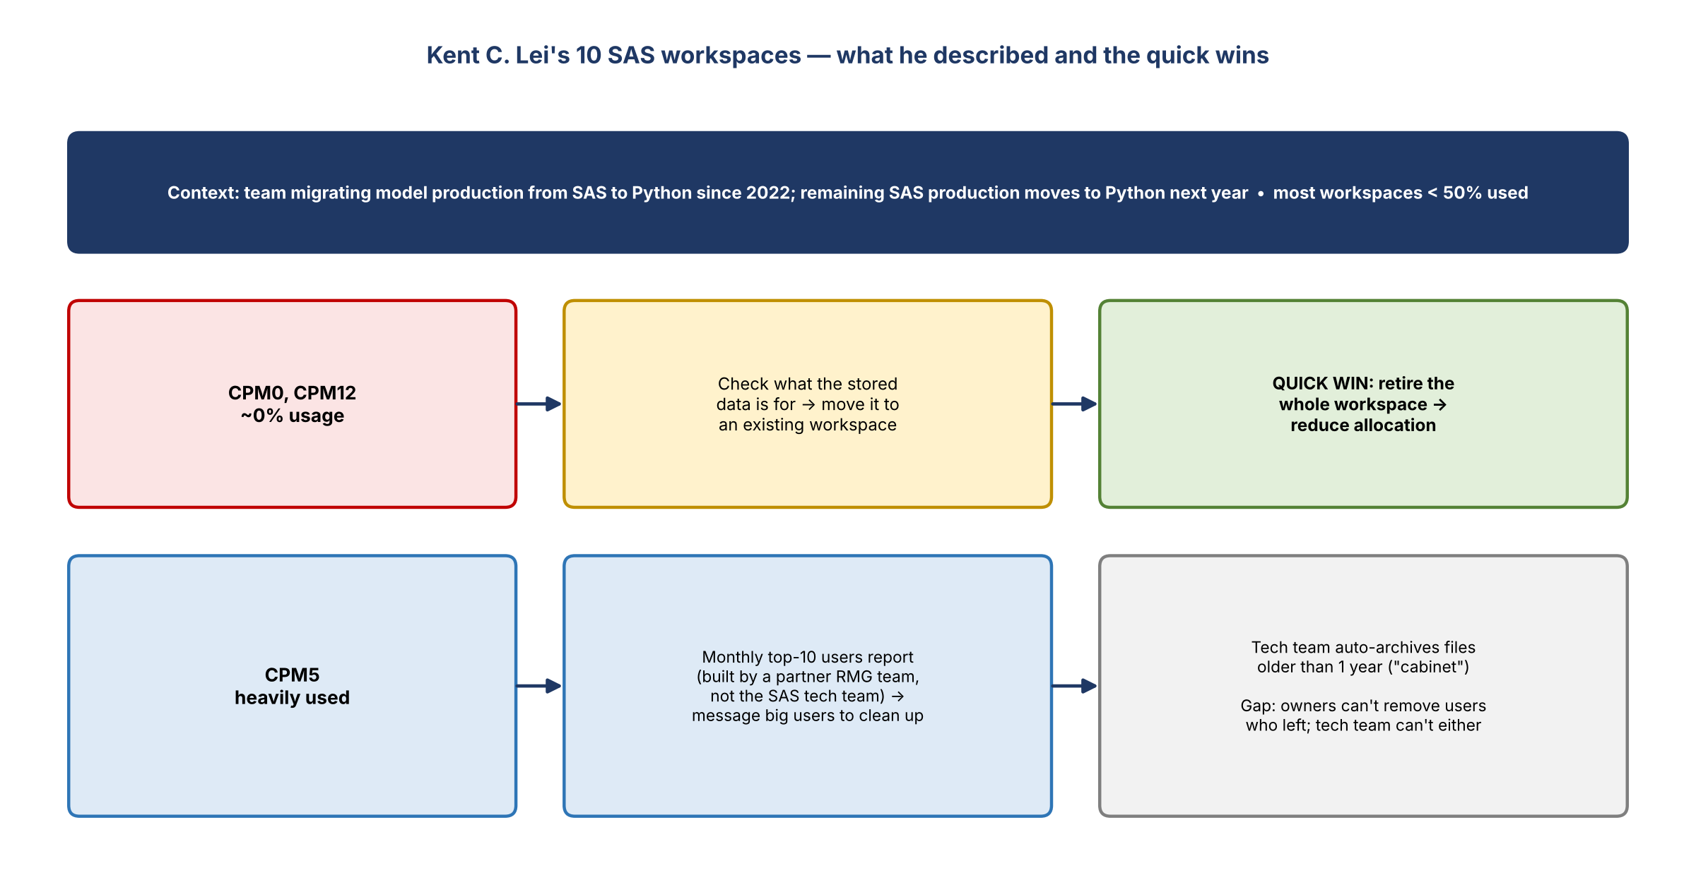
Figure 1. Kent's workspaces and the quick wins
- His team has been moving model production jobs from SAS to Python since 2022. The production still in SAS moves to Python next year.
- So most of his workspaces show less than half their storage used.
- CPM0 and CPM12: essentially zero usage. Good candidates: check what the storage is for, move it to an existing workspace if needed, then retire the whole workspace to reduce allocation.
- CPM5: heavily used. The heavy users are already known.

How Kent manages usage today
- A monthly report shows the top 10 users. If someone suddenly takes a lot of space, Kent messages them to ask why they're running such large files and to remove them ASAP.
- The tech team automatically archives files older than one year (moved to "the cabinet", not deleted).
- Kent asked the SAS tech team to generate the report, but they didn't have the resources. A partner team in his RMG group, which also owns workspaces, builds it monthly.
- With a move to another server coming, they also want to understand who uses each workspace.

4. Usage reporting lead
- Kelly asked who produces the report. BDL is looking for SAS usage reporting options rather than relying on each owner, since owners often don't know who uses their data downstream.
- Kent will share the contact for the RMG team that builds the monthly report.
- Kent: the report really helped show who occupies the most space.

5. Access control gap
- Workspaces have been around a long time. People move in and out of teams and keep using the workspace even after leaving the group.
- As owner, Kent has limited access. He can't remove people who have left the group, and the tech team can't remove them either because those people still need their access. Unlike a LAN drive, workspaces have this restriction.
- Kelly: BDL sees the same pattern. People change roles, were once responsible for a workspace, and no longer need SAS access. There's a lot of overlap and cross-team dependency, and owners often don't know who uses their workspace.

6. Action items
Action | Owner | Notes
Send the SharePoint survey link | Kelly | After the call
Complete the survey (10 entries) | Kent | Early November
Share the contact for the RMG team that builds the monthly top-10 users report | Kent | After the call
Follow up with that team on holistic SAS usage reporting | Kelly / Jake / Vic
Check contents of CPM0 and CPM12; move anything needed; request retirement | Kent with BDL | Quick win
Raise the access gap (owners can't remove departed users) | BDL | Add to the SAS escalation summary

