Meeting Notes
SAS Workspace Owner Kickoff (Corporate Risk)
Item | Detail
Meeting date | Monday, October 26, 2026 (recording started about 3:00 PM)
Format | Large kickoff call. Kelly presented the deck and SharePoint survey; Kevin led most of the Q&A.
BDL | Kelly (presenter), Kevin Moody, Jake, Vic
Audience | Corporate risk SAS workspace owners who each own a single workspace, or their delegates
Questions from | Bob (first question), Julia (and a teammate), Willis, Raylene, Ken, Belle, Vivek
Purpose | Introduce the SAS initiative (from Gwen), explain the two priorities, walk through the survey, and take questions

Note on the transcript
Auto-generated transcript; speakers aren't labeled, so attributions come from context. SAS is transcribed "SaaS". Questioner names are as heard and unconfirmed: Bob, Julia, Willis (also "Willie"), Raylene, Ken (also "King"), Belle, Vivek. Also unsure: "Lancaster" (the SAS environment Willis said expires in February) and "OC plus three" (org-level reference Raylene suggested). The company name used on the call is left out.

1. Summary
Kelly kicked off the SAS initiative with single-workspace owners across corporate risk. There's a long-term enterprise goal to move off SAS, with no date set; this phase is discovery.
- Priority 1: storage and access cleanup, already under way through a separate team.
- Priority 2: exit readiness, the focus of the call: who uses each workspace, for what, and whether an exit path exists.
Owners will get a three-step SharePoint survey, due early November, and BDL will run optional office hours for about two weeks.
The Q&A was lively. Kevin's key points:
- No cutoff date is known, and BDL isn't negotiating the SAS license.
- Cost is driven by allocated storage, not users (the agreement allows unlimited users) or actual usage. Shrinking allocations (e.g. 3 GB used of about 6,900 allocated) could defuse the top-of-house concern while justified SAS use continues.
- BDL can't yet say what replaces SAS.
Owners raised real concerns that BDL took away to follow up on:
- Server migrations are under way.
- 500+ programs are still being converted.
- SAS macros are the only way to upload to GCP.
- New SAS tools are being rolled out even as SAS is being cut back.
- Would moving data to GCP storage cut cost?

2. What was presented
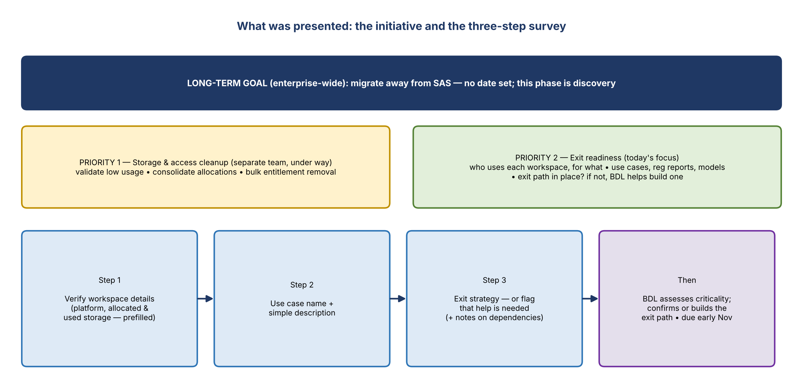
Figure 1. The initiative and the survey
- Kelly (Corporate Risk Data Management and Governance, reporting to Kevin Moody): the initiative was given to the team by Gwen, "from top of the house".
- Attendees are single-workspace owners or delegates. Multi-workspace owners, many in Brian Schiffer's org, were met separately.
- Long-term goal: migrate off SAS enterprise-wide, because SAS is expensive.
- Priority 1, storage and access cleanup (separate team, under way): validate low or no usage, consolidate allocations, and bulk-remove entitlements for inactive users.
- Priority 2, exit readiness (focus): who uses the workspace downstream and why; whether it supports use cases, regulatory reports or models; and whether an exit path to an approved data source exists. If not, BDL helps assess dependencies and build one.

The survey (SharePoint)
- Verify workspace details, which are prefilled: SAS platform / environment, and allocated and used storage. Contact BDL if anything is wrong.
- Give a use case name and a simple description of what the workspace is used for.
- Describe the exit strategy if one exists, or flag that help is needed.
- There's an additional notes and comments section for dependencies on other workspaces and other context.
- Due: early November, about a week out. BDL then reviews criticality and confirms or builds exit paths with owners and downstream users.
- The link goes out after the call. Optional office hours run roughly daily for the next two weeks.

3. Q&A
Asked by | Question | Answer (mostly Kevin)
Bob | Is there a timeline for the full exit? | No. This is the first step: discover what the environments are used for and whether exit plans exist, then assess by criticality. No known date SAS gets cut off.
Bob | Any recommended replacement tools? | Just discovery for now. Technology knows about the initiative and has thoughts on tools, but nothing to share yet.
Julia | What replaces SAS, and on what platform? Her team has 500+ programs still being converted; this would mean rewriting them. | No answer yet; BDL will look to technology partners. The current focus is cleaning up ownership and reporting (some owners don't know they own a workspace) so the allocation charged to corporate risk is accurate, and taking low-hanging fruit such as workspaces unused for two years.
Willis | Is SAS being renewed? His instance ("Lancaster") expires on the 14th with a grace period to February, and he's heard it's going away soon. | BDL isn't working on the license renewal. There are broader CDO conversations, but cutting SAS off isn't BDL's purview, and Kevin hasn't seen a cutoff confirmed. Audio problems; Willis will follow up offline (he's migrating based on the February expiry).
Raylene | Many workspaces work together. Fill out individually, or by grouping? | Groupings would be very helpful, since BDL can't see the relationships in the data. Note dependencies in the survey's comments. An org-level reference (e.g. Brian Schiffer, "OC+3") is fine.
Ken | Does exiting SAS cover server-level only, or desktop SAS too? Is there a drop-dead date? | Unknown; BDL aren't SAS experts. It could be years. Cost isn't driven by users (unlimited-user agreement) but by allocated workspace storage, even if unused. Reducing allocation (e.g. row 43: 3 GB used of about 6,900 GB) may solve most of the top-of-house concern, and justified SAS use can continue. The CDO allocation line item gets attention every year around this time.
Belle | Would moving workspace data to GCP storage cut costs? Does the SAS contract count data on our own infrastructure? SAS usually negotiates enterprise packages. | Good question. The central SAS team is migrating SAS to the cloud, but hasn't indicated a significant cost reduction. BDL will follow up and relay the enterprise-package point.
Vivek | Is this about SAS data sets, not SAS as a tool? Teams are spending time learning new SAS tools. Isn't that contradictory? | Correct: the cost driver is workspace storage allocation. Separately, CDO's goal is to get off SAS eventually, hence exit plans per workspace. BDL doesn't negotiate the contract but will raise the contradiction with the central team.
Julia | Is this only corporate risk? Server migrations are under way (so current allocations will change), and GCP uploads currently require SAS macros, so exiting SAS looks unrealistic. | An enterprise exit would affect everyone; corporate risk isn't banning SAS. This is twofold: be prepared if SAS is cut, and respond to Gwen's budget concern. BDL will follow up by email on how the cloud migration affects allocations.
Julia's teammate | Where can we record migration and GCP context? | In the survey's additional comments section.
Ken | If CDO ends the contract, SAS goes away beyond corporate risk? Would BDL communicate it? Should teams avoid investing heavily in SAS development now? | Yes, it would affect everyone, and BDL would tell corporate risk right away (the central team would too). With thousands of enterprise users it can't be cut quickly. Kevin won't tell teams what to do: the enterprise seems to be shifting away, but if SAS is the only option, use it. BDL can help explore alternatives with technology partners.

4. Cost driver
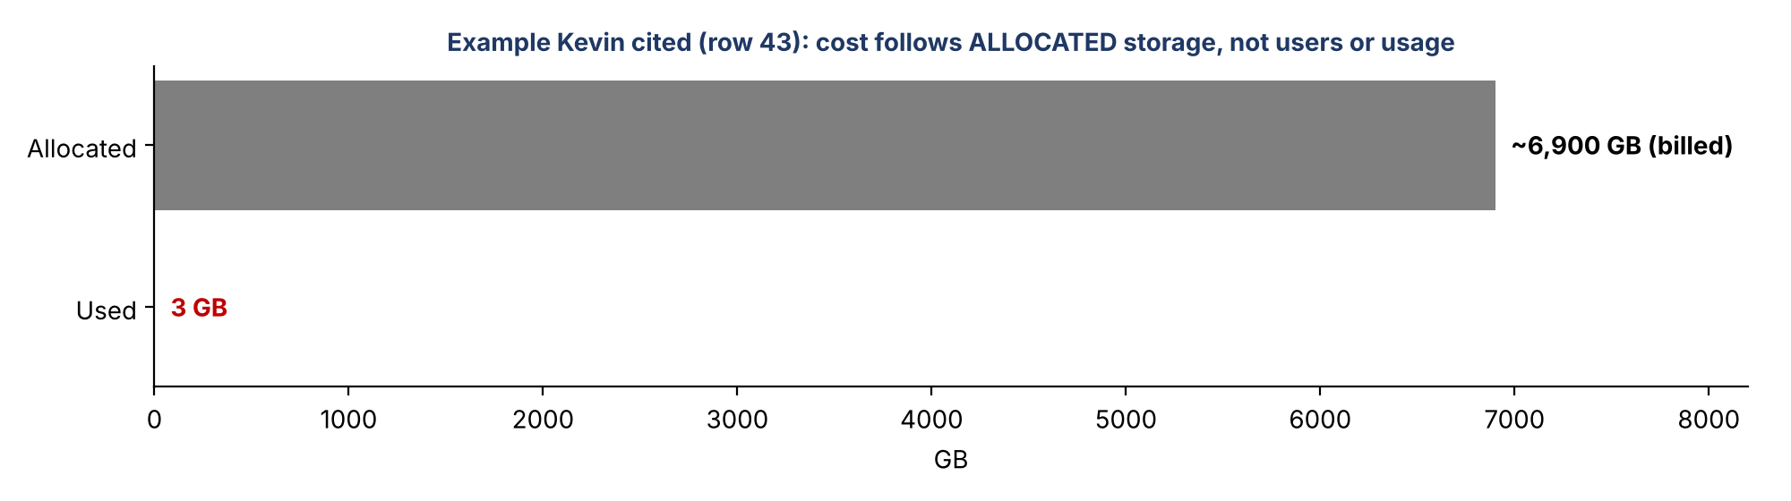
Figure 2. Allocated vs. used storage, the example cited on the call
- The agreement allows unlimited users, so entitlement counts don't drive cost.
- Cost follows the workspace storage made available (allocated), not what's used.
- Reducing allocations to fit actual use could cut the cost significantly while SAS use continues where justified.

5. Follow-ups BDL committed to
Follow-up | Owner | Notes
Send the survey link to all attendees | Jake / Kelly | After the call
Run optional office hours for survey questions | BDL | Roughly daily for ~2 weeks
Ask the central SAS team how the cloud migration affects corporate risk's allocation; email the answer | Kevin / BDL | Julia's and Belle's questions
Ask whether moving data to GCP storage would reduce cost, and relay the enterprise-package point | Kevin / BDL | Belle
Raise the new-SAS-tools vs. exit contradiction with the central team | Kevin / BDL | Vivek
Follow up offline with Willis on the "Lancaster" expiry and migration | Kevin | Willis to send source

6. Asks of workspace owners
- Complete the survey by early November: verify details, give the use case and description, and the exit strategy or a request for help.
- Note dependencies and groupings across related workspaces in the comments.
- Record context such as server migrations or GCP upload dependencies in the comments.
- Contact BDL if prefilled details (owner, platform, storage) are wrong.

