Meeting Notes
SAS Workspace Owner One-on-One: Rakesh (~10 Workspaces)
Item | Detail
Meeting date | Monday, October 26, 2026 (recording started about 12:31 PM)
Format | BDL pre-call discussion while waiting for Rakesh (he was presenting elsewhere), then the one-on-one. Kelly shared the invite, deck and survey.
BDL | Kelly (led), Vic, Jake
Workspace owner | Rakesh (Brian Schiffer org; owns about 10 workspaces inherited from former RMG members)
Referenced | Anand (CDO SAS contact), AJ, Gwen, Jacqueline, Manav, Shawn (and team)
Purpose | Walk Rakesh through the SAS initiative and survey, and learn what his workspaces are used for. Pre-call: how to escalate the SAS reporting blocker.

Note on the transcript
Auto-generated transcript; speakers aren't labeled, so attributions come from context. SAS is transcribed "SaaS"; Manav as "Monob"; Anand as "Anon"; PyFarm as "Pyfarm". Readings used: CECL, PPNR, GCP, RMG, JIRA. Unsure: workspace name "ACL BLF PD indirect", whether "Sean and team" is Shawn Douglas, and "new Data Warehouse" (the CDO migration mentioned pre-call).

1. Summary
- Pre-call: the SAS team (Anand) won't pull a central usage report. It wants each workspace owner to raise their own JIRA. AJ's bulk JIRAs kept getting cancelled because they weren't a priority, and per-owner tickets across about 60–70 owners can't be policed.
- Escalation idea: BDL writes a short summary of the problem and what's needed, takes it to Jacqueline, and has Manav and Gwen push the CDO organization to prioritize it alongside its data warehouse migration.
Rakesh made it easy. His team has been fully off SAS since about 2021 and runs on GCP and Python (PyFarm). His roughly 10 workspaces, such as monitoring, CECL loss forecast and PPNR, are legacy and were flagged for release a couple of years ago, but nothing happened. Most can be released once data retention requirements are confirmed, since some old data supported past regulatory reporting. The one to check is "ACL BLF PD indirect", which Shawn's team may still use. He'll fill out the survey (one entry per workspace) by the first week of November. Kelly will share retention guidance and the deck.

2. Pre-call: the SAS reporting blocker (Kelly, Vic, Jake)
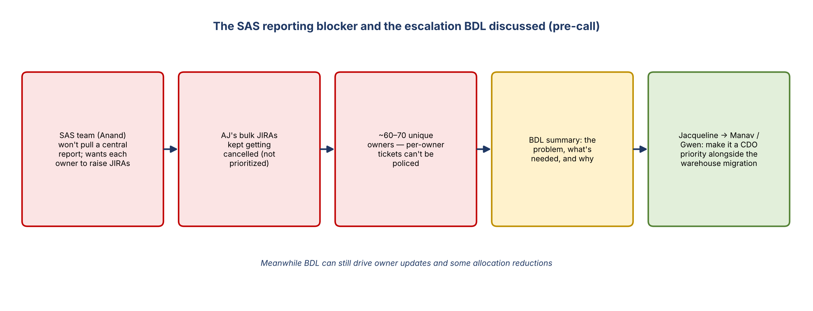
Figure 1. The blocker and the escalation path discussed
- Rakesh sits in Brian Schiffer's org, and Friday's call agreed to approach that org (the home lending RMG group) as a whole rather than model owner by model owner. Rakesh owns about 10 workspaces, far more than anyone else, so he got his own meeting.
- Jake has been going back and forth with Anand. Asking these questions is right even if the answers aren't what they want, because the information is needed to do the work.
- Anand's response: the SAS team won't help pull a report. He said it takes a couple of days, so the team may push to see what they can pull. Without it, the holistic approach with AJ falls apart.
- AJ said his big JIRAs kept getting cancelled because they weren't a priority. That's worth highlighting.
- The SAS team effectively wants each workspace owner to submit JIRAs individually. Nobody will, there's no way to police it, and there are about 60–70 unique owners (about 160 workspaces).
- Proposed escalation: summarize the issue, what's needed, and what's required to deliver Manav's and Gwen's ask. Jacqueline is expected to agree. Then Manav and Gwen push whoever Anand rolls up to under CDO to make it a priority alongside the data warehouse migration.
- Even without the report, BDL can still drive owner updates and some allocation reductions.
- Kelly pinged Rakesh and would have rescheduled if he couldn't join.

3. Introduction to Rakesh
- Kelly, Vic and Jake are Corporate Risk Data Management and Governance and roll up to Gwen. They worked with Rakesh a year or two ago on model use case lineage.
- Rakesh is listed as owner of about 10 workspaces; he "inherited everything that everyone left over."
- A larger kickoff is planned for single-workspace owners. Owners with many workspaces get one-on-ones because of dependencies and nuance.

What Kelly covered
- The initiative comes from Gwen and senior leadership because SAS is expensive enterprise-wide.
- Long term: migrate off SAS, which won't happen quickly. In the interim: learn what data is in each workspace, how many downstream users there are, and whether it feeds regulatory reports, models or other use cases.
- Path 1, storage and access cleanup: validate low usage, consolidate, remove workspaces that aren't needed (some show zero GB), and confirm de-allocation and savings.
- Path 2, exit readiness: a survey after the call asks who uses each workspace, for what, and whether an exit path already exists. If there isn't one, that's fine; it's tagged and BDL assesses where the data could go (e.g. an approved data source).

4. Rakesh's workspaces
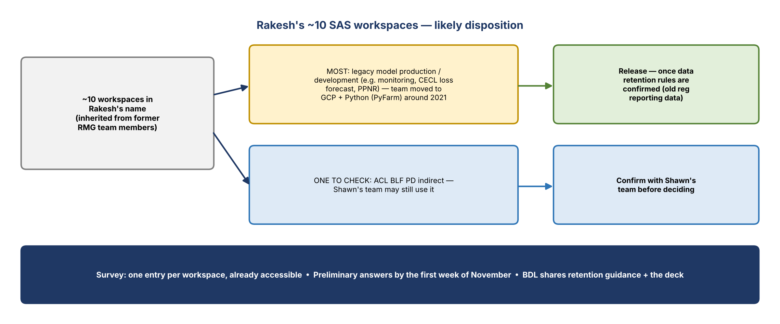
Figure 2. Likely disposition of Rakesh's workspaces
- Fully off SAS: everything his team does now runs on GCP and Python (PyFarm). They moved around 2021.
- A couple of years ago they were asked to identify unused workspaces so they could be released, and did, but nothing happened.
- The workspaces (e.g. monitoring, CECL loss forecast, PPNR) date from when SAS was used for model production and development.
- The remaining data was used for regulatory reporting in the past, so roughly 2020 and earlier. He isn't sure what retention requirements apply.
- Release: most can be released if there are no retention restrictions.
- Exception: "ACL BLF PD indirect". Shawn and team might be using it, so Rakesh will check.
- All were previously owned by RMG team members.

Kelly's response
- BDL is working with someone on SAS reporting but can't fully advise on retention. BDL will share documentation to help assess whether retention is needed.
- Filling out the survey gives BDL what it needs to drive reduction or retirement for each workspace.

5. The survey
- Includes instructions and details on what to provide. Each owner sees only the workspaces under their review.
- There's one entry per workspace, which is why multi-workspace owners get one-on-ones.
- Rakesh is already set up; no access request needed.
- Timing: preliminary information by the first week of November, per Gwen and Jacqueline. Rakesh said they can do that.

6. Action items
Action | Owner | Notes
Send the survey to Rakesh | Kelly | After the call
Share the deck reviewed on the call | Kelly | Rakesh asked
Share data retention documentation | Kelly / BDL
Complete the survey (one entry per workspace) | Rakesh | First week of November
Check with Shawn's team on ACL BLF PD indirect | Rakesh
Push the SAS team (Anand) on what usage reporting it can pull | Jake / Kelly
Write the blocker summary and escalate via Jacqueline to Manav and Gwen | Kelly / Vic / Jake | Make it a CDO priority

7. Open questions
- What retention rules apply to old regulatory reporting data (about 2020 and earlier) in these workspaces?
- Is ACL BLF PD indirect still used by Shawn's team?
- Will CDO / the SAS team prioritize central usage reporting if escalated?

