Meeting Notes
SAS Workspaces: Kelsey & John Crawford (Home Lending / Brian Schiffer Org)
Item | Detail
Meeting date | Friday, October 23, 2026 (recording started about 2:30 PM)
Format | Working call; Kelly shared the invite list, the CDO workspace spreadsheet (filtered live), and the SAS initiative slides
BDL | Kelly (led), Jake (Vic out)
Workspace side | Kelsey, John Crawford, AJ
Referenced | Brian Schiffer (org leader), Mary Tucker (senior SAS contact), Anand and Jason (bulk entitlement review), Leopold, Jennifer, David Blitvich, Gwen (CAO executive)
Purpose | Explain the SAS initiative to Kelsey and John, sort out which workspaces they actually own (including Jennifer's and David's), and agree how to approach the home lending / Brian Schiffer workspaces together

Note on the transcript
Auto-generated transcript; speakers aren't labeled, so attributions come from context. SAS is transcribed "SaaS". Confirmed: Gwen, the CAO executive (transcribed "Glenn" once). Readings used: Brian Schiffer (also "Shiffer"), John Crawford, David Blitvich, Leopold, AJ, PyFarm, 1SASGRID. A few side remarks and Friday-afternoon banter are left out. Unsure: Mary Tucker, "Jeremy" and "Karen" (greetings or names as heard), the path filter "/home2/apps", workspace names LOS 10, RET, BLM1 / BLM3 / BLM4, and who on the BDL side relayed Gwen's "no rush" message.

1. Summary
This was the follow-up to the Leopold/AJ call, now with Kelsey and John Crawford. The main blocker is that nobody knows the true workspace inventory.
- The CDO list is stale: Jennifer's and David Blitvich's workspaces are being reassigned.
- Under the SAS team's process, each current owner has to resubmit an ownership ticket, and the SAS team says it can't act until about November because of its cloud migration.
- Kelsey supports the cleanup and her team has already started, but she needs to know what she owns before doing the work.
- Brian Schiffer told his team this morning to hold until he talks to them next week, so the message hasn't been rolled out to that team yet.
Agreed approach:
- BDL keeps a manual "true owner" list.
- Kelly preliminarily reassigns workspaces based on Kelsey's emails, and Kelsey maps David's workspaces to their new owners.
- AJ reviews the list, scans the locations, and reviews access.
- Kelly sets up time with Mary Tucker (senior SAS contact) to get admin help with file and user inventories, so it doesn't fall to each owner one by one.
The ask is understanding, not a rush to get off SAS.

2. Getting SAS admin help (AJ)
- AJ's ticket for admin help is stalled. The SAS contact says each individual owner should request the changes, even though many named owners are no longer involved.
- AJ could open a ticket per drive, but there's no telling when they'd be done, and the group still needs someone to guide the process.
- The SAS team has other priorities and may not get to it until early November.
- Proposal: bring in Mary Tucker, described as the top SAS person, to see what resources she can provide. Kelly agreed to set up a separate session with her for this group.
- Kelly: Anand and Jason (outside BDL) are running a separate bulk entitlement review, removing inactive SAS entitlements. BDL focuses on what's allocated, how it's used, and the exit path.

3. Overview Kelly gave Kelsey and John
- Kelsey and John worked with BDL before on a corrective action (PDEs, models, checks and controls).
- Next week is a larger kickoff for owners of a single workspace. Familiar names and multi-workspace owners are being handled more holistically, so the home lending area is being reviewed together, with AJ helping collect details.
- The invite included a chart of workspaces tagged to David Blitvich, John and Kelsey. Owners should flag any missing workspaces or ones they should own.
- Purpose: senior leadership wants SAS allocation reduced and unneeded storage removed to save money, and to find out whether exit plans exist. If none exists, BDL helps identify where the data could live for downstream users.

Two tracks
- Storage and access cleanup: can start chipping away now.
- Use case exit readiness (longer term): once the full list exists: use cases, models and regulatory reports that rely on each workspace; number of users; whether an exit plan exists and its details.
- Clarified with Kelsey: "exit" here means getting out of specific SAS workspaces and minimizing the footprint. Separately, there's a long-term enterprise goal to move off SAS.

4. The ownership problem
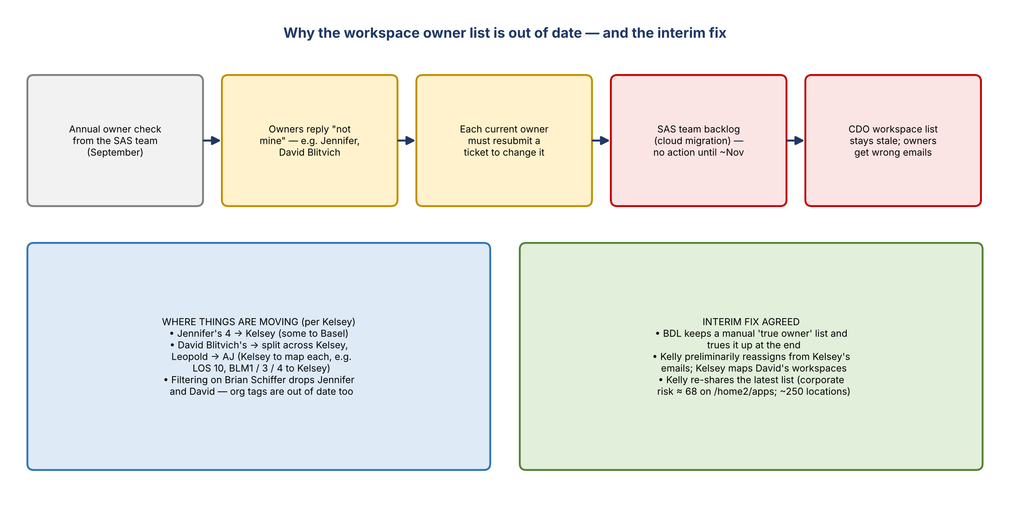
Figure 1. Why the owner list is stale, and the interim fix

Kelsey's view
- The list in the invite doesn't show everything she owns, and she knows it's inaccurate.
- She requested ownership of everything Jennifer had, but some of it needed to go to Basel. Some of David's is coming to her. Some of David's she said should go to Leopold, and he said it should go to AJ.
- Until the list is right, it's hard to act, and she risks working on her four while being asked about eight she got yesterday.
- She and her team already started cleanup this week after the emails, as they have with share drives and SharePoint: when was it last used, what for, and is it still needed? Some old items are already being handled.

Why the list is stale
- The SAS team runs an annual owner check (September). Owners who say a workspace isn't theirs must have the current owner resubmit a ticket to change ownership.
- There's a backlog in making those updates, because the SAS team is focused on its cloud migration, while its reporting still goes to senior executives.
- Formal owner updates may not show until November or later.

Filtering the list (live)
- AJ suggested filtering on the path "/home2/apps". Filtering that to corporate risk gave 68 workspaces. AJ estimates about 250 libraries or locations under apps overall.
- Adding a Brian Schiffer filter made Jennifer and David drop off, showing the org tags are also out of date after reorganizations.
- Scope is everything in corporate risk, across all SAS environments including auto.

Interim approach
- BDL will manually maintain the list of true owners and true it up at the end.
- Kelly will replace the list in the invite with the latest version and share it.
- Jennifer's four are tracked as moving to Kelsey (AJ copied). Jennifer owns nothing else in this space.
- For David's, Kelsey will map each to its new owner offline. She mentioned possibly taking LOS 10, RET, BLM1, BLM3 and BLM4.

5. Leadership messaging
- Kelsey: Brian Schiffer raised SAS this morning. He told the team not to act yet and to wait until he talks with them next week. He wants to avoid alarm before giving the message himself.
- Kelsey suggested he tell his team it's coming, since meetings are already being set up. To her, it feels disconnected because leadership hasn't rolled out the message to this team.
- Kelly: SAS migration has come up many times without movement, but leadership says the time is coming. Nothing has to move today or tomorrow.
- BDL was asked by Gwen (CAO executive) because of a multi-million-dollar SAS expense allocated to risk. Kelsey confirmed Brian is aware.
- BDL (relaying Gwen): there's no rush to get off SAS. The main goal is to learn what each workspace is used for and whether it matters; the longer technology plan follows. The intent isn't to scare anyone.

6. What an exit plan actually requires (John's question)
- John: is there an easy button, or does an exit plan mean assessing every file in every folder of every space?
- Answer: if an owner says none of the data is needed, BDL submits the request to get rid of it.
- John: can it instead be archived per company policy until it reaches seven years? (records retention)
- AJ's sequence: (1) identify all locations and assign owners; (2) get file lists (with last-modified dates) and users for each location to summarize, consolidate, and retire what isn't needed; (3) then a secondary plan to remove data older than an agreed age; (4) review who has access. He has none of this data yet.
- AJ asked Kelsey whether there's an existing process to audit or review user access for these locations. Kelsey doesn't know: ask John for Jennifer's former workspaces and Leopold for the rest.
- AJ's goal: get down to maybe two locations, which are easier to manage with better access and data management. Many are orphaned.
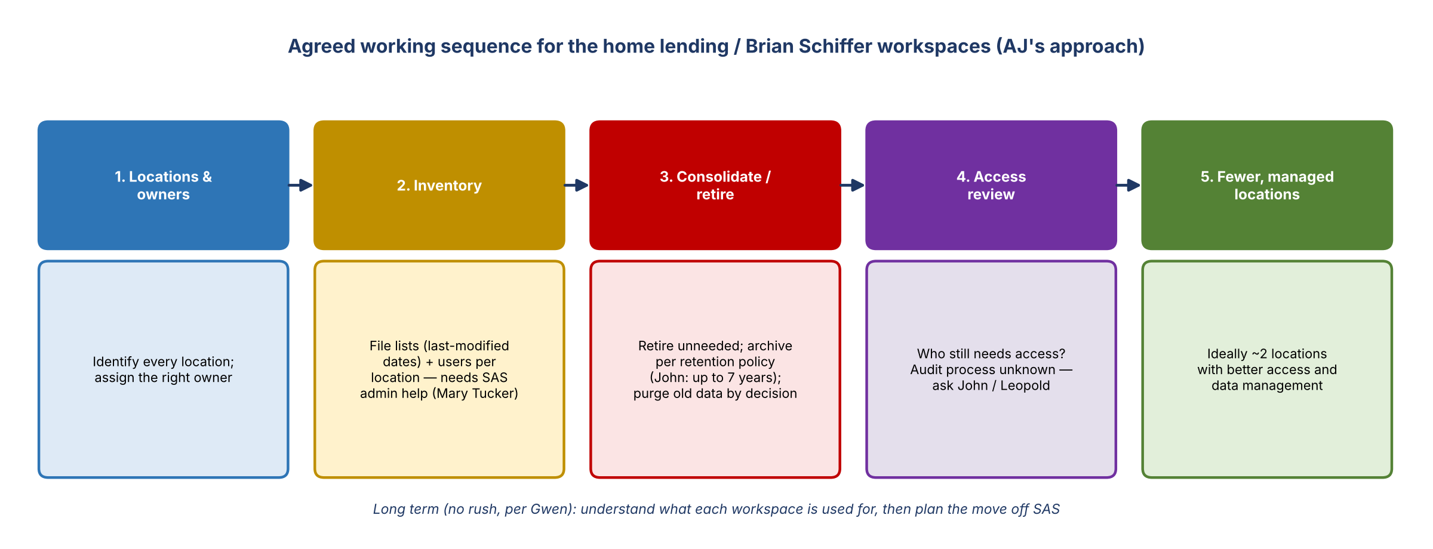
Figure 2. Agreed working sequence

7. Decisions
# | Decision
1 | BDL maintains a manual true-owner list until SAS ownership records are updated
2 | Approach the home lending / Brian Schiffer workspaces together, with AJ as the point person
3 | Seek SAS admin support through Mary Tucker rather than per-owner tickets
4 | Sequence: locations and owners, then inventory (files and users), then consolidate, retire or archive, then access review
5 | Scope covers all corporate risk SAS environments, including auto

8. Action items
Action | Owner | Notes
Set up a session with Mary Tucker on SAS admin resources (file lists, users) | Kelly | For this group
Replace the invite list with the latest workspace listing and share it | Kelly
Preliminarily reassign workspaces based on Kelsey's emails | Kelly | Manual true-owner list
Map each of David Blitvich's workspaces to its new owner | Kelsey | Offline; send to Kelly
Forward the Jennifer ownership email | Kelsey | Done on the call
Review the list, find additional locations, run scans and an access control review | AJ
Meet next week to build the plan | AJ and Kelsey (plus others as needed)
Ask John (Jennifer's former) and Leopold (rest) about existing access review processes | AJ / Kelsey
Confirm the retention requirement (archive up to 7 years?) before deleting data | BDL / John

9. Open questions
- What resources can Mary Tucker provide for file and user inventories, and when?
- When will SAS ownership changes actually be processed?
- What retention rules apply (archive vs. delete; seven years)?
- What will Brian Schiffer tell his organization next week?

