Meeting Notes
DCF Today, Roadmap, and the DataHub Future State
Item | Detail
Meeting date | Wednesday, October 7, 2026 (recording started about 3:00 PM)
Format | Kickoff working session: DCF walkthrough and lineage demo, then target-state and DataHub presentations
DCF team | Mike (Michael; DCF application business owner, presented capabilities and roadmap), Jimin (DCF technical lead; ran the lineage demo)
Target-state team | Nitin (organized and facilitated), Yashica (target-state data management vision), Anand (architect for the DataHub solution)
Also present | Kevin, Terry, and others not named
People referenced | Fikram and Terry (ORCAP; DQ issues management users), RADAR (Credit 360) contact who just left the bank
Purpose | First of a series of sessions: understand what DCF does today and its Q4/2027 roadmap, explain DataHub and the target state, and start planning the transition

Note on the transcript
Auto-generated transcript; speakers aren't labeled, so attributions are inferred. Confirmed: Yashica (transcribed "Yashika," "Ashika," "Yasika," "Yasuke"), Jimin (also "Jim," "Jimmy," "Jinmin"), Terry (transcribed "Teddy"), RFDIR (transcribed "Rifter"), and DMP (transcribed "TMP"). Names still rendered several ways: Anand (also "Anant," "Arnon," "Arnett," "Arnaz," "Arneth," "Anans," and possibly "Ernest") and Fikram (also "Bikram"). Readings used: ADMF (transcribed "ADMAP"), FCRM ("FICROM"), BSA/AML ("BSAML"), 2027 (said as "2007"), Credit 360 ("PRED 360"), Dremio ("Dreamio"), FDLZ ("FDLC"), CIB ("CID"). Confirmed from earlier meetings: ORCAP, RADAR, FCTDS, DPC. Still unclear: "ETF applications," EDCC, "DSA's," and what DCF stands for.

1. Executive summary
This was the first in a series of sessions on moving risk's data management tooling to a future state. Mike walked through DCF, a DQ validation reporting tool and metadata catalog originally built by Financial Crimes, now used mostly by Financial Crimes, RDS tenants, and CIB. Its core capabilities are DQ validation monitoring, metadata management, the Lineage Explorer, DQ issues management (JIRA tickets on critical failures), and dashboards.
Q4 work includes anomaly detection for late and missing feeds, ADMF data source integration to automate the Article 10 BSA/AML recon Kevin built, reporting enhancements for RADAR (Credit 360) and ORCAP, and a data hygiene dashboard. 2027 priorities are bringing ADMF technical metadata into DCF and speeding up onboarding. Jimin demoed DCF's element-level lineage, which impressed the target-state team.
Yashica and Anand presented the target state: a data canvas with a research agent, DQ rule governance, issue management, lineage adjustments, audit snapshots, and policy compliance, with DataHub as the backbone for a single view of technical and business metadata, lineage, and DQ results, plus agent access via MCP. Both stressed this is not a decision to retire DCF; good DCF capabilities will be folded into the target state. Next steps: recurring sessions, offline design talks between Anand and Jimin, and a DataHub adoption roadmap for DPC risk tenants starting Q1 2027.

2. Key terms
Term | Meaning from the meeting | Note
DCF | DQ validation reporting tool and metadata catalog, built by Financial Crimes | Acronym not expanded
Feed ID | The unit DCF receives DQ results for; L2 results are per data element | Configured in DCF
L1 / L2 validations | Level 1 controls on feeds; level 2 rules on data elements (many per element) | —
Flowmaster | Common rule execution engine; results converted to DCF's format | Still supported in target state
Lineage Explorer | DCF feature showing lineage at system, data set, or element level | Demoed
KBE | Key business element: business term mapped to a physical data element | In DCF data dictionary
ADMF | Enterprise metadata system of record; holds one-hop upstream sources and use cases | Integration planned
EDCC | Enterprise data check catalog (best guess) | Policy future unclear
DataHub | Third-party metadata platform chosen as the target-state backbone | MCP / agent friendly
Data canvas | Target-state stitched view of metadata, lineage, controls, and issues | Yashica's vision
Data product | Curated end-state assets governed by business partners | Business-facing view
Semantic certification | Governed process to curate, approve, and tag glossary terms | Separate session scheduled
DQ Studio | Planned tool for defining, approving, and monitoring DQ rules | Will absorb DCF ideas
ADA | CIB tool for AI-assisted DQ rule generation | Brought in for DQ Studio

3. DCF today
Mike described DCF as a DQ validation reporting tool and metadata catalog, originally developed by Financial Crimes to meet regulatory requirements and the data management policy. It's now open to all applications (transcribed "ETF applications"). Main customers are Financial Crimes, RDS, and CIB, with some apps from other domains.
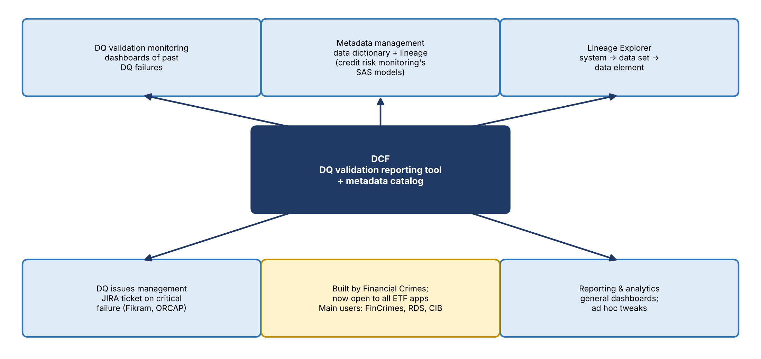
Figure 1. DCF core capabilities
Capability | Detail
DQ validation monitoring | Dashboards for onboarded apps to review past DQ failures
Metadata management | Data dictionary and lineage. Mainly used by credit risk monitoring, which decommissioned Metadata Explorer and AMDS last year and now keeps its SAS model metadata in DCF
Lineage Explorer | Visualizes lineage from system level down to data element level
DQ issues management | Creates a JIRA ticket on a critical validation failure to track remediation. Used by Fikram and Terry's ORCAP team and the RFDIR team
Reporting and analytics | General dashboards; ad hoc tweaks requested through the year

How DQ results get into DCF
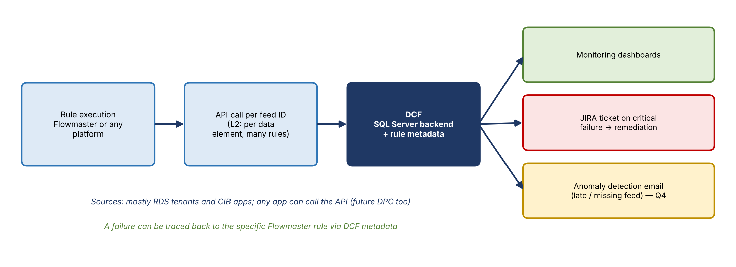
Figure 2. DQ results flow
- Teams run their rules elsewhere (typically Flowmaster), convert results to DCF's format, and publish them through an API to the configured feed ID. Results are stored in SQL Server (not Oracle).
- L2 validations are at the data element level, with potentially many rules per element.
- DCF is essentially an application waiting for API calls; any platform can call it, including future DPC. Most callers today are RDS tenants and CIB apps.
- The API payload doesn't say how a rule was run, but DCF's metadata links each check back to its source rule, so a failure can be traced to the specific Flowmaster rule.

4. Q4 2026 and 2027 roadmap
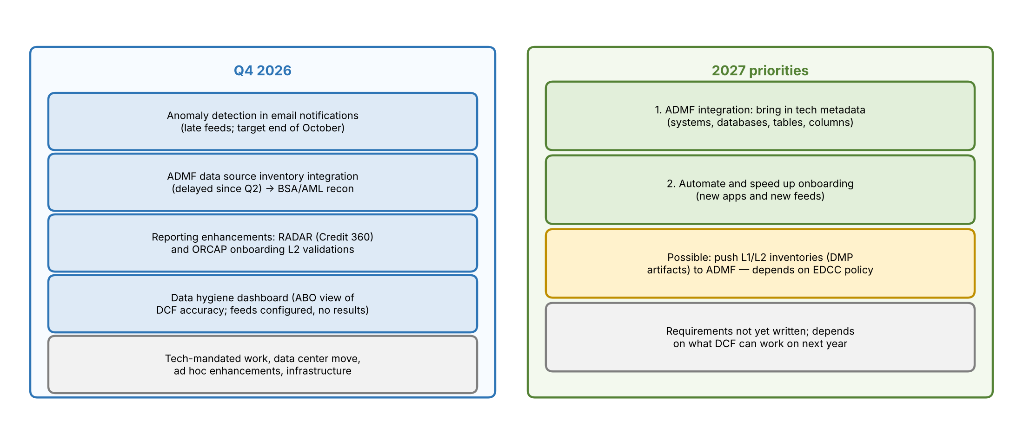
Figure 3. DCF roadmap

Anomaly detection
DCF already detects late job postings. In Q4 it will add email notifications to target applications when a feed is late; the goal is to finish by end of October barring critical vulnerabilities. It won't open to consumers until it can also detect completely missing feeds. This is feed and SLA monitoring, motivated by past cases where feeds never arrived. Example: a feed expected at 4 AM Eastern that consistently arrives at 4:30 to 6 AM triggers a notice. AI-based pattern analysis to predict future issues is a possible later capability, not Q4.

ADMF data source integration and the BSA/AML recon
Bringing ADMF data source information into DCF will improve onboarding accuracy and automate a recon FCRM wants for BSA/AML (an Article 10 requirement). Kevin built the current manual version. It's a must for Q4 and continues into Q1. This feature has been pushed back since Q2.
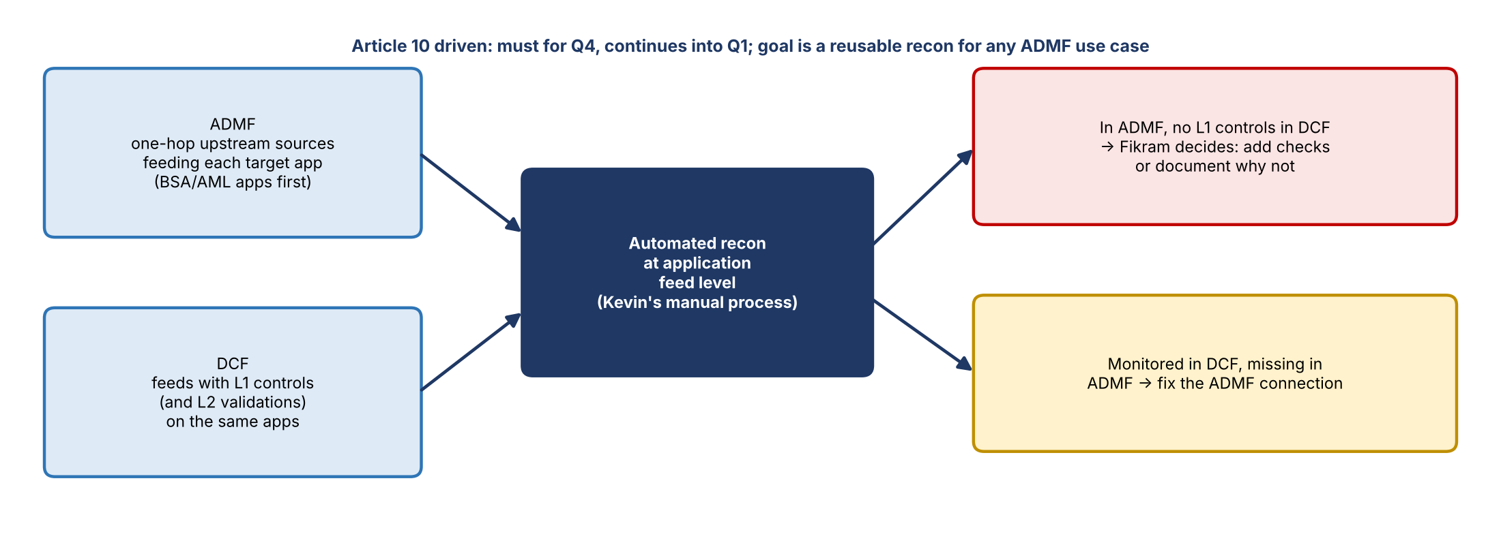
Figure 4. ADMF vs. DCF recon
- ADMF lists the one-hop upstream sources feeding each target application. DCF shows which feeds have L1 controls (and L2 validations).
- A source in ADMF without L1 controls in DCF is a gap; Fikram's team decides whether to add checks or document why none are needed.
- A monitored feed in DCF without a matching ADMF connection points to an ADMF fix.
- The comparison is at the application feed level, not the data set level. The longer-term goal is a reusable recon for any ADMF application or use case, starting with BSA/AML.

Other Q4 items
- Reporting enhancements: RADAR (Credit 360) and ORCAP are both onboarding L2 validations this quarter and will likely need dashboard changes. The RADAR contact left the bank last Friday, so a new contact is needed.
- Data hygiene dashboard: for Mike as ABO to check DCF's own accuracy (for example, feeds configured but not sending results) and notify ABOs and tech managers to fix them. A different persona from the monitoring reports.
- Maintenance bucket: tech-mandated work, the data center move, ad hoc enhancements, and infrastructure.

2027 priorities
- ADMF integration: bring ADMF's technical metadata (systems, databases, tables, columns) into DCF.
- Automate onboarding to cut the time for new applications and new feeds.
- Possible: push L1 and L2 inventories (DMP artifacts) to ADMF to automate the enterprise data check catalog. This depends on whether EDCC exists under the future policy. Initially DQ only, not lineage, though the long-term idea is that anything maintained in DCF flows to ADMF automatically instead of being entered manually.
- Requirements aren't written yet; the team first needs to know what it can work on next year.
Jimin noted a strong lineage use case: DCF can import ADMF use cases (reports, transaction monitoring models, surveillance) and, for onboarded apps, trace each one back to where the data originated.

5. DCF lineage demo
At Anand's request, Jimin demoed the Lineage Explorer using FCTDS, one of the largest Financial Crimes apps.
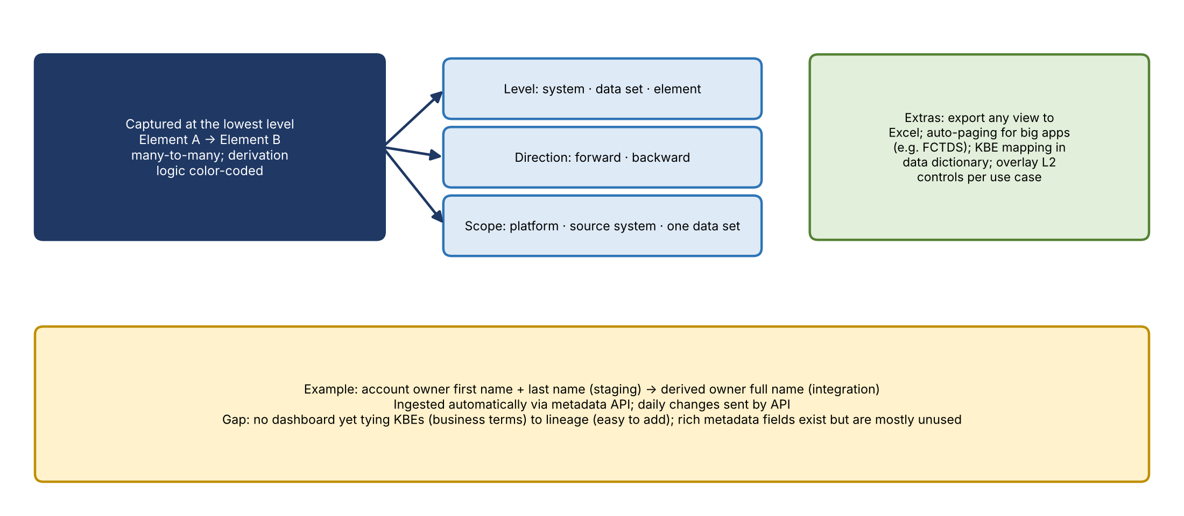
Figure 5. How DCF lineage works
- Model: lineage is tracked at the data element level (element A to element B), so it can be shown at system, data set, or element level, forward or backward, scoped to the whole platform, a source system, or one data set.
- System level: every source system feeding FCTDS, aggregated from millions of element-level links.
- Data set level: each line is a table moving from feed to raw to conformed to curated. Any view can be exported to Excel.
- Element level: effectively a source-to-target mapping for ETL apps. Large apps load with automatic paging (about 12% at a time).
- Transformations: relationships are many-to-many. Derivation logic is captured and color-coded, e.g., owner first name plus last name derived into owner full name. This has existed since day one and is ingested automatically via metadata API, with daily change updates.
- Business names: the names shown are technical. DCF has KBEs mapping business terms to physical elements in a data dictionary view, but no dashboard yet combining KBEs with lineage; Jimin said that's easy to add.
- Controls overlay: Yashica asked about overlaying controls on each hop. DCF already has a dashboard that aligns elements to a use case and shows all elements and validations across the data flow.
- Definitions and business purpose: DCF has rich metadata fields to store them, but no one currently populates them.

6. Target-state vision
Yashica shared the target-state picture: a foundation for data management, not a single tool.
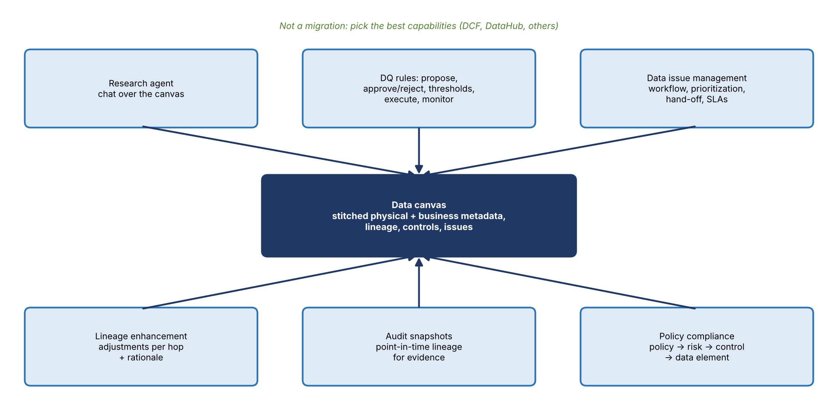
Figure 6. Target-state data management capabilities
Capability | What it means
Data canvas | Stitched physical and business metadata, lineage reflecting the current state, existing controls, breaches, and linked issues
Research agent | Lets data management groups ask in chat where an element was sourced or how long an issue has been open
DQ rules | Propose rules; data owners or stewards approve or reject; set thresholds; execute via a rule engine (e.g., Flowmaster); monitor results; feed back to the canvas. Solution TBD
Data issue management | Issues from threshold breaches or raised by business owners, with UI workflow. Each domain defines prioritization, hand-off to tech, and remediation SLAs
Lineage enhancement | Overlay which hop made which adjustment and why, explaining breaks back to the SOR (e.g., rows dropping from 10,000 to 1)
Audit capability | DataHub is near real time, so agree on snapshot timing to keep evidence (e.g., lineage for a regulatory report on a given date), with an agent over the snapshots
Policy compliance | Show the chain from policy requirement to data risk to control to each data element

Yashica was clear that DCF isn't being ruled out. Anand, as architect, will decide which DCF capabilities to incorporate. It's about building the right data management tool from the best parts, not a migration.

7. DataHub
Anand gave the case for DataHub, reiterating that DCF isn't being retired and that its lineage strengths should carry into the target state.
- Single pane of glass: technical catalog and business definitions together, replacing today's fragmented catalogs.
- End-to-end lineage across platforms: e.g., Oracle → S3 → Iceberg → Dremio → Power BI. Strong at high-level flows; fine-grained lineage needs complementary capabilities.
- 360-degree data set view: schema, lineage, DQ rules, and governance in one interface, complemented by DCF, the data canvas, or processing frameworks.
- DQ results: define rules per data set and publish run results, with agents reasoning on top; drill-downs go to the underlying execution platform. Still being evaluated.
- Multi-cloud: covers future data in Azure or GCP without another tool.
- Agent friendly: built-in MCP server components so agents can query the whole canvas. The main selling point.

How data will be organized
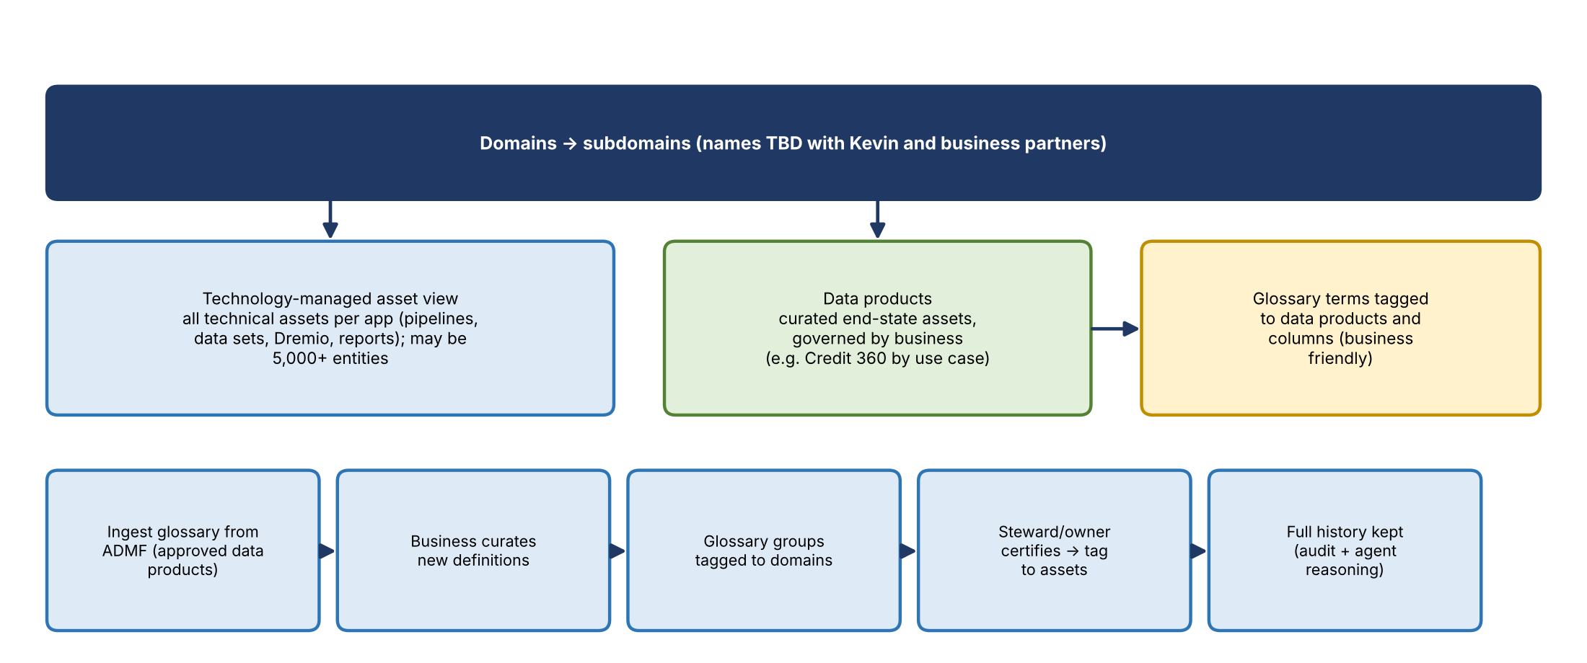
Figure 7. DataHub organization and glossary certification
- Data sets organized by domain and subdomain; names shown were placeholders and will be set with Kevin and business partners.
- Two views: a technology-managed asset view (everything per application, potentially 5,000+ entities) and business-governed data products (e.g., Credit 360's curated tables bucketed by use case).
- Glossary: ingest terms for approved data products from ADMF, let business curate new ones, organize into glossary groups by domain, and have stewards and owners certify before tagging. Full history is kept for audit and agent reasoning, so business users can ask questions in business language without knowing column names (the KBE idea).

DQ Studio
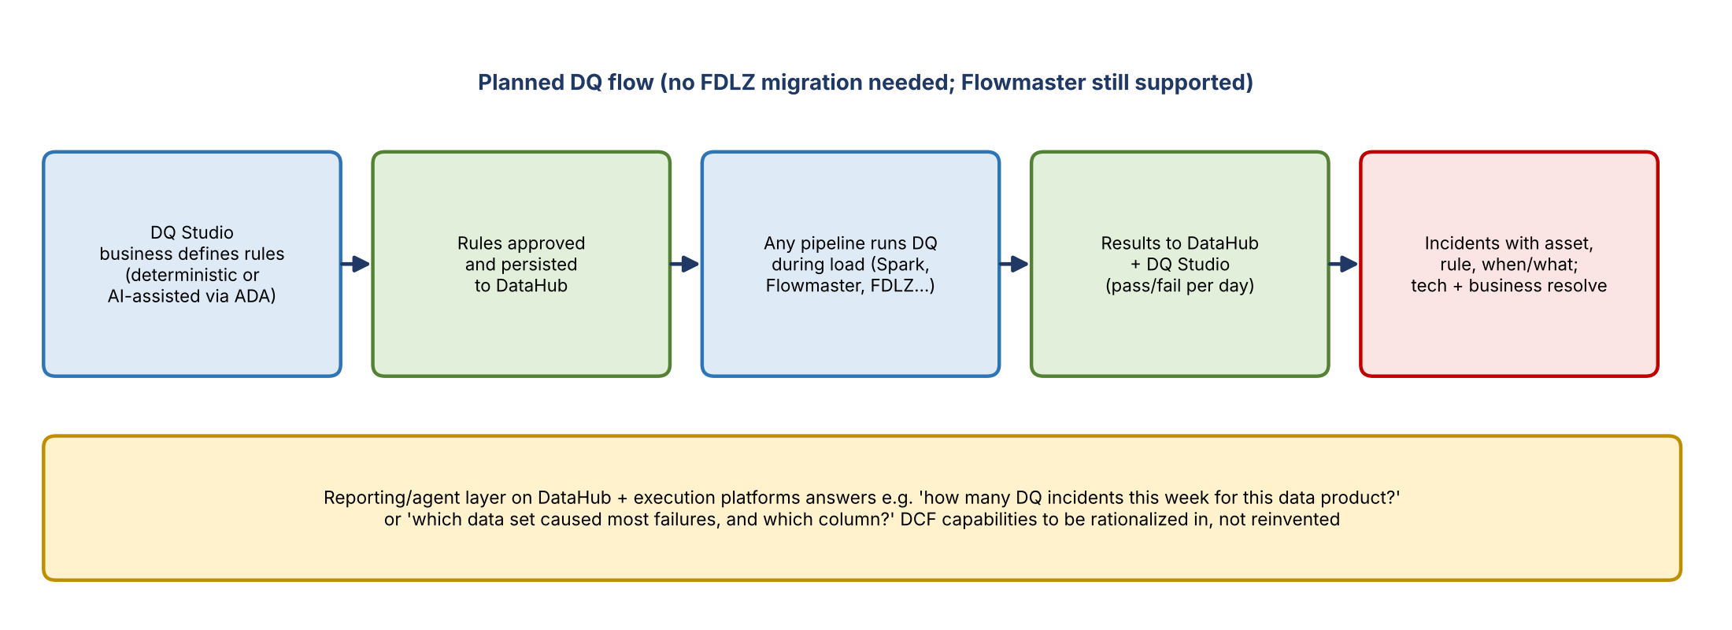
Figure 8. Planned DQ flow
- Business users define rules, deterministically or AI-assisted using ADA from CIB; approved rules persist to DataHub.
- Any pipeline executes the rules during load; results go to DataHub and DQ Studio.
- Incidents capture what happened, when, the asset, and the triggering rule, with tech and business resolving them together.
- A reporting layer combines DataHub with the execution platforms, since DataHub alone doesn't hold everything.
- Yashica clarified that FDLZ on the slide was just an example: no FDLZ migration is needed, and Flowmaster will be supported. Execution can be any federated engine, including non-DPC use cases.

8. Transition and next steps
- Nitin will set up recurring sessions for this group to track progress.
- Anand and Jimin will meet offline to decide which capabilities live where; the group will be updated as decisions are made.
- Goal: a DataHub adoption roadmap for risk tenants in Q1 2027, plus a target-state plan across Q1 to Q3 2027. Starts with DPC tenants; non-DPC apps once connectors mature.
- Mike's list of DCF capabilities will be added to the business outcome capability list; upcoming meetings will cover which applications onboard to DataHub.
- A separate semantic certification session with risk is already scheduled (thanks to Nitin).
- Mike raised that DCF can't be decommissioned until there's a plan for non-DPC applications, which are tied to Article 10 monitoring. Anand and Yashica repeated there is no plan to shut down DCF; which parts stay or go is a future conversation.

9. Decisions and agreements
- DCF is not being retired; the target state will incorporate its strong capabilities.
- DataHub adoption starts with DPC risk tenants in Q1 2027.
- This forum will continue as the place for these discussions.
- Flowmaster remains supported; no FDLZ migration required for DQ.

10. Action items
Action | Owner | Notes
Schedule recurring sessions for this group | Nitin | Showcase progress and plan
Offline design discussion on which capabilities go where | Anand and Jimin | Updates to the group
Add DCF capabilities to the business outcome capability list | Nitin | From Mike's slides
Identify applications to onboard to DataHub and build a plan | Group | Q1 2027 roadmap for DPC risk tenants
Hold the semantic certification session | Anand / Nitin | Already scheduled
Deliver anomaly detection email notifications | DCF team (Mike, Jimin) | Target end of October
Deliver ADMF integration and BSA/AML recon | DCF team, with Kevin | Q4 into Q1; Article 10
Find a new RADAR (Credit 360) contact | Mike | Previous contact left
Consider a KBE-to-lineage dashboard | DCF team | Data already exists

11. Open questions
- Which DCF capabilities move into DataHub/DQ Studio and which stay in DCF?
- What is the plan for non-DPC applications and their Article 10 monitoring?
- Will EDCC exist under the future policy, affecting the push of L1/L2 inventories to ADMF?
- How will fine-grained lineage be handled, given DataHub's strength is high-level lineage?
- What snapshot timing satisfies audit needs for near-real-time lineage?
- What are the domain and subdomain names for risk?
- What are the 2027 requirements for DCF's roadmap items?

