Meeting Notes
ORM Data Source Request Walkthrough with Jennifer (Vera)
Item | Detail
Meeting date | Wednesday, October 7, 2026 (recording started about 2:01 PM)
Format | Screen-share walkthrough of the revised source request template
Attendees | Jennifer (ORM; Vera owner and the team's single point of contact), Jake, and a colleague from Kevin's team who presented (most likely Vic)
People referenced | Jacqueline (approved this meeting and the approach), Kevin Moody (pulled the RDS details), Manish (owns the CRI assessment report in Cyber Frontline), tech CRO (owes ADMF input)
Purpose | Walk Jennifer through the simplified template built from ORM's 54 data sources, agree how ORM fills it in, and work out sequencing and the path to data access

Note on the transcript
Auto-generated transcript; speakers aren't labeled, so attributions are inferred. The presenter refers to "Jake or myself" and to talking with Jake before the call, so the presenter is most likely Vic. Readings used: Vera, RCSA (transcribed "our CSA"), STORM, Minerva, IT&V (transcribed "ITNV"/"ITMV"), FCTDS (transcribed "FTDS"), DPC (transcribed "future safety PC" and "CPC"), PDE requirements tab (transcribed "PD requirements"), risk (transcribed "RIS"). Confirmed: Nova, tachyon keys, RADAR, and CSB CRO (transcribed "CSB, BCRO"). Still unconfirmed: iGraphics and "BESI file."

1. Executive summary
The team walked Jennifer through the simplified template built from ORM's 54 data sources. It has two phases: a Source Request tab (ORM's inputs plus the team's columns on whether the data is already in RDS) and a PDE Requirements tab (field-level needs, matched against an RDS Details tab Kevin pulled). The template is meant to become the book of work for ORM and every other team requesting data, and Jacqueline wants this process repeated with every requestor.
Jennifer will be the single point of contact. Her main questions were sequencing (how far ahead to go beyond what the Vera prototype needs now) and how a high/medium/low priority turns into an actual development intake item. The group also worked through a vocabulary gap: Jennifer means AI prompts or orchestrations when she says "use case," while the data team means tier 1/2 data management use cases. They agreed ingestion isn't the use case; the AI output, and the report it feeds, is.
Next steps: Jennifer will start with RCSA and Minerva, fill in the PDE requirements, and send back prompts, user instructions, sample upload files, and JSON so the team can match sample data to source fields. ADMF is still waiting on tech CRO. The team will look into the ORC/ORCS and CRI rows. Jennifer is off next week; she'll set up a working session for the week of the 19th.

2. Key terms
Term | Meaning from the meeting | Note
Source Request tab | Phase 1: ORM's 54 sources (column E) with priority, cadence, frequency, history, and report distribution, plus the team's columns | First stop
PDE Requirements tab | Phase 2: the specific fields needed per source, aligned to PDEs, with a gap action item | Second stop
RDS Details tab | Current raw data already in RDS, matched to requested fields (pulled by Kevin) | Moves to DPC
Book of work | The single tracker of all data requests across ORM and other teams | "One-stop shop"
Use case (AI sense) | An AI prompt or orchestration in Vera | Jennifer's usage
Use case (data management) | A tier 1, 2, or 3 report or process the data supports | Data team's usage
Vera | ORM's AI tool; prototype being built out with individual orchestrations | Confirmed spelling
Nova | Environment where ORM runs its prompts against sample inputs | Confirmed
STORM | Third-party data source; Jennifer already has sample data | —
Minerva | Data source needed for an early orchestration | —
RCSA / iGraphics | RCSA data includes SHARP plus iGraphics service maps (visual RAU workflows) that ORM converts to narratives | iGraphics spelling unconfirmed; being retired under a broader IRP effort
IT&V | Second-line testing team that already sources many of these data sets | Transcribed ITNV/ITMV
Tachyon keys | Technical access ORM expects soon, enabling direct pulls from RDS | Confirmed
ORC / ORCS | Operational Resilience System of Record; found in RDS but disposed in ADMF | Need confirmed?
CRI | Cyber Risk Institute assessment; a report owned by Manish in Cyber Frontline | Follow up separately

3. The revised template
The team simplified the original template and loaded ORM's 54 sources and everything Jennifer provided (spreadsheet and PowerPoint). The added columns support a book of work that will serve ORM and every other team requesting data under the enterprise data plane initiative.
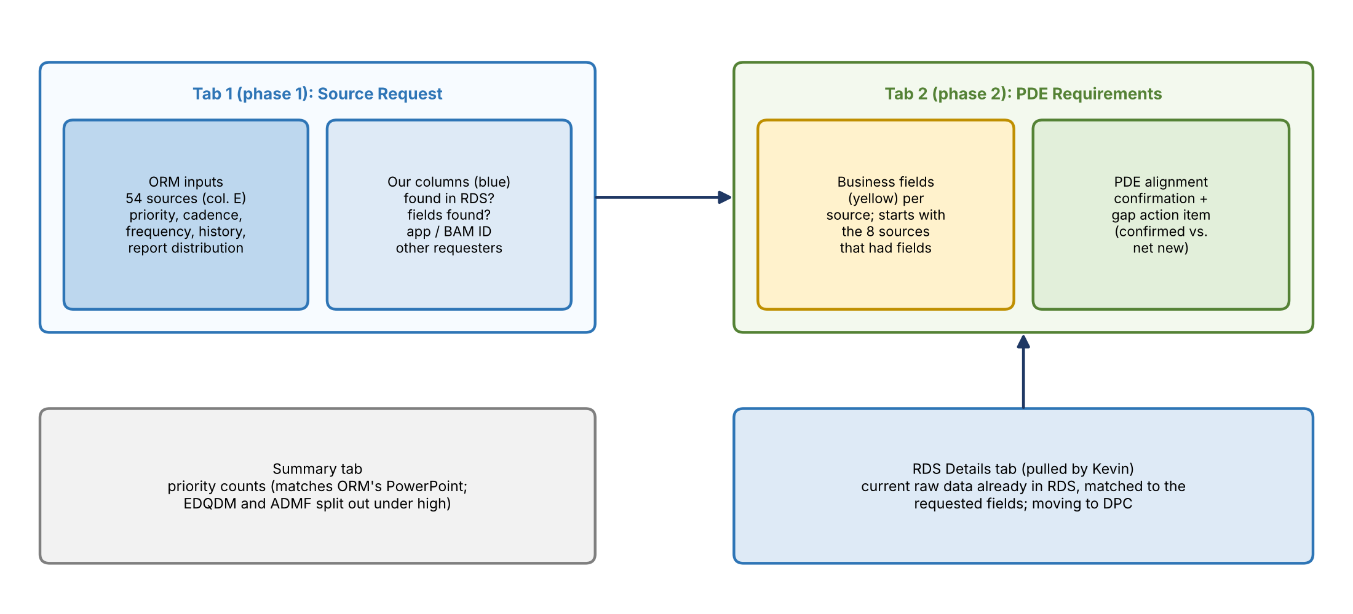
Figure 1. Template structure
- Source Request (phase 1): ORM's columns cover the use case, requirements, the why, cadence, and frequency. The blue columns are for the data team: is the source in RDS today, were any fields found, and if so the app ID or BAM registry ID, plus which other teams are also requesting it.
- Historical data: Jacqueline asked the team to find out how much history is really needed (for example, a year) versus nice to have.
- Other requesters: for example, IT&V, Beacon, CSB CRO, AI, and FCTDS are already asking for Hogan CIS. If Jennifer provides fields, the team can check what FCTDS or IT&V already sourced and say whether it fits or is net new. STORM has no other requesters.
- PDE Requirements (phase 2): starts with the 8 sources that had fields. The yellow columns are for the business. Kevin matched fields to the RDS Details tab, and the team needs Jennifer to confirm each PDE alignment. Confirmed rows show the gap action item as "confirmed" (already sourced).
- RDS Details: Jennifer doesn't need to review it; the team will use AI to help match fields.

4. Triage approach
Once the team knows the sources and fields, it fills in the blanks.
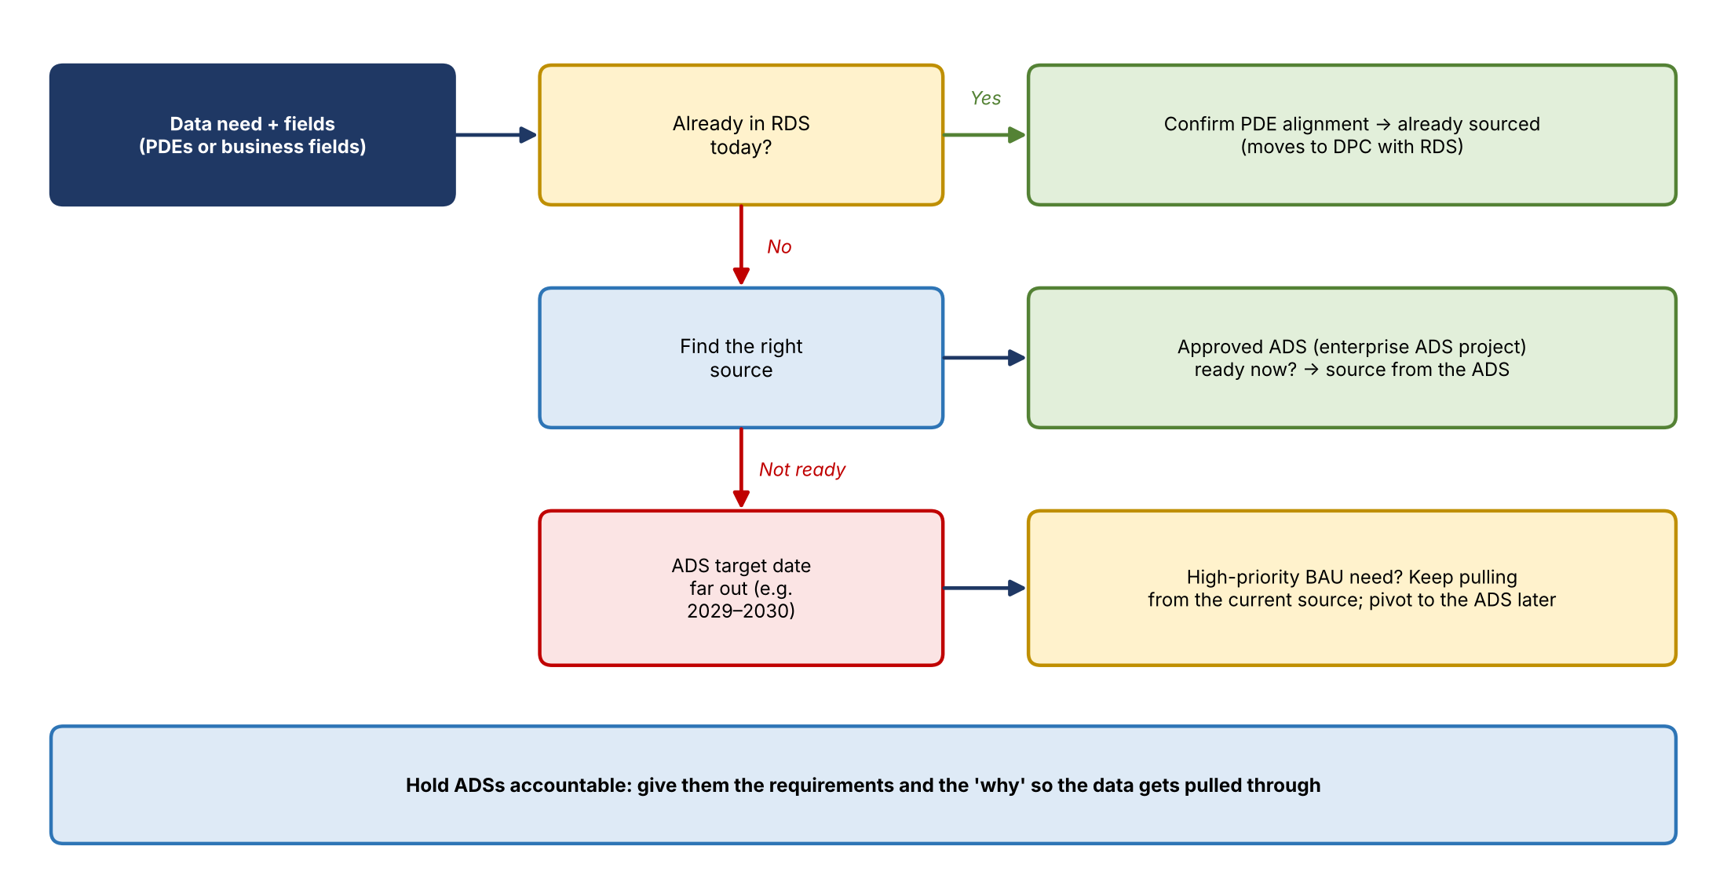
Figure 2. How each request gets triaged
- If the data is already in RDS, confirm the PDE alignment. It moves to DPC as part of the current migration.
- If not, find the right source and check whether it's an approved ADS under the enterprise ADS project, and its target date.
- If the ADS is far off (2029 or 2030) but the need is high priority, keep using the current source so BAU processes continue, and pivot later.
- The team will hold ADSs accountable by giving them the requirements and the why.

5. Sequencing and prioritization
Jennifer will be the point of contact. Vera's prototype is being built as individual orchestrations: RCSA first, then Minerva, then STORM. Her questions: how far ahead should ORM go on sources not needed for the immediate build, and how does a red/yellow/green or high/medium/low rating turn into development intake? She wants that solved now.
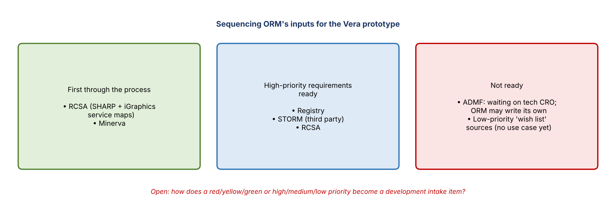
Figure 3. Sequencing of ORM's inputs
- The Summary tab's priority counts match ORM's PowerPoint (EDQDM and ADMF are split out under high).
- Proposal: tie priority to the tier of the use case. Tier 1 or 2 is high; tier 3 or ad hoc is lower. Finance risk use cases are simpler because they're all tier 1. The team offered to help define high, medium, and low.
- Jennifer explained many sources came from a "wish list" of what IT&V can already source, so many have no use case yet, which is why the low-priority list is long.
- ORM's two current focuses: AI (Vera), and later moving data analytics off the SAS environment (transcribed "SaaS").

6. What "use case" means
Jennifer named the core confusion: she uses "use case" for an AI prompt or orchestration, while the data team means a tier 1/2 data management use case. The presenter agreed and said many AI use cases are really aggregations of smaller use cases. The better question is what the BAU process was before AI: the analytics, report, or PowerPoint the data fed. Jacqueline called this fit-for-purpose use. Credit 360 (now RADAR) is an example: it supports reporting, models, and daily credit risk checks, and will also have an AI use case on top.
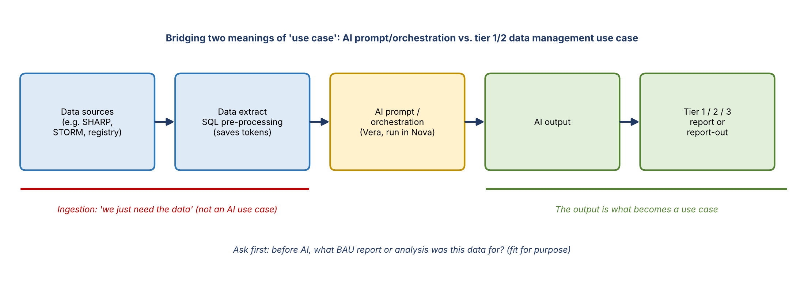
Figure 4. Agreed framing
- Agreed flow: data need → data extract → AI → AI output → tier 1, 2, or 3 report. Ingestion is not an AI use case; the output is.
- Example: the row for ADMF data isn't a use case; ORM just needs the data.
- In the template: the report distribution column can show which report each source feeds. For example, if ORM has three reports, about 20 sources might feed one, 20 another, and the rest the third. Another example: 10 sources, including SHARP, support issue management and risk assessments.
- Jennifer said the framing helps her explain this to others; she suggested whiteboarding it together later.

7. What ORM will provide
For STORM, Jennifer already knows which elements she uses and has sample data. She asked what level of detail the team wants. Her team builds prompts with sample inputs and current data extracts run in Nova; they know which registry report feeds the change management prompt and which fields the SQL parses. To save tokens, they do a lot of SQL preprocessing before running the AI.
- Jennifer will send: sample data for each source, the JSON, the prompt, user instructions, and sample upload files.
- The team will: match the sample data to source fields, compare against RDS, flag net-new requirements, and keep adding them to the PDE Requirements tab.
- Ready now: high-priority inputs for registry, STORM, and RCSA (SHARP plus iGraphics). ADMF is still waiting on tech CRO; ORM may write its own.
- iGraphics: RCSA service maps are files, not table data. ORM converts each into a narrative and uploads it. A broader IRP initiative aims to retire iGraphics, but ORM needs the content meanwhile.
- First through the process: RCSA and Minerva.

8. Rows the team flagged
Row | What the team found | Outcome
ORCS (ORC) | Found ORC with a distribution ID of "Global"; it shows as disposed in ADMF. A dashboard may still exist but could be fed by a different source now. | Jennifer: it's the Operational Resilience System of Record. She'll confirm whether it's still needed.
CRI | Couldn't find anything for the Cyber Risk Institute assessment. | It's a report owned by Manish in Cyber Frontline, using the CRI questionnaire and extracting the output. Follow up separately.
Others | Either found or fields not found in RDS. | Gap action items filled in.

9. Path to data access
ORM expects tachyon keys soon so it can pull from RDS directly, but Jennifer wants to document everything with the team rather than pull data on her own.
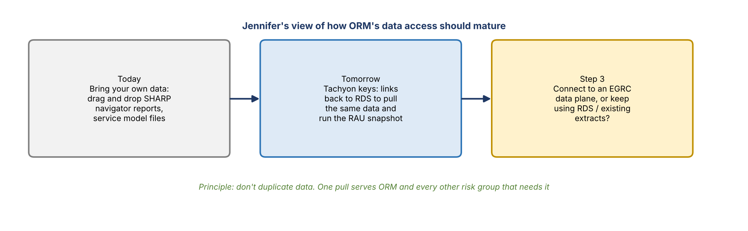
Figure 5. How ORM's data access should mature
- Team's answer: driven by priority. Data already in RDS (and DPC) is easiest. For net-new or non-risk data, use the ADS if it's ready. If not and the need is high priority, keep pulling from the current source and pivot once the ADS is ready.
- Jennifer's view: today is bring-your-own-data (drag and drop SHARP navigator reports, the service model, and a file transcribed as "BESI," unconfirmed). Next, link back to RDS to pull the same data and run the RAU snapshot. Third, decide whether to connect to an EGRC data plane or keep using RDS and existing extracts.
- Shared principle: don't duplicate data across the environment. If ORM and three other groups need the same data, it's pulled once into one place.

10. Decisions and agreements
- Jennifer is the single point of contact for ORM's inputs.
- Source Request and PDE Requirements are two separate phases.
- Ingestion is not an AI use case; data maps to the reports and outputs it feeds.
- RCSA and Minerva go through the process first.
- This walkthrough is the model to repeat with every requestor (per Jacqueline); the template should eventually be automated with tech partners.

11. Action items
Action | Owner | Notes
Update the Source Request inputs | Jennifer | Already started
Fill in PDE requirements for RCSA and Minerva | Jennifer | First sources through
Send prompts, user instructions, sample upload files, sample data, and JSON | Jennifer | After she reviews it with her dev team
Confirm whether ORC/ORCS is still needed | Jennifer | Shows as disposed in ADMF
Follow up on the CRI assessment with Manish | Team / Jennifer | Separately
Provide ADMF data requirements | Tech CRO, or ORM | ORM may write its own
Match sample data to source fields and flag net-new PDEs | Data team | Using the RDS Details tab
Help define what counts as high, medium, and low priority | Data team, with Jennifer | Possibly tied to tier
Define how priority becomes development intake | Data team | Jennifer wants this solved now
Schedule a working session | Jennifer | Week of the 19th; Jennifer is off next week

12. Open questions
- How does a priority rating turn into a development intake item?
- How far ahead should ORM define sources beyond the Vera prototype's immediate needs?
- How much historical data is actually needed?
- Who provides ADMF requirements: tech CRO or ORM?
- Is ORC/ORCS still a need, and what feeds the dashboard today?
- After tachyon keys, what's the documented process before ORM pulls from RDS?
- Will ORM connect to an EGRC data plane or keep using RDS and existing extracts?

