Draft Agendas
Data Strategy with Technology: Deep Dives, Wireframe Session & Workshop
Item | Detail
Prepared by | Jake, from the October 28, 2026 planning call
Status | Draft for Jacqueline and Kevin to review. Time boxes and roles are proposed
Sessions | Three technology deep dives (week of 11/2) · Internal wireframe session (Tue 11/3, 1–5 PM) · Workshop (Tue 11/17 and Wed 11/18, 1–5 PM)
Goal | Define the data strategy in detail by 11/17 and be direct with technology about what's needed

How to use this
• Section 2 can go to MA and technology with the deep-dive invites. Appendix A has a draft scheduling note for MA.
• Sections 3 and 4 are internal drafts for Jacqueline and Kevin to shape before the invites go out.
• The call set the dates and the 1–5 PM slots. The deep dives are one 1-hour and two 30-minute meetings. Time boxes and roles are proposals.

1. At a glance
Session | When | Length | Who | Scheduling
Deep Dive 1: DPC and target state architecture | Next week, by Fri 11/6 (this week if technology is ready) | 1 hour | Technology (Eric, Moshin + picks), Kevin, Jake, James | Jake via MA
Deep Dive 2: Tooling and AI ready | Next week | 30 min | Same | Jake via MA
Deep Dive 3: Data access, ownership and stewardship | Next week | 30 min | Same | Jake via MA
Internal wireframe session | Tue 11/3, 1–5 PM | 4 hours | Core team, James, John, outside guest (dial-in) | Jacqueline; team forwards
Workshop | Tue 11/17 and Wed 11/18, 1–5 PM | 2 × 4 hours | Core team, technology, owners, eGRC | Jacqueline (placeholders)

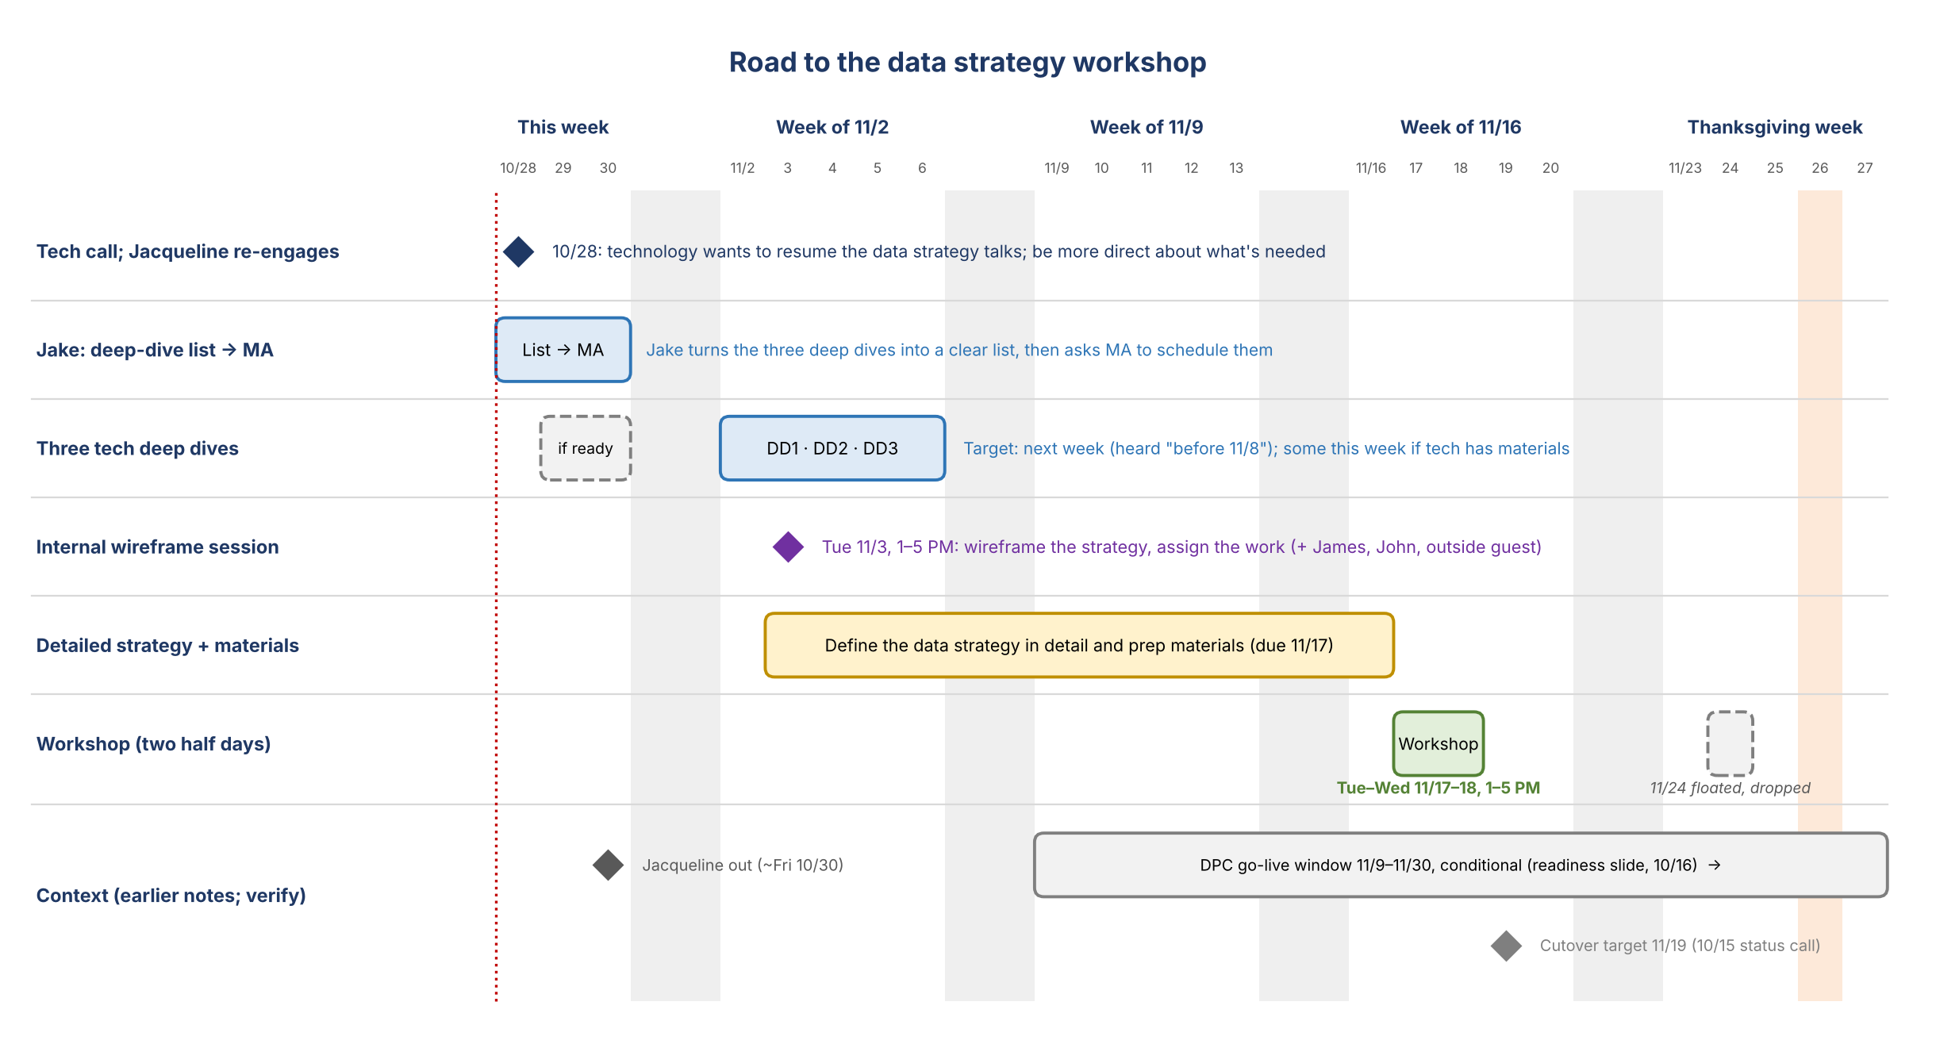
Figure 1. Road to the workshop

2. Technology deep dives (shareable)
Three walkthroughs to help the team prepare for the data strategy workshop on 11/17–18. The aim is a shared, plain-English understanding of where DPC is, what tools exist, and how access and ownership will work on the data plane.
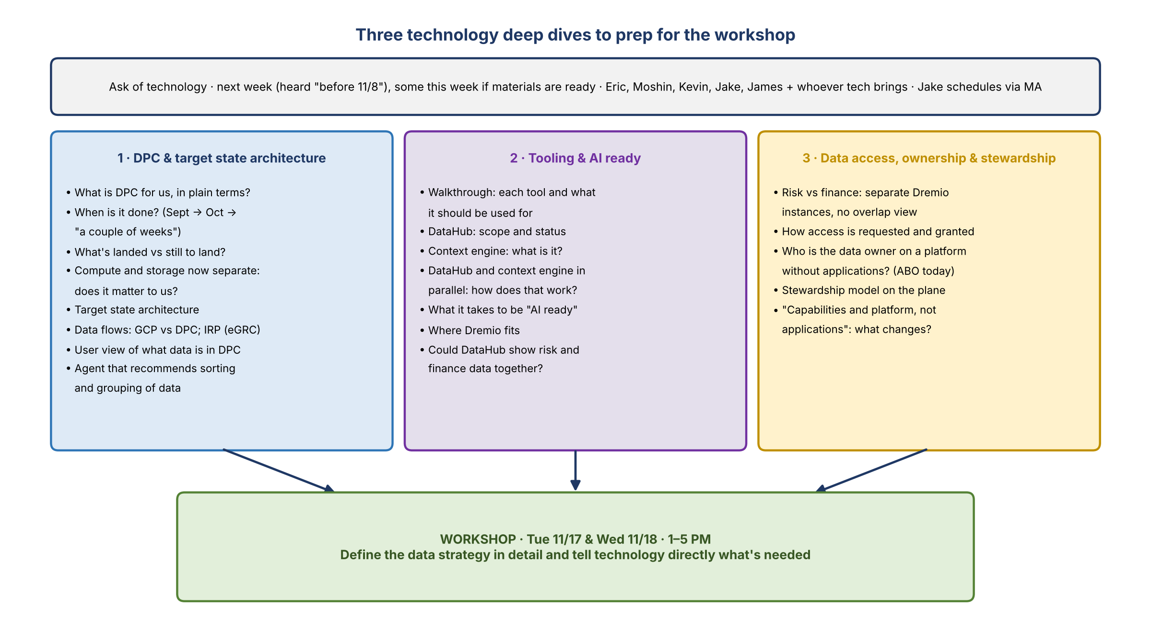
Figure 2. The three deep dives
Common details | Detail
Timing | Next week (by Friday 11/6). Earlier this week works if technology has materials ready
Attendees | Eric, Moshin, Kevin, Jake, James, plus anyone technology would like to bring
Length | Deep Dive 1: 1 hour. Deep Dives 2 and 3: 30 minutes each
Helpful to share beforehand | Deep Dive 1: DPC overview and timeline; what's landed vs planned; architecture and data-flow diagrams (GCP, DPC, IRP); background on why we chose DPC and Nexus One; a list of other DPC instances in the bank; a comparison of our DPC, the other instances and GCP, with pros and cons  Deep Dive 2: list of tools with their purpose; DataHub and context engine plans  Deep Dive 3: how access works on DPC today

Deep Dive 1: DPC and the target state architecture (1 hour)
Objective: understand what DPC is for us, why we chose it, where it stands, when it will be done, and the target state architecture and data flows.
Time | Topic | Lead | Output
0:00–0:05 | Purpose and what we need from this session | Jake | Shared goal
0:05–0:25 | DPC in plain terms: what it is for us; why we chose it (and Nexus One) and how it compares with other DPC instances and GCP; what "compute and storage are now separate" means | Technology (Eric, Moshin) | One-page DPC explainer
0:25–0:35 | Where we are: what's landed, what's next, and the timeline to "done" | Technology | Dated landed / to-land list
0:35–0:50 | Target state architecture and data flows: GCP vs DPC; IRP (eGRC) on DPC | Technology | Architecture and data-flow diagrams
0:50–0:57 | What's coming: the user view of data in DPC; the agent that recommends sorting and grouping data | Technology | Demo or screenshots
0:57–1:00 | Recap and follow-ups | Jake | Follow-up list

Questions to cover
- What is DPC for us, in plain terms? When will it be done?
- Why did we historically use DPC?
- What are the benefits of DPC over GCP?
- Are there other DPC instances in the bank? Why did we choose Nexus One?
- What are the pros and cons of our DPC versus the other DPC instances and GCP?
- What's been delivered so far, and what's still to be delivered?
- What does separating compute and storage change for users, if anything?
- What's the target state architecture? What sits on GCP vs DPC, and how does data move between them?
- What's IRP's data flow, and how will eGRC sit on DPC?
- What will the user view of DPC data show, and when?
- What will the sorting and grouping agent do, and how would it fit with how we organize data on the plane?

Deep Dive 2: Tooling and "AI ready" (30 minutes)
Objective: understand the tooling options, what each is for, how DataHub and the context engine fit together, and what "AI ready" takes.
Time | Topic | Lead | Output
0:00–0:03 | Purpose and what we need from this session | Jake | Shared goal
0:03–0:13 | Tool walkthrough: each tool, what it should be used for, who uses it, status (e.g. Dremio, DataHub, others) | Technology | Tool map
0:13–0:21 | DataHub and the context engine: what each does, how they can run in parallel, dependencies and timing | Technology | Sequencing view
0:21–0:27 | "AI ready": what it means and what it takes for risk data | Technology, Kevin | Working definition
0:27–0:30 | Fit to our use cases; recap and follow-ups | Jake, Kevin | Follow-up list

Questions to cover
- What tools are on offer, and what is each one for? Which should we use for what?
- What is the context engine, and how does it relate to DataHub?
- We heard DataHub and the context engine can be done in parallel. How does that work?
- What does "AI ready" mean in practice, and what does it take for risk data?
- Where does Dremio fit alongside DataHub?

Deep Dive 3: Data access, ownership and stewardship (30 minutes)
Objective: understand how access, ownership and stewardship work on the data plane, including seeing risk and finance data together.
Time | Topic | Lead | Output
0:00–0:03 | Purpose and what we need from this session | Jake | Shared goal
0:03–0:10 | How access works on the plane: requesting and granting, tenants, Dremio instances | Technology | Access model summary
0:10–0:18 | Seeing risk and finance data together: options given separate Dremio instances; could DataHub help? | Technology, Kevin | Options
0:18–0:27 | Ownership and stewardship on a platform: the data owner without applications; how ABO responsibilities carry over; stewardship roles | Technology, Kevin | Inputs to the ownership model
0:27–0:30 | Recap and follow-ups | Jake | Follow-up list

Questions to cover
- How is access requested and granted on the plane, and can access span domains?
- Risk and finance each have their own Dremio instance. How can overlapping data be viewed side by side?
- With "capabilities and platform, not applications", who is the data owner for a data set, and how do today's ABO responsibilities carry over?
- What stewardship roles does technology assume (e.g. the DataHub steward and owner certification steps)?

3. Internal wireframe session: Tue 11/3, 1–5 PM
Item | Detail
Objective | Agree what the data strategy needs to be, wireframe it, and assign the work to get to a detailed strategy by 11/17
Attendees | Core team (Jacqueline, Kevin, Jake, and whoever else the team thinks should be there), James, John, outside guest (dial-in)
Invite | Jacqueline sends it; the team forwards it to others
Pre-work (suggested) | Skim the Risk Data Sourcing Strategy deck (v6.2) and the data plane principles; read any deep-dive notes so far; bring open questions
Time back | If the session finishes early, everyone gets time back

Time | Topic | Lead | Output
1:00–1:10 | Goals for today; what "done" looks like by 11/17 | Jacqueline | Agreed goals
1:10–1:55 | Outside perspective: the CB/CIB data marketplace. How they're organizing their ADSs (e.g. party, transaction), their taxonomy, what's working, what to avoid, and whether we can rely on it for that business's data | Outside guest | Ideas to borrow; things to avoid
1:55–2:15 | What we've learned from technology so far | Jake | Open gaps
2:15–3:15 | Wireframe the data strategy on the whiteboard: structure, scope, principles, target state (starting point below) | All | Draft wireframe
3:15–3:25 | Break
3:25–4:10 | Design the workshop: outcomes, sessions, invitees, pre-reads (draft in Section 4) | All | Workshop plan
4:10–4:45 | Assignments and plan to 11/17: owners, dates, check-ins | John | Plan with owners
4:45–5:00 | Wrap: decisions and open items | Jacqueline | Decision log

Proposed starting wireframe for the data strategy
A skeleton to react to on 11/3, built from the team's deck and this week's call.
# | Section | Guiding questions | Inputs
1 | Purpose and outcomes | Why a data strategy now? What does success look like in 2027? | Deck goal: trusted, reusable risk data for AI, reporting and analytics
2 | Principles | What rules do we hold ourselves and technology to? | The six data plane principles (domain council slide)
3 | Current state | What's on DPC today, what's landed, what tools exist? | Deep Dives 1 and 2; DPC readiness
4 | Target state | How is data organized on the plane: by what it is, not by source application? Where does eGRC (IRP) sit? | Deep Dive 1; the CB/CIB taxonomy; the team's DPC landing plan
5 | Ownership, stewardship and access | Who owns and stewards data on a platform without applications? How is access granted, including across risk and finance? | Deep Dive 3; DataHub certification roles
6 | Tooling and AI readiness | What do we use for what (Dremio, DataHub, the context engine)? What does "AI ready" require? | Deep Dive 2
7 | Risk and finance alignment | Where do risk and finance data overlap? How do we work together on shared data? | Deep Dive 3; the CR360 (RADAR) migration
8 | Roadmap and sequencing | What comes first (e.g. ORCAP first), and what goes into 2027? | Deck order of work; priority use cases
9 | Asks of technology | Exactly what do we need technology to build, by when? | Deep dives; intake tool and DataHub priorities
10 | Governance and tracking | Who decides, how do we track progress, and how do we escalate? | Deck governance; John's plan; four-blocker format

4. Workshop: Tue 11/17 and Wed 11/18, 1–5 PM
Item | Detail
Dates and times | Two half days, 1–5 PM each (8 hours). Starts after the 12–1 monthly risk AI discussion; avoids Thanksgiving week
Format | Leaning in person, to whiteboard with Eric and Moshin; add a dial-in. To confirm
Objectives (proposed) | 1) Shared understanding of DPC today and the target state. 2) Agree how data is organized, owned, stewarded and accessed on the plane. 3) Agree tooling and what "AI ready" means for risk data. 4) Leave with a roadmap and clear asks of technology
Pre-reads (suggested) | Draft data strategy wireframe; deep-dive summaries; DPC one-pager; open questions. Send by Fri 11/13

Invitees
Group | Names | Notes
Hosts | Jacqueline, Kevin, Jake, James, John | John runs the plan and readouts; Jake takes notes and translates
Technology | Eric, Moshin (plus anyone technology suggests) | Whiteboarding
Data and application owners | Jeff Goldsmith, Deepen | Spelling of Deepen to confirm
Also needed | Dana, Gina | Roles to confirm
eGRC | Amber (technology), Jordan, Panos | Chad was also mentioned

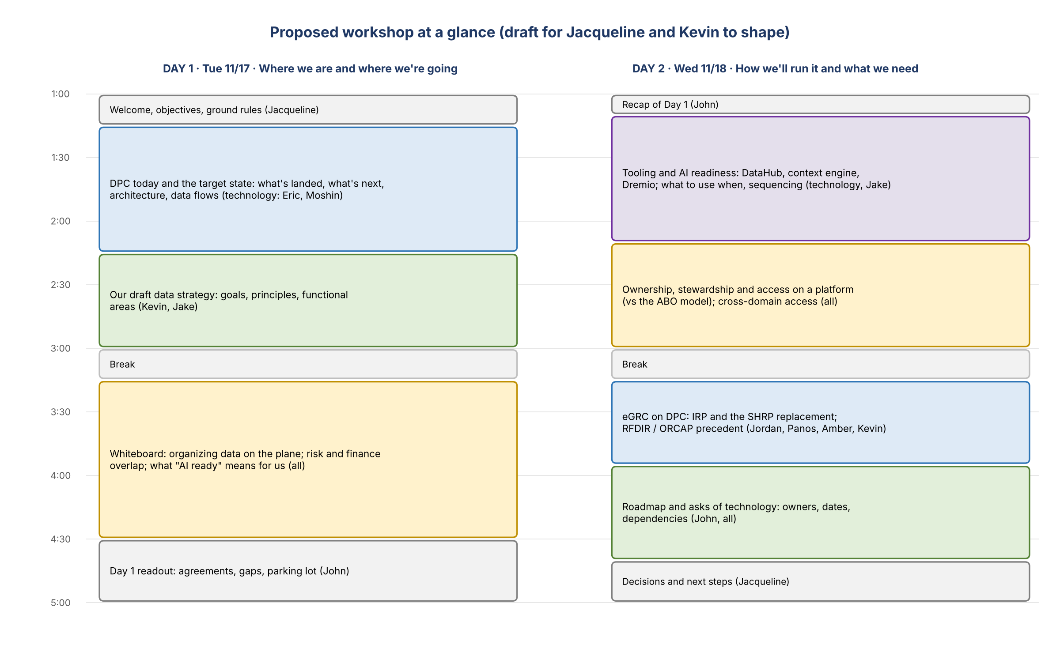
Figure 3. Proposed workshop at a glance

Day 1: Tue 11/17 · Where we are and where we're going
Time | Session | Lead | Output
1:00–1:15 | Welcome, objectives, ground rules | Jacqueline | Shared objectives
1:15–2:15 | DPC today and the target state: what's landed, what's next, architecture, data flows (GCP vs DPC; IRP) | Technology (Eric, Moshin) | Common picture of DPC
2:15–3:00 | Our draft data strategy: goals, principles, functional areas | Kevin, Jake | Reactions and gaps
3:00–3:15 | Break
3:15–4:30 | Whiteboard: organizing data on the plane (domains and data sets); where risk and finance data overlap; what "AI ready" means for us | All (facilitated) | Draft target-state picture
4:30–5:00 | Day 1 readout: agreements, gaps, parking lot | John | Readout

Day 2: Wed 11/18 · How we'll run it and what we need
Time | Session | Lead | Output
1:00–1:10 | Recap of Day 1 | John
1:10–2:10 | Tooling and AI readiness: DataHub, the context engine, Dremio; what to use when; sequencing | Technology, Jake | Tool map and sequence
2:10–3:00 | Ownership, stewardship and access on a platform (vs today's ABO model); access across domains | All | Draft ownership and access model
3:00–3:15 | Break
3:15–3:55 | eGRC on DPC: IRP and the SHRP replacement; the RFDIR and ORCAP precedent | Jordan, Panos, Amber, Kevin | eGRC fit and next steps
3:55–4:40 | Roadmap and asks of technology: owners, dates, dependencies | John, all | Asks with owners and dates
4:40–5:00 | Decisions and next steps | Jacqueline | Decision log

Roles (proposed)
- Facilitation: Jacqueline opens and closes; Kevin leads the content.
- Plan, timekeeping and readouts: John.
- Notes and technology translation: Jake.

Outputs
- A decision log and parking lot, each item with an owner.
- An agreed wireframe that becomes the detailed data strategy.
- Asks of technology with owners and dates.

Logistics checklist
Item | Owner | Status
Calendar placeholders for 11/17 and 11/18, 1–5 PM | Jacqueline | Planned
Decide in person or virtual | Jacqueline | Open
Room with whiteboards plus a dial-in | Jake / John | Open
Confirm invitees (Eric, Moshin, Jeff Goldsmith, Deepen, Dana, Gina, Amber, Jordan, Panos) | Jacqueline / Kevin | Open
Pre-reads out by Fri 11/13 | Jake / John | Open
Readout and follow-ups after the workshop | John | Open

Appendix A: Draft scheduling note to MA
Subject: Scheduling three technology walkthroughs (week of Nov 2)
Draft
Hi MA,
Jacqueline asked me to reach out about scheduling three walkthroughs with technology to prepare for the data strategy workshop on November 17–18. Could you please set up one 1-hour meeting and two 30-minute meetings next week (by Friday, November 6)? Sooner is great if technology has materials ready.
Attendees for all three: Eric, Moshin, Kevin, James and me, plus anyone technology would like to bring. The agendas are below, and the draft agenda document is attached.
1. DPC and target state architecture (1 hour)
- Purpose and what we need from the session
- DPC in plain terms: what it is for us, why we chose it (and Nexus One), how it compares with other DPC instances and GCP, and what "compute and storage are now separate" means
- Where we are: what's landed, what's next, and the timeline to done
- Target state architecture and data flows: GCP vs DPC; IRP (eGRC) on DPC
- What's coming: the user view of DPC data and the agent that recommends sorting and grouping data
- Recap and follow-ups
Helpful beforehand: DPC overview and timeline; what's landed vs planned; architecture and data-flow diagrams; background on why we chose DPC and Nexus One; a list of other DPC instances in the bank; a comparison of our DPC, the other instances and GCP, with pros and cons
2. Tooling and AI readiness (30 minutes)
- Purpose and what we need from the session
- Tool walkthrough: what each tool is for, who uses it and its status (e.g. Dremio, DataHub)
- DataHub and the context engine: what each does and how they can run in parallel
- What "AI ready" means and what it takes for risk data
- Fit to our use cases; recap and follow-ups
Helpful beforehand: a list of tools with their purpose; DataHub and context engine plans
3. Data access, ownership and stewardship (30 minutes)
- Purpose and what we need from the session
- How access is requested and granted on the data plane (tenants, Dremio instances)
- Viewing risk and finance data together, given separate Dremio instances; could DataHub help?
- Ownership and stewardship on a platform rather than applications: the data owner, how ABO responsibilities carry over, and stewardship roles
- Recap and follow-ups
Helpful beforehand: how access works on DPC today
Thank you!
Jake

