Meeting Notes
SAS Workspaces in Brian Schiffer's Org: Planning with AJ & Julia
Item | Detail
Meeting date | Thursday, October 29, 2026 (about 9:25 AM ET; Brian's org call was "in like 40 minutes" at 10:05)
Format | Working call; AJ shared the survey he'd just completed, and Kelly shared the workspace reporting
Corporate risk BDL | Kelly, Jake
Brian Schiffer's org | AJ (manages his team's SAS locations and access reviews), Julia (Brian's chief of staff; pulled in partway)
Referenced | Gwen and Jacqueline (sponsors), Brian Schiffer, Kelsey, John Crawford, David Blitvich, Jennifer, Leopold, Shawn Douglas, Rakesh, Michael Marchand, Daniel Liu, Julia Duke, Kevin Moody
Purpose | Work out how to get the SAS survey done for Brian Schiffer's org, which was held back from the main kickoff, and get on the agenda of Brian's leadership call

Note on the transcript
Pasted transcript that starts mid-conversation; speakers aren't labeled, so attributions come from context. Corrections applied: Brian Schiffer (transcribed "Ryan Schiff", and "brand" for Brian), SAS ("SaaS"), Unix groups ("Unish groups"), Shawn Douglas ("Sean"), David Blitvich ("Blitbitch"), PyFarm. Unsure: Julia's surname, Julia Duke, Michael Marchand, Daniel Liu, Jennifer's surname, "CBL CRO", the names of AJ's former leaders ("Ajit Nala", "Sander De Morgan", "Richard"), and one garbled line on the Basel models (see Section 4). Small talk is left out.

1. Summary
Kelly and Jake met AJ to plan the SAS survey for Brian Schiffer's org. That org was left out of this week's kickoff at Kelsey's request, because Brian had earlier told his people not to worry about SAS. AJ suggested going through Brian's leadership meeting, and pulled in Julia, Brian's chief of staff. She added Kelly, Jake and Kevin Moody to Brian's org call at 10:05 AM ET today.
What came out:
- Brian has changed his message. He told his leadership team yesterday (10/28) to start treating SAS as end-of-life. There's no timeline yet, but the loss forecasting teams should start moving to PyFarm.
- The org has already started cleaning up: about 80 of roughly 90 desktop SAS licenses were cancelled after the summer move to CBL CRO, and Julia Duke began a space cleanup.
- Quantitative modeling is about 95% off SAS. Only the Basel models remain, with PyFarm as the exit path. Loss forecasting is still heavily on SAS: models, EUCTs and data processes.
- Ownership is stale. AJ and Kelsey count about 87 SAS locations tied to the org. Owners such as David and Jennifer can't explain the locations they own.
- Two ways forward: (A) send the survey to every owner, or (B) take a holistic approach through a few knowledgeable people, as with the DMP work about two years ago.
Gwen wants preliminary details early next week. Julia asked for a targeted list of locations and owners. She warned that not everyone in loss forecasting has heard SAS is likely going away, so the message should be delivered gently.

2. AJ's view: Unix groups and stale ownership
- The other SAS platforms work differently from what AJ is used to: there are no entitlements, and access goes by Unix groups. He hasn't managed access that way, and doesn't have access to those platforms, so he's still getting familiar with them.
- His suggestion: start with Brian's leadership meeting, to decide who can lead this. Then get all the owners to do the survey and identify locations that aren't used, or that owners didn't know they had.
- AJ is two or three levels below Brian. He invited Julia, Brian's chief of staff, so Kelly could get on the leadership agenda.

The survey AJ just completed
- AJ shared a survey he had completed for his own workspace just before the call, after checking some of the questions with his manager. It's a different survey from Kelly's team's.
- Kelly asked him to forward it to her and Jake, to connect the dots given all the swirl around SAS.
- AJ manages one primary location and is retiring a second one, which is used for two reports, by moving its contents into the primary.

Access and ownership hygiene
- AJ has retired about 16 shared drives in the last year; it had become unmanageable after reorgs, with managers leaving and people not knowing what they own.
- He runs an annual control where owners review who has access. In a team of 40–50 people he always finds at least 10% with inaccurate access. Kelly: the team is seeing the same pattern.
- The policy already says that whoever approves or accepts an entitlement is responsible for it, and people should hand over ownership before leaving a team. In practice it's vague and nobody enforces it. AJ pushed a policy review in April under a previous leader; it shouldn't be one person's job every year.
- Kelly: the effort needs to put more ownership on workspace owners.
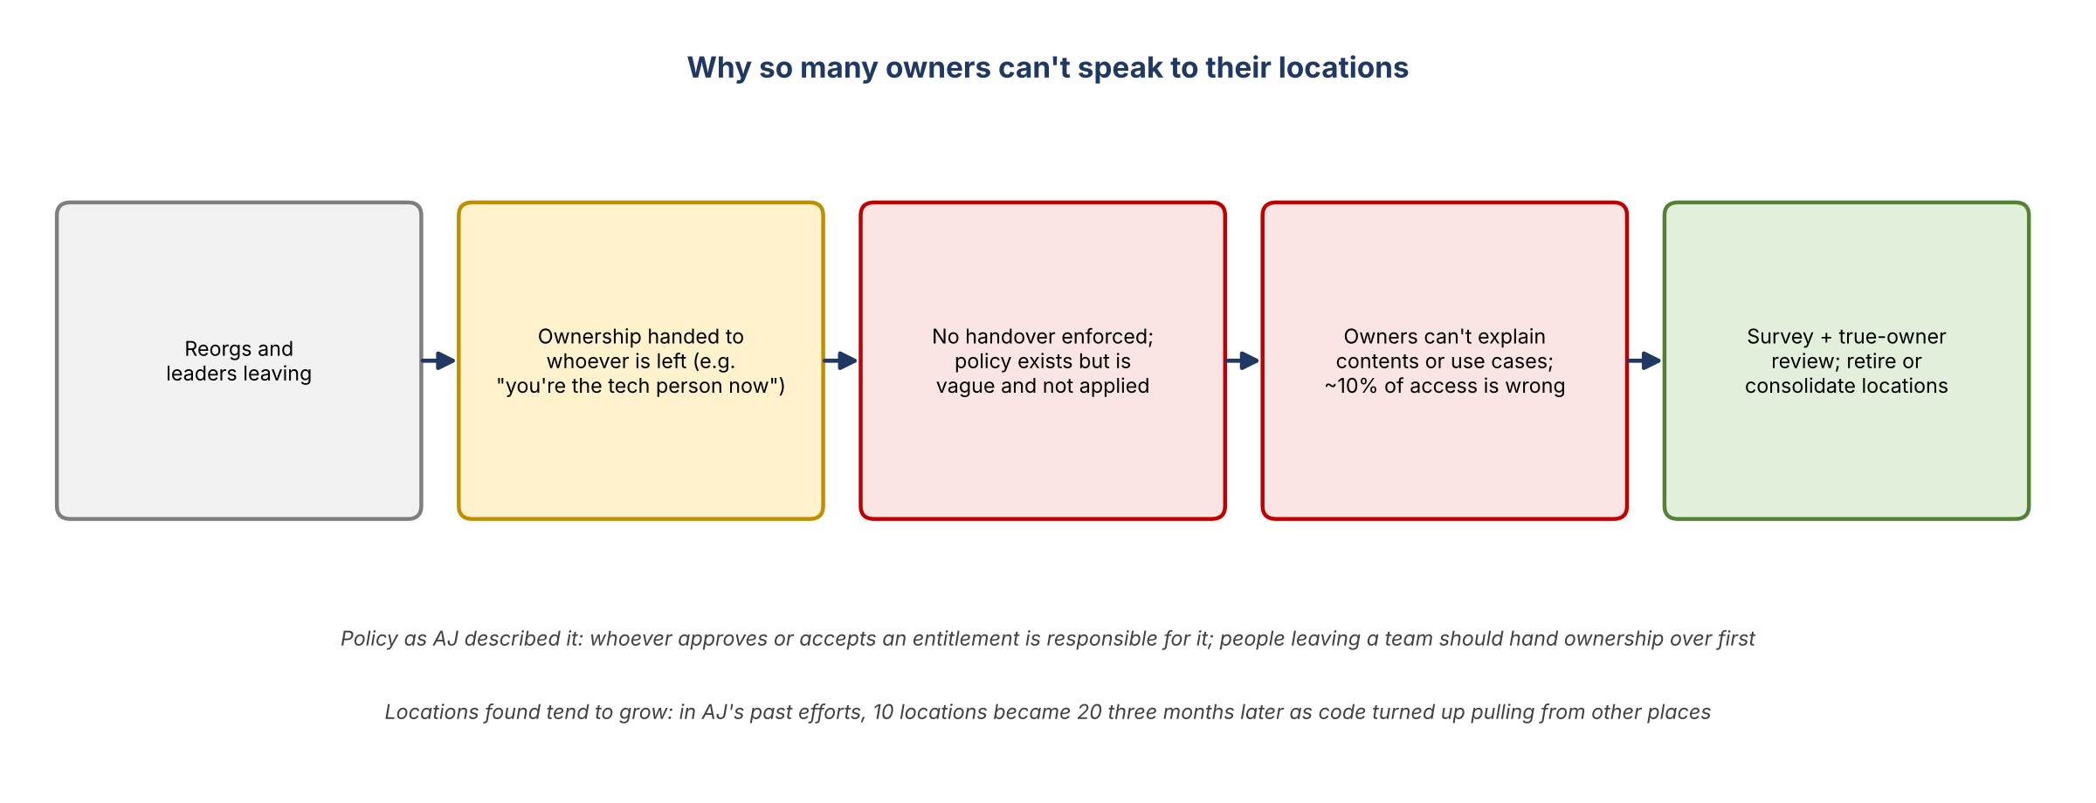
Figure 1. Why so many owners can't speak to their locations

3. Survey coverage in Brian Schiffer's org
- Gwen (top of the house) wants preliminary details early next week.
- The survey hasn't gone to Brian Schiffer's org as a whole. Kelly sent it to AJ, Kelsey and John Crawford (from last Friday's call).
- This week's kickoff with individual workspace owners excluded Brian's people, at Kelsey's request, to avoid confusion after Brian said not to worry about SAS.
- A few in his org did get the survey individually: Leopold, Shawn Douglas and Rakesh. Michael Marchand and Daniel Liu, who report to Brian, were also sent it; Michael hasn't completed it. Maybe half of that group has responded.
- Leopold: he says he doesn't really know what's in SAS. AJ thinks he probably inherited the locations when he was made the technology person, so he may not be able to speak to them. Still worth trying.
- People who moved on: some think they're off the hook because they left the team. AJ: they should have handed over their entitlements and found a new owner first.
- Follow-ups: Kelly will follow up with Jennifer, John and David on the workspaces that were reassigned, and with the others the team coordinated with.

4. Julia: what's already happening in Brian's org
Julia had worked with Kelly before. Leopold had asked her to take ownership of one of his two drives, which is how she got pulled into the wider SAS sunset effort. Kelly gave the background: leadership can see allocation and usage for each workspace, SAS costs the bank a lot, and the survey asks about data, downstream usage, regulatory reports, models and use cases, to clean up, consolidate and find exit paths (some are already moving to PyFarm). Gwen and Jacqueline are sponsoring it.
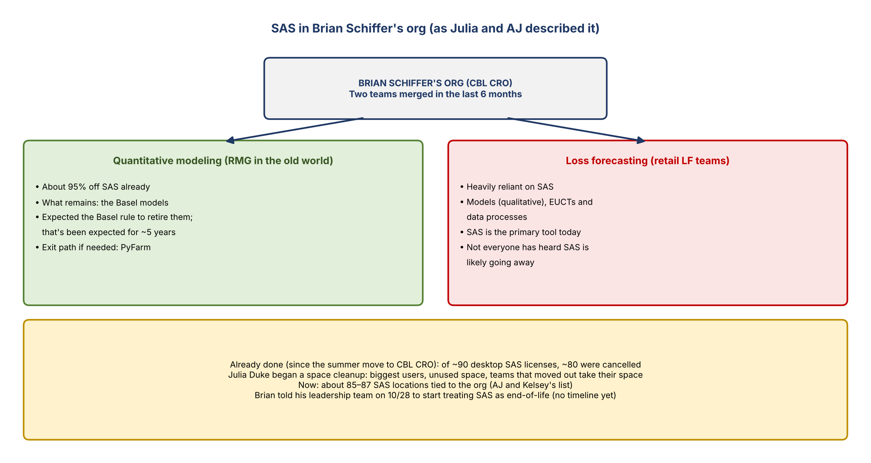
Figure 2. SAS in Brian Schiffer's org
- Brian's message changed: he told his leadership team yesterday that they're going to get off SAS. There's no timeline, but they should start treating SAS as end-of-life and wrap their arms around it.
- Cleanup since the summer move to CBL CRO: of about 90 SAS desktop licenses across Brian's org, about 80 were cancelled. Julia Duke began a big space cleanup: where they use the most, where space is unused and can be given back, and making sure teams that moved out (deposits, and now commercial) take their space with them.
- There's been a lot of change in people and leaders. Two teams came together in the last six months, both now under Brian:
  - Quantitative modeling (RMG in the old world): about 95% off SAS. What remains are the Basel models. The team expected the Basel rule to eliminate them, but that's been expected for about five years, so they haven't invested in moving them. PyFarm is the exit path if needed. (The transcript reads "we can't just move them to PyFarm", which conflicts with the rest of her point; likely "we can".)
  - Loss forecasting (all the retail loss forecasting teams): still heavily reliant on SAS, including qualitative models, EUCTs and data processes. SAS is their primary tool.
- AJ and Kelsey: over the last couple of weeks they've been taking ownership of locations whose owners sat outside Brian's org but that belong to it. They net about 85 SAS locations (later 87). The goal is to retire or consolidate them: "I don't think we need 80 drives."
- About four to six locations went to David and Jennifer, who can't say why they own them or what they're used for. Only seven or eight locations have been looked at so far, and AJ doubts other team members could fully explain theirs either.

5. Two ways to get the survey done
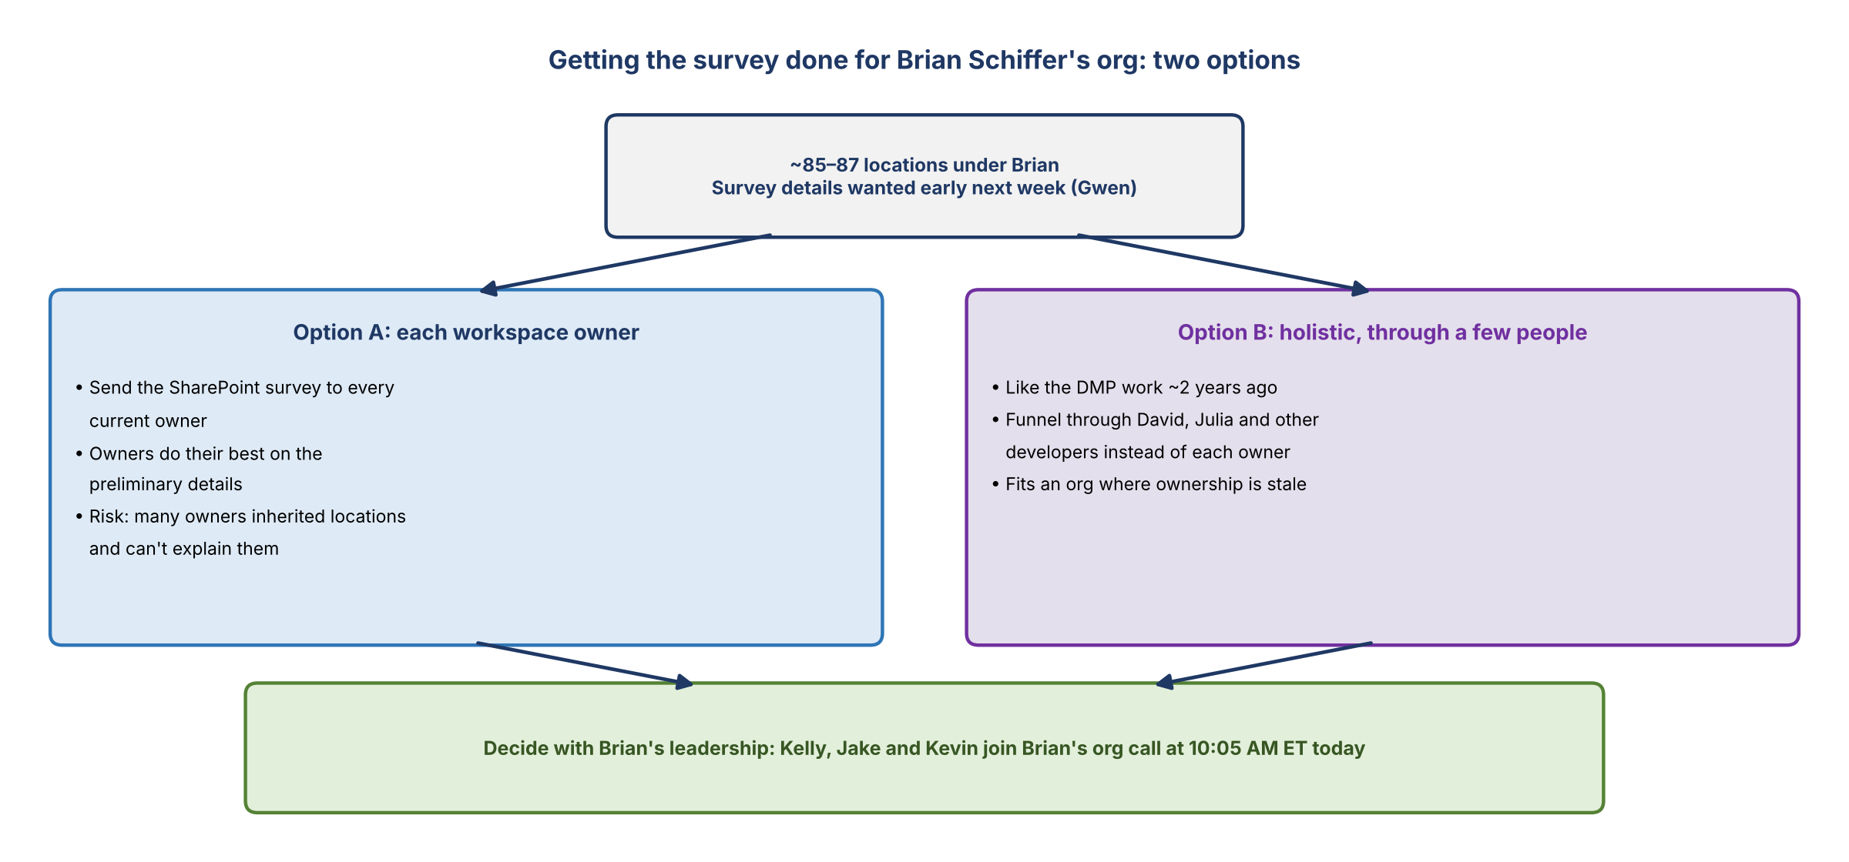
Figure 3. Two options for Brian Schiffer's org
Option | What it means
A: each owner | Send the SharePoint survey to every workspace owner in Brian's org and ask them to provide the preliminary details as best they can
B: holistic | Like the DMP work about two years ago: instead of relying on each model owner, funnel it through David, Julia and some of the other developers on the team

- Senior leadership wants details on every workspace in corporate risk, so Brian's org can't stay out.
- Kelly offered to join Brian's org call to explain who the team is and what it's doing, and to cut down on the swirl.

6. Getting on Brian's leadership call
- Julia: the call is at 10:05 AM ET today, about 40 minutes after this meeting. It's for Brian, his directs and management.
- She asked for a list of the locations and owners so the conversation can be targeted.
- What Kelly has: the enterprise workspace report, at the parent or mount level (subdirectories roll up), filtered to corporate risk. She's also tracking the owners identified so far, at least 85 under Brian. She'll share it so Brian's people can spot workspaces that should be theirs, for example where the listed owner is no longer right. She also has the PowerPoint deck she's been walking owners through, and the survey.
- Julia added Kevin Moody (for awareness; she works with him on data with MRM), Kelly and Jake to the meeting. Introduce the team as the corporate risk data management and governance team.
- Julia had no concerns yet; she may have questions after hearing more.
- Deliver it gently: not everyone on the loss forecasting team has heard SAS is likely going away. Julia is happy to have Kelly be the messenger. Brian's leadership did discuss getting the loss forecasting teams onto PyFarm, with the quantitative side helping.

AJ's list of 87
- After the call, AJ sent Kelly and Julia the link to the 87 locations he and Kelsey reviewed (versus 85). It's based on current owner names and locations, so it needs research and isn't the full picture yet.
- In AJ's experience, lists like this grow: in past efforts, 10 locations turned into 20 three months later, as code turned up pulling from places nobody knew about. That's why Brian's call matters: people can say "we have this one, is it on your list?"
- Kelly will compare it with her list. It came from her original list, so they look consistent.

7. Decisions
# | Decision
1 | Bring the survey to Brian Schiffer's org through his leadership call rather than going around it
2 | Kelly, Jake and Kevin Moody join Brian's org call today at 10:05 AM ET as the corporate risk data management and governance team
3 | Work from a targeted list of locations and owners (Kelly's report plus AJ and Kelsey's 87)

8. Action items
Action | Owner | Notes
Join Brian's org call; give background on the SAS effort and the survey | Kelly, Jake, Kevin | 10:05 AM ET today; deliver the SAS message gently
Share the corporate risk workspace list and owners with Brian's org | Kelly | So they can claim locations that belong to them
Forward the survey AJ completed | AJ | To Kelly and Jake
Compare AJ and Kelsey's 87 locations with Kelly's list | Kelly / Jake
Follow up with Jennifer, John and David on reassigned workspaces, and with Michael Marchand and Leopold | Kelly
Agree option A or B for Brian's org | Kelly with Julia / Brian's leadership
Get preliminary details in for Gwen | Kelly / Jake | Early next week

9. Open questions
- Option A or option B for Brian's org, and who leads it there?
- Who manages access on the Unix-group platforms, and how will owners be confirmed there?
- How many locations really belong to Brian's org (85, 87, or more)?
- Who is behind the other survey AJ completed, and how does it relate to this one?
- Will the Basel models be retired, or move to PyFarm, before SAS goes away?

