Meeting Notes
Holistic Surveillance (1HSUR): Use Case Status and ADS Tagging Decision
Item | Detail
Meeting date | Tuesday, October 6, 2026 (recording started about 2:31 PM)
Format | Use case status update with a decision on approved data source (ADS) tagging
Use case | Information barrier surveillance, run on 1HSUR (holistic surveillance)
Governance side | Brian (leads the governance team; ran the meeting), Manish and Kathy (governance team; use case data dictionary)
Use case owner side | Gilbert (business application owner of 1HSUR), Bernie (works on 1HSUR data feeds and quality expectations)
Risk ADS strategy | Kevin Moody (leads ADS strategy for risk; invited by Brian as a peer)
People referenced | Eugene (Gilbert's leadership; wants the work to go upstream), Evan (CIB business data leader Brian knows), John Rooney (CIB contact for BAU issues, per CIB's chief data officer)
Purpose | Review progress on the use case's data management documentation and decide whether to tag 1HSUR or its upstream systems of record as the ADS, given the timeline impact

Note on the transcript
Auto-generated transcript; speakers aren't labeled, so attributions are inferred from context. Confirmed spellings: 1HSUR (transcribed "one HSUR," "one S-U-R," "one HSCR"), CIBAPP (transcribed "TPD," "DPD," "CIB APD," "CID APD"), EMH, one-hop (transcribed "1HOPOP" and "one-up"), and CIB (transcribed "CIP"). ADMF and PDE follow standard usage from earlier meetings.

1. Executive summary
Brian's governance team gave a status update on the documentation required for the information barrier surveillance use case. Most artifacts are done or close: the risk assessable unit is tagged, desktop procedures are complete pending the ADS name, the use case data dictionary is waiting only on data quality expectations from Bernie, and the data adjustment template should be quick.
The main discussion was where to tag the approved data source. Tagging 1HSUR itself as a conditional ADS would keep the work contained and fast. Tagging the upstream systems of record means coordinating with three more domains (CIB, COO, and HR), documenting physical data elements for each, and pushing source metadata documentation late into 2027. Gilbert wants to go upstream because, as 1HSUR's owner, he needs to know the data feeding it is controlled. Kevin explained his usual approach (tag the one-hop-back source as conditional, then fix sourcing through ADS strategy) but supported either route.
Decision: tag the SORs (such as CIBAPP). There is no SLA risk: the use case artifacts can still be finished this month, the required items are due by January, and source metadata work isn't due until late 2027. Brian will start calling contacts in the domains tomorrow before committing to a timeline that Gilbert can give Eugene.

2. Key terms
Term | Meaning from the meeting | Note
1HSUR | Holistic surveillance application; generates information barrier surveillance alerts | Gilbert is the business application owner
Use case owner | Owns how 1HSUR receives and uses data to produce alerts | Same as 1HSUR's owner here
ADS (conditional / strategic) | Approved data source; conditional = approved for now, strategic = the domain's long-term target | Tag recorded in ADMF
One hop back | The source immediately feeding the use case | Kevin's usual year-one ADS choice
SOR | Systems of record feeding 1HSUR, across CIB, COO, HR, and risk | Now the chosen ADS tag
Risk assessable unit (RAU) | Who owns the risk for using this data | Tagged
UCDD | Use case data dictionary: elements, descriptions, and data quality expectations | Materially done
Data adjustment template | Records manual or tactical fixes made for poor-quality incoming data | May lead to a defect
PDE / four-part key | Physical data element: schema, table, column, etc. | Biggest documentation effort
ADMF | System of record for CDO data management artifacts; runs automated QA on uploads | —
DQ dimensions | Expectations such as completeness, accuracy (dimension 402 = valid value check), and timeliness | Needed from Bernie
CIBAPP | CIB source feeding 1HSUR; not on CIB's strategic ADS list, though no alternative exists yet | Moving to APIs
EMH | HR data onboarding that would clarify data types for employee ID and similar elements | Still pending
Upstream asset mapping | A domain's documentation of the data flow into its systems that feed the use case | Required if SORs are tagged

3. Use case and data flow
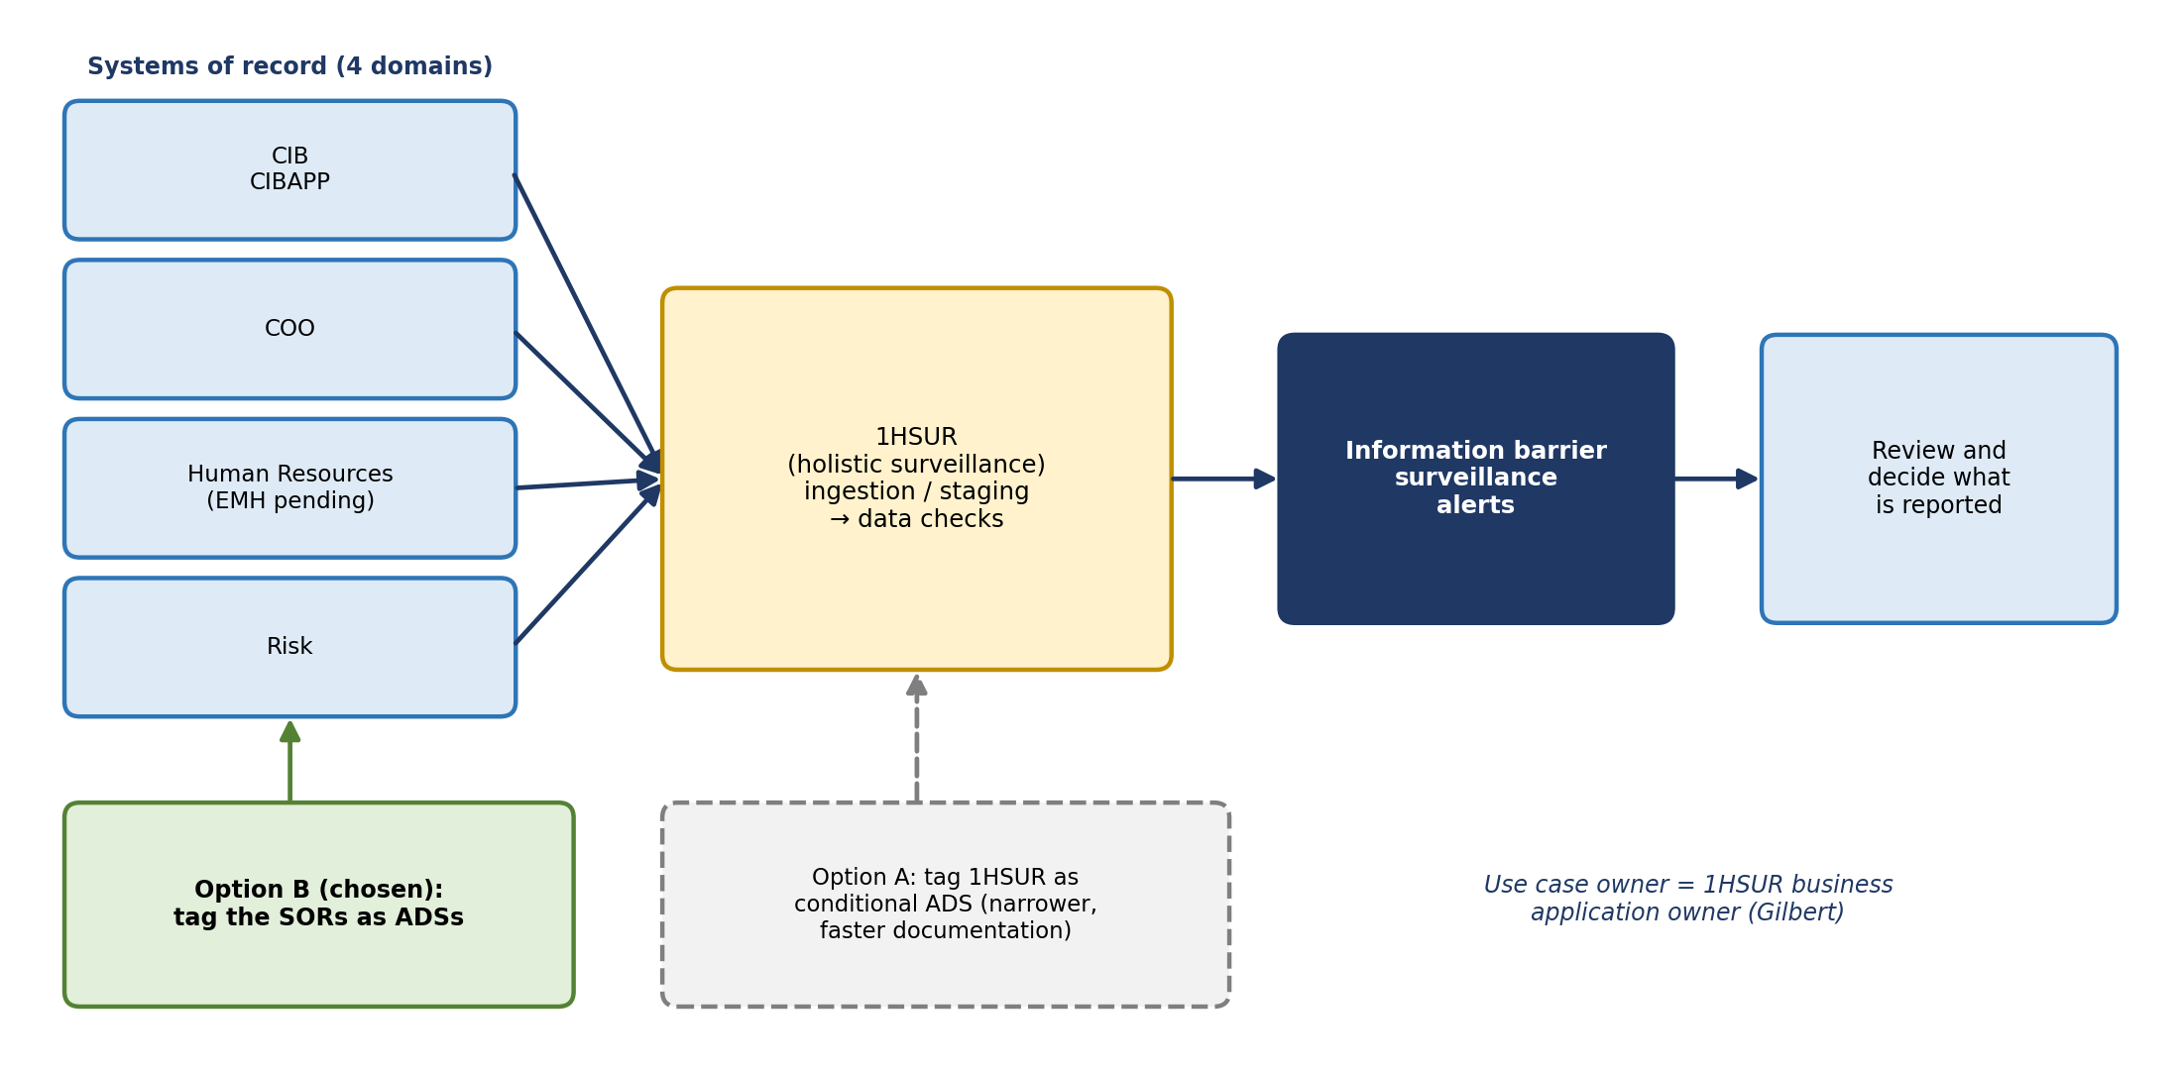
Figure 1. Data flow into 1HSUR and the two tagging options
1HSUR ingests data from systems of record in four domains (risk, CIB, COO, and human resources), runs checks, and generates information barrier surveillance alerts. Those alerts are reviewed to decide which ones need to be reported. Gilbert's team owns 1HSUR and has put data checks and critical data element identification in place throughout the year.

4. Status of use case deliverables
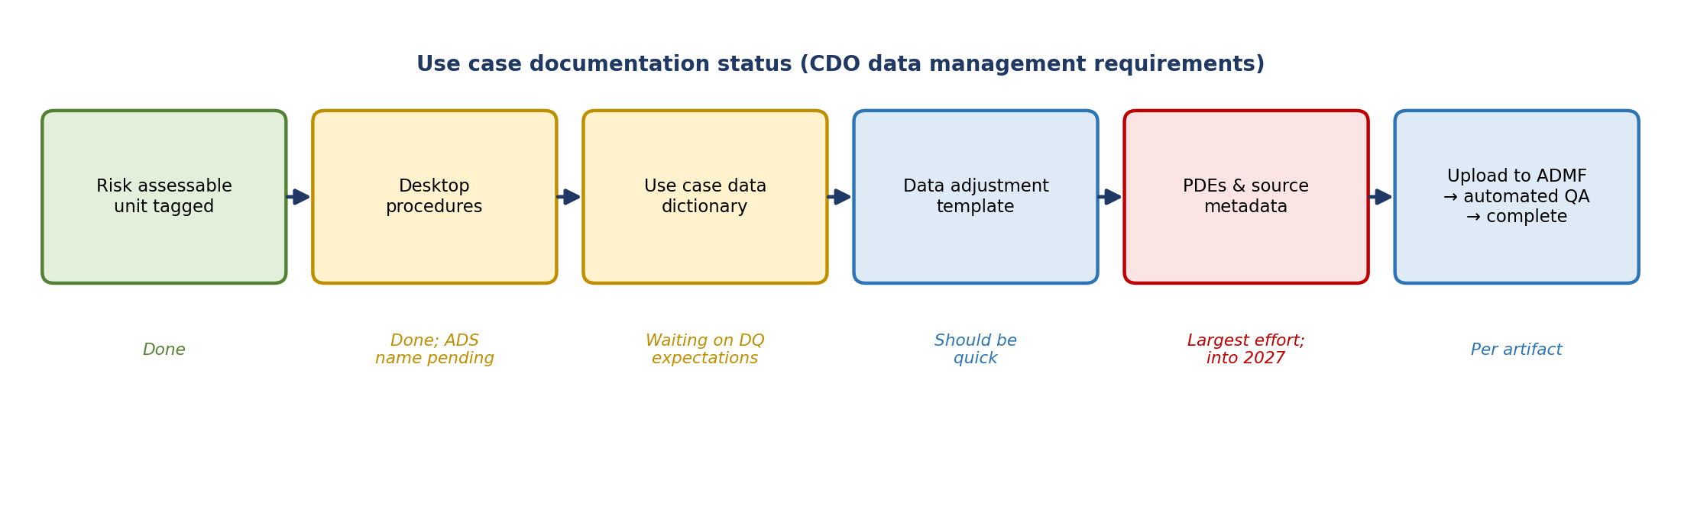
Figure 2. Documentation status
Deliverable | Status | Detail
Risk assessable unit | Done | Identifies who owns the risk of using this data
Desktop procedures | Done, pending ADS name | Complete once the approved data source(s) are confirmed
Use case data dictionary | Materially done | All elements captured; waiting on data quality expectations from Bernie (with Manish and Kathy)
Data adjustment template | Not started; should be quick | Captures any manual 'pencil updates' or system fixes for persistently poor data, which may then be raised as a defect
Physical data elements and source metadata | Largest effort | Four-part keys from the ADS tables, plus the business logic that produces each use case element
ADMF upload | Per artifact | Automated QA flags issues (e.g., grammar or subjective feedback); once addressed, the enterprise marks the artifact complete

What counts as a data adjustment
Bernie asked whether this applies to data 1HSUR receives or to alerts after they're generated. Brian clarified it applies to the receiving process: if holistic surveillance manually updates incoming data, or applies an upfront edit, to generate an alert, that is a data adjustment.

Data quality expectations (open item for Bernie)
- The CDO requires use case owners to state data quality expectations for each use case element (for example, a completeness check that a field isn't null).
- The team had been waiting for EMH to be onboarded to learn the exact data types for elements like employee ID. Since that's still pending, the standard approach is to capture at least one primary check per element per CDO guidance.
- Currently captured: accuracy dimension 402 (valid value check). Still needed from Bernie: other dimensions, such as timeliness, meaning a data delivery check that the sending system confirms the file loaded and reached the end user.
- Brian noted that when he was in CIB, he and Kevin tried to get this element-level requirement removed from the template, arguing use case owners have no real insight at that level, but they lost that argument.
- Bernie agreed to complete it; a separate working session will be set up with Bernie, Manish, and Kathy.

5. Where to tag the approved data source
Brian brought Kevin in because this decision drives the timeline: tagging the SORs instead of holistic surveillance involves many more parties.
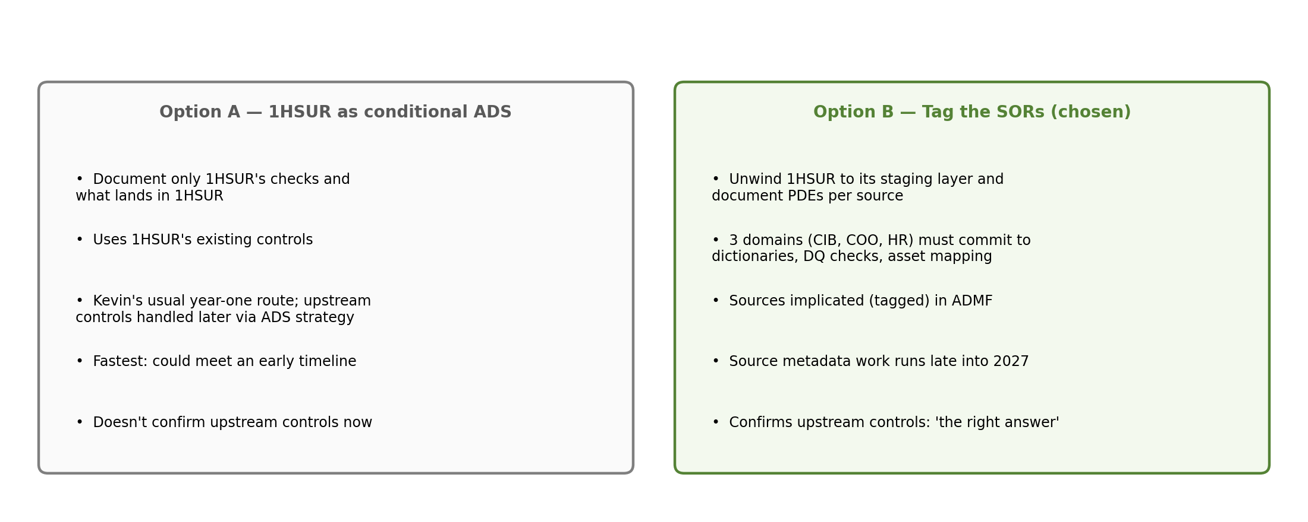
Figure 3. Comparing the two tagging options

Why the choice matters
- If 1HSUR is tagged: the CDO documentation covers only holistic surveillance: what checks it has and the metadata of what lands (and persists) in 1HSUR.
- If the SORs are tagged: the team must unwind 1HSUR back to its staging and ingestion layer and give each domain the four-part keys for the elements used from its systems. Domains typically ask to see exactly which PDEs are being used before they engage.
- Policy scope: under data management policy, the sources two or more hops back from an ADS aren't required to do the same documentation. Brian compared it to RCSA, where an RAU would still ask what upstream providers have in place, because it affects the risk profile.

Gilbert's position
As business application owner, Gilbert's team is responsible for making sure the data it receives has the right checks and that it knows its critical data elements. He had understood the data management use case to mean going upstream, telling sources which elements 1HSUR relies on and how it needs them, and requiring controls on their side. He contrasted this with regulatory reporting, where a report owner receives data from an application they don't own; here, 1HSUR generates alerts itself, so sourcing from an approved data source upstream was always the intent. Eugene agreed when Gilbert raised it: documenting only what's in 1HSUR "doesn't make sense."

Kevin's perspective
- His team's usual first-year approach: tag the one-hop-back source, whether owned by risk or not, as the conditional ADS, complete the data management documentation to "pass go," then spend most of the effort on ADS strategy to migrate elements to strategic ADSs upstream.
- Year-one documentation gives the element-level detail needed for a coherent conversation with upstream partners about which elements are needed and which controls matter.
- Most upstream sources, when asked, confirm they are the conditional ADS and document their checks. If a source says it isn't approved, that opens a separate conversation about what that means for the use case.
- CIBAPP is not on CIB's strategic ADS list. ADS strategy only began in 2025, when each domain designated its strategic ADSs to CDO; CIBAPP was once strategic but no longer is, likely changed within the last year. There's nowhere else to get the data today because CIB's strategic sources aren't built yet, so CIBAPP will likely be called a conditional ADS. The original data enablement work, which used the authoritative sources of that time, wasn't wrong.
- Option A remains viable: call 1HSUR the conditional ADS, rely on its existing checks and key controls, and pass the documentation if timelines are tight. Either route has trade-offs, and the deeper question of whether upstream data is well controlled can be solved through ADS strategy instead of the documentation template.
Gilbert's response: it isn't only about the ADS; upstream sources also need controls that meet 1HSUR's needs. Brian agreed this can be done through the documentation; timing is the only challenge.

6. What going to the SORs involves
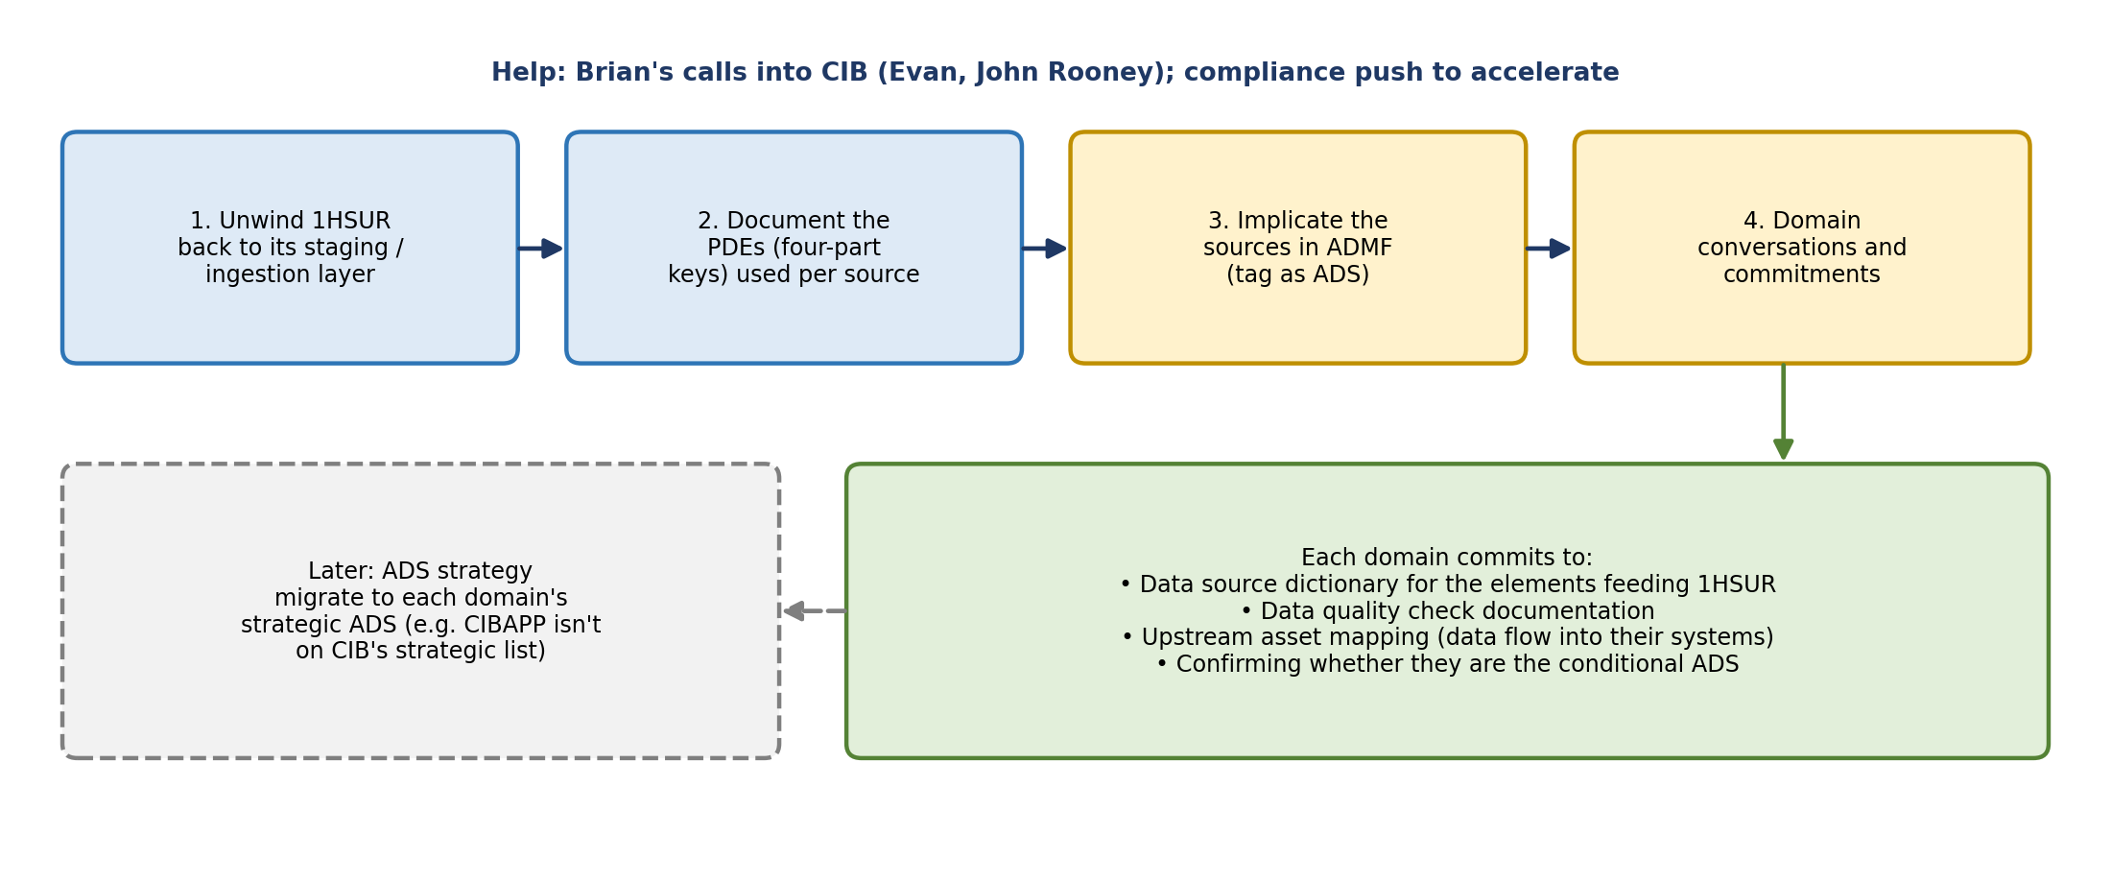
Figure 4. Steps to tag the systems of record
- Three domains to coordinate beyond risk: CIB, COO, and human resources, based on the data flow Brian received.
- Each domain must commit to a data source dictionary, data quality check documentation, and upstream asset mapping for the elements feeding holistic surveillance.
- The sources must be formally implicated (tagged) in ADMF, and they will ask for the PDEs to prove what data is used.
- Compliance partners may help push the domains to move faster.
- CIB: the most promising. Brian came from CIB and can call Evan, the business data leader. Gilbert noted CIB's chief data officer pointed them to John Rooney for BAU matters last year, and that they've been working on documenting the use case with the CIBAPP team, which has similar data issues and could use the leverage to fix its own upstreams.
- HR: expected to be the hardest.

CIBAPP's move to APIs
Bernie raised that CIBAPP wants to start transitioning 1HSUR from pushed feeds to APIs. His tech team may not have capacity in 2026; 2027 is more likely. Kevin and Brian didn't see implications for this work as long as element names and metadata stay consistent and only the transfer method changes, though Bernie wasn't fully sure how 1HSUR would store the data.

7. Decision and timeline
Decision: tag the systems of record (such as CIBAPP) as the approved data sources. Gilbert agreed. Brian: "This is what we should be doing."
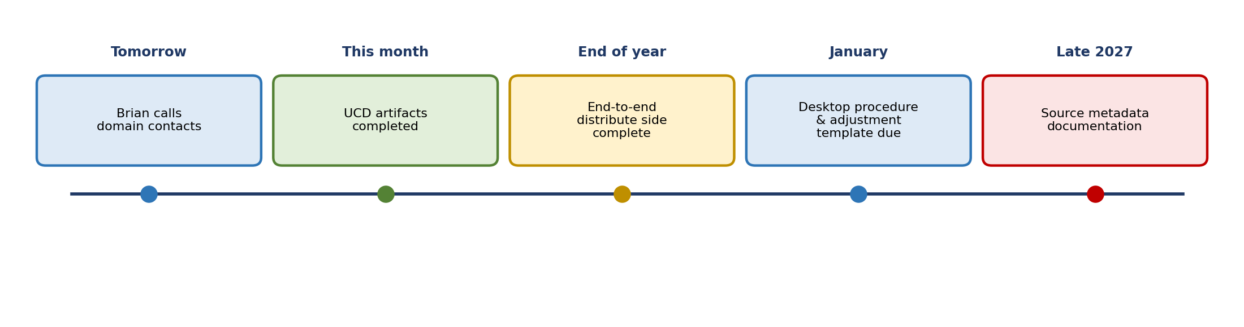
Figure 5. Timeline
- No SLA breach: the team can take the time to do the right thing.
- This month: the use case artifacts should all be done.
- End of year: everything end-to-end must be complete on the distribute side.
- January: desktop procedures and the data adjustment template are due; easily achievable.
- Late 2027: source metadata documentation.
- Accelerated timeline: Brian's concern came from his team hearing about a possible accelerated (Q1) timeline. Gilbert explained it came from Eugene, who is back from PTO and will need to hear that going upstream could take another year. Brian said it may not take a full year, but he can't commit to a date until he makes calls.

8. Action items
Action | Owner | Notes
Call contacts in CIB, COO, and HR to let them know the tagging is coming and gauge timelines | Brian | Starting tomorrow; CIB via Evan
Report back with a timeline commitment | Brian → Gilbert | After the calls
Update Eugene on the decision and timeline | Gilbert | Possibly framed as working to accelerate
Set up a working session on data quality expectations (dimensions) | Brian's team | With Bernie, Manish, and Kathy
Complete the data quality expectations for the use case data dictionary | Bernie | Timeliness and other dimensions beyond accuracy 402
Finish the use case artifacts and upload to ADMF | Governance team | Target this month
Unwind 1HSUR to staging and document PDEs per source | Governance team, with 1HSUR | Needed before engaging domains
Clarify implications of CIBAPP's move to APIs | Bernie | Likely 2027; check storage and metadata consistency

9. Open questions and risks
- How quickly will CIB, COO, and HR commit to their documentation? HR is expected to be slowest.
- Will Eugene accept a longer timeline than the accelerated one he expected?
- Will CIBAPP agree to be tagged as a conditional ADS, given it isn't on CIB's strategic list?
- When will EMH be onboarded to finalize data types for HR elements?
- Will the CIBAPP API conversion change how 1HSUR stores data or its element names?
- Which strategic ADSs will 1HSUR eventually need to migrate to, and when?

