Meeting Notes
ALRisk Historical Data: Ownership and the Finance–Risk Data Plane
Item | Detail
Meeting date | Tuesday, October 6, 2026 (recording started about 1:34 PM)
Format | Call organized by the finance side to resolve ownership of ALRisk data ahead of the DPC migration
Finance / technology side | Tina (appears to host; currently owns the finance Dremio workspace), Nikhil (moved ALRisk users to FDLZ; running the FDLZ/CADS DPC migration), Vanathi (DPC data layer and Dremio)
Corporate risk side | Kevin (central data team within corporate risk), Jake, Victor (Vic)
Also named | Michael (addressed once; role unclear)
People referenced | Arpit (finance CRO; likely business owner; invited but didn't join), Danielle Troutman (does the work today; rolls up to Grant Stewart under Colson), Cu (believes the data belongs on the risk platform), Eric (set up the original arrangement as a favor; now leads the merged ERAFT platform), Noor (provided the list of views in the invite)
Purpose | Decide who should own the leftover ALRisk data and views, and where the users should work, before everything moves to DPC

Note on the transcript
Auto-generated transcript; speakers aren't labeled, so attributions are inferred (Tina as host is a best guess). Confirmed spellings: FDLZ (transcribed "FTLZ," "FDLC," "FDL ZCADS"), Dremio (transcribed "Dreamio," "Dremel"), DPC (once as "DC"), Apigee (transcribed "Apogee"), REST API (transcribed "RISC" when describing the data API), Arpit (also "RPIT," "our pit"), Danielle Troutman, and Cu (transcribed "Sai"/"Cy"), plus CADS and ERAFT from earlier meetings. Best guess still: Vanathi (also "Vanity," "Panathia," "Bonati").

1. Executive summary
ALRisk was a standalone, tech-owned risk application that was decommissioned. Technology leadership moved its users onto finance's FDLZ (part of CADS), where the same raw data already existed, and built Dremio conformance views to feed their Power BI dashboards. Today the remaining users are a second-line investment portfolio risk oversight team that reports daily balances and net unrealized gains and losses on the investment portfolio.
With both finance and risk moving to DPC by year-end, the finance side wants the leftovers properly owned. About 95% of the data is clearly finance-owned. The problem pieces are the ALRisk historical data (stale, risk-owned in spirit, sitting in finance's bucket) and views built on data brought in "as favors" (notably an EPM rates view). The finance Dremio workspace is owned by Tina, who says she shouldn't own it, and the users aren't following the finance Dremio operating model.
The group didn't settle where the second-line team should work. Tina leans toward the risk Dremio; Kevin sees a case for them staying as finance Dremio users since they oversee finance. Everyone agreed it is a small but useful first test of how finance and risk will share data on the same data plane. Next step: Kevin will talk to Danielle Troutman and Arpit to understand the actual use, then report back.

2. Key terms
Term | Meaning from the meeting | Note
ALRisk | Former standalone risk application used for investment portfolio and liquidity (LCR) reporting | Decommissioned
FDLZ | Finance's landing zone within CADS; already had the same raw data ALRisk used | Many transcript spellings
CADS | Finance's aggregator ADS / data platform | Confirmed spelling
Dremio | Visualization/semantic layer; there is a risk Dremio and a finance Dremio | Conformance views built here
DPC | Data private cloud; common data layer that both finance and risk are moving to by year-end | Requires Ranger access
Ranger | Access control needed to reach data on DPC | —
CARD | Source of securities data (SimCorp); becoming its own tenant, outside CADS | —
EPM | Source of markets/rates data; brought in as a favor | Should come from ERAS or EFTP
ERAS / EFTP | Likely correct upstream source for the rates data | Which one is unconfirmed
DRM | Data set trying to become its own tenant (went to an approval committee); likely moving out of FDLZ | REST API (Apigee) exists
REST API (Apigee) | Data API used to get data out of Dremio (download), not to connect the two Dremios | Already set up for DRM
BAM | Application inventory; the historical piece needs a BAM / tech owner | —
Second line | The investment portfolio risk oversight team, which oversees finance | Current users

3. Background: how ALRisk data ended up on finance's platform
Nikhil gave the history.
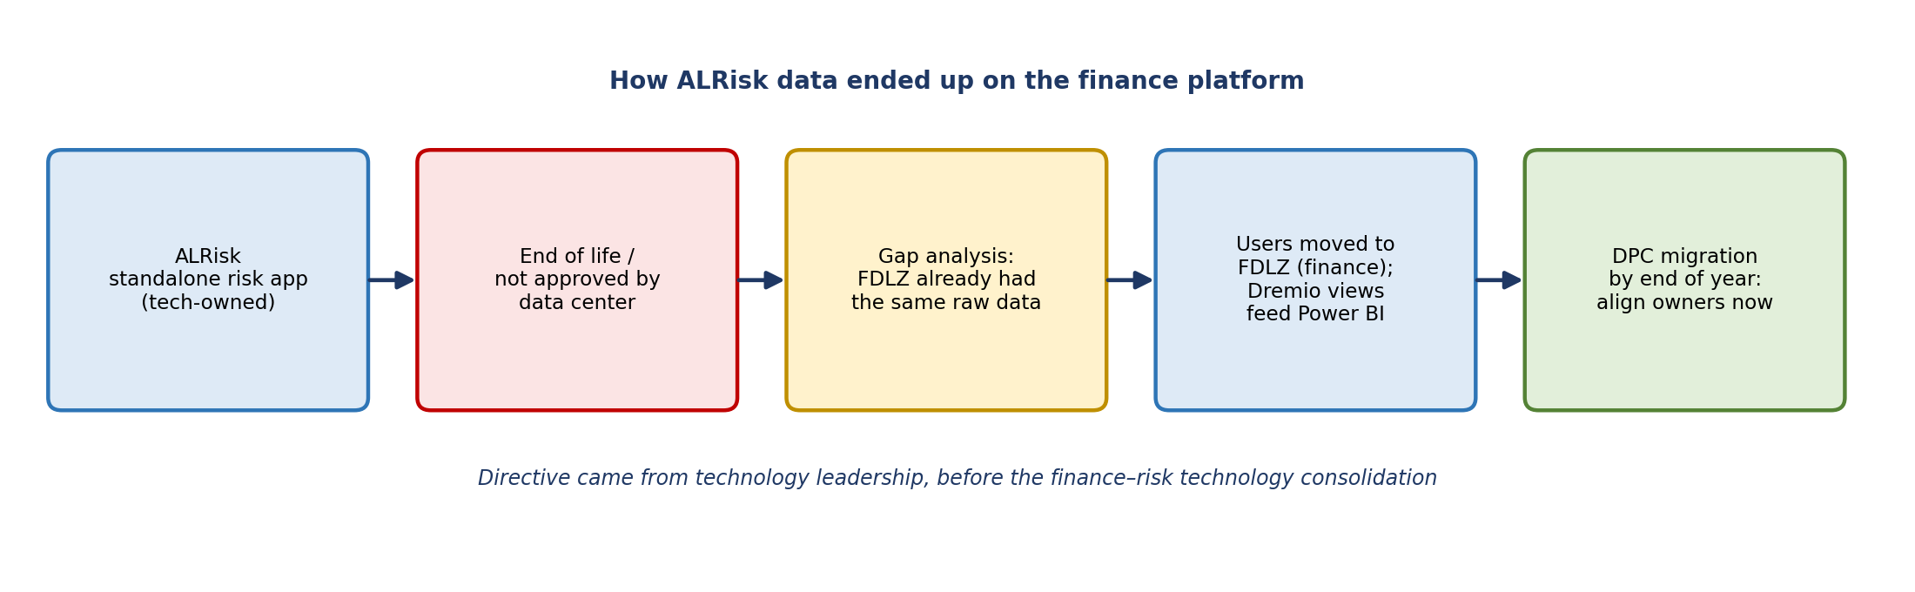
Figure 1. ALRisk history
- The directive came from technology leadership before the finance and risk technology consolidation.
- ALRisk was reaching end of life and, as Nikhil recalled, wasn't approved for further use from a data center perspective. Leadership looked for who else had the same data.
- FDLZ already had the same raw upstream data: securities, rates, and certain hierarchy information. So users were pivoted to finance data.
- Use cases were mainly Power BI dashboards. ALRisk had three to four years of persisted history, specifically around liquidity LCR reporting; that data was also available in the liquidity system.
- After a gap analysis, users were migrated to FDLZ, and the conformance logic was rebuilt as Dremio views feeding Power BI.
- The data covers about three or four products. History is used mainly for audit purposes, to go back and support reported numbers.

Current use
Tina had spoken with Danielle Troutman the day before. The investment portfolio risk oversight team shares current balances and net unrealized gain/loss on the investment portfolio daily through a Power BI report. Tina's question: what is it really used for, and is it necessary? Usage appears very low (about 12 runs, described as daily but light). Arpit would know the details.

4. Current state and problems
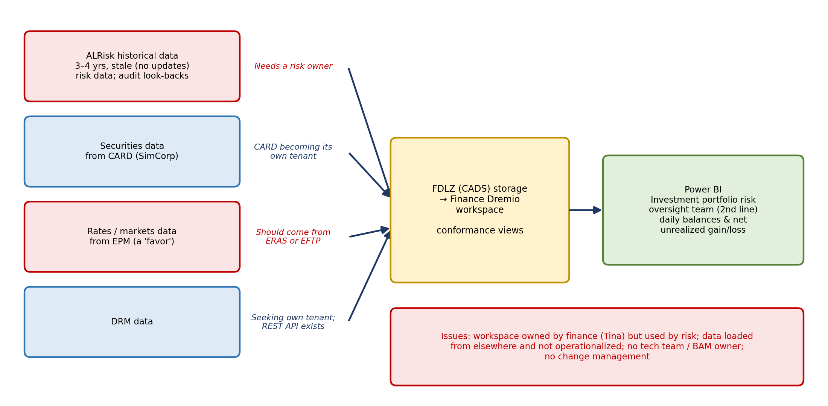
Figure 2. Data sets, platform, and problems today
Data set | Source | Status and issue
ALRisk historical data | Persisted from ALRisk | Stale (never updated). Effectively risk data, but stored in FDLZ's bucket. A few ALRisk users still use it. Needs a risk owner and a tech/BAM owner.
Securities data | CARD (SimCorp) | CARD is becoming its own tenant, so it won't be in CADS.
Rates / markets data | EPM | Brought in as a favor; not owned by CADS or FDLZ. Should be sourced properly, likely from ERAS (or EFTP), so lineage is correct.
DRM data | DRM | DRM is trying to become its own tenant and likely leaving FDLZ. A REST API on Apigee is already set up for it.

Views in use
The invite (from Noor) lists the key views currently in use. Tina confirmed the first and third views are fine; the second and fourth are the problem. The second is the EPM view (roughly "EPM_NW_ALM_RISK_RT_VW" as read out on the call). No one is sure exactly what it is; Tina has an email out to the person she believes owns it to understand their process. If it is sourced daily, the team needs that process and the access model, because Ranger access will be needed on DPC.

Workspace and operating model
- Tina owns the finance Dremio workspace and says she shouldn't.
- The users aren't following the finance Dremio operating model: they bring in data from elsewhere and load it into Dremio without operationalizing it, and they have no tech team. Proper use requires change management and the other standard controls.
- The historical piece doesn't belong in FDLZ/CADS. Eric originally set it up as a favor; Eric now leads the merged platform, so "Eric is us too."
- Nikhil is running the DPC migration for FDLZ/CADS, and this is one of several "oddball buckets" they need to place.

5. The ownership debate
Kevin joined without much background and wasn't sure why he had been added. Tina explained that this is a risk team working on finance's platform, and she needs someone who knows the risk side to own it.
- Nikhil: 95% of the data is definitely finance-owned. The historical data and a couple of data sets still need an owner tagged so there is a contact when something breaks. Users will still move to the new data center; it's about ownership tagging.
- Vanathi: on DPC the data layer is common and Dremio sits on top, so anyone can connect. The question is whether the data itself must move into a risk-owned bucket, or whether only the visualization layer needs to point to where it already is.
- Tina: the historical data is risk data, and Cu has said it should be on the risk platform. Risk can share data, but needs to know what it is. Since the users are part of risk operations, they should work on the risk Dremio and get the data the right way, under the operating model. "We don't want you to feel like you can't have the data."
- Kevin: finance data is owned by finance even when risk uses it (Tina agreed). But this is a second-line team overseeing finance, so it could make sense for them to be finance Dremio users since they are effectively finance's business partner. If credit risk wanted finance data for its own use case, sourcing it to the risk side would be clear-cut; this case could go either way.
- Kevin on business owner: his team is the central data team within corporate risk and wouldn't own this specific data. The likely business owner of the ALRisk historical data is Arpit in finance CRO. Kevin forwarded the invite to him, but he didn't join.
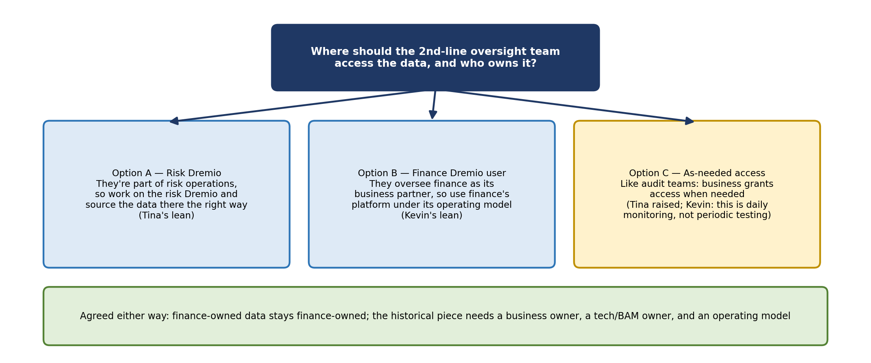
Figure 3. Options discussed for where the users work

As-needed access vs. ongoing monitoring
Tina noted that audit and similar teams have a role that lets the business grant them access on an as-needed basis; second-line teams don't usually need standing access. Kevin pointed out that this team does ongoing daily monitoring of portfolio metrics, which differs from a periodic testing team and is why they had a standalone application in the first place. Tina's follow-up: since ALRisk no longer exists, what should exist instead? It is too small a process to justify its own workspace.

Where the data should live
The group discussed a model where finance remains the source but the storage and view ownership could differ. Whoever owns the data would create the view. If it supports a recurring process, it should ideally be owned by a technology team rather than a business team building something ad hoc, as ALRisk originally was.
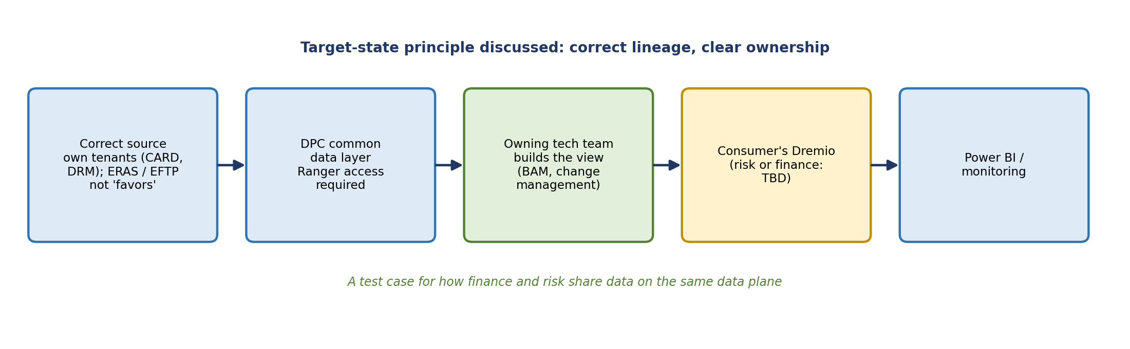
Figure 4. Target-state principle discussed

6. The broader question: one data plane for finance and risk
Kevin raised the bigger issue: technology has told both teams they will share the same environment and the same data plane, so any data sourced into CADS or DPC would be usable by risk as needed. Vanathi confirmed that's true at the data layer. But no one has defined the operating model for how finance and risk own and manage data on the shared plane, especially when most of it is finance data. Everyone agreed this is a small but good starter case to test that model. Tina: "We're breaking new ground here."
- Both finance and risk are targeting DPC by the end of the year.
- There is one DPC, plus a risk Dremio and a finance Dremio.
- Tina and her team want to cut the "band-aids" from past favors and source from the proper places so lineage is correct.

7. Decisions and agreements
- Finance-owned data stays finance-owned, even when risk uses it.
- The ALRisk historical piece needs a clear business owner (likely Arpit) and a technology owner (BAM).
- Views built on favored data (especially the EPM view) need to be re-sourced from the correct source.
- Where the second-line team should work is still open; Kevin will gather facts first.
- Use this as a pilot for the finance–risk shared data plane operating model.

8. Action items
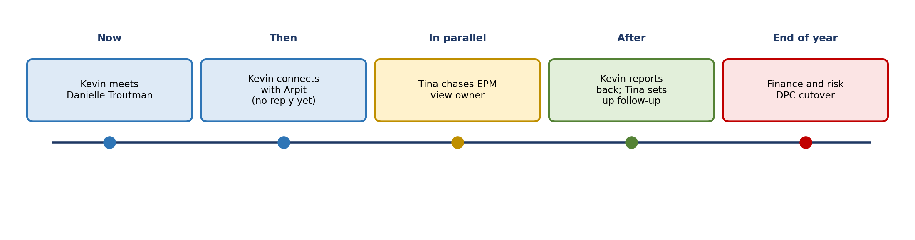
Figure 5. Next steps
Action | Owner | Notes
Meet Danielle Troutman to understand how the data is used | Kevin | She's the most recent contact; rolls up to Grant Stewart under Colson
Connect with Arpit (likely business owner) about the historical data | Kevin | Emailed, no response yet; may set up a separate call
Provide specific details on what data the users are getting, as needed | Tina | More specifics are in the meeting invite
Follow up on the EPM view's owner, process, and access needs | Tina | Email already out; source may be ERAS or EFTP
Gather usage (users, traffic, volume) for the data | Kevin, via Arpit | Requested by Vanathi
Report back and set up follow-up time | Kevin → Tina | After talking to Arpit

9. Open questions
- Does the second-line oversight team work on the risk Dremio or as a finance Dremio user?
- Who is the business owner (likely Arpit) and the technology/BAM owner for the historical data?
- Does the historical data need to physically move to a risk bucket, or just be re-pointed and re-tagged?
- Is the daily Power BI report still needed, and what is it used for?
- What exactly is the EPM view, who owns it, and is the right source ERAS or EFTP?
- How will Ranger access be set up on DPC for these users?
- What is the operating model for owning data on the shared finance–risk data plane?

