Meeting Notes
Data Plane Team: General Use Data Sets and the RDS Intake Process
Item | Detail
Meeting date | Tuesday, November 3, 2026 (inferred: the weekly report was "as of Monday" and "yesterday"; ended around lunchtime ET)
Format | Two topics back to back: Jared walked through general use data sets; Jared and Jordan walked through intake, with a live demo of the intake tool and its Power BI reporting
Team | Kevin (lead), Jared, Jordan (intake product owner), Sekar, Mike (Michael), Ryan, Mike G, Jen, Jake
Referenced | Jacqueline, Kathy, Terry, Denise (no longer with the team), Manoj (RDS Ops), Shridevi, Parul, Santosh (QA), Vanitha and Andy (DAT), Yashica, the Data Warriors and Falcons delivery teams, CCPC
Purpose | Understand where the general use data set effort stalled and how intake works today, and agree next steps

Note on the transcript
Auto-generated transcript with no date or speaker labels; attributions come from context. Readings used: Veritas, ERAFT ("ERAP"), Parul, risk team ("Rick's team"), RFDIR ("Rifter"), AIMS ("Ames"), Dremio ("Dreamio"/"Remio"), CARET ("Carrot"), VDS ("BDS"), Sekar ("Sikar"), Yashica ("Yakusha"), TISRM_API ("Tism API"), RASP, eGRC. The bank's name is left out. Reviewed and confirmed: SHRP (heard "Shard"), EGP, PR certification, CCPC / CCP, Shridevi, Ranjani, Vanitha, Beacon, the DXC team and the "four-part key".

1. Summary

General use data sets
Jared and Terry had started defining general use and conditional data sets, but stalled because data owners insist their data is sensitive, and the team has lacked "teeth".
- Decided earlier: general data sets need ADS ABO approval, plus the data owner if the requester is non-risk. Conditional ones always need both.
- Proposed (Kevin agrees): ADS ABO approves everything, and risk asking for risk needs only the ADS ABO, even for sensitive data.
- Confidentiality: RDS already flags confidential elements in its data dictionary, and that flag has been used in controls.
- Kevin's plan: find who actually uses each table and API; start with data sets that are already well defined (corporate risk hierarchy, RCSA); work from facts; validate in DPC; and move non-risk data (policy, FRCs) out if its owners won't play by RDS's rules.

Intake
- Requests go from pre-vet to data consult, then data owner review, DAT tech review and routing, then RDS Ops or a delivery team, then requester sign-off.
- The bottleneck is RDS Ops: 37 requests averaging 34 days. Yet 33 tickets bulk-processed by Manoj cleared in under a day, with over 80% going through. The DPC migration has taken priority.
- 109 intakes are active; 14 date from Q1 2026 or earlier.
- Kevin will join the Monday Intake Governance call, with Jen and Mike G. Jen ramps up as a data consultant to help, since Denise has left.
- Longer term, intake should feed machine-readable data contracts and integrate with DataHub, building on Jake's UI mock-up.

2. General use data sets
Jared shared a three-column view: current state, general and conditional data sets, and future state.

Current state
- ORCAP and RFDIR hold a mix. Some data sets are whole and well defined: RCSA (the shift-left data sets), FRCs, policy. Others are partial, e.g. compliance data with about 30 good fields plus 25–30 fields from an authoritative sources data set, which raises the question of why they're in ORCAP at all.
- Operating model today: data owner approval for every request, and a customer-specific Dremio or API consumer data set built for each one. For example, Tandems wants RCSA data, so a consumer data set gets built for it, even when an RDS data API already exists.
- Proposal (bottom right of the slide): stop building per-consumer data sets once most needs are covered by common data sets. Building them is a big reason the RDS Ops and frameworks backlog runs about six months, unless your hair is on fire.

Ranger requests
- Ranger policies tell Dremio exactly what a service account can see within a table, down to field and row level. They're used to hide confidential parts of a data set.
- Not every request needs a Ranger restriction, but turning on any service account entitlement is still manual. Jordan worked with RDS Ops to clear a large backlog of these last week. Kevin: it feels like paper-pushing.
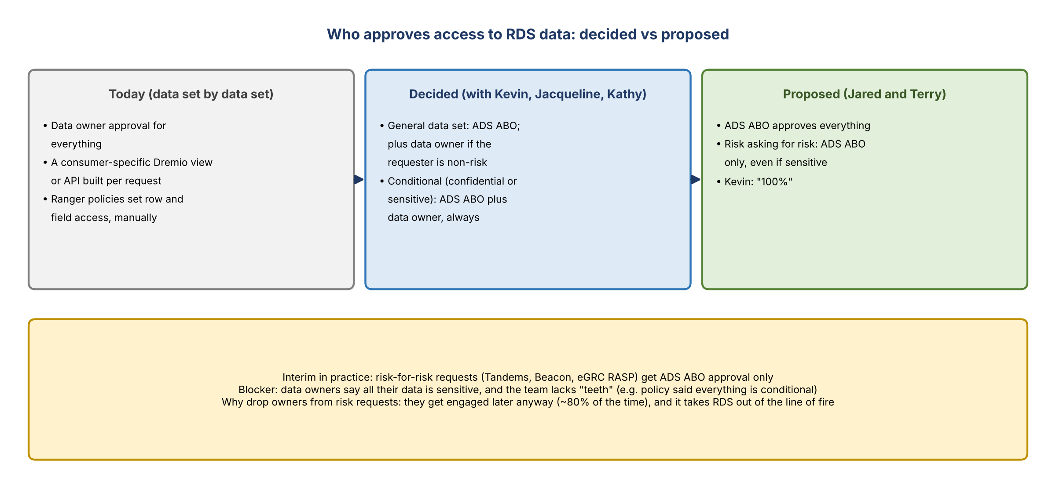
Figure 1. Who approves access to RDS data: decided vs proposed

General and conditional data sets
- This was part of the escalated conversation with Kevin, Jacqueline and Kathy about the central "loudspeaker" where everyone complains. The team's answer was the general and conditional model it was already working on.
- General: broad use; pretty much anyone can access it. Most of the data isn't sensitive; anyone with access to the source UIs (Veritas or SHRP) can see and report on it anyway.
- Conditional: confidential or sensitive, or perhaps only for risk consumers.
- Decision made: general data sets get ADS ABO approval (Terry, at the time), plus data owner approval when a non-risk requester asks. Conditional data sets need ADS ABO plus data owner approval for everything.
- Mike: shouldn't almost all ORCAP data sets be general? Jared: there's a reason they aren't. Data owners won't agree their data isn't the most sensitive at the bank, and the team hasn't had the teeth to push back.
- With org changes and the data plane coming over the last six weeks or so, the team paused pushing data owners.
- Interim: risk-for-risk requests (Tandems, Beacon, the eGRC RASP request) get ADS ABO approval only. The eGRC RASP team asked for RCSA tables. Rather than going field by field, the team pointed them to the RCSA shift-left data sets and the business model view (with joins already done), which covers most of what they need. They requested the AIMS entitlement, validated their requirements, and then the data API request went through.
- Kevin: the foundation is good; the work is slotting data sets into data plane categories.

The proposed change
- Jared and Terry had hoped for more: ADS ABO approval for everything, and only ADS ABO approval when risk asks for risk, regardless of sensitivity. That takes the data owner out of risk requests. Kevin: "100%".
- The trade-off: data owner engagement happens at some point about 80% of the time anyway, on the back end, when users have questions or need more. But it takes RDS out of the line of fire for being slow while waiting on owner sign-off. Non-risk requests can still go through owners.

Is there a confidential flag?
- Yes. Each element's security classification is captured at ingestion and flagged in the RDS data dictionary as confidential.
- Jordan: it has been used to run controls for the past three quarters, so it's accurate enough to support a control.
- Some of it was set years ago and nobody knows who set it. It should tie back to definitions like PII and CSI, and probably needs a refresh; it's likely 80–90% accurate.
- Kevin: if it's on the data plane and not confidential, no extra approval is needed. The consumer still completes the intake, which becomes the data contract.
- Mike: if a data owner approves or rejects non-risk consumers, the data set isn't really general use, which by definition is available enterprise-wide.
- Kevin: the central data plane team should know the data well enough to decide what's general use. Propose it from what the team knows about consumers and heavy hitters, e.g. the conformed RCSA data set with its joins. Ask owners what's missing or no longer maintained, and if nothing, move on. "What is the point of having RDS if we don't make it easy for teams to access data? Otherwise, they should just go to the SOR."

Knowing who uses what
- Data API requires consumer data sets to be registered, so there's traceability to every consumer of an API, visible in Grafana. Entitlements can be reported on. Ranger policies need manual reporting. DSAs carry intake numbers.
- Kafka (legacy): some consumers still use legacy Kafka APIs; the RDS data API is the preferred alternative but was never enforced. Jordan will follow up with the DXC team, who manage the Kafka APIs, on who still uses them. Ryan will ask Manoj whether Kafka goes away in DPC, which would be the path of least resistance. Raise it on the daily DPC calls.
- CARET: may still receive data through Kafka. In theory CARET goes away in Q2, since everything it does from a transformation perspective should already be in ORCAP.
- Ways to consume today: the RDS data API is preferred. For reports that can't do application to application, a VDS (a Dremio view) is provided to pull from directly.

A UI for the data, and data contracts
- Kevin: users should have a UI to look at the data, which is the "new and improved intake tool". Jake has mocked one up as a clickable HTML page from the requirements Jacqueline first wanted. It shows what's wanted; building the connections is a separate conversation.
- It's the step before intake: someone with a data need finds, for example, the ten Minerva tables most relevant to them, with fields and values so they can profile the data. DataHub's researcher reads metadata, not the actual data in RDS. Asked whether Jake is building a researcher AI like ERAFT's, the answer was that he built the UI only.
- Data contracts: finance technology set up its pipelines as data contracts, and it's now an ADS requirement (part of a certification, heard "PR certification"). Mike's idea: take the information the intake tool collects and automatically turn it into the JSON contract for the pipeline, so it's a tool, not paperwork.
- No enterprise template sets the exact contract parameters yet; teams set them. Ingestion from SORs still needs their sign-off, but provisioning is at the ADS's discretion, which is the "teeth" the team has been missing.

Pushback from data owners
- The team had owners populate Terry's template, then paused because of "don't touch my data" responses. The policy owners first reacted positively, then ran it up their chain in the enterprise policy office and came back saying all their data is confidential and conditional.
- Kevin: then start getting policy data out of ORCAP; risk doesn't need it. RDS is providing them a service: follow the rules or provision your data elsewhere, especially as a non-risk SOR. The same conversation is coming with issues and the data CCP claims ("a wild overreach"; CCP may have been retired).
- Only a few policy tables are actually sensitive, some only at row level.
- Terry's template should be compared with what Jacqueline wants per data subject (corporate risk hierarchy, subject area) and fields added or removed. The naming (common data set, subject area) is TBD.

Priority list and catalog
- The priority list is sorted by consumer count, combining API consumers and other access.
- Corporate risk hierarchy, the first one chosen, is already general use with no pushback.
- Terry's template is missing data elements because it was pulled from the catalog, which isn't accurate. Ryan's improved catalog is coming.
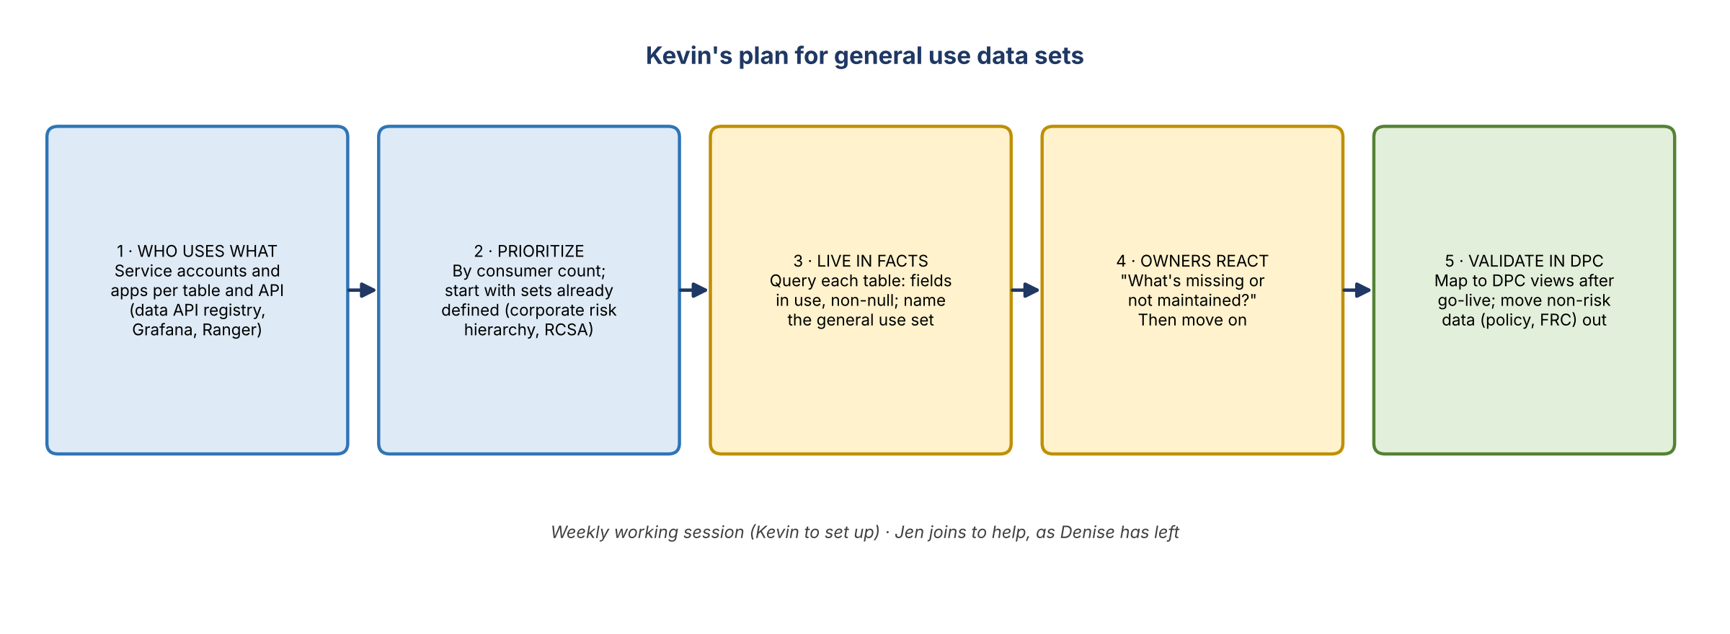
Figure 2. Kevin's plan for general use data sets

Kevin's next steps
- Work out the actual users of the data by data set: the service accounts and applications hitting each table or API, not just DSAs. Use that to prioritize.
- Bring in Jen to help, now that Denise has left; more people are needed.
- List the common data sets to go after now: those already defined (like RCSA, already joined, which can simply be named the general use data set) versus the longer tail that needs field analysis.
- Don't set up data owner conversations yet. Build a plan from facts: query each table, see the fields and which aren't null, and decide the general use fields. Validate once DPC is live.
- Inventory data that isn't risk-related (policy, FRCs) and get it out.
- Kevin will set up a weekly working session on general use data sets.

3. The intake process
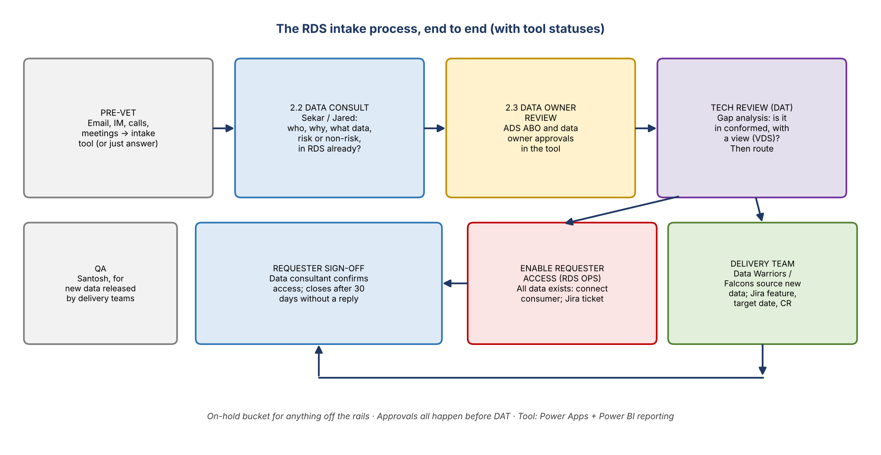
Figure 3. The RDS intake process, end to end

Jared's simplified view
- Pre-vet: requests arrive by email, phone, IM, meetings and more. Usually they're funneled into the intake tool, but sometimes the answer can just be sent, e.g. someone asking for an entitlement name.
- Requirements: a data consultant (Sekar or Jared) works out who's asking, what for, which data subject, how they want to receive it, which initiative, risk or non-risk, who should review, and whether RDS has it, can get it, or should be the place for it.
- DAT: the technology partner takes the mapped requirements, e.g. a service account mapped to the FRC and compliance tables and columns, and submits to RDS Ops, which updates the service account's access. That's where most of the backlog sits.

The intake tool (Jordan's demo)
- Built in Power Apps. One entitlement gives access to the intake tool, Ryan's data catalog of what's in RDS, and the Power BI reporting.
- Requester fields: title; business and technology contacts; use case and tier; source application; description and how the data will be used; whether it's distributed in reporting; consumption pattern (VDS, data API or Kafka API); consuming application and service account; frequency; history needed; whether it's regulatory; attachments.
- Intake operations: assignee (e.g. Jared), QA (Santosh), DAT contact (e.g. Vanitha), current status and origination date.
- Data consultant section: alignment (domain and subdomain, data set, ADS), data owner reviews, ADS ABO reviews and approvals, and comments. Approvals go out by automated email. For new data from an SOR, the field-level information gathered varies by SOR, so there's no single template; much of it is finalized with technology.
- QA (Santosh): QAs production releases of new data brought into RDS by the Data Warriors and Falcons teams. Not involved when the data already exists. The team will talk to him later this week about doing more.

DAT: gap analysis and routing
- Gap analysis: is the data in the conformed layer, and is there a view (VDS) on top of it? Data API sharing is built off those views, so data in conformed with no view can't be shared.
- Route 1, RDS Ops: all the data exists with views; RDS Ops just connects the consumer. If a view is missing, the delivery teams create it, sometimes within an hour. First-time data API consumers must be registered via a template; adding a column to an existing view has its own template.
- Route 2, delivery teams: data is missing or partial (e.g. 50 of 100 fields). The delivery team sources it from the SOR in a tech-to-tech conversation, e.g. the Data Warriors with the Minerva team, and creates the VDS. DAT collects evidence of a Jira feature, a target delivery date and the release. After the date passes, DAT confirms it went in and captures the CR number.
- All approvals happen before DAT. ADS ABO and data owner approvals are captured in the tool's approval section.
- Close-out: requester sign-off goes back to the data consultant, who confirms the requester can access the data, attaches evidence and closes it. Some tech support may be needed here.
- Sekar on Hogan: Hogan provisions through APIs, Kafka or MQ messages (it's a mainframe). As an ADS fed by 100+ applications, Hogan's ABO approves requests; it doesn't go back to each upstream owner. So this pattern is typical.
- Ideal end state: a machine-readable data contract as the output of intake, ideally in a single tool. CDO hasn't fixed exact contract parameters but will likely evaluate them in certification. A shared tool for all ADSs would be better still. Ryan's planned UI for JSON creation could merge with the intake tool.

4. Reporting and the backlog
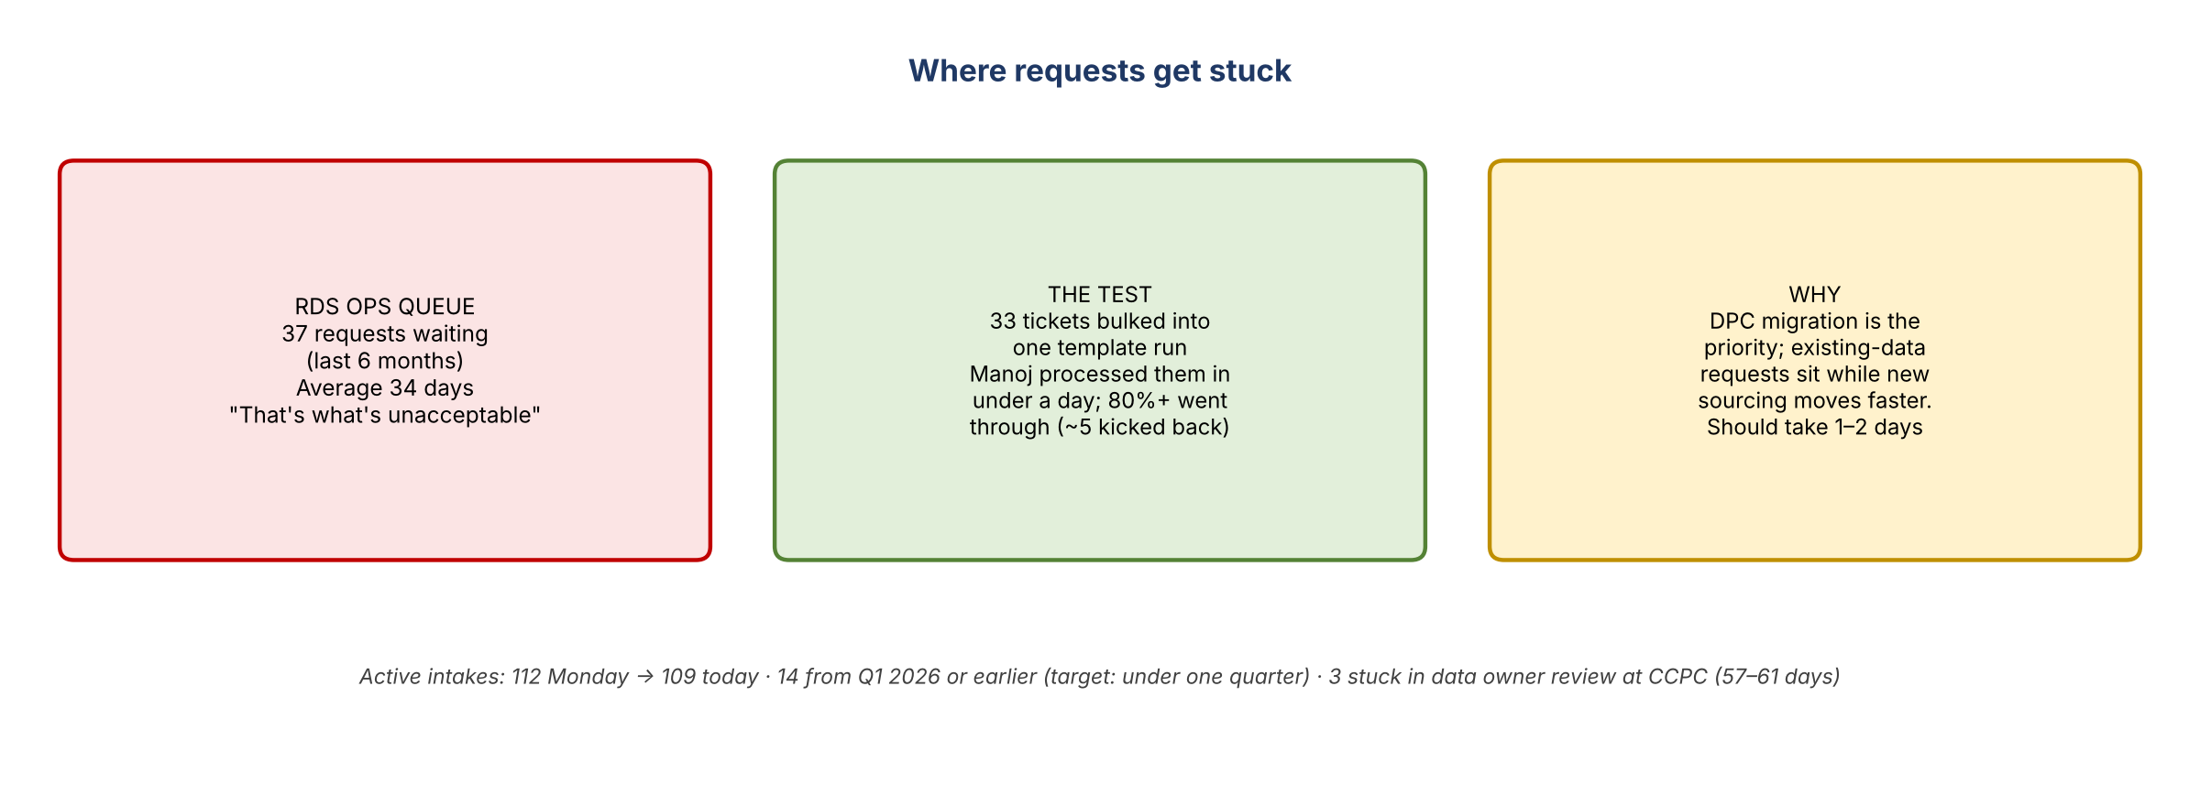
Figure 4. Where requests get stuck

Status flow in the report
- 2.2 Data consult (requirements) → 2.3 Data owner review (waiting on approval) → ready for tech review (queue) → tech review (DAT working it) → enable requester access (RDS Ops ticket) or delivery team (Jira feature) → requester sign-off (data consultant, shown in blue) → on hold, for anything off the rails or badly delayed.
- Kevin asked whether data owner reviews are backlog or new non-risk requests. Approvals are still in place, and the status can be flagged.

The RDS Ops bottleneck
- Filtered to the last six months: 37 requests sitting with RDS Ops, averaging 34 days, after data consult, approvals and tech review are done. Kevin: that's what's unacceptable, and where the complaints come from.
- How long should it take? Jordan and DAT bulked the templates for 33 requests into one run. Manoj processed them in under a day; more than 80% went through, and about five came back with errors. So a day or two at most.
- The team now delivers new data sourcing faster than data it already has, because the DPC migration has been RDS Ops' priority. RDS Ops: Shridevi is tech manager and Parul the PO, rolling up to Ranjani or possibly Manav (unclear after reorgs).
- Requesters escalate to everyone involved: Jordan as intake PO, Jared and Sekar, and DAT. The canned answer has been that DPC is the priority. Jordan hopes the focus returns to these tickets after DPC.

Jordan's Monday spreadsheet
- Exported from the intake details page; completed and cancelled records are excluded. 112 active on Monday, 109 today.
- Shows how many items sit with data consultants and DAT, RDS Ops, data owners or requesters, delivery teams, and on hold.
- Rules: anything in requester sign-off for 30 days without a reply is closed. Items in a "ready" status are flagged after 10 days, others after 30. The target is nothing older than a quarter.
- Aged items: three in data owner review for over 30 days (57–61 days) are waiting on CCPC. They're for existing data and non-risk consumers (not the risk team), including the CDO data management risk scorecard team wanting RCSA data to get off CARET dashboards. Sekar followed up this morning. Kevin offered to escalate if given the background. Twenty-two sit in enable requester access with RDS Ops.
- Fourteen items date from Q1 2026 or earlier. Many recently moved to requester sign-off after the bulk processing, so they should close once requesters confirm.
- Other checks: ADS, data subject and data set captured; delivery items have a team, Jira ID and target date, with past-due dates followed up; RDS Ops items have a ticket; completed work has a CR number.
- Priority RDS Ops tickets (escalated or AI initiatives): two closed as of Monday. DAT is validating the bulk-processed ones with requesters and passing evidence to Jared and Sekar to close. One completion last week.
- Jordan attends DAT's daily stand-up. The Monday Intake Governance call reviews the spreadsheet; Kevin asked to be added.

5. People and the future tool
- Jen: Kevin wants her to get the end-to-end view, starting with intake and the general use data set concept, since she'll need to speak to the data plane. She can take on requests alongside Jared and Sekar. Catalog and metadata come later.
- Target-state tool: intake today runs on Power Apps and Power BI. In the target state it should integrate with DataHub, or a new tool: self-service with metadata, lineage and business context, including the good parts of Jake's UI. Power Apps works for workflow and tracking but doesn't give the insights intake needs.
- Finance has a contract creation portal (it isn't on DataHub yet); Mike asked Yashica for a demo.

6. Action items
Action | Owner | Notes
Set up a weekly working session on general use data sets | Kevin
Identify the users of each data set (service accounts and apps per table and API) | Jordan / Jared / Ryan | Data API registry, Grafana, Ranger
List the data sets that already have a general use version vs those needing analysis | Jared / Sekar
Compare Terry's template with what Jacqueline wants; add or remove fields | Jared
Inventory non-risk data in ORCAP (policy, FRCs) for removal | Jared / team
Follow up with the DXC team on remaining Kafka consumers | Jordan
Ask Manoj whether Kafka goes away in DPC | Ryan
Add Kevin, Jen and Mike G to the Monday Intake Governance call | Jordan
Escalate the CCPC data owner reviews | Kevin | Sekar to provide background
Ramp Jen up on intake; assign her requests | Jordan / Jared / Sekar
Close out the bulk-processed RDS Ops tickets | DAT, Jared, Sekar
Get a demo of finance's contract creation portal | Mike | From Yashica

7. Open questions
- Will the ADS ABO-only approval for risk requests be formally agreed, and who decides?
- Does Kafka consumption end with DPC?
- Who in RDS Ops' chain can prioritize the backlog during DPC?
- What will the general use data sets be called on the data plane (common data set, subject area)?
- How will intake, data contracts and DataHub fit into one tool?

