Meeting Notes
Brian Schiffer's Leadership Call: SAS Inventory and Exit Planning
Item | Detail
Meeting date | Thursday, October 29, 2026 (recording started about 10:07 AM)
Format | Brian Schiffer's regular leadership and management call; Julia ran the agenda. SAS was a guest item
Corporate risk data management and governance | Kevin Moody, Kelly, Jake
Brian Schiffer's org | Brian Schiffer, Julia (chief of staff; host), AJ, Kelsey, Daniel, Michael, Jim, and the wider leadership and management group
Referenced | Gwen, Jacqueline, Manav and Moshin (technology), Bill Wells and Ajit (SAS data marts), Venkat (Basel), Mike, David, Jennifer, Leopold
Purpose | Explain the corporate risk SAS survey to Brian's org and agree how its workspace owners and users will respond

Note on the transcript
Auto-generated transcript; speakers aren't labeled, so attributions come from context. SAS is transcribed "SaaS". The opening admin reminders (benefits enrollment and the new twice-monthly pay schedule) aren't work for this team and are left out; a "type 1 vs type 2 overlays" item was on Brian's agenda but not discussed while the team was on. Unsure: Kelly's surname (heard "Comack"), "NOFS team" (the GCP platform team working with Google), "Charlie" and "the OC" (the level the SAS concern has reached), Ajit (possibly Ajit Nala), Daniel, Michael, Jim, Mike, Venkat, and "CRDM" (an upstream production team).

1. Summary
Julia brought Kevin, Kelly and Jake onto Brian Schiffer's leadership call to explain the SAS survey. Kevin gave the background:
- Gwen asked Jacqueline to get a handle on how corporate risk uses SAS. It's a big expense line, there's pressure from the vendor negotiations, and an exit may have to be planned.
- No exit dates are known.
- Kelly's team is gathering the information centrally, through a survey of workspace owners, due 11/3.
Brian added context:
- The SAS contract expires in November. Something will be signed, probably running through 2027 or 2028.
- His models are mostly off SAS, but his loss forecasting teams downstream are "the elephant".
- He has concerns about GCP's production experience and about getting enough parallel run time.
- IT may underestimate how much the business relies on SAS to move quickly.
- For now, focus on the inventory, and don't build anything new on SAS.
Agreed approach for Brian's org:
- AJ and Kelsey coordinate centrally across about 85 locations, about 10% of which are empty and can be retired now.
- Responses should be consistent, using Kelsey and AJ's completed survey as a template.
- Every SAS user should be included, not just owners.
- Julia will chase anyone who hasn't responded by 11/3.
Kelly is also trying to work out how this survey relates to a second one: a Qualtrics survey from CDO that appears to have gone to all SAS users.

2. Background from Kevin
- The team isn't the SAS expert. It was pulled in because Gwen tasked Jacqueline, the team's new leader, with understanding how corporate risk uses SAS.
- SAS is a big line item in corporate risk's expense allocation. More recently there's pressure from the negotiations with the vendor, and a potential exit may need to be planned. No dates are known.
- Jacqueline asked the team to manage the information gathering centrally. A kickoff with workspace owners was held this past Monday (10/26).

What the survey asks
- Are you the right owner of this workspace? CDO's ownership data is sometimes wrong.
- What are its key uses: a model, an analytic, and so on?
- Could the storage allocation be reduced? CDO charges corporate risk based on allocated storage, and many workspaces use only a small share of it. Reducing allocation would cut cost while a migration plan is worked out.
- Is the workspace already planned to move to PyFarm or another solution? If not, say so.
- Results are aggregated centrally and taken to technology. Manav and Moshin are leading the technology side of a plan to move off SAS.

3. Brian Schiffer's view
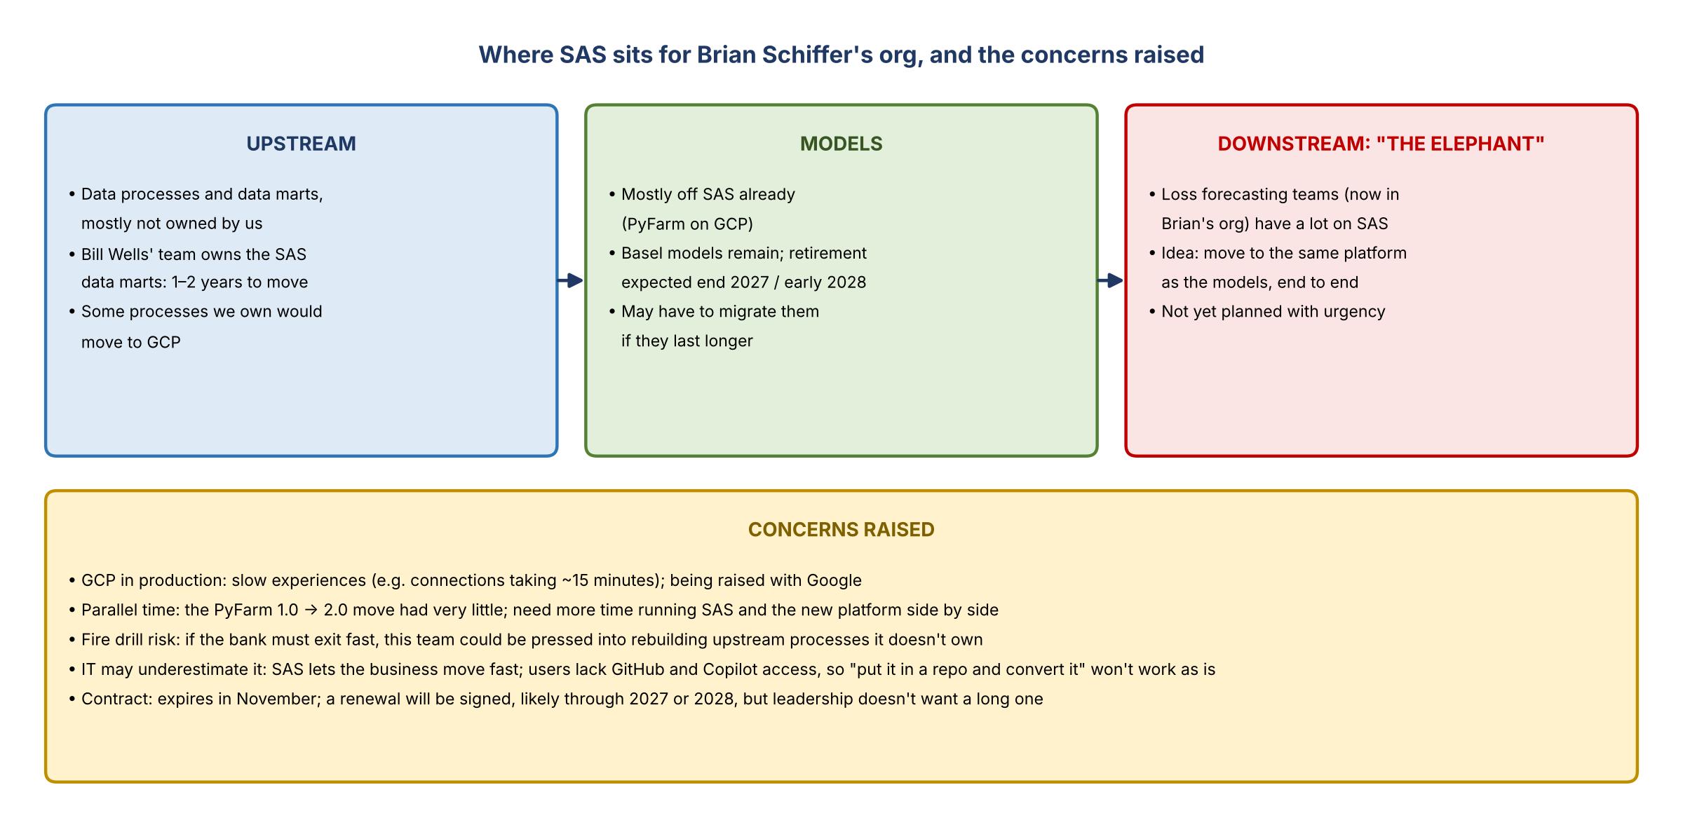
Figure 1. Where SAS sits for Brian Schiffer's org, and the concerns raised

Contract and timing
- The contract expires in November, but the bank can't operate without SAS, so something will be signed. The question is how long.
- Michael asked whether licenses are corporate or by business unit, and whether they all end at once. Brian: there's no timing yet. Likely an extension through 2027 or 2028, probably 2028, given how much is entangled.
- Brian's ideal would be a five-year phase-out with no new work on SAS. But the contracts being discussed may not even run three years.
- The concern has been escalated to at least the OC level, possibly Charlie's.

Where Brian's org stands
- Models: mostly off SAS, so in good shape. Some upstream data processes the org owns would have to be converted and moved fully to GCP.
- Downstream, "the elephant": the loss forecasting teams that joined the org have a fair amount on SAS. There's a preliminary idea to move it to the same platform as the models for an easier end-to-end process, but it hasn't been planned with any urgency yet.
- Basel: Venkat had raised that the Basel models may finally have to be migrated. They're expected to retire around the end of 2027 or early 2028; if they last longer and this picks up steam, migrating them may need to be prioritized.
- The wider bank: similar conversations are happening in CBL and the businesses, which own much of the SAS data this team pulls. It has all surfaced in the last week.

Concerns
- GCP in production: the experience hasn't been great for production users, for example a connection to GCP taking 15 minutes. That's part of why new work hasn't moved quickly beyond what was on PyFarm 1.0. The NOFS team is aware and talking with Google.
- Parallel time: the PyFarm 1.0 to 2.0 move had very little parallel time. Mike agreed: there needs to be more time running SAS and the new platform side by side.
- Upstream fire drill: most upstream data processes aren't owned by this team. If the bank has to get off SAS in a hurry, the team could be pressed into rebuilding them. Bill Wells' team owns the SAS data marts; Brian has told Bill and Ajit, and Bill estimates at least one and probably two years to move them.
- IT may be naive: the business uses SAS because it can get things done quickly; handed to IT, much of it would become a five- to ten-year project. On the earlier call, the architect suggested putting all SAS code in a repo and converting it with Copilot. But many users, including upstream production teams like CRDM, don't have their code in repos because they aren't allowed GitHub access, and the same goes for Copilot.

Brian's guidance for now
- Focus on information gathering: what you do on SAS and how you use it.
- Don't set up anything new on SAS. For new initiatives, look at GCP, even if it isn't the finished product yet.

4. How Brian's org will respond
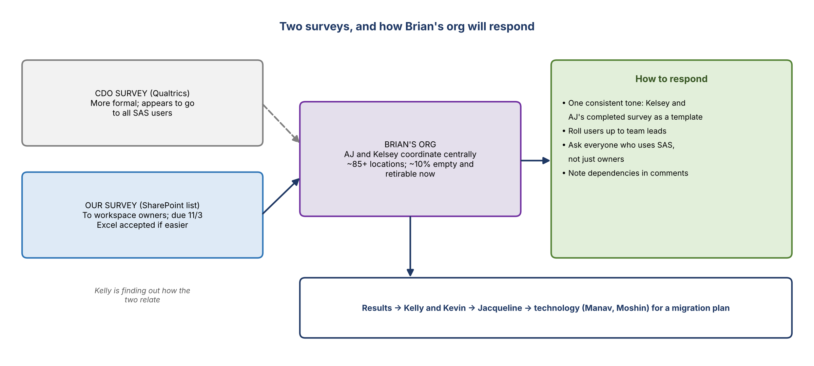
Figure 2. Two surveys, and how Brian's org will respond

Coordination
- Kelly: the survey went to every workspace owner. The team then connected with AJ, who will coordinate centrally for Brian's org with Kelsey. Either route works; the due date is 11/3. Kelly can raise the timing with Jacqueline if the volume needs more time.
- AJ: about 85 locations identified so far; about 10% can be retired right away because they hold no data. More are surfacing that the org didn't know about or that sit with other teams after years of reorgs.
- AJ and Kelsey want to get all current owners together to work through it as a group; it's a lot of work.

Survey mechanics
- Daniel owns many workspaces and has had technical trouble with the SharePoint survey. Responses can come in Excel or any format. Jake and Kelly will connect with him on the errors.
- Daniel's ask: he owns workspaces but doesn't use them, so before agreeing to decommission anything he wants a report of each workspace's users and the latest modified dates.
- Kelly: CDO's reporting gives user lists for only one platform (1SASGRID or SAS Grid 1, to confirm). The team also recently found file inventory extracts that list every file with the UID of the person who last edited it. It's consolidating them to share, especially with owners of workspaces across several environments.
- Brian: de-duplicate the user lists and roll them up to team leaders, so owners aren't chasing 30 individuals.

Consistency and coverage
- Brian: respond consistently. If everyone answers separately, the org could say different things.
- Kelsey and AJ filled in the survey this morning (5–10 minutes) and agreed a consistent view of how important SAS is. AJ will share it with Julia as a template.
- Go to everybody, not just space owners. People use SAS space they don't own, and there are pockets of use across the team; financial crimes, for example, uses SAS.
- Kelly: the survey's comments field captures dependencies on other SAS workspaces.

The second survey
- A second, more formal survey (Qualtrics) has gone out from CDO, apparently to all SAS users rather than workspace owners. Kelly is finding out how it relates. The team's survey is a SharePoint list.

Close
- Julia: if results aren't in by 11/3, tell her and she'll tap people on the shoulder.
- Kelsey got involved early because David and Jennifer passed her a number of workspaces, as did Leopold.
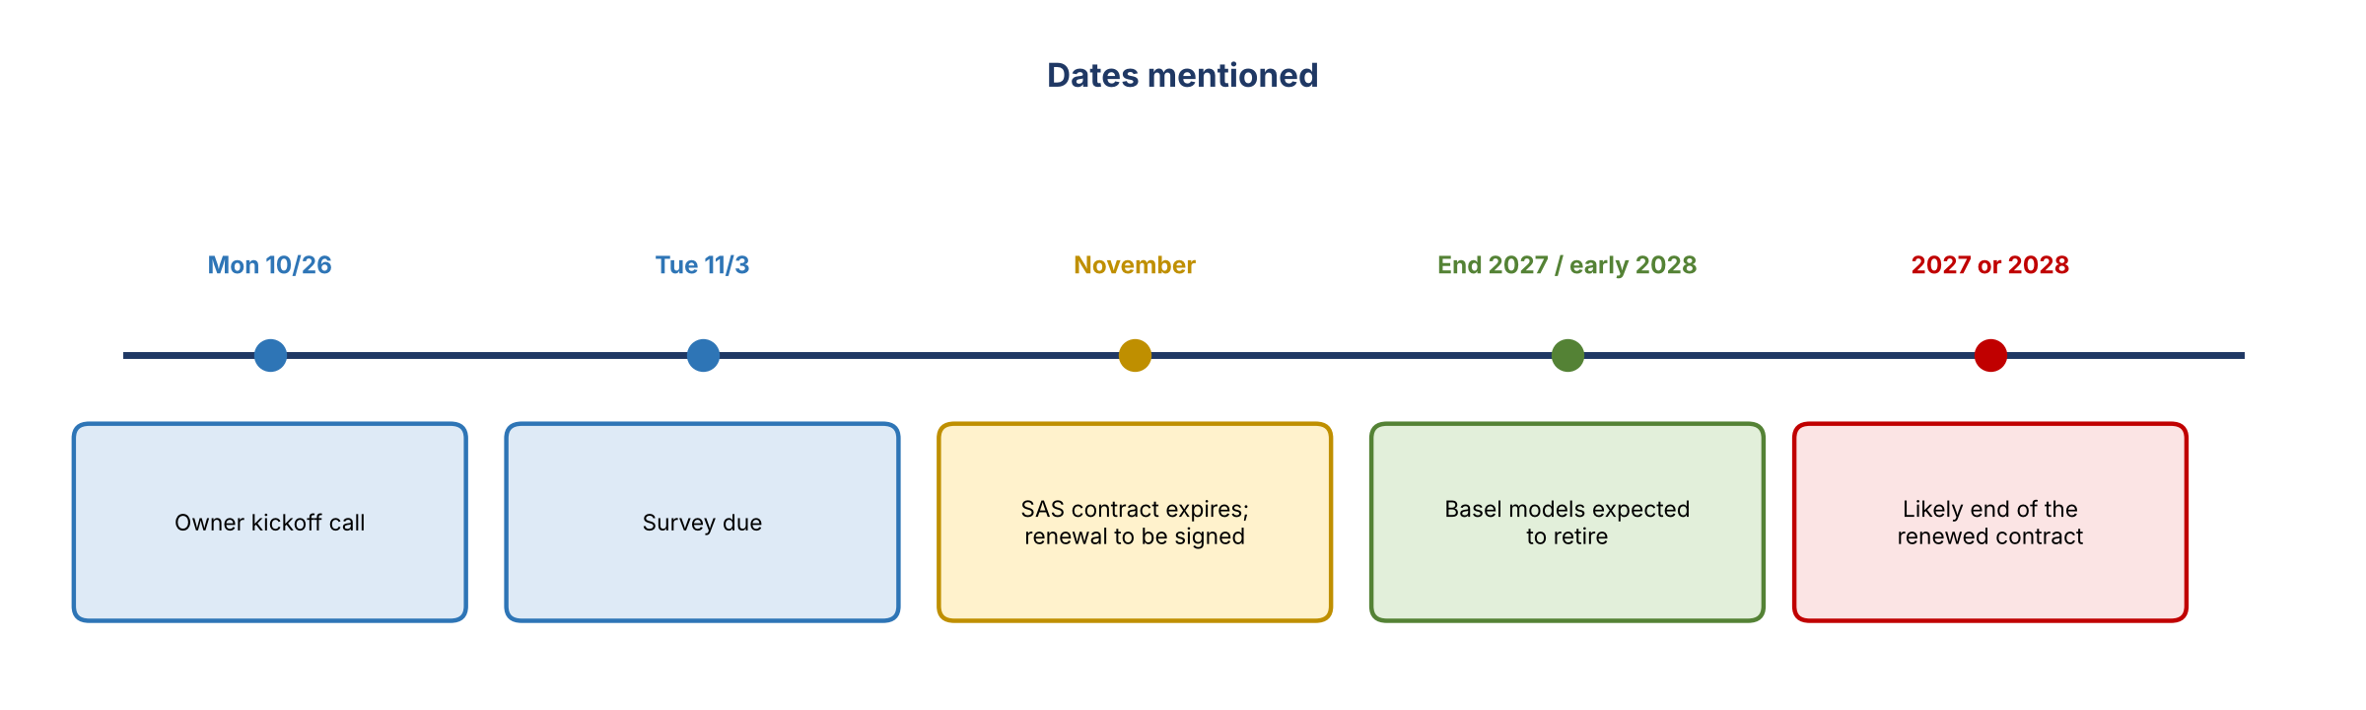
Figure 3. Dates mentioned

5. Decisions
# | Decision
1 | AJ and Kelsey coordinate the survey centrally for Brian's org
2 | Responses use one consistent view, with Kelsey and AJ's completed survey as the template
3 | Coverage includes everyone who uses SAS, not only workspace owners
4 | No new work goes on SAS in Brian's org; new initiatives look at GCP
5 | Survey stays due 11/3; Julia escalates anyone who misses it

6. Action items
Action | Owner | Notes
Coordinate survey responses for Brian's org; bring current owners together | AJ, Kelsey | About 85 locations
Share the completed survey as a template | AJ | To Julia
Help Daniel with the survey errors; accept Excel if easier | Jake, Kelly
Share user lists and file inventory (last-editor UIDs) by workspace | Kelly, Jake | Confirm which platform CDO user lists cover
Roll user lists up to team leads | AJ, Kelsey | Per Brian
Find out how the CDO Qualtrics survey relates to ours | Kelly
Raise the 11/3 timing with Jacqueline if needed | Kelly
Chase owners who haven't responded by 11/3 | Julia
Retire the empty locations (about 10%) | AJ, Kelsey with owners

7. Open questions
- How long will the renewed contract run: through 2027 or 2028?
- How does CDO's Qualtrics survey relate to the team's SharePoint survey?
- Which platform do CDO's user lists cover: 1SASGRID or SAS Grid 1?
- Who rebuilds the upstream SAS processes and data marts (Bill Wells' team) if the timeline is short?
- Will the loss forecasting work move to the same platform as the models, and when?
- Will GCP's production performance and parallel-run time be addressed before any migration?

