Meeting Notes
ECRM Model Input Check: Leveraging ADMF, ECRLT and DCF
Item | Detail
Meeting date | Thursday, October 29, 2026 (recording started about 1:03 PM)
Format | Working session; Alice shared the EDCC data quality report from ADMF, then Mike shared the DCF checks for ECRLT
Model team | Alice (designing the ECRM model input check)
Corporate risk BDL | Kevin, Mike (Michael; DCF ABO), Jake
Referenced | Nick Divirgillo (Kevin's team; eCPR elements), Andrew (idea to use ADMF; former ECRLT ABO), Ryan and Jennifer Lane (defect management), Gina (FCRM data governance; ABO team), Josh Kessler (ECRLT ABO now), Jeff Cameron and Brian Burling (financial crimes technology), Liz (BCM), Andy, Hogan and WCIS (source applications)
Purpose | Pressure-test the model team's approach to the new MRM model input check requirement for ECRM before socializing it with MRM

Note on the transcript
Auto-generated transcript; speakers aren't labeled, so attributions come from context. Kevin is transcribed "Kelvin" in places; MRM as "MLM". Readings used: RFDIR ("Rifter"), WCIS ("WICUS"), DQ ("dequeal"), Jira ("juror"), FCT (financial crimes technology), ECRLT, EDCC, DCF. Confirmed: Nick Divirgillo (transcribed "E-Vergilio"), Jennifer Lane, Ted (no longer at the bank), EDQDM (the enterprise defect tool), Verkess (a previous ECRLT ABO). Unsure: eCPR, Andy, Jeff Cameron, Brian Burling, Liz, and "ECN"/"ECNS" (element names).

1. Summary
A new MRM model risk control guidance requires model input checks. Alice is designing them for ECRM (part of the ECRR use case). ECRM is different from the monthly batch transaction monitoring models: it runs continuously, fed by many source applications, so the model owner can't pause it to check inputs before each load.
Alice's plan, following Andrew's idea, is to point MRM to the enterprise framework already in place:
- Upstream source applications run element-level data quality checks, documented in ADMF's EDCC report.
- Issues become Jira tickets, then data defects in EDQDM.
- The BDL team facilitates the defect process, and the model owner does the impact assessment.
Kevin agreed that's the right upstream story, but expects MRM pushback, so the model team should involve the BCMs. His strongest suggestion is to add ECRLT, the application the model runs on:
- ECRLT isn't an ADS, so it has no element-level checks in ADMF. Its checks are onboarded to DCF, where Mike is the ABO.
- Only three elements have level 2 checks today: ECN, ECNS and client ID.
- Tell the full story: upstream checks, the ECRLT checks, and the gaps. Then build more ECRLT checks if MRM asks.
Adding checks takes a week or two to about a month if the check already runs in ECRLT, and up to a quarter if it has to be built. Alice will finalize the design and socialize it with MRM tomorrow (10/30).

2. Side item: eCPR elements
- Kevin asked whether Alice had connected with Nick Divirgillo on his team. Nick is reviewing the file she sent on the new elements needed for eCPR and has a couple of questions before it goes out. He'll reach out today or tomorrow.

3. The requirement and why ECRM is different
- MRM issued new model risk control guidance requiring model input checks, among other checks. This call covered the input check design.
- In scope: the ECRM model, part of the ECRR use case.
- Batch models (e.g. TM): the model owner runs monthly and can check inputs before loading everything into production.
- ECRM: runs constantly and is supported by many source applications. The owner can't intercept it to check whether inputs are accurate at a given moment.
- Andrew's idea: use the end-to-end process in ADMF, which is more comprehensive than the standalone check MRM asked for, and reference it back to MRM, showing where the model owner gets involved. Building checks on their own would be fragmented.

4. The upstream story: ADMF and the defect process

Element-level checks (EDCC report)
- MRM wants checks at the data element level. Alice pulled the EDCC data quality report from ADMF, which lists element-level checks such as completeness, accuracy and rules, with descriptions of what each does.
- These checks run on the applications upstream of ECRM. Their source system owners run them on their own schedules, under their own big C monitoring controls. Kevin: the model team doesn't need to monitor them.
- Control ID (column P): the big C control that should monitor each check. Where it's not known, it can be marked unknown.
- The data management policy says all these checks should be monitored, but implementation varies. A common control is coming for ABOs and ADSs. Historically, whether every check ties to a big C control has been a mixed bag, but the control IDs can still be cited as things that help ensure the quality of data feeding ECRM.
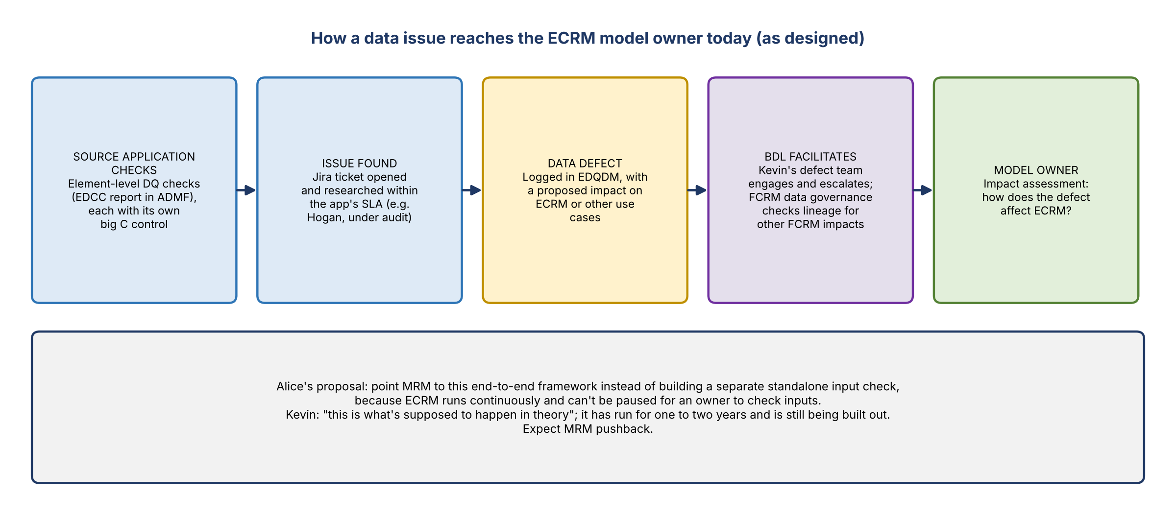
Figure 1. How a data issue reaches the ECRM model owner today (as designed)

From issue to model impact
- A source application's check finds an issue under its control and opens a Jira ticket to research it.
- The application researches within its SLA. Hogan, for example, is under audit and has specific SLAs.
- If it's a data defect, it's logged in EDQDM, with a proposed impact on ECRM or other use cases.
- The BDL team researches and escalates it to the model owner (use case owner).
- The model owner does an impact assessment: how would this input defect affect the model? This is where the model owner gets involved.

Who facilitates (Kevin)
- Kevin's team, beyond Jake and Mike, facilitates defect management for corporate risk: Jennifer Lane and others. Alice usually works with Ryan on Andrew's team; it used to be Ted, who is no longer at the bank.
- When an application such as Hogan or WCIS logs a defect in EDQDM, it proposes impacts on ECRM or other models and use cases, and has to do an impact assessment.
- Separately, the FCRM data governance team under Gina reviews holistically. If Hogan is in ECRM's lineage and has a defect affecting another use case, does it also affect ECRM or other FCRM use cases? That's another control point to cite.
- Kevin: this is how it's supposed to work in theory, and what the team is building towards. It probably doesn't happen every time. Alice: it's been operating for about one to two years.

5. Kevin's caution: expect MRM pushback
- Kevin expects pushback from MRM. Engage the BCMs. He forwarded this to Liz, who was in Charlotte this week and is traveling back to Minnesota, but isn't sure she's the right BCM.
- He isn't certain what model policy requires for the DQ monitoring control, or whether the model team can say it doesn't need one because upstream checks exist. ECRM is unusual in not being a batch load, unlike, for example, the allowance models.
- Alice: an audit call raised the same question. TM had something similar and still missed things, so can you simply rely on this?
- Kevin asked whether the model team can check inputs as ECRM runs, such as null or validity checks. Alice: no visibility. The process is supported entirely by FCT (financial crimes technology), and the model team doesn't run anything in it.
- Kevin: MRM wants the model owner to have visibility of the checks technology runs, not just the upstream ADS checks. Start by finding out what FCT runs on ECRLT, where the model is deployed. Contacts: Jeff Cameron or Brian Burling.

6. The ECRLT layer
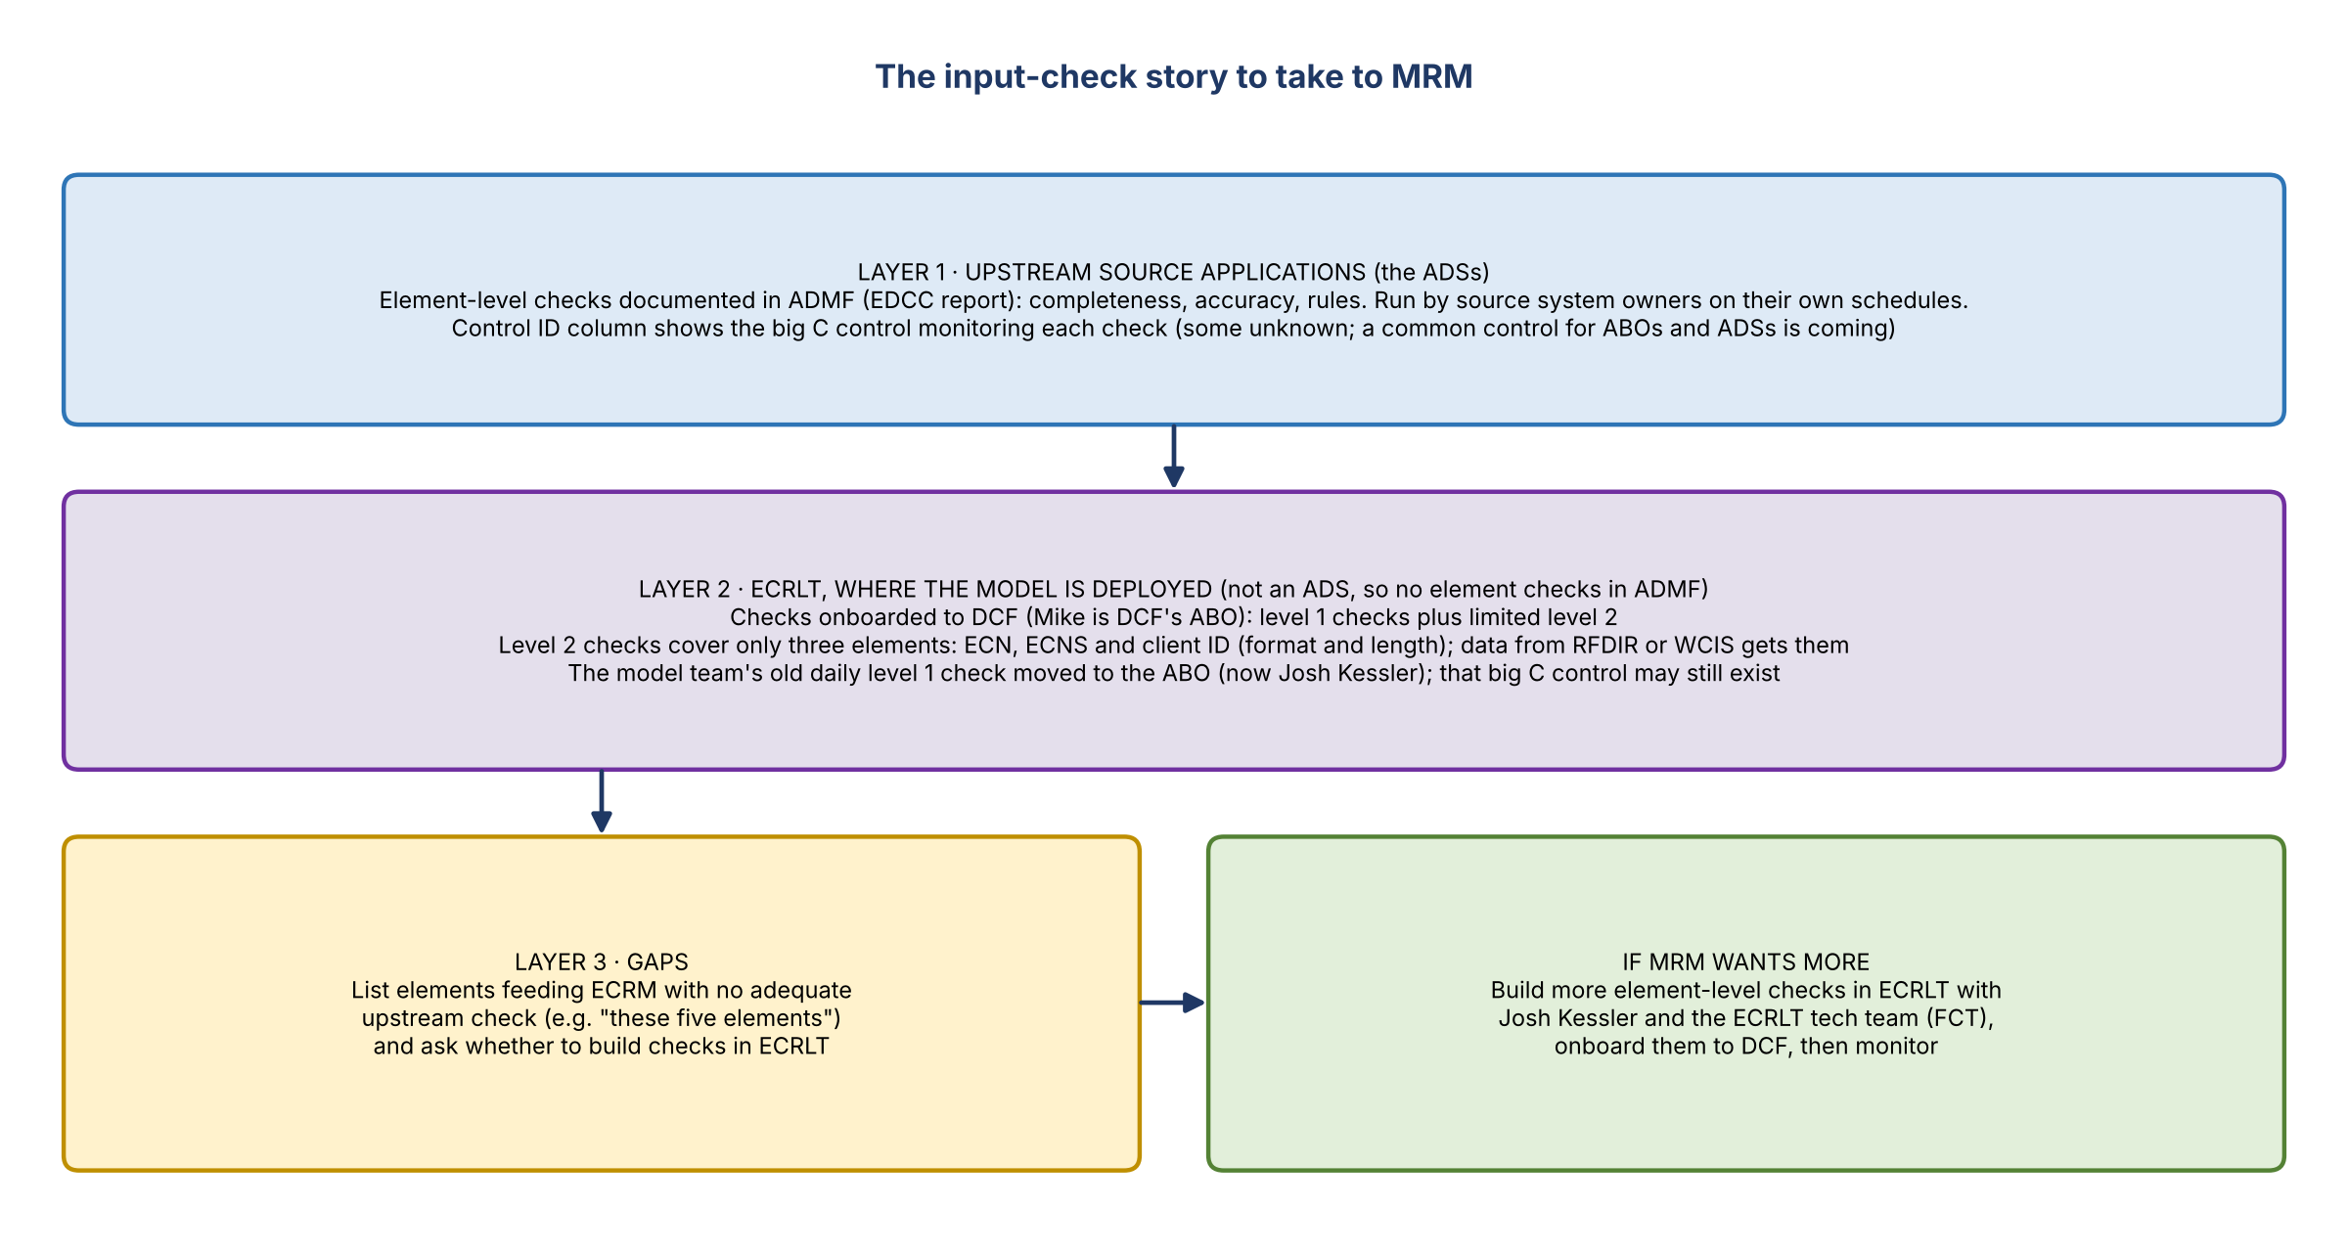
Figure 2. The input-check story to take to MRM
- ECRLT is onboarded to DCF, with level 1 checks and limited level 2 checks.
- Alice: the model team used to run a level 1 check daily as ECRLT's ABO. That moved to the ABO (no longer Andrew; now Josh Kessler), so the model team doesn't run it any more. Kevin: now, as model owner, you'd have to.
- Kevin: the strongest argument is an element-level check review on ECRLT, since the model is deployed on it.
- ECRLT isn't an ADS; it's an ingestion point, and the ADSs are upstream. So element-level checks aren't documented for it in ADMF, because policy doesn't require them. But the technology teams onboarded their checks into DCF.
- Either Josh Kessler or the model team could build a control over those, like the one the model team used to run as ABO. That big C control probably still exists and could show the model team is monitoring model inputs.

What DCF shows (Mike)
- Only three elements have level 2 checks: ECN, ECNS and client ID. The checks cover things like format and length (e.g. number of characters for client ID). Data coming from RFDIR or WCIS gets at least these.
- Many more elements feed the model; whether they should have checks is open.
- Why these three? Unknown. Gina's team is the ABO today (previously Verkess, then Kessler). The checks likely predate them and the monitoring control, and may have been built by Andy.
- Three today isn't the end of the road. If MRM wants input checks on more elements, that's a conversation with technology.

How to tell the full story
- Review the upstream element-level checks in the ADMF (EDCC) export.
- On ECRLT, show the elements you're comfortable with because of those checks, plus the existing DCF checks.
- Call out the gaps, e.g. five elements without adequate upstream checks, and ask whether to build something in ECRLT for them.
- If MRM wants everything checked at ECRLT, treat that as an enhancement. Work with Josh Kessler and the ECRLT tech team on what else can be built, or whether the real-time nature rules it out.

7. Timelines and policy
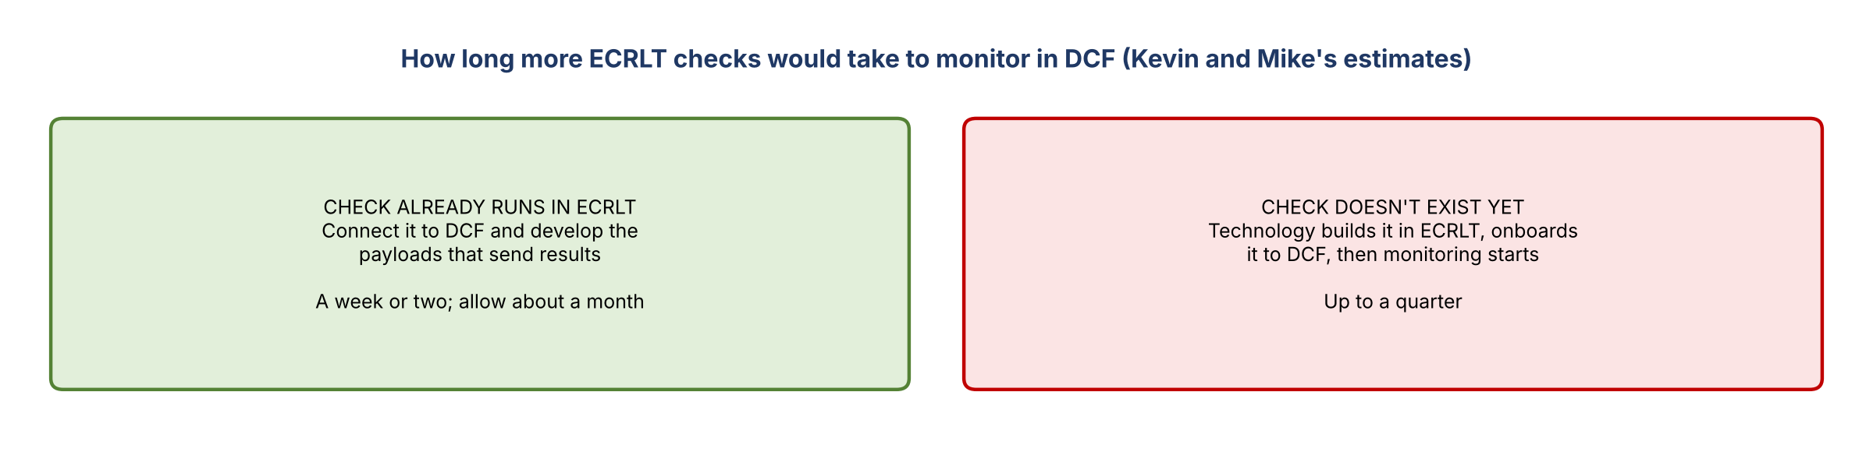
Figure 3. How long more ECRLT checks would take to monitor in DCF
- If the check already runs in ECRLT, onboarding it to DCF takes a week or two; allow about a month to develop the payloads that send results.
- If technology has to build the check in ECRLT first, it can take up to a quarter.
- Why it's not there today: the enterprise data management policy doesn't require element-level checks on ECRLT. MRM's model risk policy is what now requires element-level input checks.
- How much granularity MRM needs isn't clear yet, to either MRM or the team, because the guidance is new. If MRM is satisfied with source-level checks, a second layer at ECRLT may not be needed. From a data management policy view, the source checks matter most.
- Kevin: he'd still build some element-level checks on ECRLT, and bring in the BCMs, who have been helping modeling teams across risk deploy big C controls over model input checks and may know what passes MRM.

8. Next steps
- This isn't a validation or an MRF; it's a new input check setup. MRM has no very specific requirement, so Alice will socialize the approach with MRM.
Action | Owner | Notes
Finalize the input check design and socialize it with MRM | Alice | Tomorrow (Fri 10/30)
Confirm the right BCM and their guidance (Liz?) | Kevin | Will share what he hears
Reach out to Liz separately | Alice
Find out what checks FCT runs on ECRLT | Alice with Jeff Cameron / Brian Burling
Discuss more ECRLT element checks with Josh Kessler and tech, if MRM requires them | Alice / Josh Kessler | 1 week to a quarter, depending on whether the check exists
Reach out to Alice about the eCPR elements file | Nick Divirgillo | Today or tomorrow

9. Open questions
- How will MRM interpret the element-level input check requirement: source-level checks, or checks at ECRLT too?
- Does model policy allow relying on upstream checks for the DQ monitoring control?
- Which BCM covers ECRM?
- Does the old ECRLT level 1 check and its big C control still exist?
- Which elements feeding ECRM lack adequate upstream checks?

