Meeting Notes
FCRM Data Defect Review
Item | Detail
Meeting date | Friday, October 9, 2026 (recording started about 10:30 AM)
Format | Recurring defect review; Jennifer shared the defect tracker
Ran the meeting | Jennifer
Attendees | Laura and Carl (FCRM), Abhishek, Manish, Sheik, Nick, Jody, and others; Nitin was on another call
Out today | Kelly; BCM was not on the call
People referenced | Jeff (Laura's new manager), Swati, Tracy, John, Donna, Tara, Mark Kay, Patrick, Greg
Purpose | Walk through open FCRM data defects, closures, and blockers

Note on the transcript
Auto-generated transcript; speakers aren't labeled, so attributions are inferred, and small talk (new laptops, the hurricane, office locations) is left out. Defect numbers are as spoken: "89.41" is read as 8941 and "101.11" as 10111. Unclear: "VEDA" (the work Laura is handing to Carl), "RAC" (a model review body the lookback decision depends on), "CIV" (read as CIB), "CEMANTS" (the source the FAN model would move to), and BCM.

1. Executive summary
Jennifer walked through the open FCRM data defects. Three are at or near closure: 6114 (awaiting Nitin's approval), 8941 (ready to close; confirming by email since some people were out), and 8730 (can close if Donna confirms the accounts are internal trust accounts that don't need monitoring).
Several are waiting on others. 9860, a critical defect, is done on our side but CIB is revisiting documentation. 9644 won't reach RAC until at least December, so no lookback decision has been made. 9646 and 9438 need model owner updates.
Two are long-term. 8096 (corporate functions, external-party input errors) won't be cancelled: a tactical fix may work, but the strategic fix has to be captured, and related defects 8831 and 8543 need to be understood first. Re-sourcing the FAN model for 10111 is at least six months out. Jennifer will also confirm with BCM that linked issues cover the remediation for some defects, including one cancelled without our approval under new guidance.
Team change: Laura is moving from FCRM to regulatory and exam management (reporting to Jeff) and handing her work to Carl, who joined FCRM around the same time and also does the BSA/AML metrics.

2. Team change
- Laura is transferring out of FCRM to regulatory and exam management; on the org chart she already reports to Jeff.
- Carl transferred into FCRM around the time of the org change. He'll keep doing metrics (BSA/AML metrics) and take over the work Laura has been doing (transcribed "VEDA").
- Jennifer hadn't known about the transition and welcomed Carl.

3. Defect status board
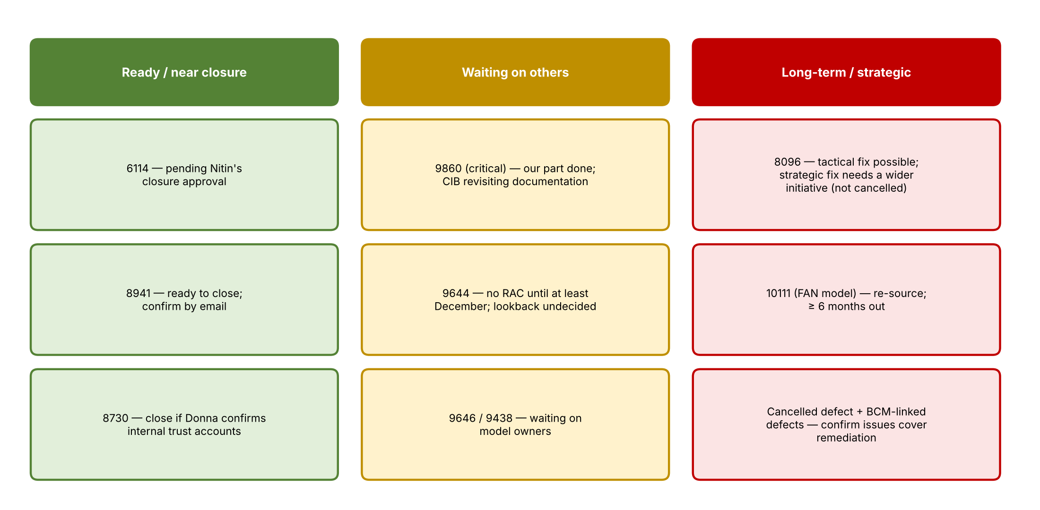
Figure 1. Defects by status
Defect | Status | Update | Next step
6114 | Pending closure | In Nitin's queue for closure approval. Kelly pushed it through; it's been one of the most engaged defects | Reach out to Nitin to approve
8941 | Ready for closure | Evidence explains why historical transactions weren't remediated; Mark Kay said it would be very difficult, and those present agreed | Email for confirmation since some people are out
8730 | Verification | John confirmed the accounts appear to be internal trust accounts. If so, they don't need monitoring (a good outcome for an aging defect) | Donna verifying
9860 | Waiting on CIB (critical) | Done on our end; CIB needs to revisit the documentation | Jennifer follows up with Greg
9644 | Waiting on RAC | Patrick: model owners haven't started the RAC work. No RAC in October or November; at least December. No lookback determination yet | Track; tracker note corrected
9646 | Waiting on model owners | No data update yet | Abhishek checks with model owners
9438 | Waiting on model owners | Needs an update similar to 9644's | Follow up
8096 | Long-term (not cancelled) | See Section 4 | Wider conversation with corporate functions
10111 | Long-term | FAN model re-sourcing; see Section 6 | Manish sends a formal response
Cancelled defect | Cancelled | Cancelled by the owning domain without our approval under new guidance | Confirm with BCM (Section 5)

4. 8096: corporate functions input errors
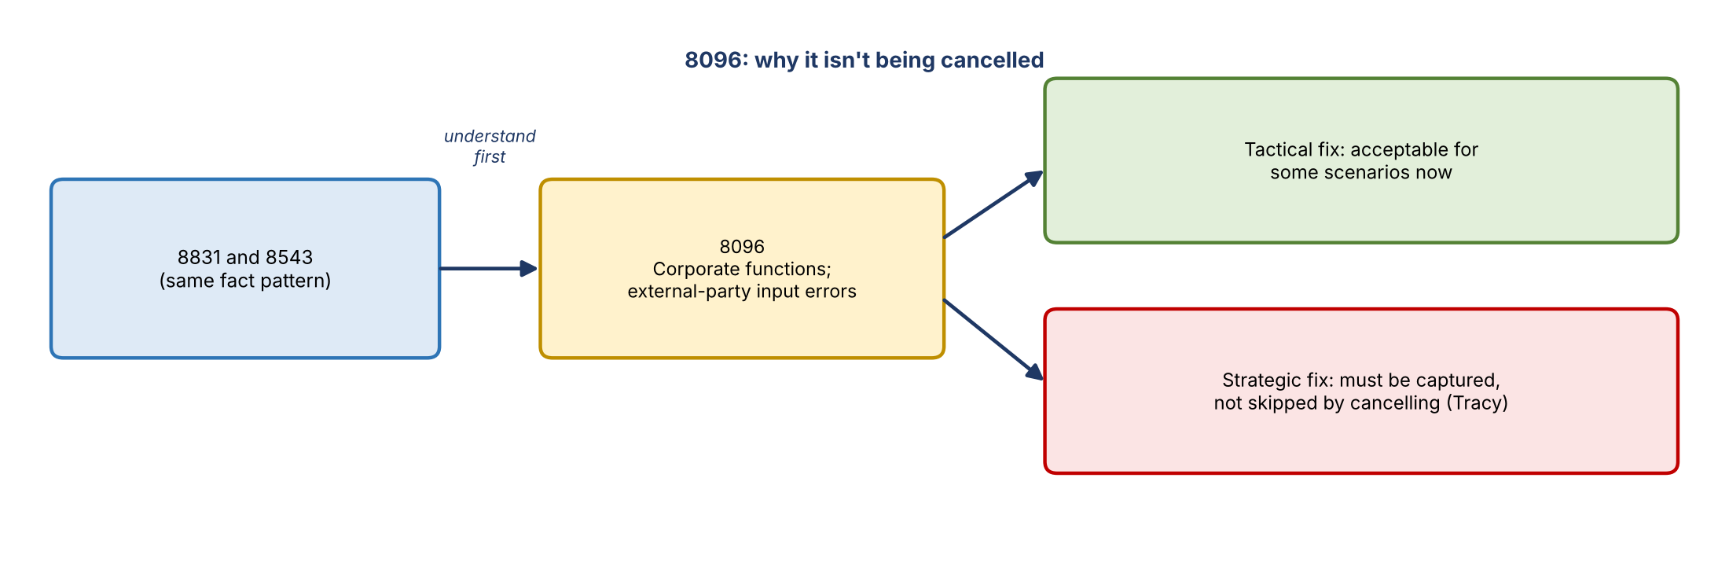
Figure 2. Why 8096 stays open
- Nitin and Manish asked for an update. Discussions have mostly happened offline.
- Earlier this week Swati met corporate functions, limited to the BDLs. A larger conversation is planned to document what corporate functions has done with external parties to prevent these input errors.
- Corporate functions appears to want to cancel the defect. The team is comfortable that a tactical fix can work for some scenarios, but the strategic fix must be captured rather than avoided. Tracy pushed on this point.
- It's part of a larger initiative covering several defects with the same fact pattern, so it will take time.
- 8096 isn't being cancelled. The team wants to understand 8831 and 8543 before getting comfortable with that.

5. Cancellations and BCM-linked defects
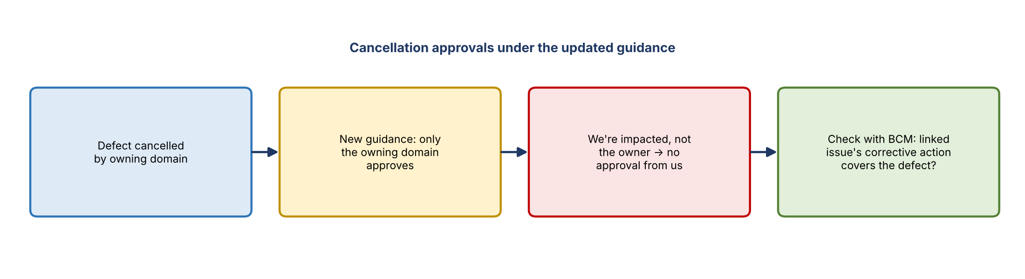
Figure 3. Cancellation approval under the updated guidance
- Updated guidance means only the owning domain approves some cancellations. Since FCRM is impacted but not the owner, one defect was cancelled without going through the team.
- An issue is aligned to it, and its corrective action specifically mentions the defects, so it should be fine. Jennifer will still confirm with BCM.
- Separately, under the updated guidance, Jennifer wants to confirm that issues cover the remediation for a couple of defects. She'll work with Tara on these.

6. 10111: FAN model re-sourcing
- Jennifer asked Manish for a timeline to update the FAN model's sourcing (to the source transcribed as "CEMANTS").
- Manish: no timeline yet. It has two parts: changing the model itself, and working with the platform team on the needed changes.
- Source changes have usually been forced on the team when a source changed; this is a proactive change, which is new for them.
- Expect at least six months; not a quick fix. Manish will reply formally to Kelly's email.

7. Action items
Action | Owner | Notes
Approve closure of 6114 | Nitin | Attendees to nudge him
Send confirmation email to close 8941 | Jennifer | Several people out
Verify internal trust accounts for 8730 | Donna | Closes if confirmed
Follow up with Greg on CIB documentation for 9860 | Jennifer | Critical
Share 9644 RAC update (include Jennifer) | Sheik / Abhishek | Email already sent to Kelly
Get model owner updates for 9646 and 9438 | Abhishek | Put defect numbers in chat
Track the corporate functions conversation on 8096 | Jennifer | With Swati; review 8831 and 8543
Confirm BCM is comfortable with the cancelled defect and issue coverage | Jennifer with Tara | Under updated guidance
Send a formal response on the 10111 FAN model timeline | Manish | Reply to Kelly's email
Update the tracker notes so Kelly sees the 9644 change | Jennifer | Kelly out today

8. Open questions
- Will 8096's strategic fix be documented, and how will 8831 and 8543 be resolved?
- When will 9644 reach RAC, and what will the lookback decision be?
- When will CIB finish revisiting 9860's documentation?
- Do the linked issues fully cover remediation for the BCM-related and cancelled defects?
- What is the FAN model's re-sourcing timeline?

