Meeting Notes
FCRM Defect Review: Status, Look-Back Debate & Next Steps
Item | Detail
Meeting date | Friday, October 23, 2026 (recording started about 10:31 AM, partway in)
Format | Recurring FCRM defect review; Jennifer walked the defect report
Attendees (from context) | Jennifer (facilitator), Kelly, Jake, Alicia and Laura (FCRMDG), Tracy, Alex, Manish, Abhishek, Cu; Nitin and Donna not present
Referenced | Mike and Rita, Chang, Benicia's team, Melissa Romans (FI relationships), PAL team, Max (EWRA), Rasika (ABO, FCDS), Joe (model owner), John Smigla, Lily, Tara, Roberta, Mark K, Pat / Patrick, Liz, Ron (RAC), Greg, Jonathan (Newton), BMG
Purpose | Walk open and recently closed FCRM defects, unblock approvals, and settle how remediation and look-backs should be evidenced

Note on the transcript
Auto-generated transcript that starts mid-call. Speakers aren't labeled; attributions come from context. Readings used: Cu (transcribed "Sai"), Manish (also transcribed "Vanish"), Nitin (transcribed "Knitten"), CIMADS (transcribed "CMATS"), FCRM, DMP, TM (transaction monitoring), RAC, Newton. Defect numbers are as heard (e.g. "96.46" read as 9646; "101.1.1" as 10111). Unsure: Benicia, Melissa Romans, Rasika, John Smigla, Mark K, "pre-vet" (heard "prevent"), PAL team, Greg's org (heard "with CEO"), "AFA43", SPR, ITV, and "872" vs. 9872.

1. Summary
- 6114 is closed and was kept on the report this once to mark it; the issue timeline is being worked.
- Bad data from other FIs: 8096 and related defects (8831, 9872, about 4–5 in all) come from other financial institutions sending incorrect data. They stay open and go the issue route, with a pre-vet with the respective BCMs.
- 8730 can be cancelled (internal trust accounts) pending approvals from Rasika and Joe.
- 8755 is out of deferral and needs its impact re-reviewed.
- 8941 can close once evidence is clarified.
The main discussion was look-backs (9438): what counts as remediation for a defect when the period impacted is both historical and on the run. Positions diverged and practice has been inconsistent, so a meeting with Pat, Nitin and Liz plus a write-up from TM will settle a consistent approach.
- 9860 (critical, CIB): the blocking issue was cancelled around 10/2 and controls are back to effective, so CIB should be able to close it.
- 10111 (switch to CIMADS): this needs a driver, since a moderate defect won't force a sourcing change.
- 10164 and 10166: need the Newton team to name the impacted elements.

2. Defect status
Defect | Status | Notes / next step
6114 | Closed | Kept on the report this once; thanks to the team. Jennifer working the issue timeline.
8096 | Open: issue route | Other FIs send incorrect info; industry-wide. See Section 3.
8831, 9872 (+ others) | Open: same root cause | Treat the same way as 8096. Laura posted 9872 in chat.
8730 | To cancel | Confirmed internal trust accounts; Donna's team OK to cancel. EWRA approval (Max) received. Still need Rasika (now ABO over FCDS) and Joe (model owner).
8755 | Out of deferred status | Jennifer set time with Tara, Alex and Kelly to recheck issue alignment and impact assessment against updated guidance. Watch the COO domain swirl.
8941 | Closing on evidence | Roberta got confirmation from Mark K that no more historical remediation is needed. Not on Abhishek's closure list. SPR meeting already held. Kelly and Jen agree to close once evidence is clarified.
9438 | Look-back debate | Records not reprocessed in Newton, so no systematic look-back is possible. See Section 4.
9646, 9644 | Pending look-back decision | Same fact pattern as 9438, but the historical piece was remediated. Revisit after the look-back discussion.
9860 (critical) | Should close (CIB) | Issue cancelled ~10/2; controls effective; ITV testing the control. Meeting with Greg next Friday (10/30). See Section 5.
10111 | Source change needed | Switch from BMG data to CIMADS. See Section 6.
10164 | Needs Newton input | Description changed from creditor party details to creditor agent. Need Newton to confirm the impacted element.
10166 | Needs Newton input | Beneficiary name and address missing in Newton; Newton says a workaround protects TM. Need actual element names. See Section 7.

3. Defects from other FIs' data (8096 family)
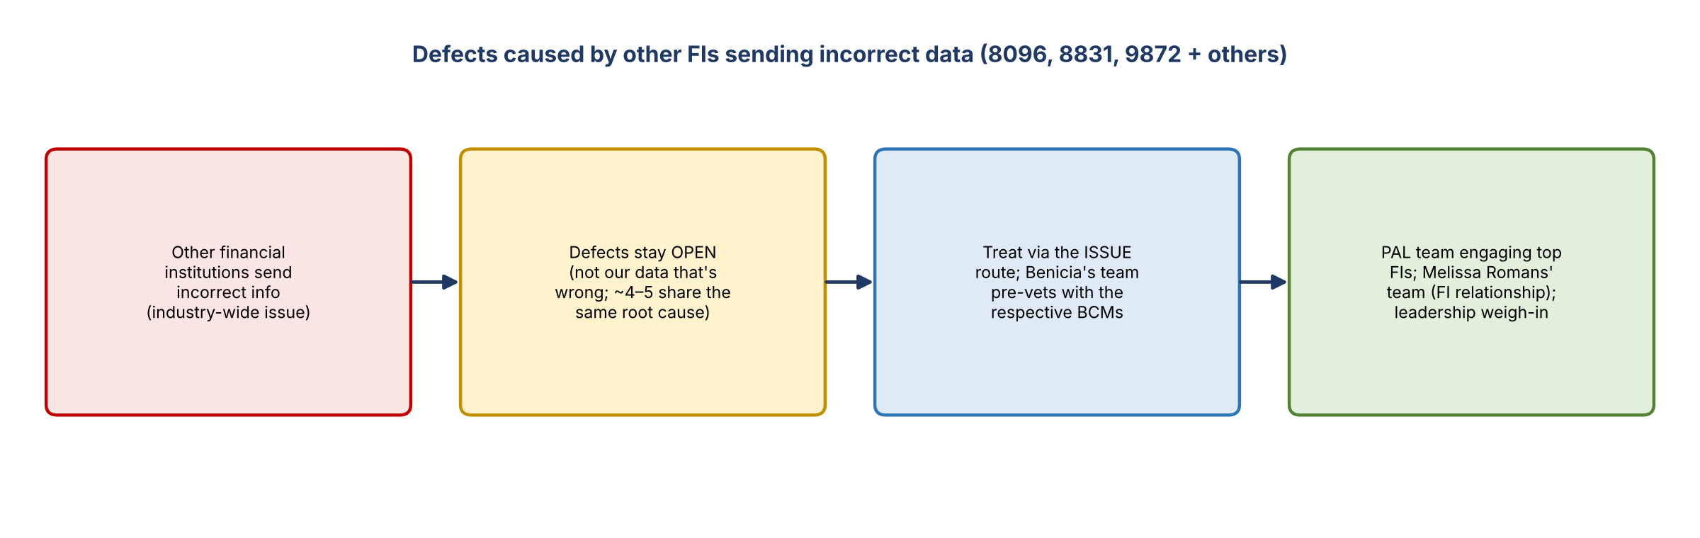
Figure 1. How the external-FI defects are being handled
- Corporate Functions has a takeaway on documenting its work with external parties to avoid input errors in future. Tracy wanted to take it to leadership.
- Laura: the root problem is other FIs sending incorrect information. It's not our data that's wrong, and it looks like an industry issue that may never be fully resolved. The PAL team has reached out to top FIs, and more calls are being set up with Melissa Romans's team, which owns the FI relationships.
- Alicia (spoke with Mike and with Chang last Friday): there was some miscommunication. The defects stay open; nobody closes them. Benicia's team does a pre-vet, working with the respective BCMs to prevent repeat issues.
- It started as two defects, but Chang says four or five now share the same root cause, so all should be treated the same way.
- Agreed: the issue route is the right course rather than the defect route. The defects stay open until that's done.

4. Look-backs and what remediation means (9438)
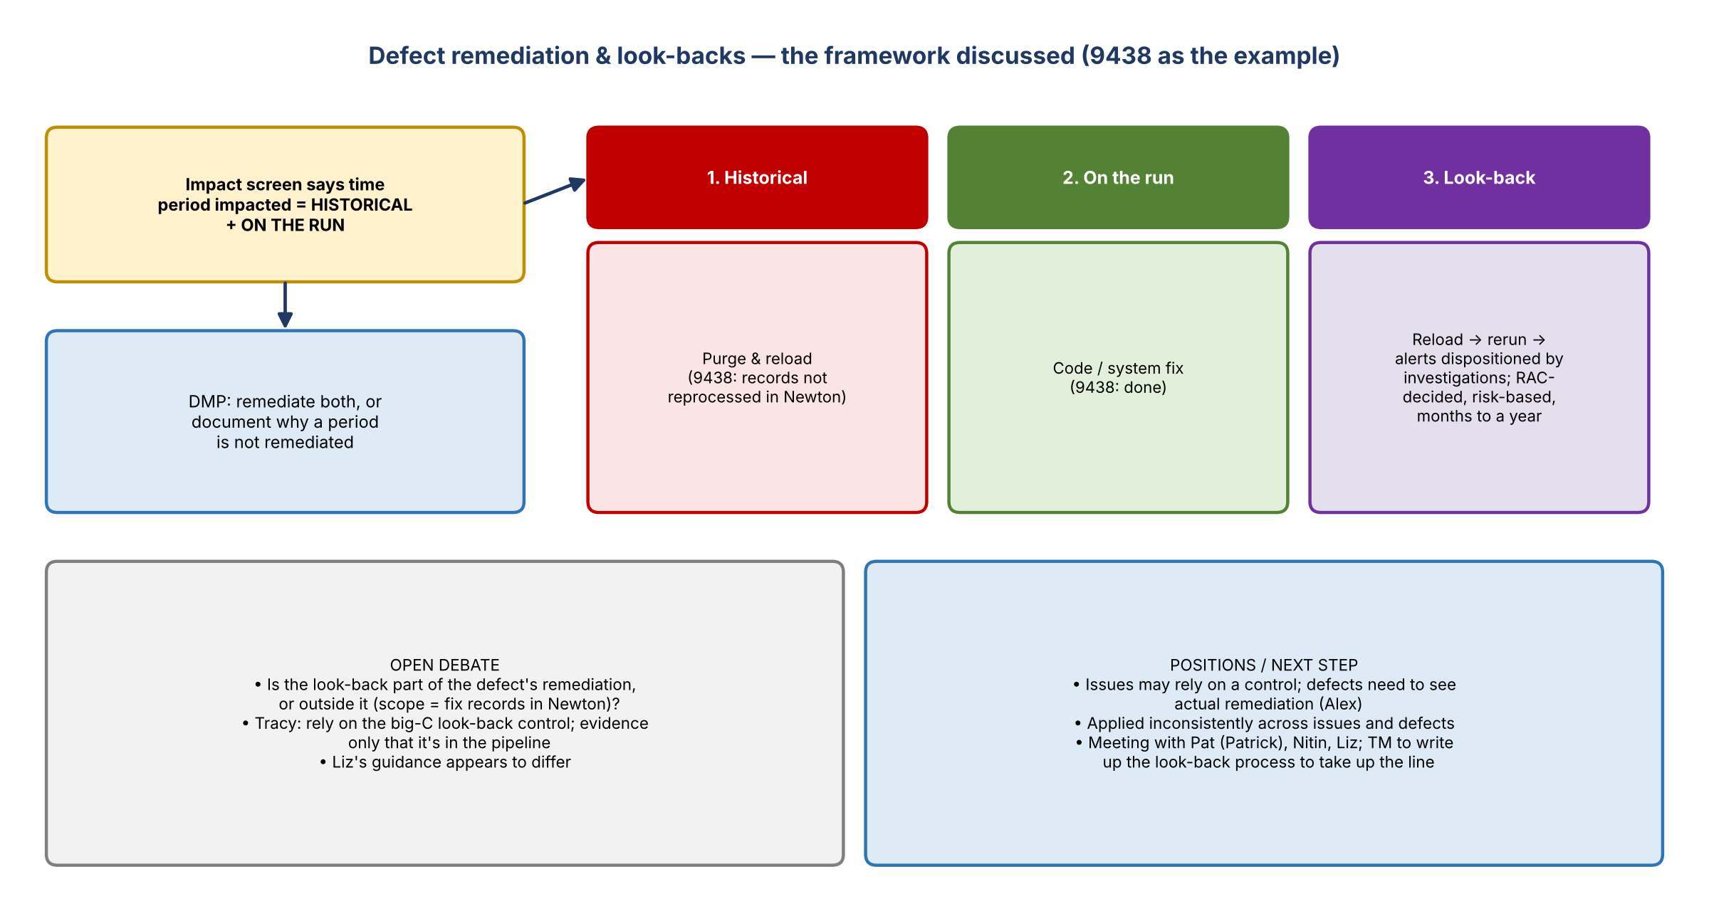
Figure 2. Remediation pieces and the open question on look-backs

Facts on 9438
- The system was fixed, but the records weren't reprocessed or reloaded into Newton. Without reprocessing, a systematic look-back isn't possible.
- Manual assessments have been done before. Whether that's an option depends on Pat, the record count, and the level of risk.

Tracy's position
- There's a big-C control that manages look-backs and their pipeline, which can take months to a year.
- She's comfortable relying on that control. If evidence is needed, it should only show the item is in the pipeline, not that it's complete.
- Liz's guidance seems different. Tracy wants a meeting with Patrick and Nitin present, since she doesn't have the detail to address Liz's concerns.

DMP alignment (Jennifer and Kelly)
- If the impact screen says historical and on the run were impacted, then both must be remediated, or the file must say why a piece isn't. Confirmed as accurate.
- For 9438, on the run is remediated. Email confirmation (shared by Kelly) shows the team was comfortable not remediating historical transactions, i.e. no purge and reload. Jonathan's detailed response supports that.

Alex's position and the three pieces
- For an issue, you can rely to an extent on a control. For a defect, you need to see the remediation itself; being in the look-back pipeline may not count as full remediation.
- Three pieces: (1) historical: purge and reload; (2) on the run: code change; (3) formal look-back assessment, e.g. across all 20 models, decided through RAC.
- Tracy has been challenged that remediation scope should be limited to fixing the records in Newton, with the follow-on investigation outside it.

Inconsistency
- Tracy (six months in): there's never been a clear, consistent process. Look-backs are sometimes in issues, sometimes in defect remediations, sometimes neither. Issues haven't applied it consistently either; guidance has changed.
- How TM look-backs work: no central remediation group. Pat's group handles them, and Ron's control brings them to RAC. The steps are reload, rerun, and alert dispositioning by investigations. It depends on resourcing, alert volumes and model cadence, and it's risk-based; a miss doesn't automatically trigger a look-back.
- Evidencing the RAC decision was suggested, but RAC agendas are time-limited, which creates a bottleneck. There was some disagreement on whether it's literally one decision per meeting.
- The company's remediation policy covers only customer remediation, so it doesn't apply.

Next step
- A senior attendee asked for an email so they can raise the look-back application question with control, Pat and Liz and agree a consistent approach.
- Tracy prefers that transaction monitoring write it up, since she doesn't want to misrepresent a complex process.
- Jennifer asked to be kept in the loop.

5. Critical defect 9860 (CIB)
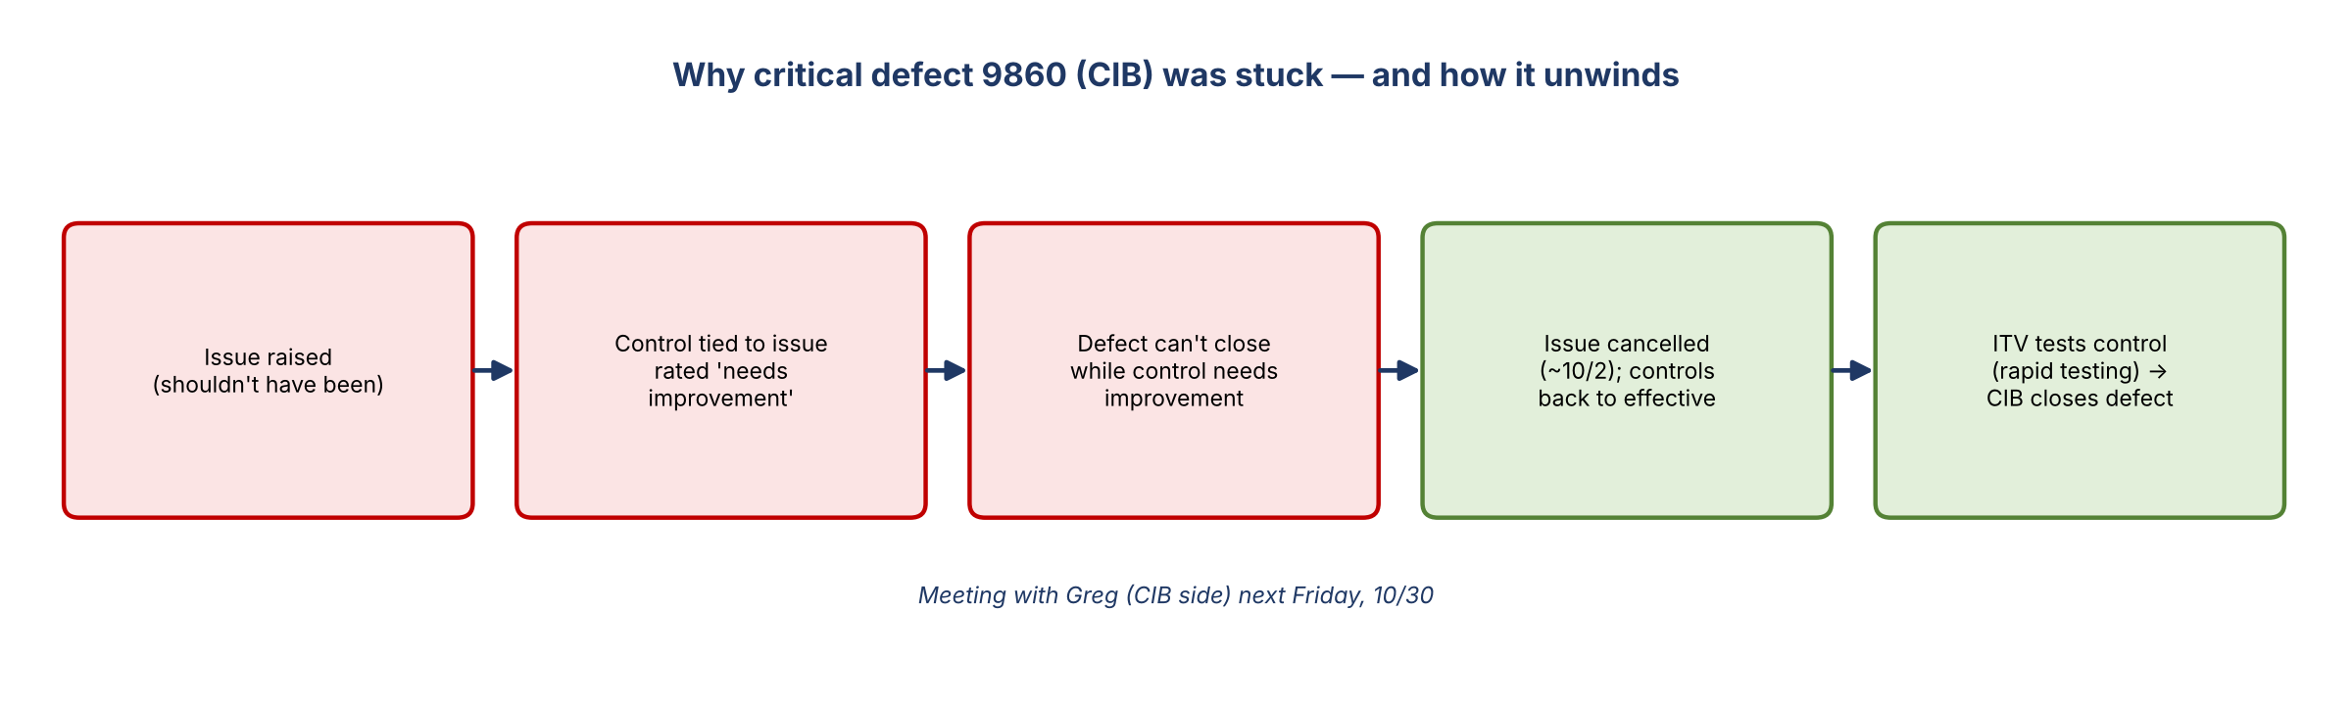
Figure 3. The issue / control / defect cycle on 9860
- The defect is complete from FCRM's side, and the holdup is on CIB's side. Greg set time with the team next Friday (10/30).
- Cause: CIB was trying to cancel the issue, not the defect. The issue shouldn't have been raised. Because it was tied to a control, that control was rated "needs improvement", and the defect can't close while the control is rated that way.
- Alicia and Kelly saw the issue was cancelled as far back as about 10/2, and the controls are back to effective, so CIB should be closing the defect.
- ITV will test the control under its rapid testing program; that was the condition for cancelling the issue.

6. 10111: changing the source to CIMADS
- Plan: update the sourcing from BMG data to CIMADS. Jennifer asked what's needed to get it moving.
- Manish: a source change usually follows a non-compliance or non-adherence finding on a source, and this hasn't been raised to that level. BMG says it provides data as-is, and the only fix is to go to CIMADS. But nothing from a TM view says CIMADS is the right source.
- It isn't technically non-adherence, since the current source was approved.
- Could the impact assessment be made critical to drive action? If it turns out critical, that would be an incentive. A moderate defect alone won't drive it.
- Sourcing changes take a while; six months is very optimistic.
- Scope (Kelly): from a TM view it's customer numbers, one PDE / core CDE. Several fields are pulled from BMG.
- Jennifer asked Manish to loop the team into those conversations.

7. 10164 and 10166: Newton impact
- 10164: an email went out asking about impacted elements. The description changed from creditor party details to creditor agent. Need the Newton team to confirm the impacted element before impact analysis can proceed.
- 10166: beneficiary name and address are missing in Newton. Newton says a workaround means TM models aren't affected, but if Newton is impacted, TM models usually are. Need confirmation of the FDM impact and whether the defect should be opened.
- Cu: Abhishek asked for the actual impacted field names in Newton. Jonathan replied that a workaround means no fields are impacted, but the workaround is temporary. The specific element names are still needed (name and address were mentioned, not the fields).
- Jennifer: Newton has a temporary tactical fix that can be documented; another tactical fix may be needed; Corporate Functions still needs a strategic fix. Donna and Roberta to support.

8. Action items
Action | Owner | Notes
Follow up with Tracy on leadership weigh-in for the 8096 family | Jennifer
Write a summary of defects sharing the external-FI root cause | Alicia | 4–5 defects
Get Rasika's approval for 8730 cancellation via John Smigla | Jennifer
Get Joe's (model owner) approval for 8730 | Manish / Nitin | 1–2 days
Meet Tara, Alex and Kelly on 8755 impact and issue alignment | Jennifer | Scheduled
Clarify 8941 evidence and proceed to closure | Kelly / Jennifer | Not on Abhishek's list yet
Set a look-back meeting with Pat, Nitin and Liz | Tracy / Jennifer | 9438, 9646, 9644
Email the look-back consistency question; TM to write up the process | Tracy / TM | Take up the line
Confirm CIB closes 9860; meet Greg 10/30 | Jennifer | Issue cancelled, controls effective
Loop Jennifer into CIMADS sourcing conversations for 10111 | Manish
Get Newton impacted element names for 10164 and 10166 | Cu / Abhishek with Donna's team | Reply to Jonathan

9. Open questions
- Is a look-back part of a defect's remediation, or covered by reliance on the big-C look-back control?
- Is a manual look-back feasible for 9438 given the volume and risk?
- Should 10111's impact be raised to critical to drive the move to CIMADS?
- Which Newton elements are impacted in 10164 and 10166, and how long will the workaround last?

