Meeting Notes
Brief for the SAS Workspace Owner Kickoff Deck
Item | Detail
Recording date | Friday, October 23, 2026 (about 12:47 PM)
Format | Short dictated brief (under 2 minutes), recorded to drive a PowerPoint for an upcoming kickoff call; Copilot was mentioned as the tool
Speaker | Kelly (BDL; refers to "myself, Jake, and Vic" as the BDL team)
Purpose | Capture what the kickoff deck for the single-workspace SAS owners needs to say: the long-term goal, the two short-term priorities, BDL's role, and next steps

Note on the transcript
Auto-generated transcript. SAS is transcribed "SaaS". Kelly is inferred as the speaker. Opening small talk is left out. This isn't a meeting with decisions; it's the content brief for a deck, organized below as notes plus a suggested slide outline built from what was said.

1. Summary
Kelly dictated the content for a PowerPoint to be used on a kickoff call with SAS workspace owners who each own only one workspace. The call explains that the bank is migrating away from SAS long term, and that there are two short-term priorities. Priority 2 is the more important one.
- Priority 1, storage and access cleanup: validate low usage, consolidate allocations, and confirm the de-allocation and billing impact of the bulk removal already under way.
- Priority 2, exit readiness path: who uses each workspace and why, use case dependencies such as regulatory reports and models, and whether an exit path and target date exist. If not, BDL helps create one.
After the call, BDL (Kelly, Jake, Vic) sends each owner a SharePoint survey. BDL then assesses criticality, dependencies, and controls based on the responses.

2. Audience and purpose of the kickoff call
- Audience: individual workspace owners, each owning only one workspace. (Multi-workspace owners such as Leopold are being handled in separate calls.)
- Purpose: educate owners on the broader, enterprise-wide initiative to migrate away from SAS long term.
- Frame the two short-term priorities the bank is focused on now.

3. The message
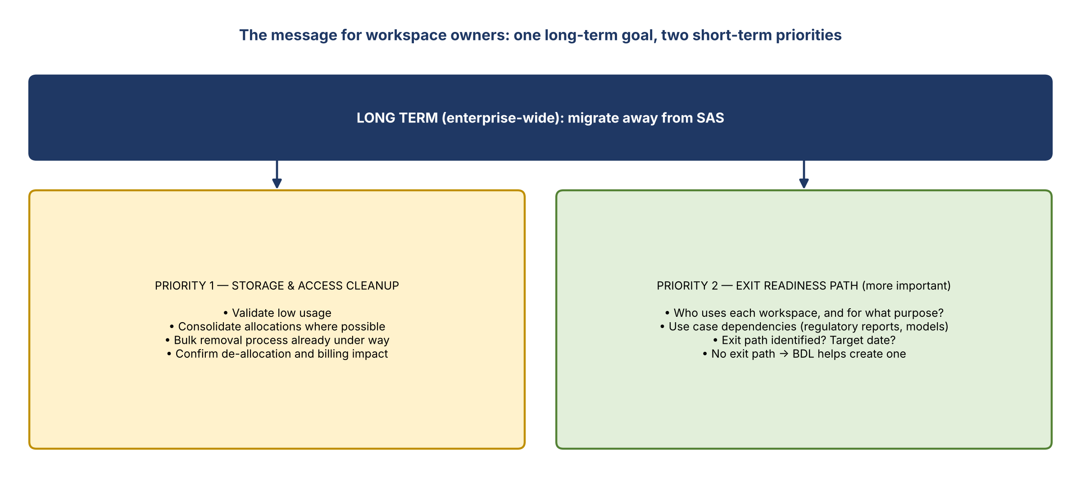
Figure 1. Long-term goal and the two short-term priorities

Priority 1: storage and access cleanup
- Validate low usage.
- Consolidate allocations where possible.
- A bulk removal process is already running. The team is confirming the de-allocation and the billing impact.

Priority 2: exit readiness path (more important)
- Each workspace feeds downstream users. Who uses it, and for what purpose?
- Are there use case dependencies, such as regulatory reports or models that consume data from the workspace?
- Is an exit path already identified? What's the target date?
- If there's no exit path, BDL will help create one.

BDL's role
- Using use case owners' survey responses, BDL assesses criticality, dependencies, and any controls that can help through the process.

4. Next steps after the call
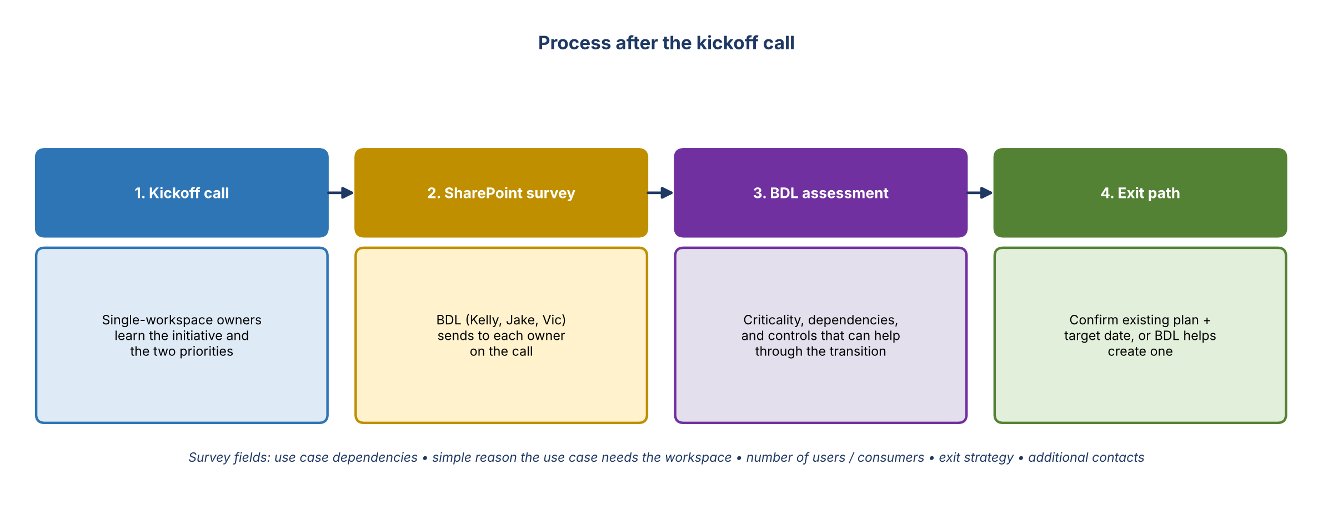
Figure 2. What happens after the kickoff
- BDL (Kelly, Jake, Vic) sends a SharePoint survey to each workspace owner on the call.
Survey field | What it captures
Use case dependencies | Models, regulatory reports, and other uses that consume data from the workspace
Why the use case needs the workspace | A simple description
Number of users | Who actually consumes data from the workspace
Exit strategy | Whether a plan exists, and if so the plan and target date; if not, say so
Additional contacts | If needed

5. Suggested slide outline (built from the brief)
# | Slide | Content
1 | Title | SAS workspace owner kickoff: storage cleanup and exit readiness
2 | Why we're here | Enterprise-wide initiative to migrate away from SAS long term
3 | Two short-term priorities | Storage and access cleanup; exit readiness path (the more important one)
4 | Priority 1 details | Validate low usage, consolidate allocations, bulk removal under way, confirm de-allocation and billing impact
5 | Priority 2 details | Downstream users and purpose; dependencies (regulatory reports, models); exit path and target date; BDL support if none
6 | How BDL will help | Assess criticality, dependencies and controls from survey results; help build exit paths
7 | Next steps | SharePoint survey from BDL (Kelly, Jake, Vic); survey fields; contacts for questions

6. Action items
Action | Owner | Notes
Build the kickoff PowerPoint from this brief | Kelly / Jake | Copilot was the planned tool
Finalize and send the SharePoint survey to each workspace owner after the call | Kelly, Jake, Vic
Confirm de-allocation and billing impact of the bulk removal | BDL | Priority 1
Assess criticality, dependencies and controls from survey responses | BDL | Priority 2

