Meeting Notes
SAS Workspace Owner One-on-One: LOB Forecast Workspace
Item | Detail
Meeting date | Friday, October 23, 2026 (recording started about 12:32 PM)
Format | Short one-on-one; Kelly shared the meeting invite, the utilization spreadsheet, and the SAS initiative slides
BDL | Kelly (led), Jake
Workspace owner | Shawn Douglas, owner of the LOB Forecast SAS workspace
Purpose | Introduce the SAS reduction initiative, review the workspace's utilization, and explain the survey that's coming

Note on the transcript
Auto-generated transcript. Speakers aren't labeled. The workspace owner is Shawn Douglas (confirmed; the transcript also says "John" once). Jake's contribution was barely captured. The recording starts after the intro and runs a few seconds past the end of the call; that post-call chatter is left out.

1. Summary
Kelly walked Shawn Douglas, owner of the LOB Forecast SAS workspace, through the enterprise SAS reduction effort. Shawn knows the workspace, which puts him ahead of many owners who didn't know they owned one. The workspace is at about 11% utilization, well below the roughly 60% leadership wants allocations to sit at, so its allocation is a candidate to reduce.
Before changing anything, BDL wants to understand who uses the workspace, what data is there, and whether an exit plan exists. A survey will follow the call. Results are wanted by early November, and contacts who know more are an acceptable answer where the owner doesn't. A larger kickoff call is next week.

2. Why the team reached out
- Shawn was identified as a SAS workspace owner and confirmed he knows the LOB forecast workspace.
- Senior leadership is reducing SAS allocation across the enterprise because SAS is costing the bank a lot of money.
- Goal of these conversations: understand the purpose, who uses it and what data is there, and whether it can be consolidated or reduced.
- Shawn had heard the bank is moving off SAS. Kelly: there have been whispers before, but this time there's more eagerness to actually do it. It won't happen tomorrow, but the cleanup starts now to save money, and the long-term goal is to migrate off SAS.
- These one-on-ones go to owners BDL already knows. A larger kickoff call is planned for next week.

3. The two tracks
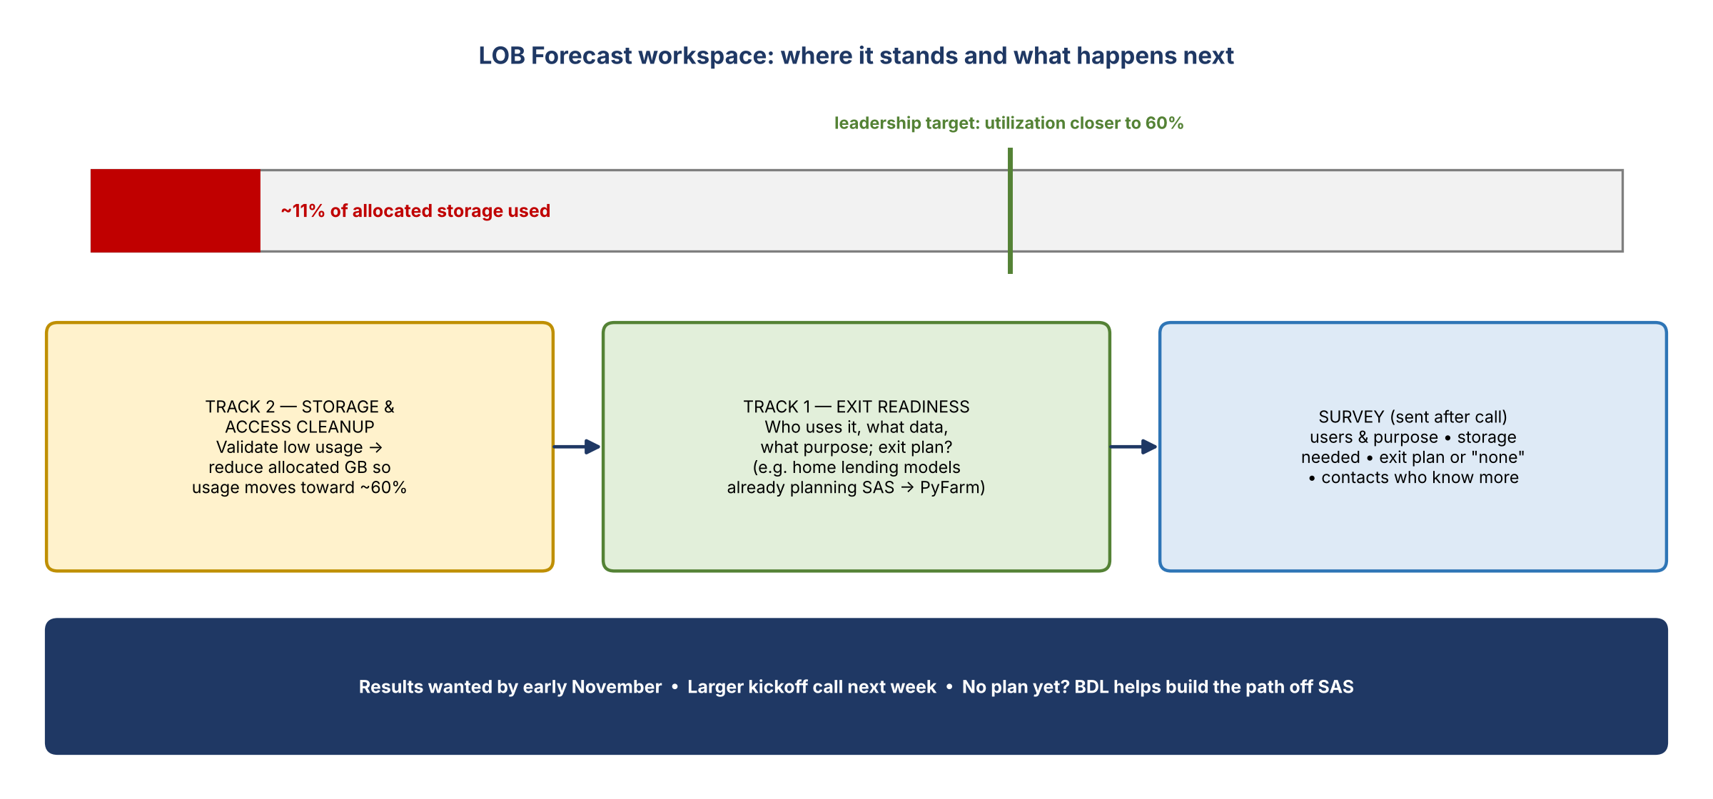
Figure 1. The workspace's utilization against the target, and the next steps

Track 2: storage and access cleanup
- Workspaces with zero or low usage (under 60%) have been identified.
- LOB forecast: about 11% utilization. Low, though not as low as some.
- Leadership wants storage allocations closer to 60% utilization, so this workspace's allocated gigabytes could likely be reduced.
- Nothing will change until Track 1 is understood.

Track 1: exit readiness
- Understand what the workspace is used for, who uses it, and what data it holds.
- Find out whether an exit plan exists. For example, many home lending models already plan to move from SAS to PyFarm.
- If there's no plan, or the conversation hasn't happened, say so, and BDL will help work out how to move off SAS.

4. The survey
Ask | Detail
Who uses the workspace and why | Users and purpose
Storage need | Is all the allocated storage needed, or can the number of GB be reduced?
Exit plan | Is one in place? If not, say "no plan"
Contacts | People who may know more, if the owner doesn't have every answer

- Timing: leadership wants results by early November. Provide as much detail as possible; partial answers plus contacts are fine and BDL will follow up.

5. Action items
Action | Owner | Notes
Send the survey link to Shawn | Kelly / Jake | After the call
Complete the survey: users, purpose, storage need, exit plan, contacts | Shawn Douglas | Early November
Follow up with any contacts named in the survey | Kelly / Jake
Invite Shawn to next week's larger kickoff call | Kelly

